Sprout v1.0

Sprout is an Android app contributes to adolescent education and hands-on activity within family as an auxiliary tool, produced by The Pink Rapper.



Goal

Sprout is an Android-based platform application tailor-made for families with children. The primary objective of the Sprout app is to provide basic knowledge of plants and some necessary auxiliary functions for activities based on this knowledge to help users improve their practical skills while acquiring knowledge of plants.

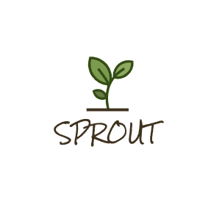

What can be done by using this app

1.Search

Sprout provides searching function for capturing information of any plants you want.

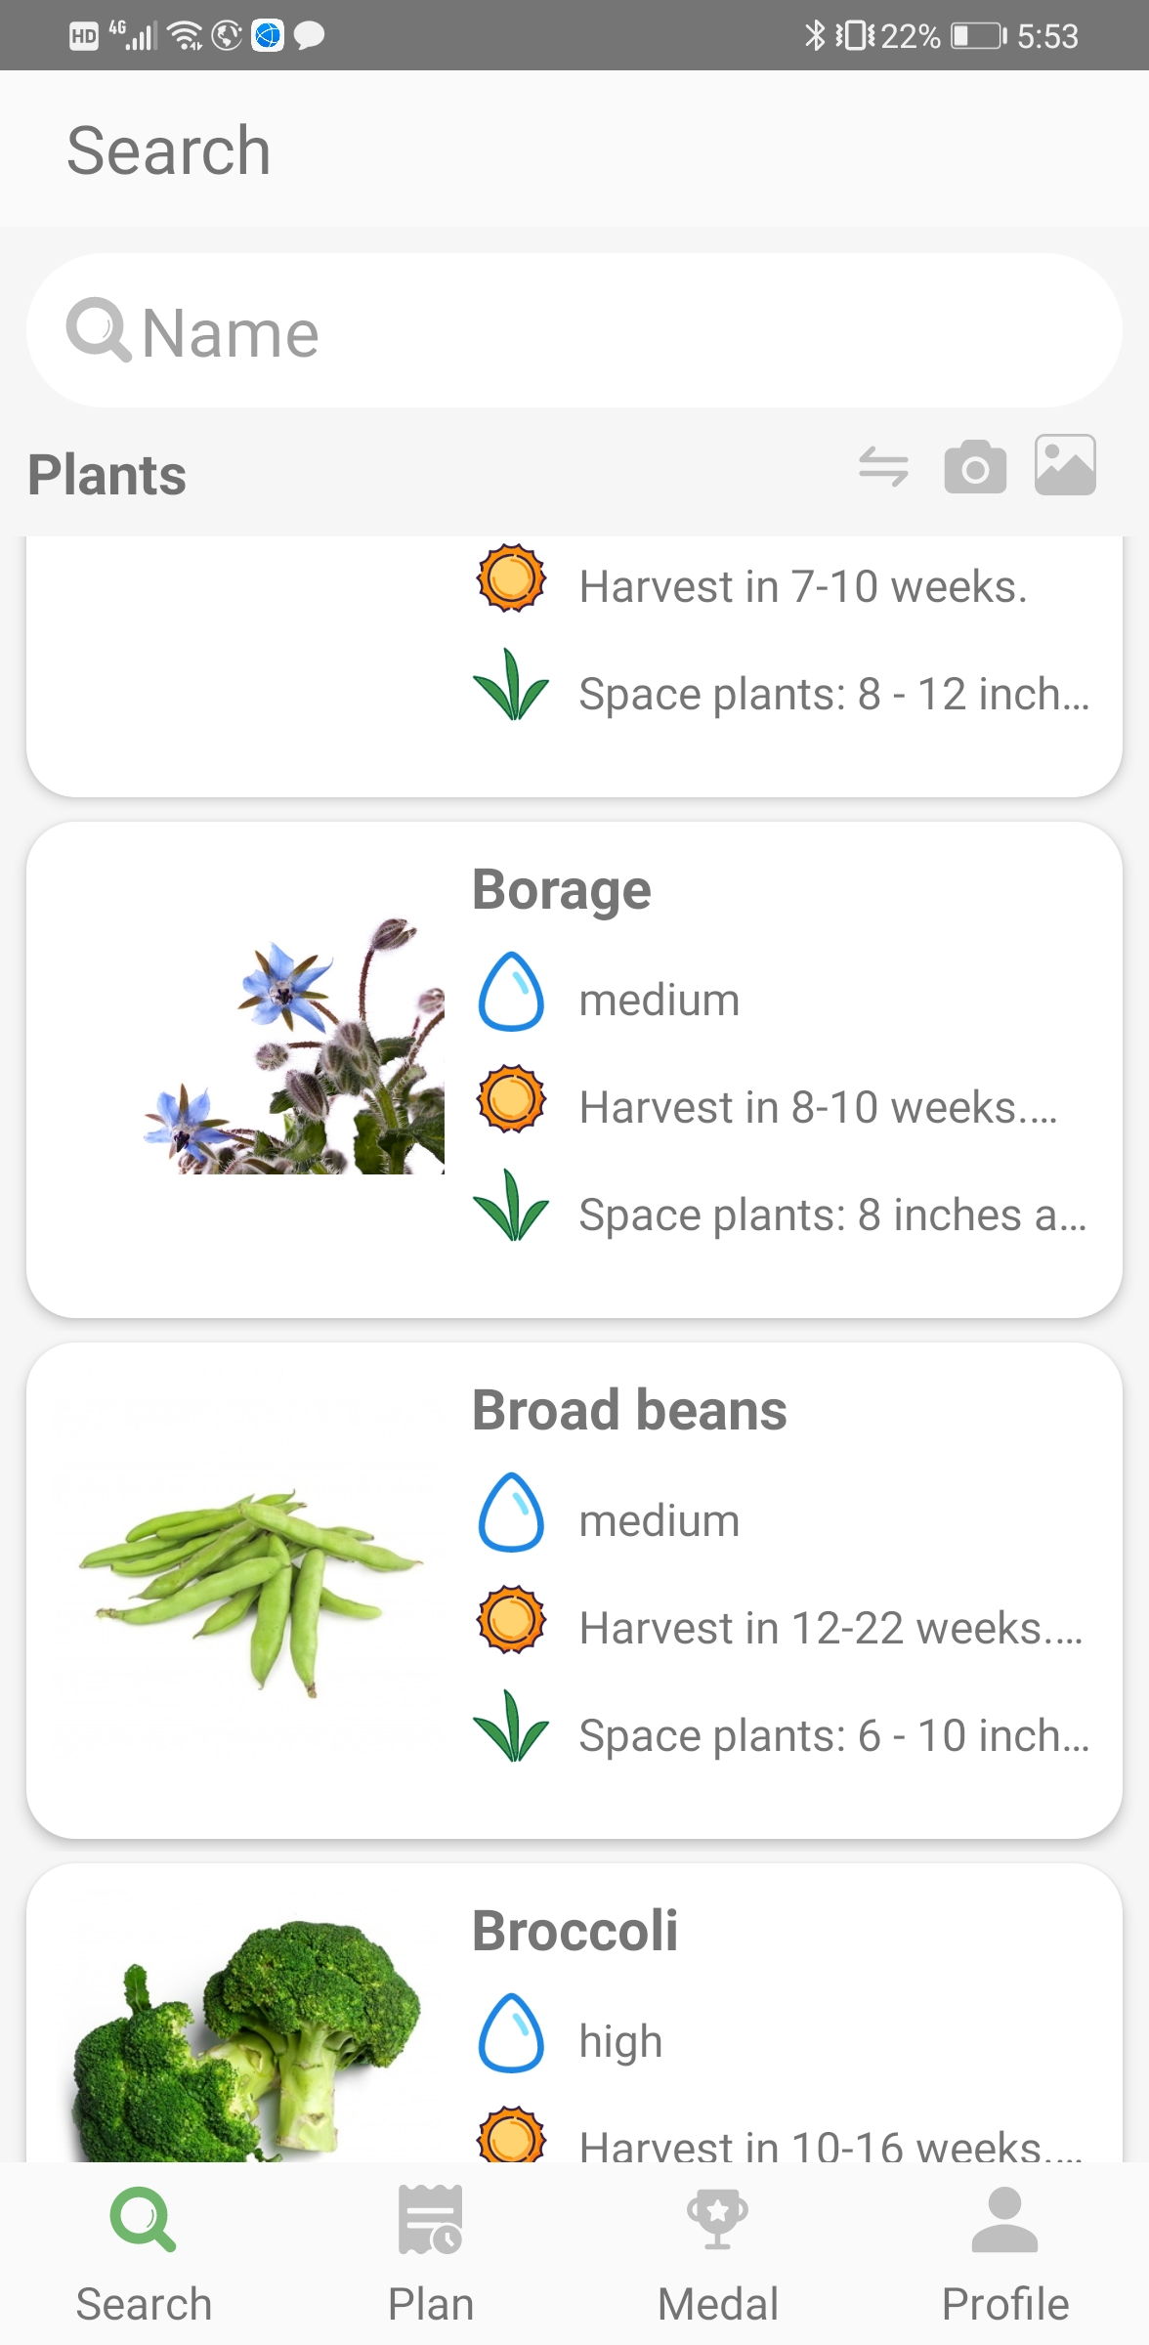

Also, Sprout supports searching by AI recognition and inputting the value of “water need” or “harvest time”.

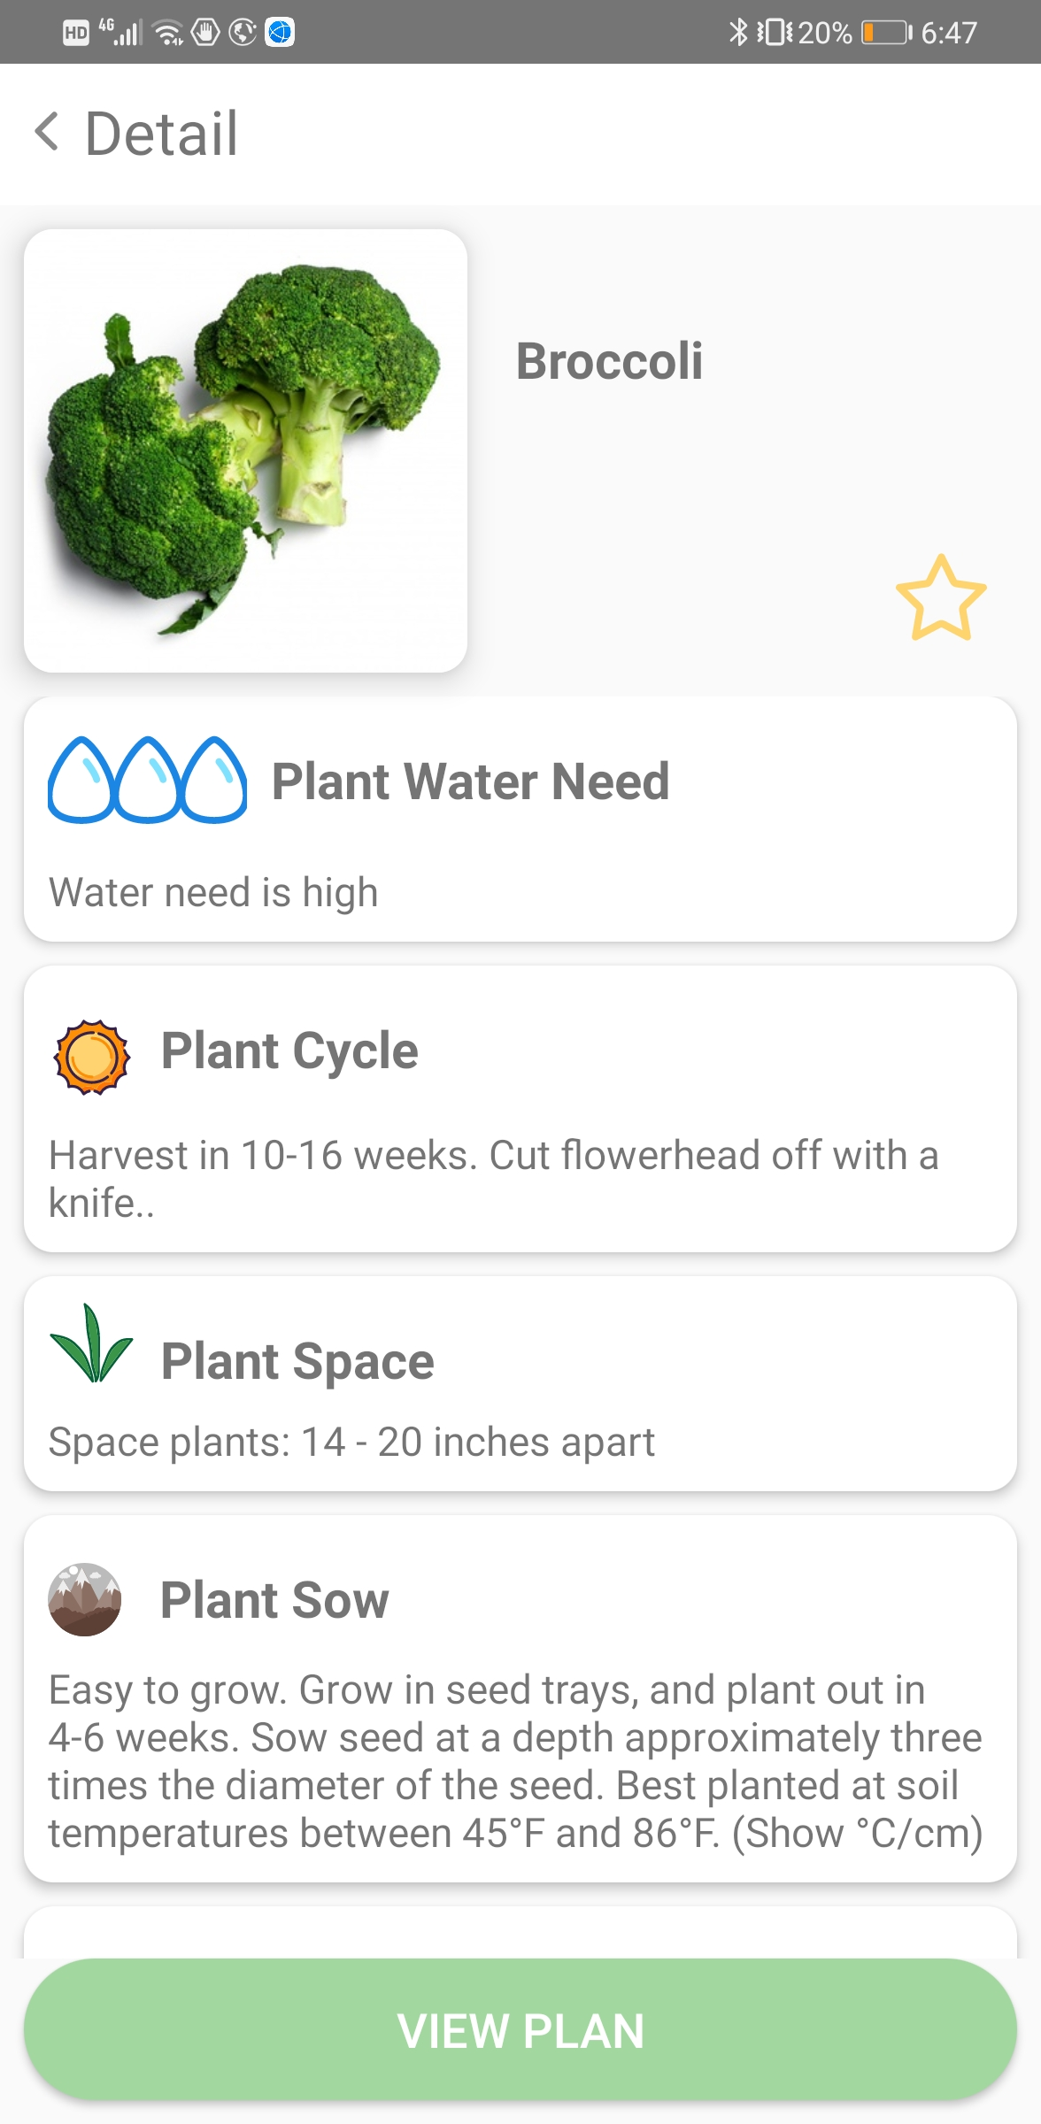

2.Plan

The feature of plan supports to generate a customized planting plan for what users want to grow.

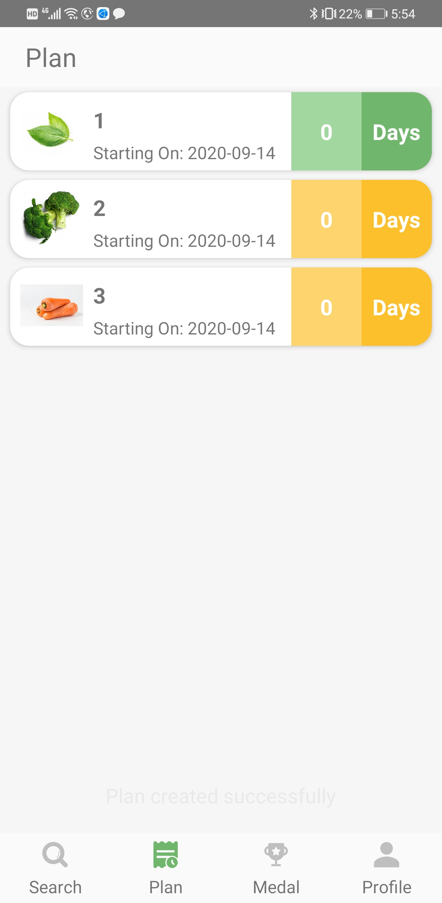

providing information of watering frequency and recording mechanism as well as informing watering by Pop-up information.

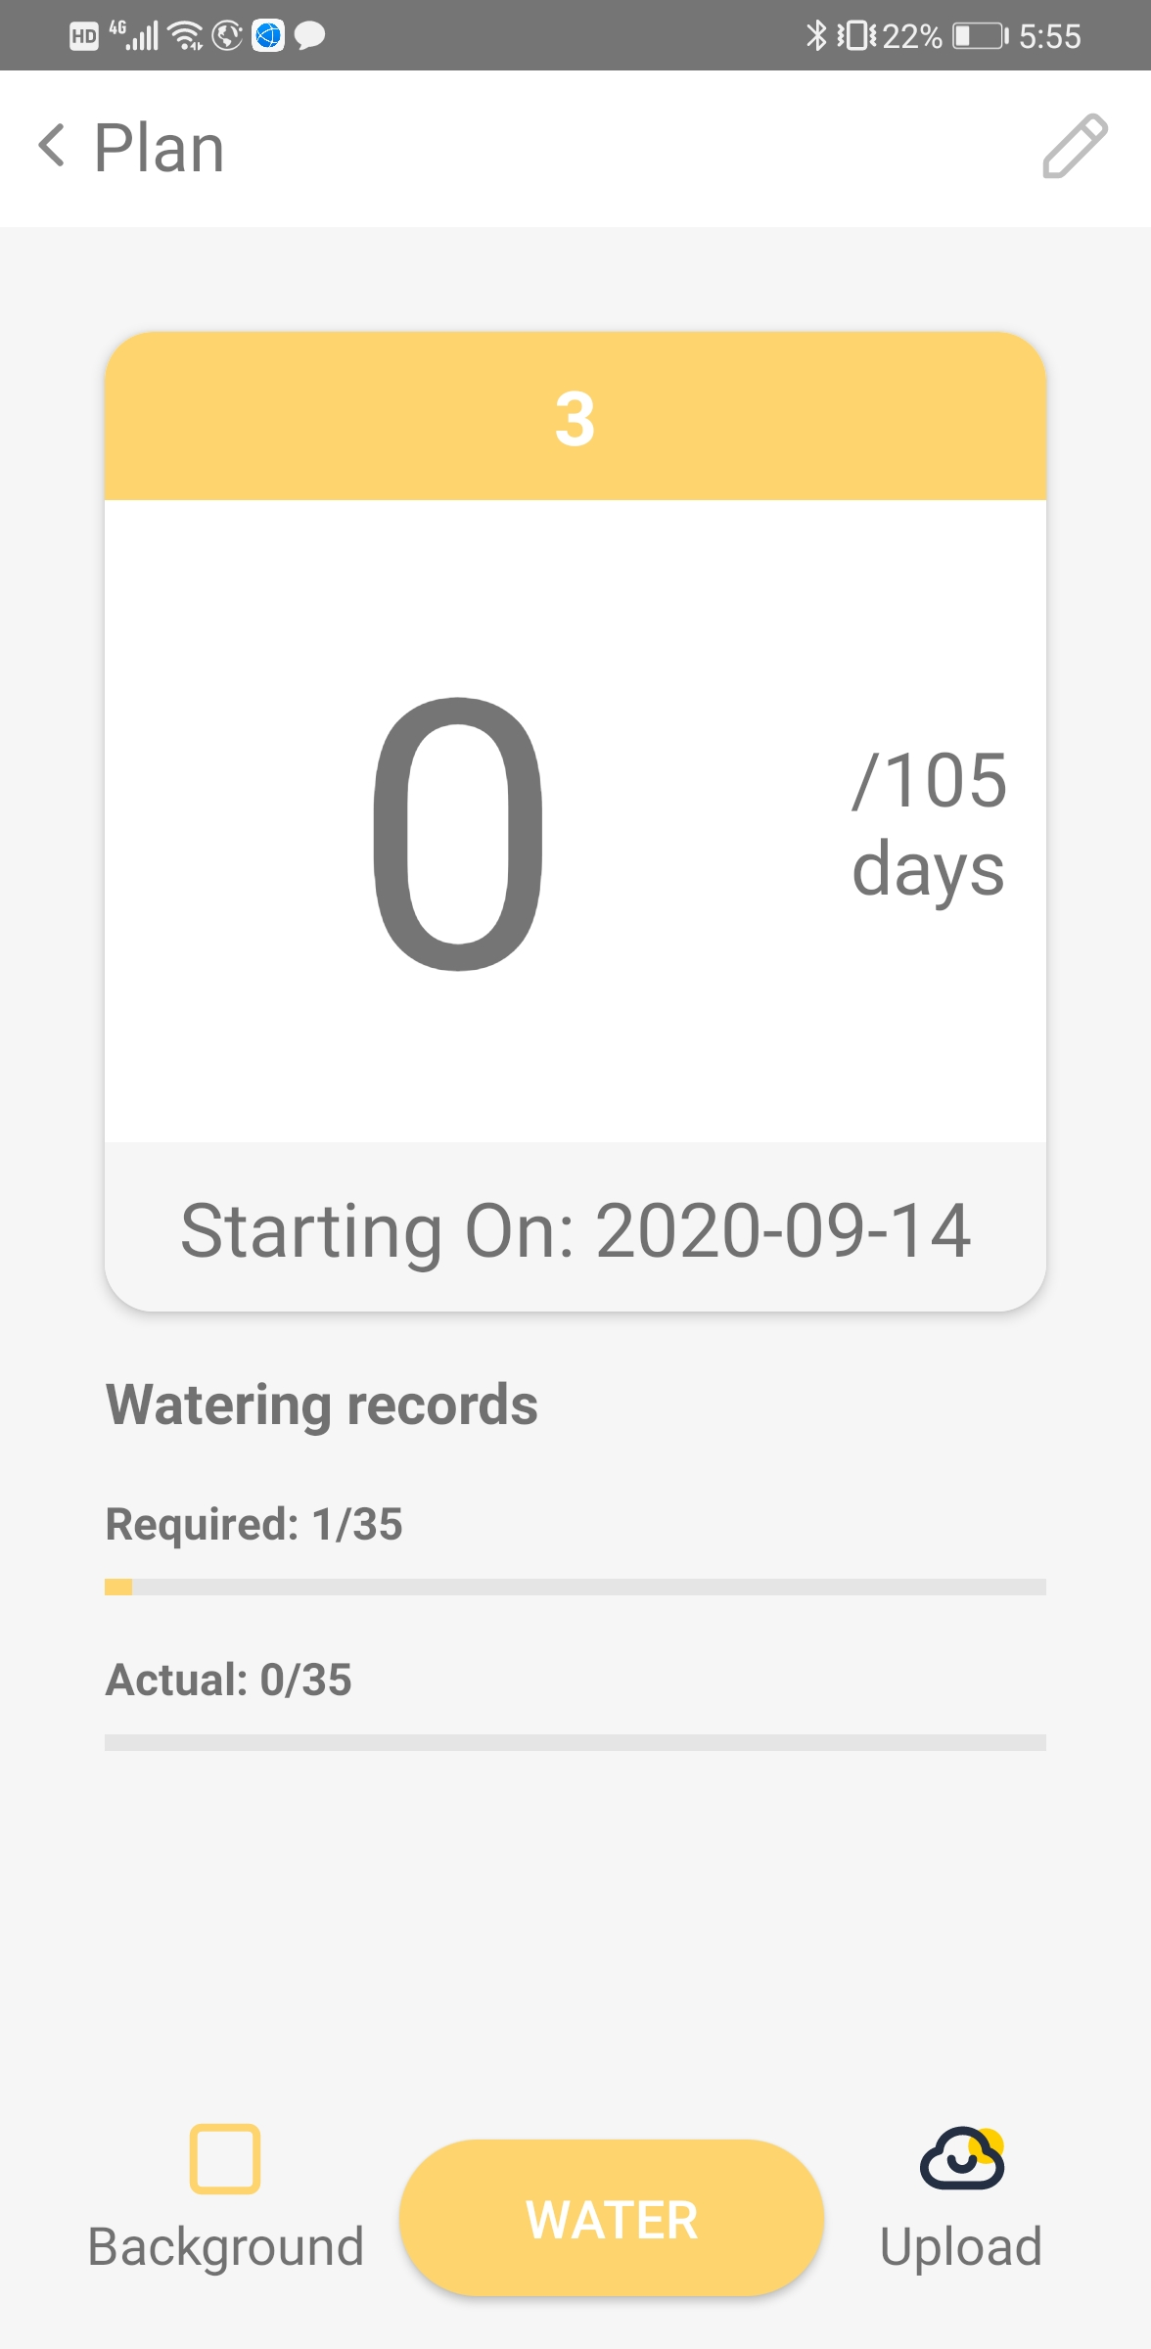

3.Madals

Tech

JAVA

AWS server

Android