Bayesian Task Analyses 30 May

**Modifications to “2 Bayes Summary- Completed Pts.csv” data file**

* Probability values of selecting left and right boxes (A and B respectively) calculated in columns U and W
* Prior odds recoded in column X such that if any Odds A = 0, value will be changed to 0.000001. Likewise, if value = 1, value recoded to 0.999999. This is done to avoid errors in calculating LogBaserate
* Calculated LogLLA (i.e. Log likelihood of Box A based on draw evidence) and LogBaserate (i.e. log base rate odds) in columns Y and Z respectively.
* Renamed “Condition” variable (column C) to “ConditionOld”. Recoded in Column D as new dichotomous “Condition” variable.
  + WR coded as 0 (i.e. baseline)
  + SR coded as 1
  + CM also coded as 1, but these rows will be omitted in R analyses.
* Row 1419 had data entry error for OddsA. Double checked this against my dataset from Honours thesis and corrected it.
* Deleted all invalid values for StartKSS (i.e. value = 8888) and PtResp (i.e. value =99) so that R will read it as actual missing data for the mixed model.

# Sleep restriction effect on KSS score

* Used StartKSS score here.
* I’ve provided two outputs here, one using the raw StartKSS score and the other using a log transformed KSS score (to correct positive skew).
* Sleep restriction significantly increases KSS score.

## With Raw KSS score

> summary(b_KSS)

Linear mixed model fit by REML. t-tests use Satterthwaite's method ['lmerModLmerTest']

Formula: StartKSS ~ 1 + Condition + (1 | PtID)

Data: dataKSS

REML criterion at convergence: 395

Scaled residuals:

Min 1Q Median 3Q Max

-2.95187 -0.65379 0.07991 0.57825 2.12983

**Random effects:**

Groups Name Variance Std.Dev.

PtID (Intercept) 0.7252 0.8516

Residual 1.4781 1.2158

Number of obs: 112, groups: PtID, 37

**Fixed effects:**

Estimate Std. Error df t value Pr(>|t|)

(Intercept) 3.1746 0.2028 52.1630 15.65 <2e-16 ***

Condition 2.7829 0.2540 92.3092 10.95 <2e-16 ***

---

Signif. codes: 0 ‘***’ 0.001 ‘**’ 0.01 ‘*’ 0.05 ‘.’ 0.1 ‘ ’ 1

Correlation of Fixed Effects:

(Intr)

Condition -0.423

>

## With Log-transformed KSS Score

> summary(b_KSSlog)

Linear mixed model fit by REML. t-tests use Satterthwaite's method ['lmerModLmerTest']

Formula: KSS_log ~ 1 + Condition + (1 | PtID)

Data: dataKSS

REML criterion at convergence: 116.3

Scaled residuals:

Min 1Q Median 3Q Max

-3.1672 -0.4654 0.0972 0.5877 2.8487

**Random effects:**

Groups Name Variance Std.Dev.

PtID (Intercept) 0.08875 0.2979

Residual 0.10463 0.3235

Number of obs: 112, groups: PtID, 37

**Fixed effects:**

Estimate Std. Error df t value Pr(>|t|)

(Intercept) 1.07096 0.06271 44.92249 17.078 < 2e-16 ***

Condition 0.65970 0.06882 86.60467 9.586 2.96e-15 ***

---

Signif. codes: 0 ‘***’ 0.001 ‘**’ 0.01 ‘*’ 0.05 ‘.’ 0.1 ‘ ’ 1

Correlation of Fixed Effects:

(Intr)

Condition -0.361

>

# Effect of Sleep restriction on Bayesian Task Accuracy

* No sig. effect on task accuracy

## Output

> summary(b_acc)

Generalized linear mixed model fit by maximum likelihood (Laplace Approximation) ['glmerMod']

Family: binomial ( logit )

Formula: IsCorrect ~ 1 + Condition + (1 | PtID)

Data: dataSRWR

AIC BIC logLik deviance df.resid

4880.3 4899.6 -2437.1 4874.3 4722

Scaled residuals:

Min 1Q Median 3Q Max

-3.0396 0.3563 0.4636 0.5728 0.7788

**Random effects:**

Groups Name Variance Std.Dev.

PtID (Intercept) 0.1974 0.4443

Number of obs: 4725, groups: PtID, 41

**Fixed effects:**

Estimate Std. Error z value Pr(>|z|)

(Intercept) 1.36516 0.08415 16.222 <0.0000000000000002 ***

Condition -0.10494 0.07801 -1.345 0.179

---

Signif. codes: 0 ‘***’ 0.001 ‘**’ 0.01 ‘*’ 0.05 ‘.’ 0.1 ‘ ’ 1

Correlation of Fixed Effects:

(Intr)

Condition -0.336

# Decision Weight Analyses

* Participants overweigh base rate odds during well-rested. Overweighting of odds becomes more pronounced with sleep restriction, but the numbers suggest this is due to a **decrease in decision weight on draw evidence** rather than an increase in decision weight on base rate odds.

## Probit model

>summary(b1)

Generalized linear mixed model fit by maximum likelihood (Laplace Approximation) ['glmerMod']

Family: binomial ( probit )

Formula: PtResp ~ 1 + LogLLA + LogBaserate + Condition + Condition * LogLLA + Condition * LogBaserate + (1 | PtID)

Data: dataSRWR

AIC BIC logLik deviance df.resid

4756.3 4801.5 -2371.2 4742.3 4682

Scaled residuals:

Min 1Q Median 3Q Max

-137.151 -0.815 0.018 0.756 75.795

**Random effects:**

Groups Name Variance Std.Dev.

PtID (Intercept) 0.01137 0.1066

Number of obs: 4689, groups: PtID, 41

**Fixed effects:**

Estimate Std. Error z value Pr(>|z|)

(Intercept) 0.14619 0.03211 4.553 0.00000529 ***

LogLLA 0.16970 0.01100 15.427 < 0.0000000000000002 ***

LogBaserate 0.20591 0.01002 20.543 < 0.0000000000000002 ***

Condition -0.08605 0.04463 -1.928 0.0538 .

LogLLA:Condition -0.03483 0.01709 -2.038 0.0415 *

LogBaserate:Condition 0.02096 0.01806 1.161 0.2457

---

Signif. codes: 0 ‘***’ 0.001 ‘**’ 0.01 ‘*’ 0.05 ‘.’ 0.1 ‘ ’ 1

Correlation of Fixed Effects:

(Intr) LogLLA LgBsrt Condtn LLLA:C

LogLLA 0.022

LogBaserate 0.084 0.398

Condition -0.525 -0.012 -0.059

LgLLA:Cndtn -0.013 -0.642 -0.255 0.008

LgBsrt:Cndt -0.046 -0.219 -0.553 0.074 0.362

>

### **Confidence intervals**

2.5 % 97.5 %

sd_(Intercept)|PtID NA NA

(Intercept) 0.08325597 0.209114072

LogLLA 0.14814393 0.191264419

LogBaserate 0.18626426 0.225555302

Condition -0.17351108 0.001416537

LogLLA:Condition -0.06832439 -0.001335194

LogBaserate:Condition -0.01442967 0.056354560

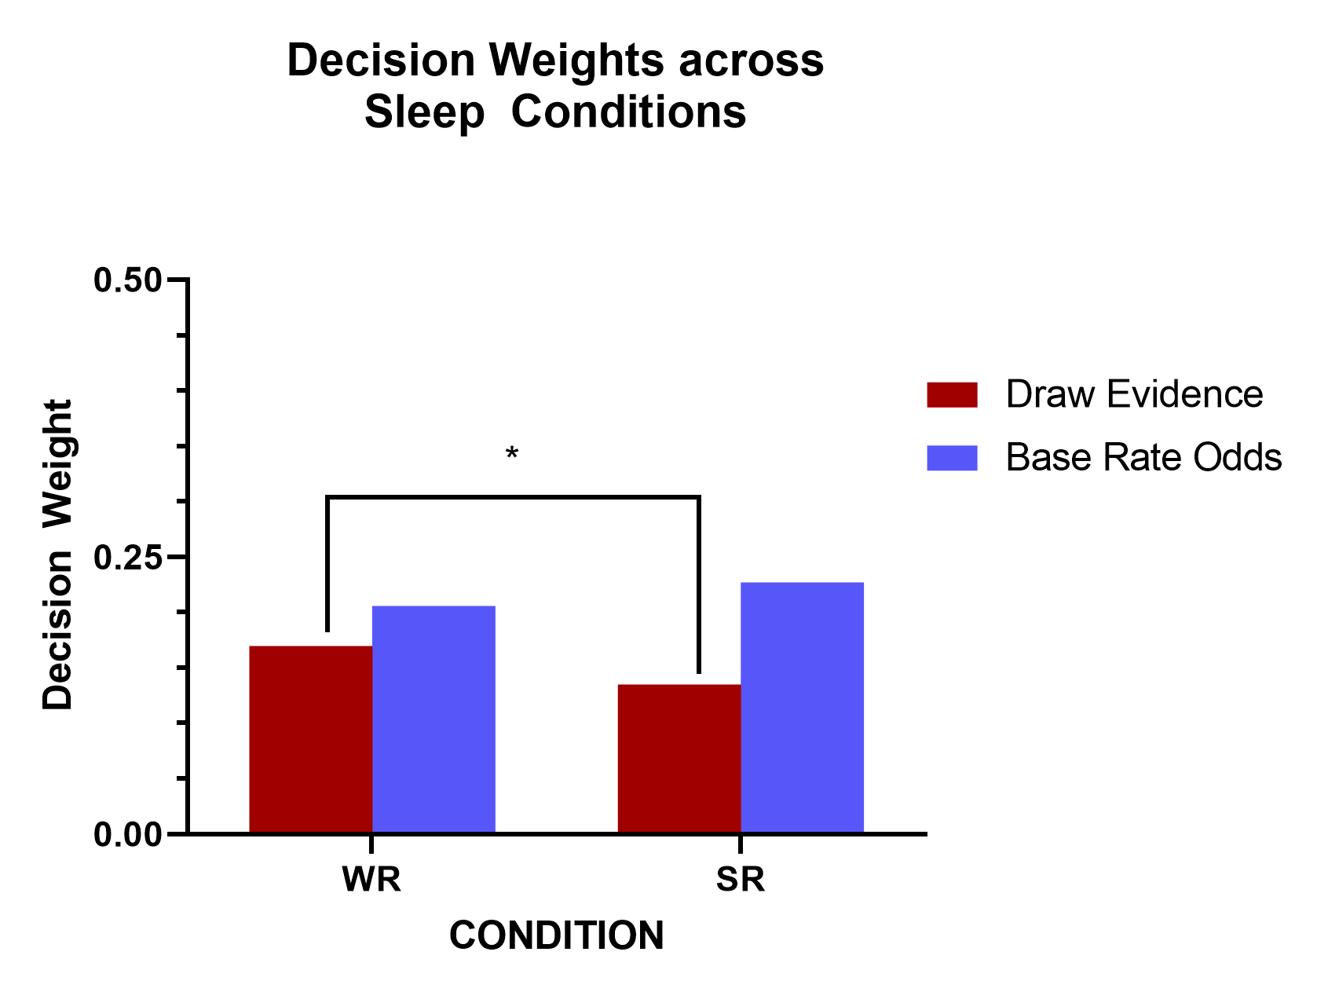

## Relative Decision Weight

* Calculated with $\frac{β_{1}- β_{2}}{β_{1}+ β_{2}}$
  + positive values indicate a bias toward draw evidence, and negative values indicate a bias toward base rate odds

|  |  |
| --- | --- |
| Decision Weight (WR) | Decision Weight (SR) |
| -0.09639048 | -0.2543157 |

### **Chi Square test to compare decision weights in each condition**

* significant values indicate significant difference between decision weights of draw evidence and base rate odds.
* Numbers here indicate participants significantly overweighed base rate odds in both conditions

**For WR:**

Linear hypothesis test

Hypothesis:

- LogLLA + LogBaserate = 0

Model 1: restricted model

Model 2: PtResp ~ 1 + LogLLA + LogBaserate + Condition + Condition * LogLLA +

Condition * LogBaserate + (1 | PtID)

Df Chisq Pr(>Chisq)

1

2 1 9.8021 0.001743 **

---

Signif. codes: 0 ‘***’ 0.001 ‘**’ 0.01 ‘*’ 0.05 ‘.’ 0.1 ‘ ’ 1

**>**

**For SR:**

Linear hypothesis test

Hypothesis:

- LogLLA + LogBaserate - LogLLA:Condition + LogBaserate:Condition = 0

Model 1: restricted model

Model 2: PtResp ~ 1 + LogLLA + LogBaserate + Condition + Condition * LogLLA +

Condition * LogBaserate + (1 | PtID)

Df Chisq Pr(>Chisq)

1

2 1 32.407 0.0000000125 ***

---

Signif. codes: 0 ‘***’ 0.001 ‘**’ 0.01 ‘*’ 0.05 ‘.’ 0.1 ‘ ’ 1

>

