**Computational modelling of GUM4 data**

I ran two computational models in Stan – the Value plus Sequential Exploration model (see [Ligneul, 2019](https://journals.plos.org/ploscompbiol/article?id=10.1371/journal.pcbi.1006989)) and the Prospect Valence Learning-Delta model (see [Steingroever et al., 2013](https://www.ncbi.nlm.nih.gov/pmc/articles/PMC3847555/)). **Model comparison metrics show the VSE model is the better fit of the GUM4 data by quite a large margin**. Participants who had 62 trials due to the task-crashing bug were still included, as we can still approximate latent parameter values given a 62-trial choice pattern.

For your reference,

* Pages 2-3: VSE model functional form.
* Pages 4-5: Results of linear mixed models, with VSE parameter estimates as DVs in each model.
* Page 6-7: Contrasts and figure illustration.

Brief description of VSE model parameters:

1. **Value Sensitivity:** sensitivity to gain or loss amounts received on each trial. *Higher values = more sensitive*
2. **Decay Rate:** retention of expected values associated with each deck over consecutive trials, like a working memory component. *Higher values = better retention*
3. **Exploration Bonus:** the subject’s bias toward exploiting advantageous decks vs. exploring other decks. The VSE model seeks to capture “directed exploration”, i.e. exploring alternatives to seek information, independent of expected values. *Negative values = exploitative, Positive values = explorative.*
4. **Exploration Update:** the rate at which the subject returns to the baseline bias (i.e., Exploration Bonus) to explore alternative decks that have not been chosen in a while. *Higher values = faster rate of return.*
5. **Consistency:** Choice stochasticity, *higher values = more deterministic choices, lower values = more random choices*. Because the VSE model already has a directed exploration module, this may also capture *undirected* exploration.

Results brief summary:

* Re: effects of caffeine, results are in line with the original paper. **There are no significant effects of drug on any of the VSE parameter estimates, nor are there any significant interactions.** The results presented here are of models dropping the *session* x *drug* interaction (i.e., drug groups pooled, just like in the original paper).
* Regression models show:
  + Subjects are **significantly lower on Value Sensitivity by 75h TSD**, relative to Baseline
  + Subjects are **significantly lower in Consistency at both 51h and 75h TSD**, relative to Baseline
* Post-hoc contrasts show:
  + **No meaningful difference in Value Sensitivity between Baseline and 51h TSD, but sig. decrease from 51h – 75 TSD**
  + **Significant decrease in Consistency from Baseline – 51h TSD, no meaningful difference between 51h – 75h TSD**

## Value plus Sequential Exploration model

The VSE model has 5 free parameters, and two over-arching cognitive components (exploitation and exploration). Its basis is to capture exploratory, information-seeking behaviour (in addition to value exploitation), which previous cognitive process models of the IGT don’t do adequately.

### 1. Exploitation Weights

Exploitation weights determine the degree to which each deck is likely to be repeatedly selected because of its value. Exploitation weights for each deck are initialised as 0 at the start of the task (trial *t* = 0).

The value of the chosen deckon trial *t* is given by the following equation:

* Where is the **value sensitivity** parameter, bounded between 0 and 1. Higher values indicate greater sensitivity to the gain/loss amounts obtained on each trial.

On each trial, the exploitation weight of deck *d* (*exploitd*) is updated for trial *t +* 1 as follows:

* Where is the **decay rate** parameter, bounded between 0 and 1. indicates perfect retention of deck expected values, and lower values indicate faster “forgetting” of expected values, akin to a working memory component.

### 2. Exploration Weights

Exploration weights determine the degree to which each deck is likely chosen due to “goal-directed exploration”, i.e., information seeking behaviour, *independent of deck values* (see [Wilson et al., 2014](https://pubmed.ncbi.nlm.nih.gov/25347535/)). Exploration weights for each deck are initialised as the subject’s exploration bonus parameter value at the start of the task.

On each trial, the exploration weight of deck *d* (*explored*) is updated for trial *t +* 1 as follows:

* Where is the **exploration bonus** parameter, unbounded. Positive values indicate tendency to ***explore***, while negative values indicate a more exploitative choice pattern.
* And is the **exploration update** parameter, bounded 0-1, controlling the degree to which subjects return to their baseline tendency to explore other deck options (higher = faster return).

### 3. Softmax Choice Rule

Incorporating both exploitation and exploration modules, the probability of selected deck *d* on each trial is given as follows:

* Where ***C*** is the **consistency** parameter, transformed from an inverse temperature free parameter by the equation *. Higher values of *C* indicate choices are more deterministic and show a higher degree of alignment with exploitation and exploration modules, whereas lower values of *C* indicate more random choice patterns.

* The original Ligneul (2019) paper approximated and then transformed it to *C*. For the sake of computational efficiency, I approximated *C* directly.

## Regression model results (Value Sensitivity & Decay Rate as DVs)

|  |  |  |  |  |  |  |
| --- | --- | --- | --- | --- | --- | --- |
|  | **Value Sensitivity** | | | **Decay Rate** | | |
| *Predictors* | *Estimates* | *95% CI* | *p* | *Estimates* | *95% CI* | *p* |
| (Intercept) | 0.430 | 0.349 – 0.512 | **<0.001** | 0.665 | 0.574 – 0.755 | **<0.001** |
| session [51h TSD] | -0.012 | -0.118 – 0.094 | 0.817 | 0.047 | -0.081 – 0.174 | 0.466 |
| session [75h TSD] | -0.256 | -0.362 – -0.150 | **<0.001** | -0.040 | -0.167 – 0.088 | 0.538 |
| **Random Effects** | | | | | | |
| σ2 | 0.04 | | | 0.06 | | |
| τ00 | 0.01 PtID | | | 0.00 PtID | | |
| ICC | 0.21 | | | 0.07 | | |
| N | 29 PtID | | | 29 PtID | | |
| Observations | 81 | | | 81 | | |
| Marginal R2 / Conditional R2 | 0.222 / 0.384 | | | 0.020 / 0.085 | | |

Highlighted effects are significant at *p* < .05.

## Regression model results (Explore Bonus, Explore Update, Consistency as DVs)

|  |  |  |  |  |  |  |  |  |  |
| --- | --- | --- | --- | --- | --- | --- | --- | --- | --- |
|  | **Exploration Bonus** | | | **Exploration Update** | | | **Consistency** | | |
| *Predictors* | *Estimates* | *95% CI* | *p* | *Estimates* | *95% CI* | *p* | *Estimates* | *95% CI* | *p* |
| (Intercept) | -0.567 | -1.066 – -0.067 | **0.027** | 0.508 | 0.433 – 0.583 | **<0.001** | 0.872 | 0.735 – 1.008 | **<0.001** |
| session [51h TSD] | 0.296 | -0.155 – 0.747 | 0.196 | 0.038 | -0.058 – 0.134 | 0.435 | -0.27 | -0.435 – -0.105 | **0.002** |
| session [75h TSD] | 0.336 | -0.115 – 0.787 | 0.142 | 0.042 | -0.054 – 0.138 | 0.384 | -0.392 | -0.557 – -0.227 | **<0.001** |
| **Random Effects** | | | | | | | | | |
| σ2 | 0.68 | | | 0.03 | | | 0.09 | | |
| τ00 | 1.15 PtID | | | 0.01 PtID | | | 0.04 PtID | | |
| ICC | 0.63 | | | 0.24 | | | 0.32 | | |
| N | 29 PtID | | | 29 PtID | | | 29 PtID | | |
| Observations | 81 | | | 81 | | | 81 | | |
| Marginal R2 / Conditional R2 | 0.013 / 0.633 | | | 0.009 / 0.251 | | | 0.170 / 0.434 | | |

Highlighted effects are significant at *p* < .05.

## Contrasts with Bonferroni Correction

|  |  |  |  |  |  |
| --- | --- | --- | --- | --- | --- |
| **Contrast** | **Estimate** | **SE** | **df** | **t.ratio** | **p.value** |
| ***Value Sensitivity*** |  |  |  |  |  |
| Baseline - 51h TSD | 0.01 | 0.05 | 52.95 | 0.23 | 1.000 |
| Baseline - 75h TSD | 0.26 | 0.05 | 52.95 | 4.81 | <.001 |
| 51h TSD - 75h TSD | 0.24 | 0.05 | 50.82 | 4.49 | <.001 |
| ***Decay Rate*** |  |  |  |  |  |
| Baseline - 51h TSD | -0.05 | 0.06 | 53.18 | -0.73 | 1.000 |
| Baseline - 75h TSD | 0.04 | 0.06 | 53.18 | 0.62 | 1.000 |
| 51h TSD - 75h TSD | 0.09 | 0.07 | 51.14 | 1.32 | 0.581 |
| ***Exploration Bonus*** |  |  |  |  |  |
| Baseline - 51h TSD | -0.30 | 0.23 | 51.70 | -1.30 | 0.594 |
| Baseline - 75h TSD | -0.34 | 0.23 | 51.70 | -1.48 | 0.433 |
| 51h TSD - 75h TSD | -0.04 | 0.23 | 50.17 | -0.18 | 1.000 |
| ***Exploration Update*** |  |  |  |  |  |
| Baseline - 51h TSD | -0.04 | 0.05 | 52.87 | -0.78 | 1.000 |
| Baseline - 75h TSD | -0.04 | 0.05 | 52.87 | -0.88 | 1.000 |
| 51h TSD - 75h TSD | 0.00 | 0.05 | 50.74 | -0.09 | 1.000 |
| ***Consistency*** |  |  |  |  |  |
| Baseline - 51h TSD | 0.27 | 0.08 | 52.70 | 3.25 | .006 |
| Baseline - 75h TSD | 0.39 | 0.08 | 52.70 | 4.71 | <.001 |
| 51h TSD - 75h TSD | 0.12 | 0.08 | 50.60 | 1.44 | 0.465 |

Highlighted contrasts are significant at *p* < .05.

### Figure: Distribution of VSE Parameter Values

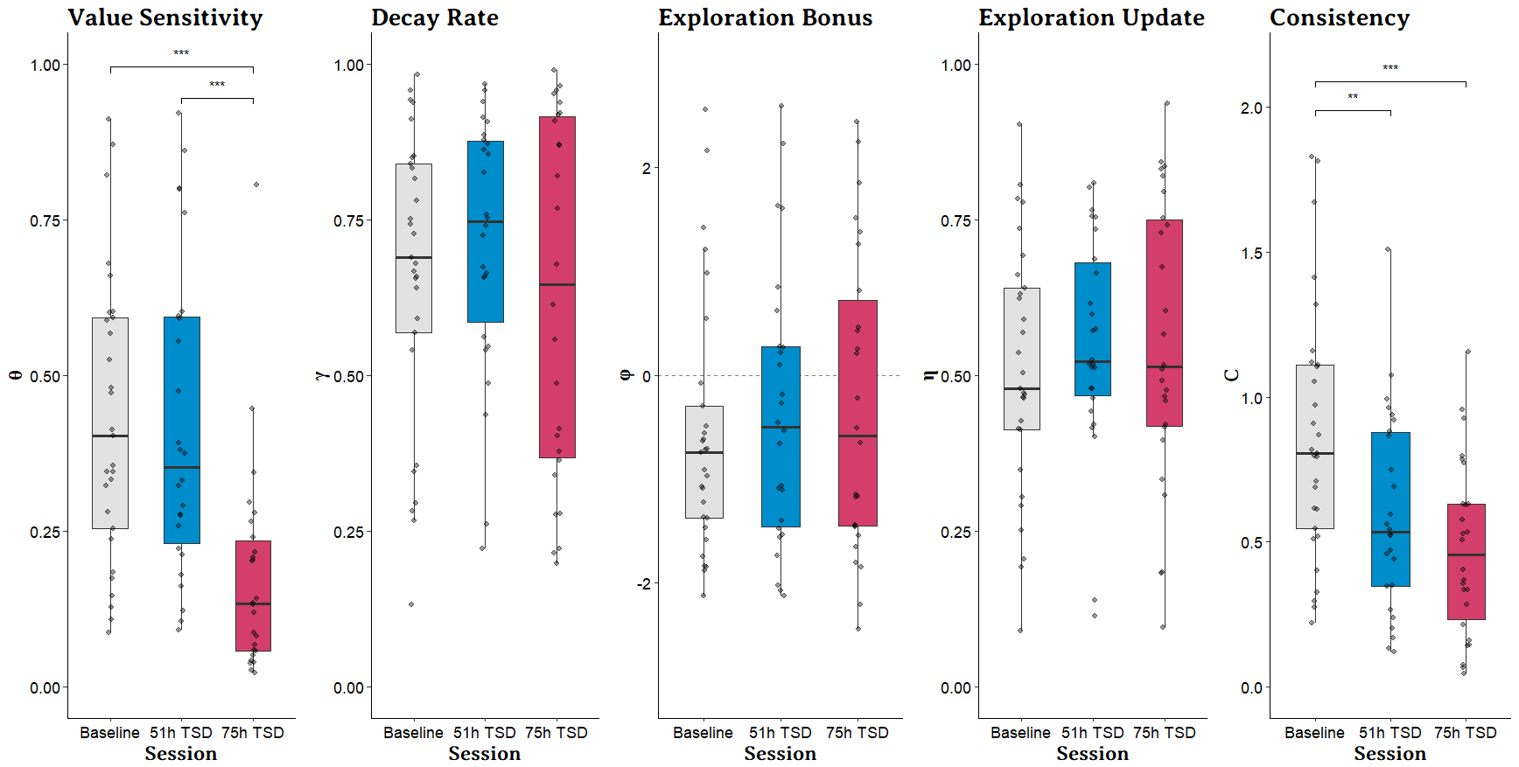

**Note: *p* values obtained from contrasts with Bonferroni correction.**