|  |  |
| --- | --- |
| **Income**  Rental Income = **$2000/month**  (Laundry Income) = **0**  (Storage Income = **0**  (Misc) = **0**  ------------------------------------------------------------  Total Monthly Income = **$2000/ month** | **Cashflow**  Income – Expenses  2000/month – 1610/month  ------------------------------------------------------------  Total Monthly Cashflow = **$390/month** |
| **Expenses**  Tax = **$150/month**  Insurance = **$100/month**  Utilities (sometimes landlord pays sometimes tenant pays [**$0** expense if tenant pays])   * Electric * Water * Sewer * Garbage * Gas   Home Owners Association (HOA) =**$0/month**  Lawn/Snow = **$0/month**  Vacancy – every month, set aside a little money knowing it’s going to be vacant (maybe roughly 5% of rental income)  = $2000 * 0.05 = **$100/month**  Repairs = **$100/month**  CapEx (big things) – every few years you need to replace roof so set aside some money each month = **$100/month**  Property Manager (maybe 10% of rent) = **$200**  Mortgage (there is a downpayment) – lets say that we are expecting a 160k mortgage at 5% over 30 year span: **$860/month**  ------------------------------------------------------------  Total Monthly Expenses = **$1610/ month** | **Cash on Cash Return on Investment**  What return on your cashflow are you getting?  Determine how much money you put into a deal?   1. Downpayment – **4000 (20% of 200k)** 2. Closing costs – **3000** 3. Repair budget - **7000** 4. Misc/Other - **0**   Total Investment = **50,000**  $390x12 = **$4,680 in annual cashflow**  Annual Cashflow/Total Investment  4680 / 50000 = .0936  .0936*100 = 9.36%  ------------------------------------------------------------  Cash on Cash ROI = **9.36%**  ------------------------------------------------------------  Is this good? That depends on your goals, strategy, what you’re trying to do.  Imagine you can invest in stock right now and make 20% - then it’s not good  If you earn 2% on stocks in 10 years, then 9% is good.  What if we got a deal? If we got it for 200k but everything is actually worth 1m. if we could sell for 1m tomorrow, then it would be good investment  Determine how much house might increase over years. Maybe 3% up per year. Then that should be calculated into the return. |

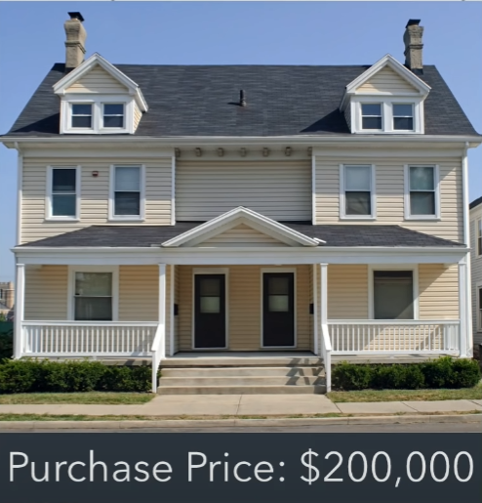

Let’s say that it’s a duplex (2 places to live). Each rent is $1000. Because there is 2, rental income is $2000.