Name: ________JACKSON LIN_________________

Lesson 5: Joins and Unions

1. Join the film to the film_actor table.

SELECT * FROM film JOIN film_actor ON film.film_id = film_actor.film_id ORDER BY film.film_id

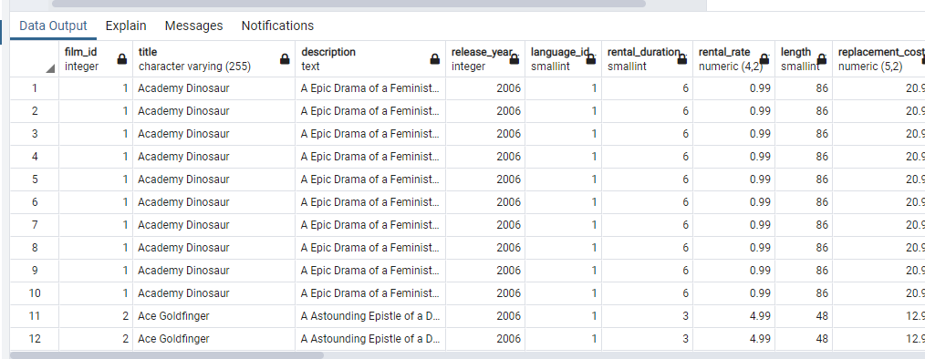

1. Join the actor table to the film_actor table.

SELECT * FROM actor JOIN film_actor ON actor.actor_id = film_actor.actor_id ORDER BY actor.actor_id

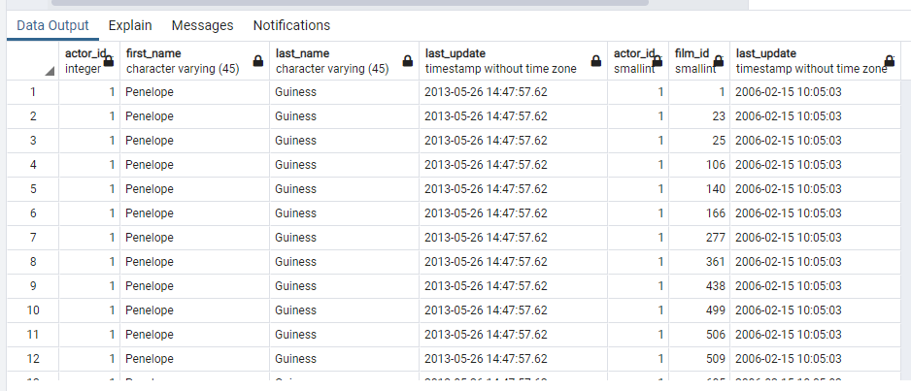

1. Try to join the actor, film_actor, and film table together (3 joins!)

SELECT * FROM actor JOIN film_actor ON actor.actor_id = film_actor.actor_id JOIN film ON film.film_id = film_actor.film_id

