Step 5:

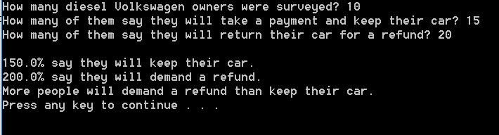

Description: The input involves a scenario where 15 owners would keep their cars and 20 would return, despite there being a maximum of 10 owners surveyed, causing nonsensical results. Both percentages of those who will keep or refund their cars are above 100%, producing an illogical total of 350%.

Error introduced in Step 6 (logic_error.cpp): numKeep++; //line20

Output produced:

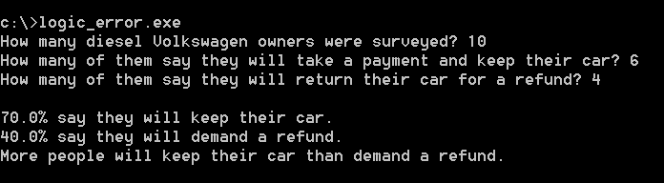

Logic error: For 10 surveyed Volkswagen owners, 6 would keep theirs and 4 would return, bringing up the calculations up to 60% and 40%. In this case, the numKeep++ changes numKeep to 7 which brings the percentage up to 70% and the total over 100%. The build compiled without error nonetheless.

Errors introduced in Step 7 (compile_error.cpp):

1. int numRefund //line11

The declaration of the integer numRefund is missing a semicolon which renders the statement unfinished.

1. double pctRefund = 100.0 * numRefund / numSurveyed; //line21

The variable numberSurveyed is renamed to numSurveyed which changes the reference to a separate variable that has not been declared.

With these errors the build did not compile and failed. The Output window produced:

error C2146: syntax error: missing ';' before identifier 'cout'

error C2065: 'numSurveyed': undeclared identifier