Opera Logistics and Musical Performance Integration Application
(OLYMPIA)

CS 437 Software Engineering

Functional Requirements and Design Document

Prepared by

Deghdzunyan, Anna
Hurley, John
Knaur, Keenan
Mejia, Victor
Narvekar, Sanmit
Ng, Johnny
Yang, Xuan
Zhang, Fan

May 30, 2010

Opera Logistics and Musical Performance Integration Application
(OLYMPIA)

Prepared By:

Deghdzunyan, Anna
Hurley, John
Knaur, Keenan
Mejia, Victor
Narvekar, Sanmit
Ng, Johnny
Yang, Xuan
Zhang, Fan

Approved By:

__________________ ___5/30/2010______
Jose Macias Date

Document Change Log

Update | Date Released | Changes
Draft #1 | 3/15/2010 | First Draft
Final | 5/30/2010 | Delivery

Table of Contents

Page
1.0 INTRODUCTION ................................................................................ 6

1.1 Purpose ..…………………………………………………………......... 6

1.2 Scope ………………………………………………………………….. 6
1.2.1 Document Organization ………………………………………………. 7

1.2.2 Relationship to Other Documents …………………………………….. 7

1.3 OLYMPIA Architecture ……………………………………………… 7

1.3.1 Context Diagram (Level 0 Data Flow Diagram) ……………………… 7

1.3.2 Description and Major Functions ……………………………………… 7

1.3.3 Hardware and Software Considerations ……............………………… 7

1.4 Documentation of the Development Process …………………………. 8

1.5 References .............................................................................................. 9

1.5.1 Controlling Documents .......................................................................... 9

1.5.2 Applicable Documents ........................................................................... 9

1.5.3 Standards ………………………………………………………………. 9

2.0 OLYMPIA DETAILED FUNCTIONAL DESCRIPTION............... 10

2.1 Detailed OLYMPIA Functional Description ………………………….. 10

2.1.1 Level 1 Data Flow Diagram (DFD) …..………………………………. 10

2.1.2 Detailed Functional Description of OLYMPIA Major Sub-Units …….. 11

3.0 OLYMPIA REQUIREMENTS ……………………….……………. 15

3.1 OLYMPIA Functional Requirements ………………………………… 15

3.2 OLYMPIA Non-Functional Requirements ……………………………. 26

3.3 OLYMPIA Hardware Requirements …………………………………. 26

4.0 OLYMPIA DETAILED DESIGN………………………………… 27

4.1 Level 2 DFDs ………………………………………………………. 27

5.0 OLYMPIA IMPLEMENTATION……………………………….. 33

5.1 Introduction …………………………………………………………. 33

5.2 Descriptions of Java Classes ……………………………………………. 33

6.0 OLYMPIA TEST PLAN …..…………………………………… .. 36

6.1 Introduction ……………………………………………………….. 36

6.2 Functional Requirements Validation Matrix …………………. 36

Appendix A. ACRONYMS …................................................................. 43

Appendix B. DATA DICTIONARY ........................................................... 45

List of Figures

Figure 1-1 Context Diagram (Level 0 Data Flow Diagram)
Figure 2-1 Level 1 Data Flow Diagram
Figure 4.1.1 Level 2 Data Flow Diagram-Main Control Module
(Figure 4.1.2 Level 2 Data Flow Diagram-Login Omitted)
Figure 4.1.3 Level 2 Data Flow Diagram-Sound Recognition Module
Figure 4.1.4 Level 2 Data Flow Diagram-Lighting Module
Figure 4.1.5 Level 2 Data Flow Diagram-Special Effects Module
Figure 4.1.6 Level 2 Data Flow Diagram-Mechanical Operations Module
Figure 4.1.7 Level 2 Data Flow Diagram-Supertitles Module

List of Tables

None.
1.0 INTRODUCTION

1.1 Purpose

The purpose of this document is four-fold:

a) Define a full set of requirements for OLYMPIA. These sections correspond to a Software Requirements Document, SRD).

b) Define the design for OLYMPIA. These sections correspond to a Software Design Document (SDD).

c) Define the implementation of OLYMPIA. These sections correspond to a Software Implementation Document (SID).

d) Define the Test Plan for OLYMPIA. These sections correspond to a Software Test Plan (STP).

The complete definition of all OLYMPIA requirements provides the requirements to be used in the subsequent software subsystem documents.

1.2 Scope

This documentation was developed as part of a Software Design class, CS 337 and a Software Engineering class, CS 437.

The scope of this document includes the following:

- All functional and non-functional requirements. These requirements are organized by key OLYMPIA functional units shown on the Level 1 DFD given in section 2.0.
- A trace matrix, relating all OLYMPIA functional requirements to functional subunits as expanded in lower level DFDs.
- Functional descriptions of each of the modules of OLYMPIA.
- General descriptions of hardware necessary for implementation of OLYMPIA.
- A matrix showing testing methods for each functional requirement.

1.2.1 Document Organization

The organization of this document provides a natural 'flow' or allocation of requirements to each succeeding section. Details regarding the overall document structure are discussed in sub-section 1.4.

1.2.2 Relationship to Other Documents

The OLYMPIA SRD/SDD/STP/SID is a complete self-contained document. However, Java code is included in separate files. Some relationships to other documents in the literature are indicated below in sub-section 1.5.

1.3 Project Name Architecture

1.3.1 Context Diagram (DFD Level 0)

OLYMPIA’s architecture is summarized in the Context Diagram (DFD Level 0) given below. A more detailed Functional Description is given in Section 2 of this document. 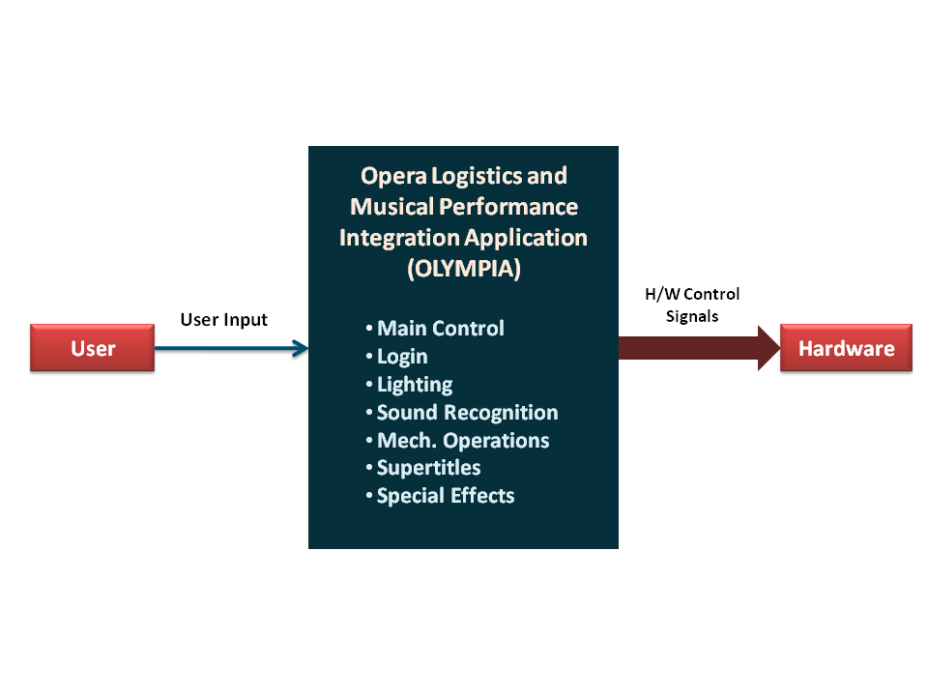
Figure 1-1: Level 0 DFD

1.3.2 Description and Major Functions of OLYMPIA

OLYMPIA automates logistical aspects of opera performance staging. The system offers programmed control of lighting, curtains and backdrops, special effects hardware, and other mechanical hardware. OLYMPIA also provides a versatile means of providing supertitles in each patron’s chosen language. Each of these functions is synchronized to a previously recorded rehearsal version of the performance and matched to the preset cues using sound recognition functionality. OLYMPIA is controlled by a GUI with both planning-time and performance-time modes.

The name OLYMPIA commemorates a mechanical doll with which the protagonist falls in love in Offenbach’s opera “The Tales of Hoffman.”

1.3.3 Hardware and Software Considerations

OLYMPIA requires standard computer hardware. Other hardware requirements include lights, several forms of special effects and stage set hardware and their mechanical controllers, and patron display devices for supertitles and other patron messages. The display devices will be similar to Personal Digital Assistants, including touchscreens for user input, but will be fixed to seatbacks or armrests.

1.4 Documentation of the Development Process

OLYMPIA’s detailed functional description is documented in section 2.0. Section 2 is a succinct software description document. The overall detailed functional description is based on higher level DFDs (above level 1). All major functional units are described in detail in this part of the document.

Requirements for OLYMPIA are captured in Section 3.0 of this document. This section includes both functional and non-functional software requirements, supplemented with more detailed information when necessary.

Section 4 is OLYMPIA’s detailed Design Description Document (SDD).

Section 5 is OLYMPIA’s Software Implementation Document (SID).

Section 6 is OLYMPIA’s Software Test Plan (STP).

1.5 References

All references used in the creation of this document are listed below.

1.5.1 Controlling Documents

There is no other document controlling this document.

1.5.2 Applicable Documents

No additional applicable document has been used in the production of this document.

1.5.3 Standards

No standard has been used in the creation of this document. However, some Standards described in textbooks have been examined as a reference. In particular, the IEEE standard has been briefly discussed in class.

2.0 DETAILED FUNCTIONAL DESCRIPTION OF OLYMPIA

2.1 Detailed OLYMPIA Functional Description.

The major tool used to design OLYMPIA is the Data Flow Diagram, DFD. The rationale for the selection of DFDs as the preferred design tool is its simplicity and versatility. In the future additional tools may be used if a stronger correlation from Design to Requirement to Implementation and Testing is required.

2.1.1 Level 1 DFD

OLYMPIA’s major functional subunits are shown in the DFD Level 1 shown below:

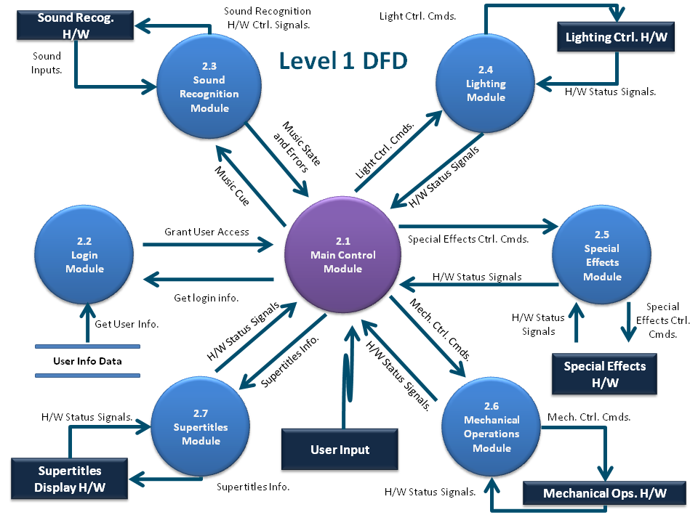

Figure 2.1: Level 1 DFD

2.1.2 Detailed Functional Description of OLYMPIA’s Major Units.

The description of OLYMPIA’s major functional units shown in Figure 2.1 follows. Most of OLYMPIA’s operations depend on the use of set cues during a performance and on cue events, the events triggered by cues. Cue events include lighting changes, special effects, backdrop changes, and many other activities.

Main Control - Module 2.1

The Main Control Module (MCM) provides the GUI and functionality for programming performance cues in OLYMPIA. The MCM contains submodules for cue programming, cue tracking, and troubleshooting.

A GUI used at rehearsal or planning time allows the user to set cues and program cue events to occur with each cue. A performance-time interface allows the user to adjust the pacing and to make changes in real time using the GUI. The GUI is based on a multi-touchscreen interface and will be arranged in a series of tabs that allow the user to switch between screens that control different functions, such as lighting or special effects. The GUI displays the libretto and contains functionality to play back recorded sound for reference during programming.

The Cue Programming Submodule (CPS) stores a rehearsal performance and provides functionality for setting cue events to be implemented by other modules. Music cues are synchronized to the recorded performance, while user cues require specific signals from the user at performance time. Cues, sound, and the libretto and score, which are electronically read in from files, are stored in local databases for future use.

The Cue Tracking Submodule (CTS) runs the opera by providing the cue information to other modules at performance time. The user begins the sequence by loading an opera and initiating the performance using the GUI. The CTM then iterates through the cue sequence of the opera and begins executing the cues as their time comes. The CTS does this by retrieving the preset theme information for each cue and sending the required signals to the other modules to execute the planned actions. The hardware simulation output is displayed in the GUI.

Music cues are executed based on timing information simulated by a music player. User cues must be signaled by the user in the GUI. Cue Tracking alerts the user when the cue in the sequence is a user cue. The opera terminates after the last cue, or if the stop opera button is pressed. A log is created of the performance.

The Feedback Submodule (FS) is responsible for monitoring all OLYMPIA modules. It handles errors, ensures atomic transactions, detects and avoids deadlocks, and is responsible for safety (such as dealing with pyrotechnics). During the performance, all executed actions and errors are logged, and this allows OLYMPIA to examine history and recover from errors. These errors are displayed back to the user with suggested actions. The feedback module also autonomously provides appropriate recovery actions to each module in OLYMPIA.

Log-in / Security function - Module 2.2

The Login module provides standard security features to protect the system from unauthorized access.

Sound Recognition - Module 2.3

The Sound Recognition Module (SRM) matches preset cues to the actual performance. On receiving the user-input signal that the performance is about to begin, the SRM signals hearing hardware to search for a live sound signal. The hearing hardware consists of microphones and other listening equipment situated around the stage.

The live sound signal is processed each nanosecond and sent to SRM’s Sync Module, which compares it to the prerecorded sound. A time marker advances incrementally with the actual sound, and is used to match the preset cues to the performance. If the actual performance is faster or slower than the prerecorded version, the time marker will ensure that the cues are nonetheless sent at appropriate times.

SRM’s Signaling submodule sends music state and any hardware signals detected by the Hearing module to Main Control, which distributes the information to the other modules as needed to execute cue events.

Lighting Control - Module 2.4

The Lighting Control Module controls all aspects of lighting hardware. The LCM consists of five sub-modules.

The Light Positioning and Beam Control Module (LPBCM) controls the mechanical aspects of the lighting system, such as the vertical, horizontal, and diagonal positioning of each light. The LPBCM also allows the user to change the diameter of a projected beam of light and control beam intensity with dimmers.

The Color Module (CM) allows the user to adjust Red, Green, and Blue values of all lights. The CM can also be used to set colors from a predefined list of choices or from a preprogrammed theme, such as sunrise, sunset, sea and so on.

The Spotlight Control/Motion Tracking Module (SCMTM) will provide automatic or manual control of all spotlights. This module provides manual control of spotlights so that they may track performers moving across the stage at variable speeds. In a future iteration, each spotlight may be mapped to a performer who will be tracked using Radio Frequency ID or other technology.

The Lighting System Troubleshooting Module (LSTM) provides automatic handling of various error conditions that may arise in the lighting system. It allows for automatic switching to backup lights in case of bulb failure, or switching to backup circuits in case of more serious hardware failure. Any problems that LSTM cannot automatically correct will generate error signals that will be sent to the Main Control Module.

Additionally, the Lighting Control Module (LCM) allows users to preset and save themes for Light Positioning and Beam Control Module (LPBCM) and the Color Module (CM).

Special Effects - Module 2.5

Opera often features special effects, such as fire effects, fog, wind, mist, and rain. The Special Effects Module contains five submodules: fog, pyrotechnics, air and fans, water, and miscellaneous special effects, which include confetti, props, and odor.

The Special Effects Module also contains a main control submodule that is responsible for routing control signals to each submodule, which then routes them to the control hardware.

Mechanical Operations - Module 2.6

The Mechanical Operations Module (MOM) handles performance-related hardware including curtains and backdrops, trap doors, moveable set pieces. Curtains and backdrops may be raised or lowered. Trap doors may be closed or opened at various speeds or in response to weight. Track or wire-mounted set pieces may be moved in one or two dimensions.

This module contains four submodules. All I/O passes through a central Control Gateway. Curtains/backdrops, trap doors, and set pieces each are controlled by specialized submodules.

Supertitles - Module 2.7

Opera is usually performed in languages that most of the audience does not understand. In addition, even when the patron understands the language, text that is sung and accompanied by an orchestra is often hard to distinguish. For these reasons, opera houses use supertitles in the local language. Most opera houses project supertitles in a single language onto a screen above the stage.

OLYMPIA’s Supertitles Module (SM) outputs titles to individual display screens mounted on seatbacks or armrests. The screens show parallel text in the original language of the libretto and in a language of the patron’s choice. OLYMPIA can use this system to push patron messages, such as “Please turn off your cellular telephones at this time.”

SM will contain two submodules. The Control Gateway will route all communication as needed between the libretto database, patron display devices, and OLYMPIA’s Main Control module. This communication includes the full libretto information loaded before the performance, line by line titles sent to patrons at performance time, and all hardware control signals for the module. The Text Processor stores a working copy of the libretto and feeds out line by line output.

3.0 OLYMPIA REQUIREMENTS

3.1 OLYMPIA Functional Requirements

This Section lists OLYMPIA’s functional requirements. This section includes the complete set of functional requirements, along with explanations for cases in which the statement of the requirement was deemed insufficient or requires additional clarification. All requirements relate to the design modules described in Section 2. An effort has been made to standardize the correlation between the design modules and the requirements to make access and organization more consistent. For example, requirement number “n” affecting module 2.1 will be labeled 3.1.n

Requirements Related to Design Module 2.1: Main Control
Requirement No. | Requirement Description
 | Main Module Graphical User Interface (MMG)
3.1.1 | MMG shall consist of four tabs: Cue Programming, Lighting, Special Effects and Cue Tracking.
3.1.2 | MMG shall provide a tabbed window format for each element.
3.1.3 | MMG shall provide the necessary controls for all aspects of the hardware.
3.1.4 | MMG shall display any necessary error, or other messages to the user.
3.1.5 | MMG shall display the score / libretto to the user.
3.1.6 | MMG shall allow the user to map cues to specific points in the music.
 | Cue Programming Submodule (CPS)
3.1.7 | CPS shall read libretto inputs from files.
3.1.8 | CPS shall read score inputs from files.
3.1.9 | CPS shall store libretto and score in a database.
3.1.10 | CPS shall receive music recorded at rehearsal time.
3.1.11 | CPS shall store rehearsal music in a permanent database.
3.1.12 | At cue programming time (CPT), CPS shall retrieve music and libretto from DB.
3.1.13 | At CPT, CPS shall route music and libretto text to the GUI.
3.1.14 | CPS shall receive input from the GUI for actions to match to cues.
3.1.15 | CPS shall match input actions to sequential cues synchronized to the recorded music.
3.1.16 | CPS shall store cues in cue storage.
3.1.17 | CPS shall receive all hardware status signals from the hardware it controls.
3.1.18 | CPS shall receive requests for hardware status from the GUI.
3.1.19 | CPS shall provide requested hardware information when available.
3.1.20 | CPS shall receive requests from MCM for information on all existing cues.
3.1.21 | CPS shall retrieve cue information on request from MCM.
3.1.22 | CPS shall route cue information to MCM upon request.
3.1.23 | CPS shall contain a music player for reference at programming time
 | Cue Tracking Submodule (CTS)
3.1.24 | CTS shall ask the user to choose an opera to load.
3.1.25 | CTS shall ask the User to start the opera through the Main Module GUI.
3.1.26 | CTS shall load the opera selected and receive the cue sequence for that opera.
3.1.27.1 | CTS shall request the instructions for a cue when that cue is the next one to execute.
3.1.27.2 | The instructions shall consist of which module to signal, what the module shall do, and when to do it.
3.1.27.3 | CTS shall receive the instructions for the cue.
3.1.27.4 | CTS shall send the preset theme instructions for that cue to the appropriate sub module.
3.1.27.5 | CTS shall signal that preset’s module to start executing the cue.
3.1.28 | CTS shall initiate a cue when it’s time has come, as programmed in the CPS.
3.1.29.1 | CTS shall receive a music state every millisecond from a built in music player.
3.1.29.2 | CTS shall initiate any cues that are signaled by that music state.
3.1.29.3 | The music state shall consist of the time marker that the song is currently at in milliseconds.
3.1.29.4 | CTS shall initiate any cues that are signaled by the completion of other cues.
3.1.29.5 | CTS shall initiate user cues when signaled by the user.
3.1.30 | CTS shall have the option to pause and resume an opera that has been loaded.
3.1.31 | CTS shall have the option to stop, or terminate the opera when the appropriate command is issued.
3.1.32 | CTS shall display the current line of the libretto being spoken, as programmed in the CPS, to the Main Module GUI.
3.1.33 | CTS shall display hardware output from the cues that have executed to the Main Module GUI.
3.1.34 | CTS shall create a log of the performance and write it to a text file after the performance is over.

MODULE 2.1 Requirements Not Implemented
Requirement No. | Cue Programming Submodule (CPS) | Reasons Not Met:
3.1.7 | CPS shall read libretto inputs from files. | Libretto not displayed due to time constraints
3.1.8 | CPS shall read score inputs from files. | Score not displayed due to time constraints
3.1.9 | CPS shall store libretto and score in a database. | Previous two unimplemented so no database necessary
3.1.12 | At cue programming time (CPT), CPS shall retrieve music and libretto from DB. | No database used
3.1.13 | At CPT, CPS shall route music and libretto text to the GUI. | Not met due to time constraints
3.1.17 | CPS shall receive all hardware status signals from the hardware it controls. | Necessary Hardware not available
3.1.18 | CPS shall receive requests for hardware status from the GUI. | Necessary Hardware not available
3.1.19 | CPS shall provide requested hardware information when available. | Necessary Hardware not available
3.1.20 | CPS shall receive requests from MCM for information on all existing cues. | Not met due to time constraints
3.1.21 | CPS shall retrieve cue information on request from MCM. | Not met due to time constraints
3.1.22 | CPS shall route cue information to MCM upon request. | Not met due to time constraints
3.1.23 | CPS shall route cue information to MCM upon request. | Not met due to time constraints
3.1.35 | CTS shall display where in the performance the opera is currently at to the Main Module GUI. | Low Priority
3.1.36 | CTS shall receive the live music state from the SRM for music triggered cues. | Lack of Time

Requirements Related to Design Module 2.2: Login
Requirement No. | Requirement Description
Login module shall provide standard access security services

MODULE 2.3 NOT IMPLEMENTED DUE TO TIME CONSTRAINTS

Requirements Related to Design Module 2.4: Lighting Module

Requirement No. | Requirement Description
 | Light Position and Beam Control Module (LPBCM)
3.4.1 | LPBCM shall adjust light positioning.
3.4.1.1 | LPBCM shall be able to adjust the vertical axis of the lights.
3.4.1.2 | LPBCM shall be able to adjust the horizontal axis of the lights.
3.4.1.3 | LPBCM shall be able to adjust the diagonal axis of the lights.
3.4.1.4 | LPBCM shall be able to raise and lower the lighting fixtures.
3.4.2 | LPBCM shall allow the user to adjust the beam of the light.
3.4.2.1 | LPBCM shall allow the user to adjust the diameter of the projected beam of light.
3.4.2.2 | LPBCM shall allow the user to adjust the fade level of the lights (how bright or dim the lights are).
3.4.3 | LPBCM shall be able to adjust lights individually.
3.4.4 | LPBCM shall be able group lights and adjust them as a group.
 | Color Module (CM)
3.4.5 | CM shall allow the user to adjust the color of the lights.
3.4.5.1 | CM shall allow the user to adjust the R, G, B values of the lights individually.
3.4.5.2 | CM shall allow the user to choose from a range of preprogrammed color choices.
3.4.5.3 | CM shall allow the user to choose from preprogrammed color themes.
3.4.5.4 | CM shall allow the user to program their own color themes.
3.4.5.5 | CM shall allow the user to adjust lights individually.
3.4.5.6 | CM shall allow the user to group lights together and adjust them as a group
 | Lighting Effects Module (LEM)
3.4.6 | LEM shall coordinate with modules 2.3.1 and 2.3.2 to create different lighting effects.
3.4.6.1 | LEM shall provide a list of preprogrammed effects.
3.4.6.2 | LEM shall allow the user to program their own effects.
3.4.6.3 | LEM shall provide a timing component that will allow the user to have effects unfold over a given time period.
3.4.6.4 | LEM shall allow the user to change the pattern of the projected light.
 | Spotlight Control and Motion Tracking Module (SCMTM)
3.4.7 | SCMTM shall allow the user to manually control the spotlight.
3.4.7.1 | SCMTM shall allow the user to adjust the speed of the spotlight.
3.4.8 | SCMTM shall allow the spotlight to track performers on the stage
3.4.8.1 | SCMTM shall allow the user to map the spotlight to different performers onstage.
3.4.8.2 | SCMTM shall be able to switch between performers in real time.
3.4.9 | SCMTM allow the user to switch between manual and automatic control at performance time.

MODULE 2.4 REQUIREMENTS NOT IMPLEMENTED:
Requirements Related to Design Module 2.4: Lighting Module
Requirement No. | Requirement Description | Reason Not implemented
 | Light Position and Beam Control Module (LPBCM)
3.4.1.4 | LPBCM shall be able to raise and lower the lighting fixtures. | lower priority
 | Lighting Effects Module (LEM)
3.4.6.3 | LEM shall provide a timing component that will allow the user to have effects unfold over a given time period. | lower priority
 | Spotlight Control and Motion Tracking Module (SCMTM)
3.4.9 | SCMTM allow the user to switch between manual and automatic control at performance time. | lower priority
 | Lighting System Troubleshooting Module(LSTM) | lack of hardware

Requirements Related to Design Module 2.5: Special Effects Module (SEM)

Requirement No. | Requirement Description
 | Special Effects
3.5.0 | Special Effects shall be controlled by a GUI (SEGUI) with four separated panels for wind, mist, pyro and fog.
3.5.0.1 | SEGUI shall contain for each of four panels five mini panels for five different machines.
3.5.0.2 | SEGUI shall contain a checkbox for each of the five mini panels.
3.5.0.3 | SEGUI shall contain for each of five mini panels a slider.
3.5.0.4 | SEGUI shall display intensity settings from 0 to 20 each wind machine.
3.5.0.5 | SEGUI shall display intensity settings from 0 to 20 each mist machine.
3.5.0.6 | SEGUI shall display intensity settings from 0 to 5 for each pyro machine.
3.5.0.7 | SEGUI shall display intensity settings from 0 to 30 for each fog machine.
3.5.0.8 | SEGUI shall contain “Save” button for saving selected properties.
3.5.0.9 | SEGUI shall bring file chooser when “Save” button is pressed.
 | Special Effects Control Module (SECM)
3.5.1 | SECM shall process all SEM communication with the main control module.
3.5.1.1 | SECM shall receive all hardware control signals routed to SEM from the Main Control Module.
3.5.1.2 | SECM shall route all special effects signals received from MCM to the special effects control h/w.
3.5.1.3 | SECM shall receive all requests for special effects control h/w status information from MCM.
3.5.1.4 | SECM shall supply error signals from special effects control h/w to MCM when available.
 | Fog Machine Module (FMM)
3.5.2 | FMM shall process all communication between SCEM and the fog control hardware.
3.5.2.1 | FMM shall provide fog at five intensity levels, measured in cubic meters output per second.
3.5.2.2 | FMM shall communicate with trap door control hardware to perform requested signals simultaneously.
3.5.2.3 | FMM shall provide fog in three locations of the stage: left, center, and middle.

 | Air and Fans Module (AFM)
3.5.3 | AFM shall process all communication between SCEM and the air and fans control hardware.
3.5.3.1 | AFM shall provide wind at five intensity levels.
3.5.3.2 | AFM shall communicate with fog module to perform requested signals simultaneously.
 | Pyrotechnics Module (PM)
3.5.4 | PM shall process all communication between SCEM and the pyrotechnics control hardware.
3.5.4.1 | PM shall provide fire at five intensity levels.
3.5.4.2 | PM shall light torches on stage when requested.
3.5.4.3 | PM shall provide three levels of artificial explosions.
3.5.4.4 | PM shall monitor all existing fires each millisecond for conformity to safety protocols.

REQUIREMENTS NOT COMPLETED FOR SPECIAL EFFECTS MODULE:
 | Miscellaneous Special Effects Module (MSEM) | Reason Not Completed
3.5.6 | MSEM shall process all communication between MCM and the misc. special effects control hardware. | lower priority
3.5.6.1 | MSEM shall provide confetti when requested. | lower priority
3.5.6.2 | MSEM shall provide different types of odor. | lower priority
 | Special Effects Troubleshooting Module | lower priority
3.5.7 | SETM shall process all communication between MCM and the special effects control hardware. | lower priority
3.5.7.1 | SETM shall receive error signals from special effects control hardware and suggest appropriate actions for user. | lower priority
3.5.7.2 | SETM shall autonomously provide control signals to special effects control hardware to fix errors. | lower priority
 | Water Effects Module (WEM)
3.5.5 | WEM shall process all communication between SECM and the water control hardware. | lower priority
3.5.5.1 | WEM shall turn on waterfalls on stage. | lower priority
3.5.5.2 | WEM shall provide three levels of artificial rain. | lower priority
3.5.5.3 | WEM shall provide artificial mist. | lower priority
3.5.5.4 | WEM shall monitor the water tanks, pipes, and hoses each millisecond. | lower priority

MECHANICAL OPERATIONS MODULE NOT COMPLETED DUE TO LOWER PRIORITY

Requirements Related to Design Module 2.6: Mechanical Operations Module (MOM)
Requirement No. | Requirement Description | Reason Not Implemented
 | Control Gateway Submodule(CGS)
3.6.1 | CGS shall process all MOM communication with the main control module. | lower priority
3.6.1.1 | CGS shall receive all hardware control signals routed to MOM from the Main Control Module. | lower priority
3.6.1.2 | CGS shall route all curtain and backdrop control signals received from MCM to the curtains / backdrop control interface. | lower priority
3.6.1.3 | CGS shall route all set piece control signals received from MCM to the set piece control interface. | lower priority
3.6.1.4 | CGS shall route all trap door control signals received from MCM to the trap door control interface. | lower priority
3.6.1.5 | CGS shall receive all curtain and backdrop hardware status signals. | lower priority
3.6.1.6 | CGS shall receive all set piece hardware status signals. | lower priority
3.6.1.7 | CGS shall receive all trap door hardware status signals. | lower priority
3.6.1.8 | CGS shall receive all requests for mechanical operations hardware status information from the Main Control Module. | lower priority
3.6.1.9 | CGS shall supply requested mechanical operations hardware status information to MCM when available. | lower priority
 | Curtains/Backdrop Control Submodule(CCS) | lower priority
3.6.2 | CCS shall process all communication between the CGS and the curtains/backdrop hardware. | lower priority
3.6.2.1 | CCS shall process curtain and backdrop control signals and send commands to curtain and backdrop hardware. | lower priority
3.6.2.2 | CCS shall receive all hardware status signals from the curtain and backdrop hardware. | lower priority
3.6.2.3 | CCS shall receive all requests from CGS for hardware status signals from the curtain and backdrop hardware | lower priority
3.6.2.4 | CCS shall provide requested hardware status information to CGS when available | lower priority
3.6.2 | Set Piece Control Submodule (SPS) | lower priority
3.6.3 | SPS shall process all communication between the CGS and the set piece hardware. | lower priority
3.6.3.1 | SPS shall process set piece control signals and send commands to set piece hardware. | lower priority
3.6.3.2 | SPS shall receive all hardware status signals from the set piece hardware. | lower priority
3.6.3.3 | SPS shall receive all requests from CGS for hardware status signals from the set piece hardware | lower priority
3.6.3.4 | SPS shall provide requested hardware status information to CGS when available | lower priority
 | Trap Door Control Submodule (TDS) | lower priority
3.6.4 | TDS shall process all communication between the CGS and the trap door hardware. | lower priority
3.6.4.1 | SPS shall process trap door control signals and send commands to trap door hardware. | lower priority
3.6.4.2 | SPS shall receive all hardware status signals from the trap door hardware. | lower priority
3.6.4.3 | SPS shall receive all requests from CGS for hardware status signals from the trap door hardware | lower priority
3.6.4.4 | SPS shall provide requested hardware status information to CGS when available | lower priority

Requirements Related to Design Module 2.7: Supertitles
Requirement No. | Requirement Description
 | Control Gateway Submodule(CGS)
3.7.1 | CGS shall process all SM communication with the main control module.
3.7.1.1 | CGS shall receive the full libretto text in all available languages during load time .
3.7.1.2 | CGS shall send prompts for language choice to patron display devices during load time.
3.7.1.3 | CGS shall receive language choice input from patron display devices.
3.7.1.4 | CGS shall receive cues from MCM during performances.
3.7.1.5 | CGS shall route cue information to the Text Processor.
3.7.1.6 | CGS shall receive line by line text in the libretto language and in all available translation languages from the Text Processor during performance.
3.7.1.7 | CGS shall send text in the libretto language and the individually chosen translation languages to each patron display device during performances.
3.7.1.8 | CGS shall receive patron messages from MCM at runtime.
3.7.1.9 | CGS shall send patron message text to patron display devices.
 | Text Processing Submodule (TPS)
3.7.2 | TPS shall handle all tasks related to storing, parsing, and retrieving libretto text for patron displays.
3.7.2.1 | TPS shall receive a full copy of the libretto text in all available languages at load time from the module’s CGS.
3.7.2.2 | TPS shall store the libretto text in memory at load time.
3.7.2.3 | TPS shall receive cues from CGS during performances.
3.6.2.4 | TPS shall retrieve line-by-line text from memory during performance.
3.7.2.5 | TPS shall supply line-by-line text to CGS.

3.2 OLYMPIA Non-Functional Requirements

This Section collects all the OLYMPIA Non-Functional Requirements. All non-functional requirements are numbered “NF – n” where “n” indicates the n^{th} requirement.

NF - 1 OLYMPIA requires sufficient data storage to store a library of rehearsal recordings as well as machine-read librettos and scores.
NF - 2 OLYMPIA must execute cue events as rapidly as a professional stage crew.
NF - 3 OLYMPIA must be operable by creative professionals who have little technical training.

3.3 OLYMPIA Hardware Requirements

This Section collects all OLYMPIA’s electronic hardware requirements. All hardware requirements are numbered “H – n” where “n” indicates the n^{th} requirement.

H - 1 OLYMPIA will run on standard microcomputer hardware

H - 2 OLYMPIA will require Patron display devices for supertitle display. Each device must include a touchscreen suitable for simple text input and a screen capable of clearly displaying parallel libretto text in two languages.

4.0 OLYMPIA DETAILED DESIGN

In this section, OLYMPIA will be designed in detail including several higher level DFDs. Each major module detailed design is included in correspondence with the design sections defined in Section 2 and responding to the requirements listed in its correlated sub-section in chapter 3.

The detailed design of each of the modules discussed in section 2 with requirements presented in section 3 is presented in the Figures below.

4.1 Level 2 DFDs

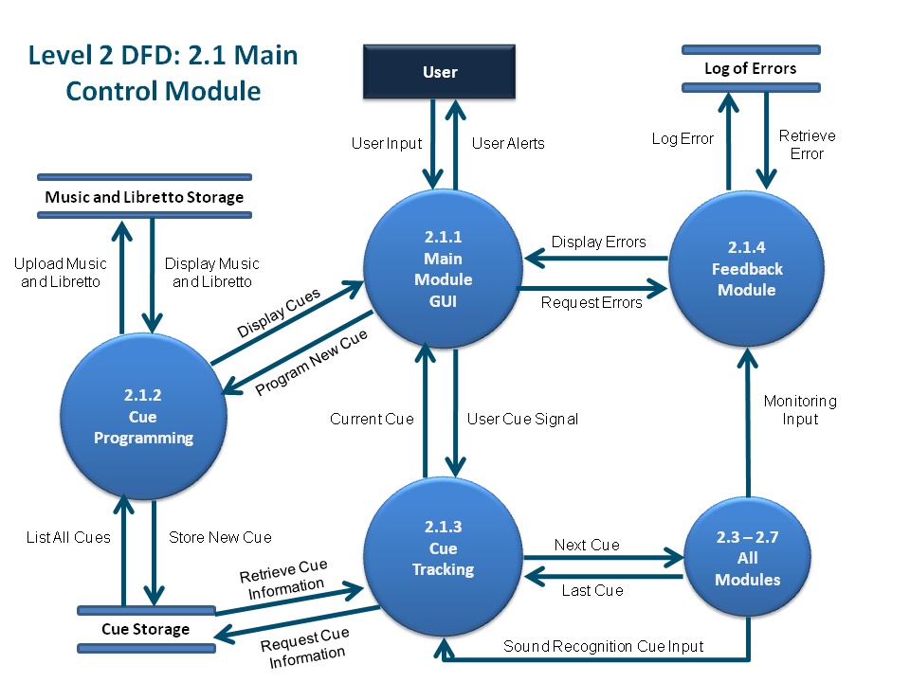

Figure 4.1.1: Level 2 DFD for Main Control Module

(Figure 4.1.2, Level 2 DFD for Login Module, Omitted)

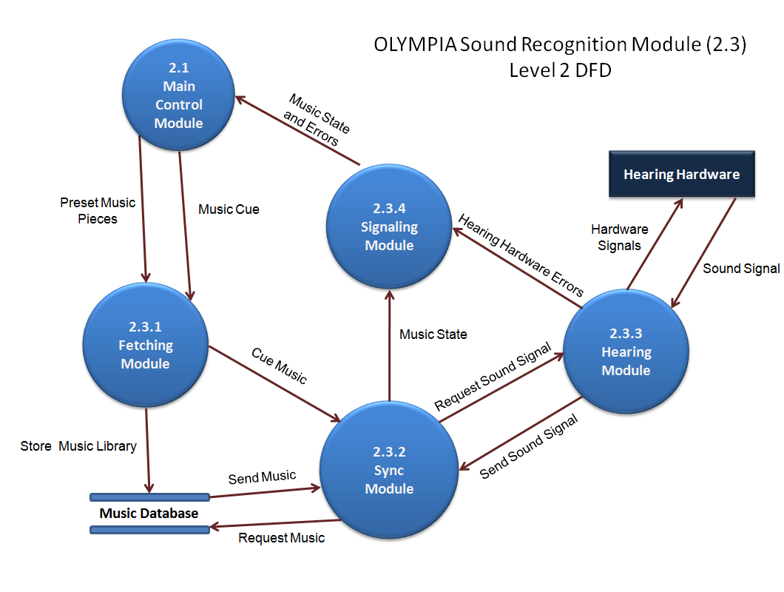

Figure 4.1.3: Level 2 DFD for Sound Recognition Module
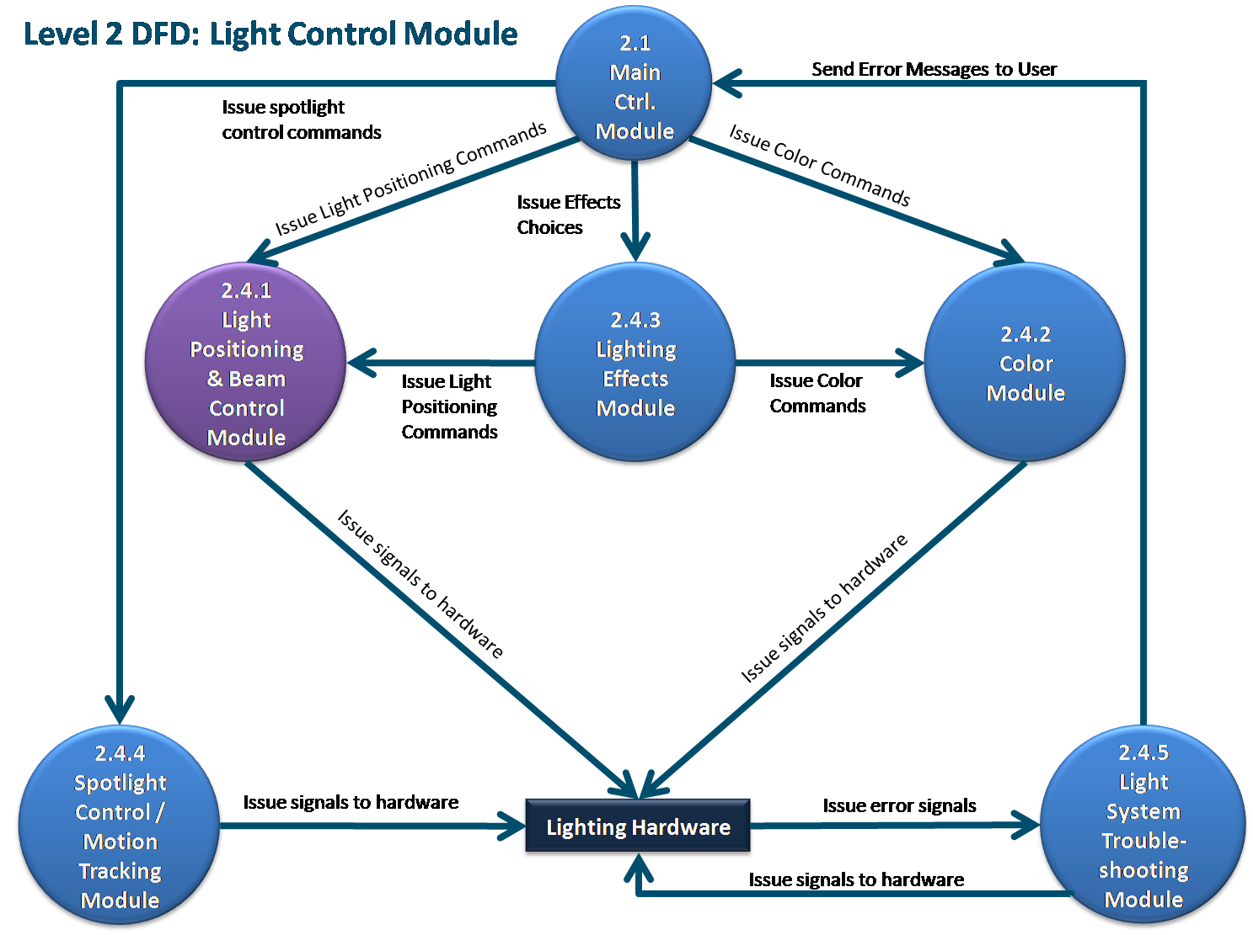
Figure 4.1.4: Level 2 DFD for Lighting Effects Module

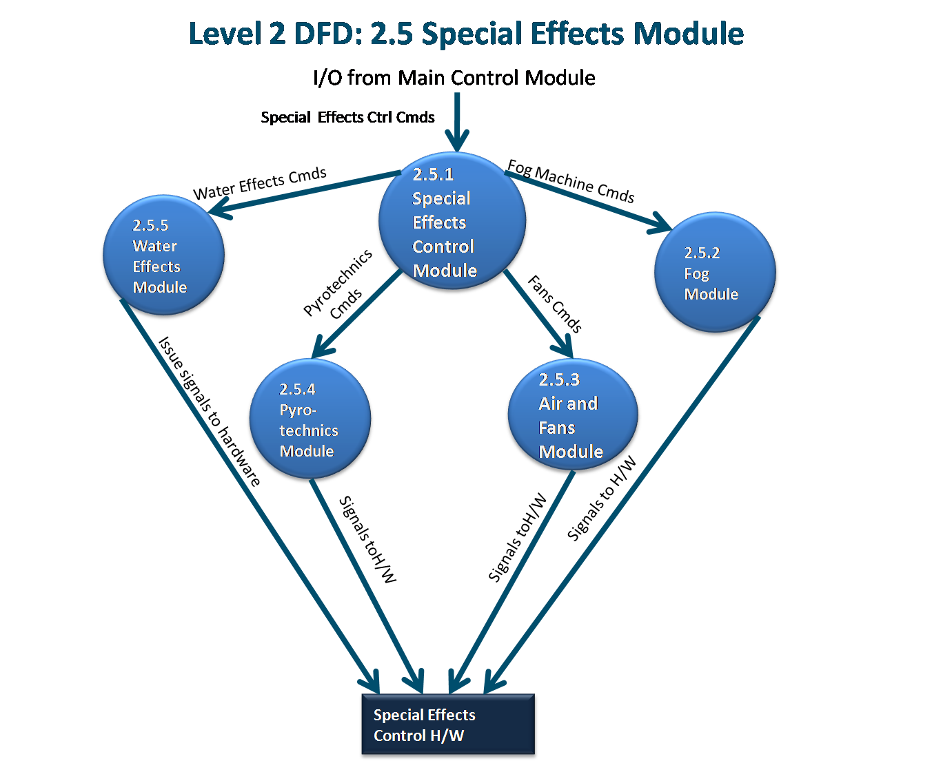

Figure 4.1.5: Level 2 DFD for Special Effects Control Module

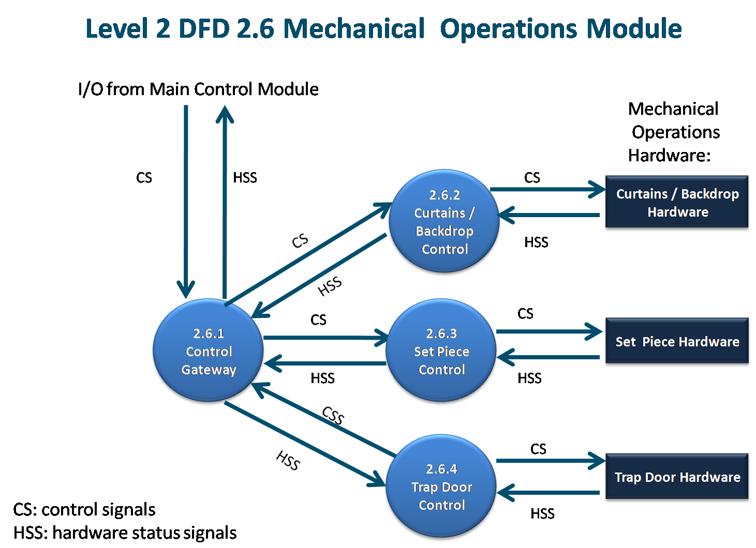

Figure 4.1.6: Level 2 DFD for Mechanical Operations Module

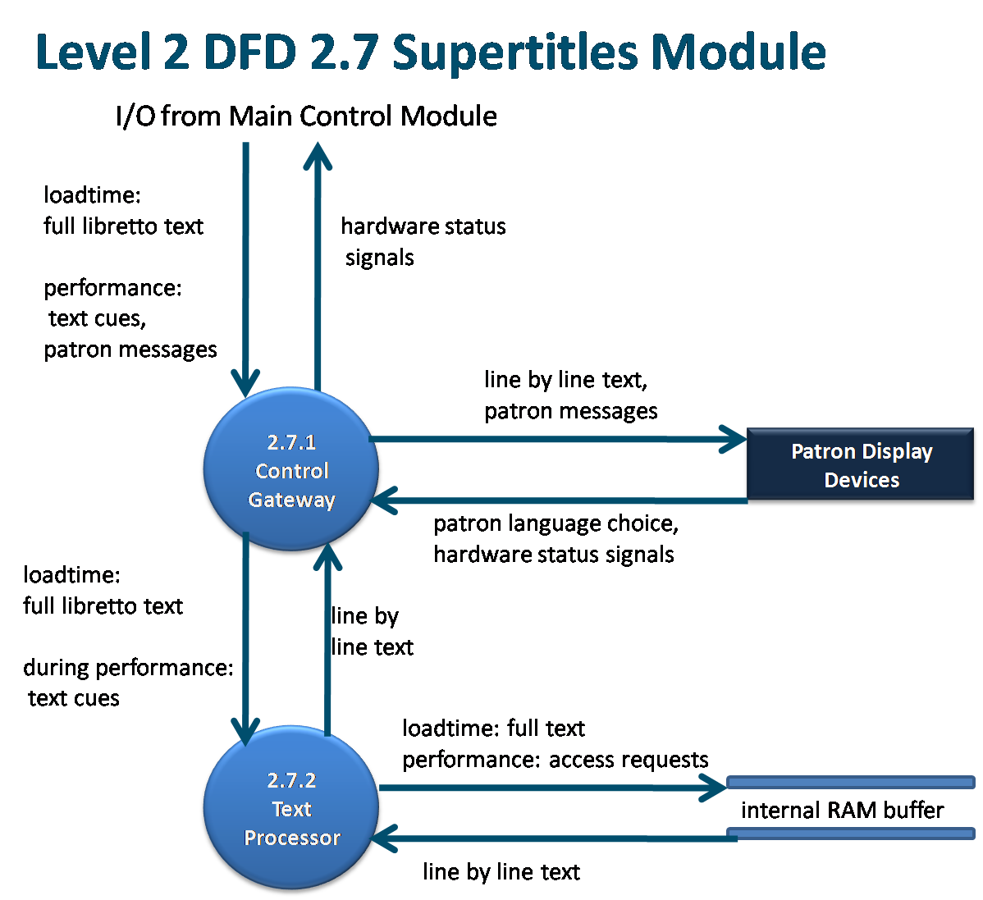

Figure 4.1.7: Level 2 DFD for Supertitles Module

5.0 OLYMPIA ELEMENTS OF IMPLEMENTATION

5.1 Introduction

This section descries the implementation of the requirements described above. We include brief descriptions of each of the coded classes. Java code files are included separately.

5.2 Descriptions of Java Classes

Main GUI:

OlympiaGUI is the main GUI and starting point for the program.

Cues and Operas:

The Cue class is used to represent opera cues, which consist of a type (music or user triggered), execution time, and a list of preset themes to be executed at that time. Additional functionality is provided to store and recreate cues from strings, which is used to save the cues to an opera.

The Opera class is used to represent an opera, which consists of a list of cues and the name of the opera. Methods are provided to save the opera to a file, restore an opera from an .olympia file, and add/edit cues in the opera.

Cue Programming:

CueProgrammingGUI handles the creation of the main GUI of the Cue Programming Tab. It creates all of the buttons and necessary components and assigns actions to each of the buttons. The class also handles all of the action. It uses various java layout managers to provide a nice looking layout for the user. This class allows you to program the Cues and save them as an Opera object.

CueProgrammingTable handles the creation of the table where all of the cues are kept so the user can see what has been programmed. All of the actions associated with the table are handled in the CueProgrammingGUI class.

CueProgrammingTree creates the JTree of programmable Cues. It is displayed once the user selects the top level directory of where all the Cues are kept. The Cues are displayed in a tree structure organized into folders according to the type of Cue it is i.e. Lighting, Special Effects, etc. The tree is created dynamically and if a cue is added or deleted from any of the folders, the tree can be refreshed and the changes will be updated accordingly. The tree can also be changed should the user wish to load a different set of Cues.

CustomFile stores the name of a file and the path to that file. It is used instead of a Java File object because when the File object is bound to a Tree Node the toString method is called and the entire path of the File is displayed in the node instead of just the file name. The CustomFile class is used to overcome this implementation issue. It's toString method simply displays the name of the file and this is what the CueProgrammingTree class uses to display on each of the nodes in the tree.

Cue Tracking:

SoundPlayer is a GUI that allows .wav sound files to be played, with significant control over how to play it. The music is loaded into memory at play time, and can be forwarded, rewound, paused, stopped, and resumed. The position of the music is available in milliseconds.

OperaPlayer provides the functionality to the Cue Tracking GUI. It is responsible for sending each preset theme of a cue to the appropriate submodule for handling when that cue's execution time occurs. OperaPlayer interfaces with Lighting, SpecialEffects, Supertitles, and the controls of the Cue Tracking GUI to do this. The opera player's music simulation is done using SoundPlayer. Controls are provided to load an opera; play, pause, and stop it; execute user cues; and create a log when finished. Hardware output is sent to the console textbox, and the current supertitle is sent to the supertitles box.

Lighting:

Light is the basic class. It includes the fundamental elements in the lighting module and it also includes the applyTheme method which is used by the cue.

JColorChooseDemo implements the color module; it extends JFrame and is invoked by LightingGUI. Users can use this class to choose colors.

LightDisplay simulates the combined effect of the lights in GUI. It retrieves the saved light file from specific folder and creates the fallen beams displayed on the GUI.

LightingGUI is the main control GUI, it integrated all the modules (classes). It extends the JFrame and it also includes the presets and saved function. It is integrated into the OlympiaGUI

LightPosition implements the Light Position module. It extends JFrame and is integrated into the LightingGUI. It simulates the light beam which is fallen on the stage. Users can click on the GUI to simulate the beam.

MovingBeam implements the spotlight module. It extends the JFrame and is integrated into the LightGUI. It simulate the moving spot light. As simulation, Users can drag the blue spot to move the position of the spot light.

Special Effects:

SpecialEffectsMain is the top level controlling class for the Special Effects Module.

SFXMachine is an interface implemented by the effects machines and specifying some key methods and attributes used to standardize the machine controls.

AirMachine, Fog Machine, MistMachine, and PyroMachine simulates special effects hardware.

AirSFX, FogSFX, MistSFX, and PyroSFX are the controllers for the machinery listed above.

Supertitles:

SupertitlesMain is the main controller for the Supertitles module

DisplayScreen provides a GUI for patron display screens

Libretto represents the text of an opera. It contains data storage and functionality to construct and iterate through operas.

LibrettoLine represents one line of a libretto, in several languages.

PatronDisplay is the controller for a single patron screen.

6.0 OLYMPIA TEST PLAN

6.1 INTRODUCTION

In this section the testing methodology used to V&V each of the requirements listed in section 3.0 has been identified. At points some additional testing may be required and they shall be documented as an attachment to this document.

The methodologies and testing strategies identified at this point include three major approaches with various variations to adapt to the OLYMPIA project:
- Testing using additional ad-hoc created software including a correlation testing unit.
- Demonstration of the specified capability
- Inspection of the software code possibly using additional inspection techniques

6.2 FUNCTIONAL REQUIREMENTS VALIDATION MATRIX

Requirements Related to Design Module 2.1: Main Control
Requirement No. | Requirement Description |  | Test Methodology
 | Main Module Graphical User Interface (MMG)
3.1.1 | MMG shall consist of four tabs: Cue Programming, Lighting, Special Effects and Cue Tracking. |  | Demonstration
3.1.2 | MMG shall provide a tabbed window format for each element. |  | Demonstration
3.1.3 | MMG shall provide the necessary controls for all aspects of the hardware. |  | Demonstration
3.1.4 | MMG shall display any necessary error, or other messages to the user. |  | Demonstration
3.1.5 | MMG shall display the score / libretto to the user. |  | Requirement not met
3.1.6 | MMG shall allow the user to map cues to specific points in the music. |  | Demonstration
 | Cue Programming Submodule (CPS)
3.1.7 | CPS shall read libretto inputs from files. |  | Requirement not met
3.1.8 | CPS shall read score inputs from files. |  | Requirement not met
3.1.9 | CPS shall store libretto and score in a database. |  | Requirement not met
3.1.10 | CPS shall receive music recorded at rehearsal time. |  | Simulation
3.1.11 | CPS shall store rehearsal music in a permanent database. |  | Demonstration
3.1.12 | At cue programming time (CPT), CPS shall retrieve music and libretto from DB. |  | Demonstration
3.1.13 | At CPT, CPS shall route music and libretto text to the GUI. |  | Demonstration
3.1.14 | CPS shall receive input from the GUI for actions to match to cues. |  | Demonstration
3.1.15 | CPS shall match input actions to sequential cues synchronized to the recorded music. |  | Demonstration
3.1.16 | CPS shall store cues in cue storage. |  | Demonstration
3.1.17 | CPS shall receive all hardware status signals from the hardware it controls. |  | Simulation
3.1.18 | CPS shall receive requests for hardware status from the GUI. |  | Requirement Not Met
3.1.19 | CPS shall provide requested hardware information when available. |  | Requirement Not Met
3.1.20 | CPS shall receive requests from MCM for information on all existing cues. |  | Demonstration
3.1.21 | CPS shall retrieve cue information on request from MCM. |  | Demonstration
3.1.22 | CPS shall route cue information to MCM upon request. |  | Demonstration
3.1.23 | CPS shall contain a music player for reference at programming time |  | Demonstration
 |  | Cue Tracking Submodule (CTS)
3.1.24 |  | CTS shall ask the user to choose an opera to load. | Demonstration
3.1.25 |  | CTS shall ask the User to start the opera through the Main Module GUI. | Demonstration
3.1.26 |  | CTS shall load the opera selected and receive the cue sequence for that opera. | Demonstration
3.1.27.1 |  | CTS shall request the instructions for a cue when that cue is the next one to execute. | Inspection
3.1.27.2 |  | The instructions shall consist of which module to signal, what the module shall do, and when to do it. | Inspection
3.1.27.3 |  | CTS shall receive the instructions for the cue. | Demonstration
3.1.27.4 |  | CTS shall send the preset theme instructions for that cue to the appropriate sub module. | Demonstration
3.1.27.5 |  | CTS shall signal that preset’s module to start executing the cue. | Demonstration
3.1.28 |  | CTS shall initiate a cue when it’s time has come, as programmed in the CPS. | Demonstration
3.1.29.1 |  | CTS shall receive a music state every millisecond from a built in music player. | Inspection
3.1.29.2 |  | CTS shall initiate any cues that are signaled by that music state. | Demonstration
3.1.29.3 |  | The music state shall consist of the time marker that the song is currently at in milliseconds. | Inspection
3.1.29.4 |  | CTS shall initiate any cues that are signaled by the completion of other cues. | Demonstration
3.1.29.5 |  | CTS shall initiate user cues when signaled by the user. | Demonstration
3.1.30 |  | CTS shall have the option to pause and resume an opera that has been loaded. | Demonstration
3.1.31 |  | CTS shall have the option to stop, or terminate the opera when the appropriate command is issued. | Demonstration
3.1.32 |  | CTS shall display the current line of the libretto being spoken, as programmed in the CPS, to the Main Module GUI. | Demonstration
3.1.33 |  | CTS shall display hardware output from the cues that have executed to the Main Module GUI. | Demonstration
3.1.34 |  | CTS shall create a log of the performance and write it to a text file after the performance is over. | Demonstration

Requirements Related to Design Module 2.4: Lighting Module
 | Light Position and Beam Control Module (LPBCM)
3.4.1 | LPBCM shall adjust light positioning. | Demonstration
3.4.1.1 | LPBCM shall be able to adjust the vertical axis of the lights. | Demonstration
3.4.1.2 | LPBCM shall be able to adjust the horizontal axis of the lights. | Demonstration
3.4.1.3 | LPBCM shall be able to adjust the diagonal axis of the lights. | Demonstration
3.4.1.4 | LPBCM shall be able to raise and lower the lighting fixtures. | Demonstration
3.4.2 | LPBCM shall allow the user to adjust the beam of the light. | Demonstration
3.4.2.1 | LPBCM shall allow the user to adjust the diameter of the projected beam of light. | Demonstration
3.4.2.2 | LPBCM shall allow the user to adjust the fade level of the lights (how bright or dim the lights are). | Demonstration
3.4.3 | LPBCM shall be able to adjust lights individually. | Demonstration
3.4.4 | LPBCM shall be able group lights and adjust them as a group. | Demonstration
Requirement No. | Color Module (CM) | Testing Methodology
3.4.5 | CM shall allow the user to adjust the color of the lights. | Demonstration
3.4.5.1 | CM shall allow the user to adjust the R, G, B values of the lights individually. | Demonstration
3.4.5.2 | CM shall allow the user to choose from a range of preprogrammed color choices. | Demonstration
3.4.5.3 | CM shall allow the user to choose from preprogrammed color themes. | Demonstration
3.4.5.4 | CM shall allow the user to program their own color themes. | Demonstration
3.4.5.5 | CM shall allow the user to adjust lights individually. | Demonstration
3.4.5.6 | CM shall allow the user to group lights together and adjust them as a group | Demonstration
 | Spotlight Control and Motion Tracking Module (SCMTM)
3.4.7 | SCMTM shall allow the user to manually control the spotlight. | Demonstration

Requirements Related to Design Module 2.5: Special Effects Module (SEM)

Requirement No. | Requirement Description | Testing Methodology
3.5.0 | Special Effects shall be controlled by a GUI (SEGUI) with four separated panels for wind, mist, pyro and fog. | Demonstration
3.5.0.1 | SEGUI shall contain for each of four panels five mini panels for five different machines. | Demonstration
3.5.0.2 | SEGUI shall contain a checkbox for each of the five mini panels. | Demonstration
3.5.0.3 | SEGUI shall contain for each of five mini panels a slider. | Demonstration
3.5.0.4 | SEGUI shall display intensity settings from 0 to 20 each wind machine. | Demonstration
3.5.0.5 | SEGUI shall display intensity settings from 0 to 20 each mist machine. | Demonstration
3.5.0.6 | SEGUI shall display intensity settings from 0 to 5 for each pyro machine. | Demonstration
3.5.0.7 | SEGUI shall display intensity settings from 0 to 30 for each fog machine. | Demonstration
3.5.0.8 | SEGUI shall contain “Save” button for saving selected properties. | Demonstration
3.5.0.9 | SEGUI shall bring file chooser when “Save” button is pressed. | Demonstration
 | Special Effects Control Module (SECM)
3.5.1 | SECM shall process all SEM communication with the main control module. | Demonstration
3.5.1.1 | SECM shall receive all hardware control signals routed to SEM from the Main Control Module. | Simulation
3.5.1.2 | SECM shall route all special effects signals received from MCM to the special effects control h/w. | Simulation
3.5.1.3 | SECM shall receive all requests for special effects control h/w status information from MCM. | Simulation
3.5.1.4 | SECM shall supply error signals from special effects control h/w to MCM when available. | Simulation

 | Fog Machine Module (FMM)
3.5.2 | FMM shall process all communication between SCEM and the fog control hardware. | Simulation
3.5.2.1 | FMM shall provide fog at five intensity levels, measured in cubic meters output per second. | Simulation
3.5.2.2 | FMM shall communicate with trap door control hardware to perform requested signals simultaneously. | Simulation
3.5.2.3 | FMM shall provide fog in three locations of the stage: left, center, and middle. | Simulation
 | Air and Fans Module (AFM)
3.5.3 | AFM shall process all communication between SCEM and the air and fans control hardware. | Simulation
3.5.3.1 | AFM shall provide wind at five intensity levels. | Simulation
3.5.3.2 | AFM shall communicate with fog module to perform requested signals simultaneously. | Simulation
 | Pyrotechnics Module (PM)
3.5.4 | PM shall process all communication between SCEM and the pyrotechnics control hardware. | Simulation
3.5.4.1 | PM shall provide fire at five intensity levels. | Simulation
3.5.4.2 | PM shall light torches on stage when requested. | Simulation
3.5.4.3 | PM shall provide three levels of artificial explosions. | Simulation
3.5.4.4 | PM shall monitor all existing fires each millisecond for conformity to safety protocols. | Simulation

Requirements Related to Design Module 2.7: Supertitles Module
Requirement No. | Requirement Description | Testing Methodology
 | Control Gateway Submodule (CGS)
3.7.1 | CGS shall process all SM communication with the main control module. | Demonstration
3.7.1.1 | CGS shall receive the full libretto text in all available languages during load time . | Demonstration
3.7.1.2 | CGS shall send prompts for language choice to patron display devices during load time. | Demonstration
3.7.1.3 | CGS shall receive language choice input from patron display devices. | Demonstration
3.7.1.4 | CGS shall receive cues from MCM during performances. | Demonstration
3.7.1.5 | CGS shall route cue information to the Text Processor. | Demonstration
3.7.1.6 | CGS shall receive line by line text in the libretto language and in all available translation languages from the Text Processor during performance. | Demonstration
3.7.1.7 | CGS shall send text in the libretto language and the individually chosen translation languages to each patron display device during performances. | Demonstration
3.7.1.8 | CGS shall receive patron messages from MCM at runtime. | Demonstration
3.7.1.9 | CGS shall send patron message text to patron display devices. | Demonstration

 | Text Processing Submodule (TPS) | Demonstration
3.7.2 | TPS shall handle all tasks related to storing, parsing, and retrieving libretto text for patron displays. | Demonstration
3.7.2.1 | TPS shall receive a full copy of the libretto text in all available languages at load time from the module’s CGS. | Demonstration
3.7.2.2 | TPS shall store the libretto text in memory at load time. | Demonstration
3.7.2.3 | TPS shall receive cues from CGS during performances. | Demonstration
3.7.2.4 | TPS shall retrieve line-by-line text from memory during performance.
3.7.2.5 | TPS shall supply line-by-line text to CGS. | Demonstration

A. ACRONYMS

AFM Air and Fan Module (part of SECM)
CCS Curtain Control Submodule
CGS Control Gateway Submodule
CM Color Module (part of LM)
CPS Cue Programming Submodule
CTS Cue Tracking Submodule
FM Feedback Module (part of MCM)
FMM Fog Machine Module (part of SEM)
LPBCM Light Positioning and Beam Control Module (component of LM)
LM Lighting Module
LSTM Lighting System Troubleshooting Module (component of LM)
MCM Main Control Module
MMG Main Module Graphical User Interface
MOM Mechanical Operations Module
MSEM Miscellaneous Special Effects Module
OLYMPIA Opera Logistics and Musical Performance Integration Application
PM Pyrotechnics Module
SECM Special Effects Control Module
SCMTM Spotlight Control and Motion Tracking Module
SEM Special Effects Control Module (component of SEM)
SEM Special Effects Module
SPS Set Piece Submodule
SRM Sound Recognition Module
SM Supertitles Module
SRM Sound Recognition Module
TDS Trap Door Submodule
TPM Text Processing Submodule
V&V Verification and Validation
WEM Water Effects Module
B. DATA DICTIONARY

Cue A specific point in a planned performance

Cue Event A planned event synchronized to a cue

