DC Runs Summary
Jin Liu

10/27/2016

This note is the summary of recently DC runs. Assuming there is a linear relationship between the heater power drops, which after applying DC current to the surface of the core vs. DC power; we obtained the slope parameter M for each core temperature. Table 1 lists the date, core and gas (H2/He) of the runs and M parameter vs. the core temperature. Note: the red inked of M is from the interpolation of the quadratic equation, except the IPB1 H2, which is from the cubic equation. Figure 1 is the plot of the M vs. the temperatures. Figure 2 through Figure 6 are each run’s output of the Heater Power, Core Temperature, DC Power and DC volt vs. the time.

Table 1 Summary of DC Runs

Figure 1 . M vs. Temperature of DC Runs

Figure 2. IBP2-H2-DC 08/29/2016

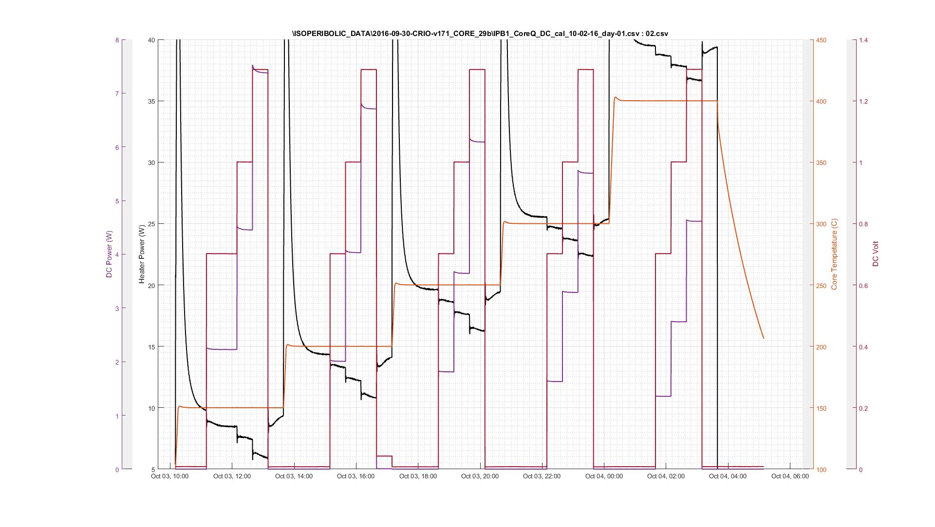

Figure 3. IBP1-He-DC 10/02/2016

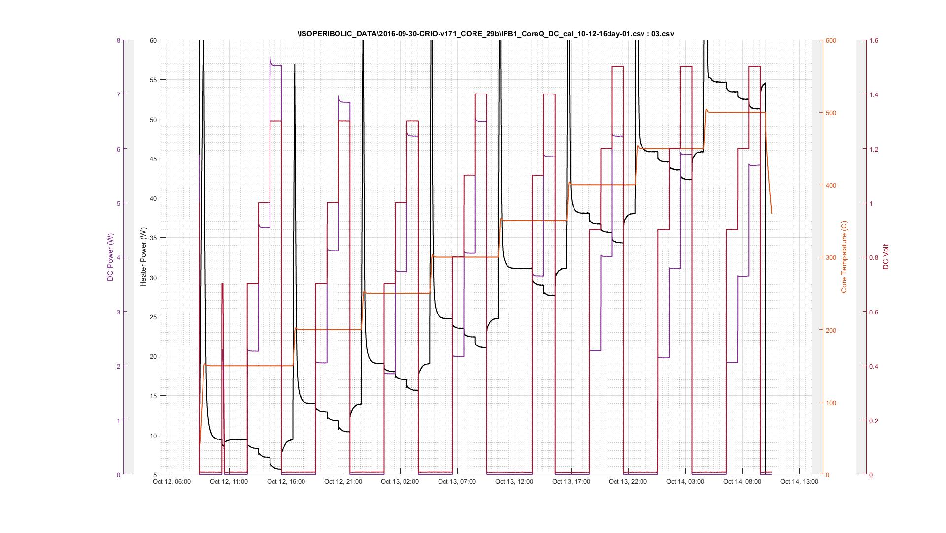
Figure 4. IBP1-He-DC 10/13/2016

Figure 5. SRI-IBP2-H2-DC 10/16/2016

Figure 6. IBP1-H2-DC 10/26/2016

