**Summary**

**Trophy Case Sports** - Sarah Nordheim manages the website for Trophy Case Sports, a sports memorabilia store located in Beavercreek, Ohio. She has asked you to work on creating a script for the shopping cart page. The script should take information on the items that the customer has purchased and present it in table form, calculating the total cost of the order. A preview of the page you will create is shown in **Figure 10–39**.

[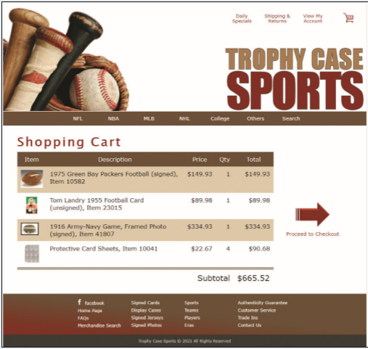](https://cdn.filestackcontent.com/1CfqULIbRHmB6kQau2Kg)*Figure 10–39*

## Document Setup

Open the tc_cart.html, tc_cart.js and tc_order.js files and enter your **name** and the **date** in the comment section of each file. Next, go to the tc_cart.html file in your editor. Directly above the closing </head> tag, insert script elements to link the page to the tc_order.js and tc_cart.js files in that order. Defer the loading and running of both script files until after the page has loaded.

## Create the Shopping Cart

Scroll down the file and directly below the h1 heading titled **Shopping Cart** insert a div element with the ID cart.

Within the tc_order.js file, you will create arrays containing information on a sample customer order. Create an array named item that will contain the ID numbers of the items purchased by the customer. Add the following four item numbers to the array: **10582**, **23015**, **41807**, and **10041**. Create an array named itemDescription containing the following item descriptions:

* 1975 Green Bay Packers Football (signed), Item 10582
* Tom Landry 1955 Football Card (unsigned), Item 23015
* 1916 Army-Navy Game, Framed Photo (signed), Item 41807
* Protective Card Sheets, Item 10041

Create an array named itemPrice containing the following item prices: **149.93**, **89.98**, **334.93**, and **22.67**.

Create an array named itemQty containing the following quantities that the customer ordered of each item: **1**, **1**, **1**, and **4**.

**Create the table to Display the Total Cost**

Open the *tc_cart.js* file and in your script begin the logic for calculating a running total of the cost of the order. Start by declaring a variable named orderTotal and set its initial value to **0**. Then declare a variable named cartHTML that will contain the HTML code for the contents of the shopping cart, which will be displayed as a table. Set its initial value to the text string:

<table>  
<tr>  
<th>Item</th><th>Description</th><th>Price</th><th>Qty</th><th>Total</th>  
</tr>

**Calculate the Total Cost of the Order**

Create a for loop that loops through the entries in the item array. Each time through the loop, execute the commands described in *steps 1* through *5* listed below:

1. Add the following HTML code to the value of the cartHTML variable:

<tr>  
<td><img src='tc_item.png' alt='item' /></td>

where **item** is the current value from the item array.

1. Add the following HTML code to the cartHTML variable to display the **description**, **price**, and **quantity** ordered of the item:

<td>description</td>   
<td>$price</td>  
<td>quantity</td>

where **description** is the current value from the itemDescription array, **price** is the current value from the itemPrice array preceded by a **$** symbol, and **quantity** is the current value from the itemQty array.

1. Declare a variable named itemCost equal to the price value multiplied by the quantity value for the current item.
2. Add the following HTML code to the cartHTML variable to display the cost for the item(s) ordered, completing the table row:

<td>$cost</td></tr>

where **cost** is the value of the itemCost variable, preceded by a **$** symbol.

1. Add the value of the itemCost variable to the orderTotal variable to keep a running total of the total cost of the customer order.

After the for loop has completed, add the following HTML code to the value of the cartHTML variable, completing the shopping cart table:

<tr>  
<td colspan='4'>Subtotal</td>  
<td>$total</td>  
</tr>  
</table>

where **total** is the value of the orderTotal variable, preceded by a **$** symbol.

Apply the cartHTML value to the inner HTML of the div element with the ID cart. Document your script file with appropriate comments.

Open the website in the browser preview and verify that the page now shows the shopping cart data for the sample customer order.