**Summary**

**The Civil War and Reconstruction** - Peter Craft is a professor of military history at Mountain Crossing University. The university is offering a series of online courses, one of which is “The Civil War and Reconstruction” taught by Professor Craft. He has developed the online content and has had a colleague help with the page layout. You’ve been asked to complete the project by creating text and color styles. A preview of the sample page is shown in *Figure 2–60*.

[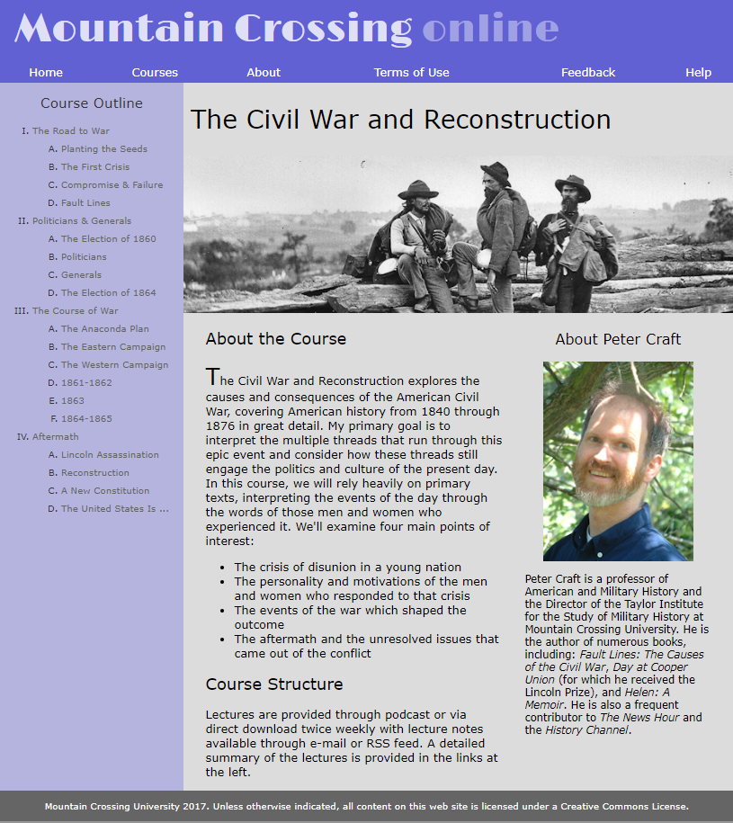](https://cdn.filestackcontent.com/oT5H3W5SDaIIPNlHEP81)

*Figure 2-60*

**Grading**

This lab will be reviewed by your instructor, and your grade will be adjusted down from 100% if it does not meet the grading requirements. You can use the **Website Refresh** button to refresh your website preview at any point. You view a full-page version of your website by clicking the arrow in the top right corner of your website preview. Complete all lab requirements before you submit your work. To submit, click the checkbox and click the "Submit" button in the task list.

1/5

**Document Setup**

Open the *cw_class.html* and *cw_styles.css* files and enter your **name** and the **date** in the comment section of each file.

Next, go to the *cw_class.html* file and within the document head, create a link to the *cw_styles.css* style sheet file.

Using the Google Fonts website, locate the **Limelight** font. Copy the code for the link element to use this font and paste the copied code to the document head in the *cw_class .html* file.

Study the content and structure of the *cw_class.html* file and then close the file.

Open to the *cw_styles.css* file. At the top of the file, define the character encoding as **utf-8**. On the next line, use the @import rule to import the contents of the *cw_layout.css* file into the style sheet.

2/5

**Structural Styles**

Go to the "Structural Styles" section. Within that section create a style rule to set the background color of the browser window to **rgb(151, 151, 151)**.

Create a style rule to set the background color of the page body to **rgb(180, 180, 223)** and set the body text to the font stack: **Verdana**, **Geneva**, **sans-serif**.

Display all h1 and h2 headings with **normal** weight.

Create a style rule for every hypertext link nested within a navigation list that removes underlining from the text.

Create a style rule for the footer element that sets the text color to **white** and the background color to **rgb(101, 101, 101)**. Set the font size to **0.8em**. Horizontally center the footer text, and set the top/bottom padding space to **1** pixel.

**Header Styles**

Next, you’ll format the body header that displays the name of the university. Go to the "Body Header Styles" section and, for the body > header selector, create a style rule that sets the background color to **rgb(97, 97, 211)**.

The university name is stored in an h1 heading. Create a style rule for the h1 heading that is a direct child of the body header that sets the font size to **4vw** with the color value **rgba(255, 255, 255, 0.8)**. Display the text with the font stack: **Limelight**, **cursive**. Set the margin space to **0** pixels, the top and bottom padding to **10px** and the right and left padding to **20px**.

The last word of the h1 heading text is enclosed within a span element. Create a style rule for the span element nested within the h1 heading that is nested within the body header, setting the text color to **rgba(255, 255, 255, 0.4)**.

3/5

**Navigation Styles**

Go the "Navigation Styles" section. In this section, you format the navigation list that has the ID mainLinks. For hypertext links within this navigation list, set the top and bottom padding space to **5** pixels.

For previously visited and unvisited links within the mainLinks navigation list, create a style rule that displays the hypertext links in a **white** font.

For hovered or active links within the mainLinks navigation list, create a style rule that displays the hypertext links in **white** with an opacity of **0.8** and set the background color to the value **rgba(51, 51, 51, 0.5)**.

**Outline Styles**

Go to the "Outline Styles" section. In this section, you’ll format the course outline that appears on the page’s left column. The navigation list in this outline has the ID outline. Create a style rule for this navigation list that sets the text color to **rgb(51, 51, 51)** and the font size to **0.8em**.

Horizontally center the h1 headings within the outline navigation list. For the first level ol elements that are a direct child of the outline navigation list, create a style rule that sets the line height to **2em**, the top/bottom margin to **0** pixels and the left/right margin to **5** pixels. Display the list marker as an upper-case Roman numeral.

Display the second level of ol elements nested within the outline navigation list with an uppercase letter as the list marker.

Display all previously visited and unvisited links in the outline navigation list using the color value **rgb(101, 101, 101)**.

Display hovered and active links in the outline navigation list using the color value **rgb(97, 97, 211)** with the text underlined.

4/5

**Section Styles**

Go to the "Section Styles" section. In this section, format the description of the course. Create a style rule that sets the background color of the section element to **rgb(220, 220, 220)**.

Format the heading of this section by creating a style rule for the section header h1 selector that sets the font size of **2.2em** and the left padding space to **10** pixels.

**Article Styles**

Go to the "Article Styles" section and create a style rule for h2 headings within the article element that sets the font size to **1.4em**. Display the first letter of the first paragraph within the article element with a font size of **2em** and vertically aligned with the baseline of the surrounding text.

Use the first-of-type pseudo-class and the first-letter pseudo-element.

**Aside Styles**

Information about Peter Craft has been placed in an aside element. Go to the "Aside Styles" section and create a style rule that sets the font size of text in the aside element to **0.9em**.

For h1 headings nested within the aside element, create a style rule that sets the font size to **1.4em** and horizontally centers the text.

Task

When you have completed the assignment, check this task, open the task list and submit your work to your instructor.

**0**

5/5