**Summary**

*Figure 3–80* shows a proposed layout for a new web page. At this point the final content is not ready for the web page, so the layout is shown using lorem ipsum text. You’ve been given the HTML code for the page and your challenge is to create the page layout using CSS grid styles.

[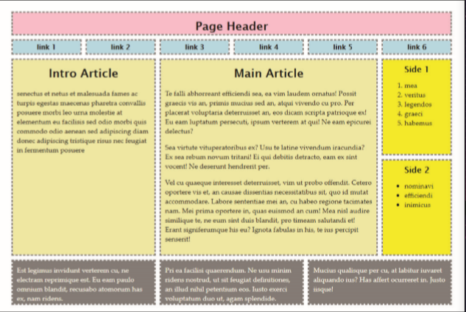](https://cdn.filestackcontent.com/lnq5g1OqSLysDUVzWpA5)*Figure 3-80*

Do the following:

Tasks

Open the file *code3-2.html* and *code3-2_layout.css* and in the comment section enter your **name** (First + Last) and the **date** (MM/DD/YYYY) into the Author: and Date: fields of the file.

**4**

Go to the *code3-2.html* file and within the head section insert a link element linking the page to the *code3-2_layout.css* file. Study the contents of the file, taking note of the structure, element names, and element ids.

**2**

Go to the *code3-2_layout.css* file. Create a style rule for the header, footer, aside, article, and a (hyperlink) elements to set the padding space to **10** pixels and add a **3-pixel** **gray** dashed outline.

**5**

Create a style rule for the body element that:

1. Sets the width to **90%** of the browser window, ranging from a minimum width of **640** pixels up to a maximum width of **1024** pixels.
2. Sets the top/bottom margin to **30** pixels and the left/right margin to **auto**.
3. Displays the body as a CSS grid.
4. Creates six grid columns each with a width of **1fr**.
5. Creates five grid rows with widths of **50** pixels, **30** pixels, **1fr**, **1fr**, and **100** pixels.
6. Adds a grid gap of **15** pixels.

**3**

Set the size of the grid items as follows:

1. Have the header element span from **gridline 1** to **gridline -1**.
2. Have the article#intro element span two rows and two columns.
3. Have the article#main element two rows and three columns.
4. Have the footer element span two columns.

**4**

Open the webpage in the browser preview and verify the layout of the page resembles that shown in *Figure 3–80*.