**Summary**

**Austen Vynes** - Emelia Dawes shares her passion for the works of Jane Austen by managing a website named Austen Vynes dedicated to the writer and her works. Emelia is revising the layout and design of her website and would like your assistance in redesigning the front page. She wants the front page to display a random Jane Austen quote every time the page is loaded by the browser. Emelia asks you to write a JavaScript program to supply a randomly selected quote. A preview of the page is shown in **Figure 9–46**.

[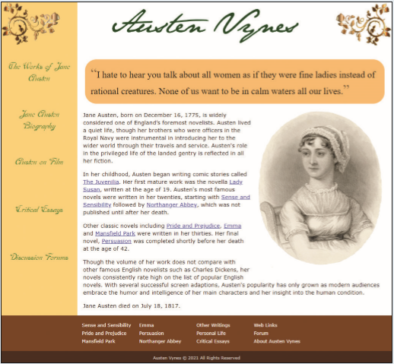](https://cdn.filestackcontent.com/xs5BStQzSkm7RqPpJKPZ)

*Figure 9-46*

## Document Setup

Open the ja_vynes.html and ja_quote.js files and enter your **name** and the **date** in the comment section of each file. Next, go to the ja_vynes.html file and directly above the closing </head> tag, insert a script element that links the page to the ja_quote.js file. Defer the loading of the script file until the rest of the page is loaded by the browser. Study the contents of the file.

## Complete the JavaScript File

Open the ja_quote.js file and at the top of the file, insert a statement indicating that the code will be handled by the browser assuming strict usage. Directly below the comment section, insert a function named randomInt that will be used to generate a random integer. Specify two parameters for the function named lowest and size. The lowest parameter will specify the lowest possible value for the random integer and the size parameter will set the number of integers to be generated. Use those two parameter values and the Math.floor() and Math.random() methods to return a random integer within the specified range.

Above the randomInt() function insert a command to call the function, generating a random integer from **0** to **9**.

Remember that the size of this interval is **10** because it includes **0** in its range.

Store the result from the function in the randomQ variable. Create a variable named quoteElem that references the first element in the document that has the quote tag **name**.

Call the getQuote() function using the randomQ variable as the parameter value to generate a random Jane Austen quote. Display the text of the quote as the inner HTML code of the quoteElem variable. Add appropriate comments to your code to document your work.

Open the ja_vynes.html file in the browser preview and verify that a random Jane Austen quote appears at the top of the page. Reload the page several times and verify that with each reloading, a different Austen quote appears on the page.