Sf_effects.css + Instructions.

@charset "utf-8";

/*

New Perspectives on HTML5 and CSS3, 8th Edition

Tutorial 4

Case Problem 1

Save your Fork Graphic Design Styles

Author:

Date: 04/15/2023

Filename: sf_effects.css

*/

/* Body Header Styles */

body {

box-shadow: 10px 0px 50px rgb(51,51,51),

-10px 0px 50px rgb(51,51,51);

}

/* Navigation Tabs List Styles */

body > header nav.tabs {

background-image: url(sf_back1.png);

background-repeat: no-repeat;

background-size: cover;

background-position: center;

}

body > header nav.tabs li {

transform: perspective(50px) rotateX(20deg);

}

body > header nav.tabs li:hover {

background-color: rgb(231,231,231);

}

/* Left Section Styles */

section#left nav.vertical {

border: 1px solid rgb(20,167,170);

border-radius: 25px;

}

section#left nav.vertical h1 {

border-radius: 25px 25px 0px 0px;

}

/* Center Article Styles */

section#center article {

background: radial-gradient(white 30%, rgb(151,151,151));

border: 1px solid rgb(151,151,151);

border-radius: 50px;

box-shadow: 10px 10px 20px rgb(51,51,51),

-10px 10px 20px rgb(51,51,51);

}

/* Blockquote Styles */

blockquote {

background-image: url(sf_speech.png);

background-repeat: no-repeat;

background-size: 100% 100%;

filter: drop-shadow(5px 5px 10px rgb(51,51,51));

}

cite img {

border-radius: 50%;

}

**Summary**

**Save your Fork** - Amy Wu has asked for your help in redesigning her website, Save your Fork, a baking site for people who want to share dessert recipes and learn about baking in general. She has prepared a page containing a sample dessert recipe and links to other pages on the website. A preview of the page you’ll create is shown in *Figure 4–70*.

[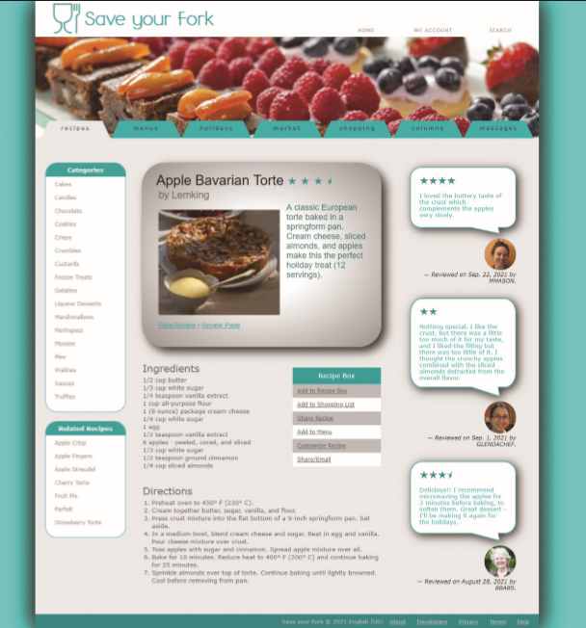](https://cdn.filestackcontent.com/VzZY2iq0RKu76mZH8crO)*Figure 4-70*

Amy has already created a style sheet for the page layout and typography, so your work will be focused on enhancing the page with graphic design styles.

**Grading**

This lab will be reviewed by your instructor, and your grade will be adjusted down from 100% if it does not meet the grading requirements. You can use the **Website Refresh** button to refresh your website preview at any point. You view a full-page version of your website by clicking the arrow in the top right corner of your website preview. Complete all lab requirements before you submit your work. To submit, click the checkbox and click the "Submit" button in the task list.

1/4

**Document Setup**

Open the *sf_torte.html* and *sf_effects.css* files and enter your **name** and the **date** in the comment section of each file. Next, go to the *sf_torte.html* file in your editor. Within the document head create links to the *sf_base.css*, *sf_layout.css*, and *sf_effects.css* style sheet files in that order. Take some time to study the structure of the document and then close the document.

**Body Header Styles**

Go to the *sf_effects.css* file and within the "Body Header Styles" section, create a style rule for the body element to add drop shadows to the left and right border of the page body with an offset of **10** pixels, a blur of **50** pixels, and the color **rgb(51, 51, 51)**. Note that the right border is a mirror image of the left border.

**Navigation Tabs List Styles**

Go to the "Navigation Tabs List Styles" section. Amy has created a navigation list with the class name tabs that appears at the top of the page with the body header. Create a style rule for the body > header nav.tabs selector that changes the background to the image file *sf_back1.png* with no tiling, centered horizontally and vertically within the element and sized to cover the entire navigation list.

Amy wants the individual list items in the tabs navigation list to appear as tabs in a recipe box. She wants each of these “tabs” to be trapezoidal in shape. To create this effect, you’ll create a style rule for the body > header nav.tabs li selector that transforms the list item by setting the perspective of its 3D space to **50** pixels and rotating it **20°** around the x-axis.

As users hover the mouse pointer over the navigation tabs, Amy wants a rollover effect in which the tabs appear to come to the front. Create a style rule for the body > header nav.tabs li selector that uses the pseudo-element hover that changes the background color to **rgb(231, 231, 231)**.

**Left Section Styles**

Go to the "Left Section Styles" section. Referring to *Figure 4–70*, notice that in the left section of the page, Amy has placed two vertical navigation lists. She wants these navigation lists to have rounded borders. For the vertical navigation lists in the left section, create a style rule for the section#left nav.vertical selector that adds a **1** pixel solid border with color value **rgb(20, 167, 170)** and has a radius of **25** pixels at each corner.

The rounded corner also has to apply to the h1 heading within each navigation list. Create a style rule for h1 elements nested within the left section vertical navigation list that sets the top-left and top-right corner radii to **25** pixels.

3/4

## Center Article Styles

Go to the "Center Article Styles" section. The article element contains an image and brief description of the Apple Bavarian Torte, which is the subject of this sample page. Create a style rule for the section#center article selector that adds the following:

1. A radial gradient to the background with a **white** center with a color stop of **30%** transitioning to **rgb(151, 151, 151)**.
2. A **1** pixel solid border with color value **rgb(151, 151, 151)** and a radius of **50** pixels.
3. A box shadow with horizontal and vertical offsets of **10** pixels with a **20** pixel blur and a color of **rgb(51, 51, 51)**.

## Blockquote Styles

Go to the "Blockquote Styles" section. Amy has included three sample reviews from users of the Save your Fork website. Amy wants the text of these reviews to appear within the image of a speech bubble. For every blockquote element, create a style rule that does the following:

1. Set the background image to the sf_speech.png file with no tiling and a horizontal and vertical size of **100%** to cover the entire block quote.
2. Use the drop-shadow filter to add a drop shadow around the speech bubble with horizontal and vertical offsets of **5** pixels, a blur of **10** pixels and the color **rgb(51, 51, 51)**.

Amy has included the photo of each reviewer registered on the site within the citation for each review. She wants these images to appear as circles rather than squares. To do this, create a style rule for the selector cite img that sets the border radius to **50%**.