Design GUI of Project 1: Text Analysis

jonathan Lam kam cheung – S#40945909

2018

# GUI Interface Design

* main_Window

Menu Bar

Frame B

Frame A

Frame C

* frameA_Window

|  |
| --- |
| Label  Entry  Project Title  Manually Enter File Path  C://InputFilePath_Entry.txt  Reset All Button  Browse File Button  Buttons  Run Analysis Button  Check Box |

* frameB_Window

Label

Status

Progress Bar

List Box

3. MacBeth.txt Processing…

0. NewResult.txt Exported

0. D:/Input_Folder/NewResult.txt

2. TaleOfWar.txt Completed

2. TaleOfWar.txt Processing…

1. LesMiserables.txt Completed

1. LesMiserables.txt Processing…

* frameC_Window

Text Box

3.Name of text: MacBeth.txt

Total Non-blank Character Count: 2646715

Total Blank Character Count: 514912

Total Character Count: 3161627

Percentage Blank Character: 16.29%

Total Word Count: 566321

Word/Count Dictionary:

newsletter : 1

Gutenberg-tm, : 1

http://www.gutenberg.org : 1

facility: : 1

PG : 1

edition. : 1

Thus, : 1

included. : 1

Domain : 1

editions, : 1

eBooks : 3

Hart : 1

Professor : 1

* menu_Bar

|  |
| --- |
| Exit | Export | About  -> Text  Output to .txt File |

# UML State Chart

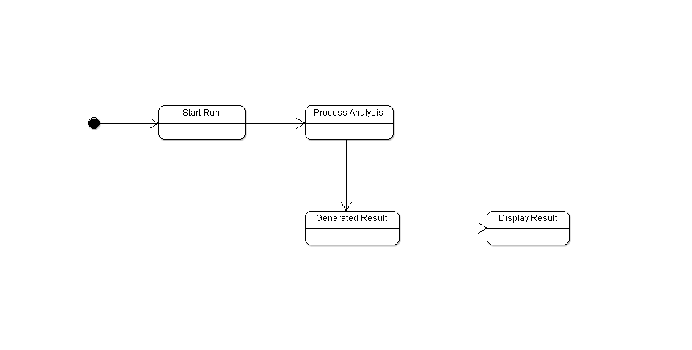

# UML Activity Diagram

