**Jaylon Kiper**

**Database Design Project**

**CS300**

**Database Management Systems**

**3/16/21**

**Original Design Narrative #1:**

A famous Greek shipping magnate, Stell, owns many container ships. Containers are collected at one port and delivered to another port. Customers pay a negotiated fee for the delivery of each container. Each ship has a sailing schedule that lists the ports the ship will visit over the next six months. The schedule shows the expected arrival and departure dates. The daily charge for the use of the port is also recorded.

**List of Assumptions:**

For the Container Ship data table, I had made assumptions on a ship’s characteristics. This includes the ship’s number and name to identify it. Also there are the containers on said ship and the count of how many are on each ship. Lastly, the count of the crew is also written in. For the Port table, I included the port's name, location, and daily charge for the use of said port. The ship number is a primary key for the main table, but a foreign key for some tables. The Schedule table has the date of the ship's arrival and departure. The arrival and departure tabs describe if the ship came and left. The Customer table has the order number for the container as a primary key. Said container is a foreign key to connect to the container ship table. This table also includes the customer’s name and negotiated fee for the delivery.

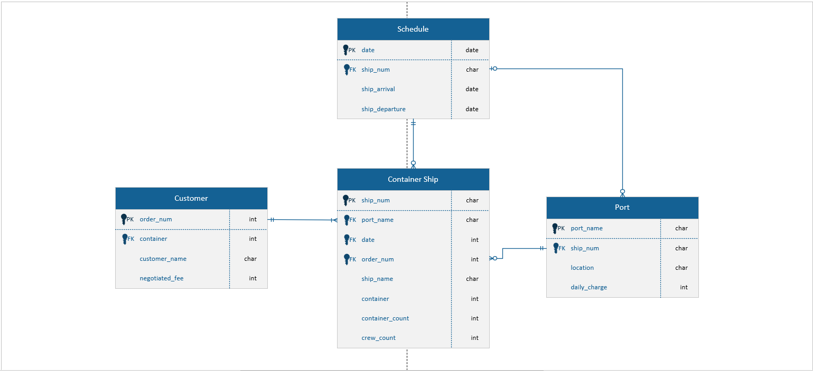

**Original Design Narrative #2:**

A real estate investment company owns many shopping malls. Each mall contains many shops. To encourage rental of its shops, the company gives a negotiated discount to retailers who have shops in more than one mall. Each shop generated an income stream that can vary from month to month because rental is based on a flat rental charge and a negotiated percent of sales revenue. Also, each shop has monthly expenses for scheduled and unscheduled maintenance. The company uses the data to compute its monthly net income per square meter for each shop and for ad hoc querying.

**List of Assumptions:**

In the main Mall table, the mall’s name is the primary key. Also included is the mall’s address and count of the store’s in each one. Within the Shop table, the shop’s name is the primary key. It also has what type of shop it is to describe. The income stream of the shop is also included for each store. Then both the scheduled and unscheduled monthly expenses are listed. In the Rent table, the rental fee for each store is the primary key. The income stream from the Shop table is a foreign key. Also listed is the negotiated discount, flat rental charge, and sales revenue. Lastly, in the Company table, the company’s name is the primary key. The foreign key of the shop name is connected to see which company owns which store. Also included is the store’s monthly net income and querying ad-hoc.

