Method

* Programmed(python, turtle module)

Background

* Because ill be using the turtles module to make the game I thought I’d make the premise two turtles that want to meet, the maze being an obstacle.

Aspects of theme integrated

* Characters are turtles
* Aforementioned turtle python module

Features.

* Top Down puzzle game
* Use the arrow keys to navigate the maze and get the green turtle to the red turtle
* Note that I could not program hard walls but the green turtle(player) leaves a trail indicating where they have been

Key

* Playable on a computer
* Movement is intuitive
* Simple

Target

* Anyone with a computer.

Technical details:

* Since I have actually developed this on the platform I would like to use I would just want to address my shortcoming in that I could not get the walls to actually stop the player's movement(object collision). Everything else works how I would like it.

Concept Art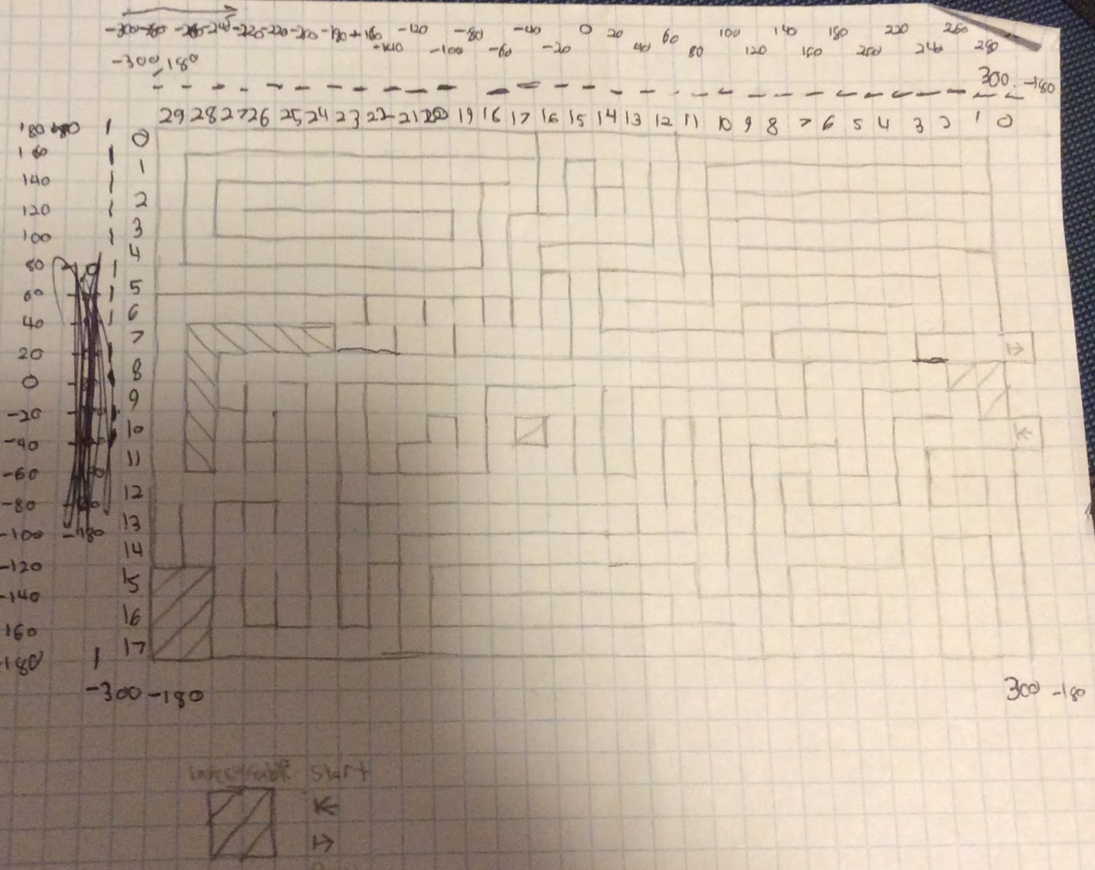

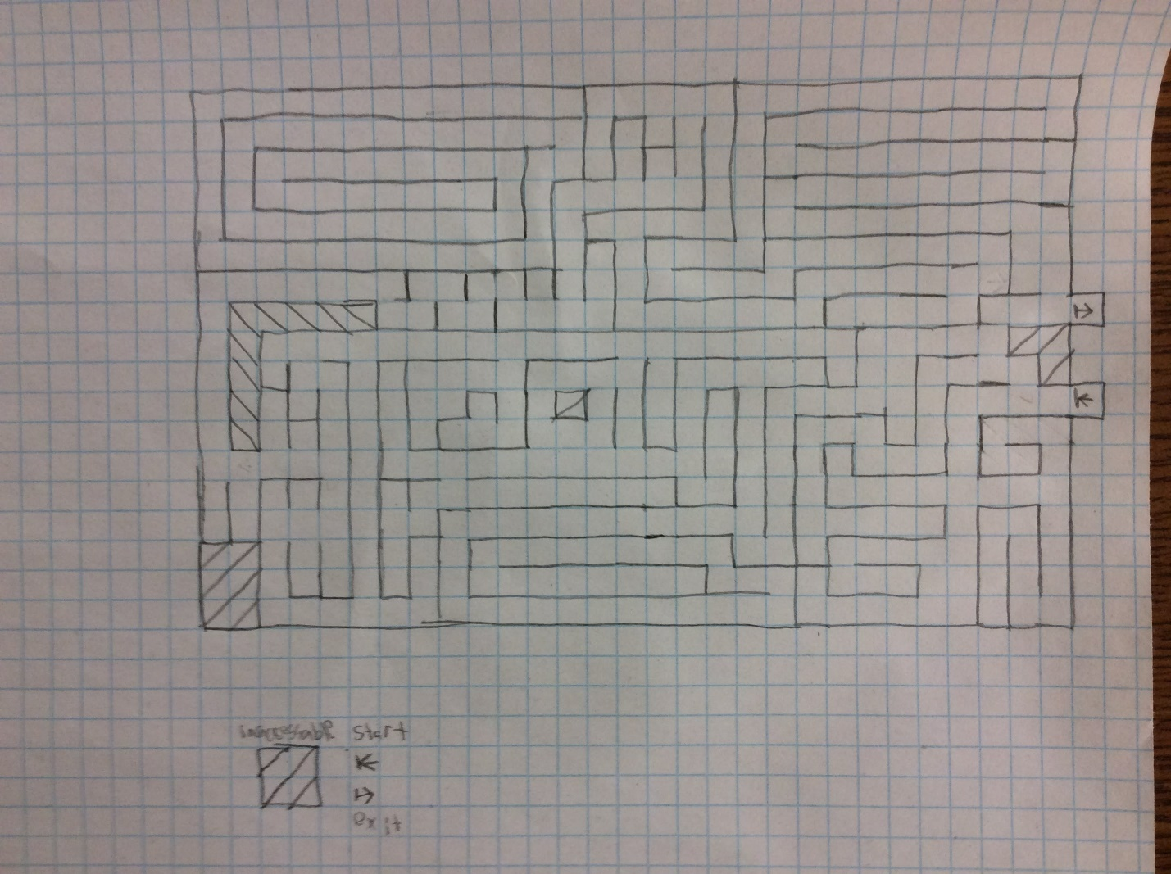 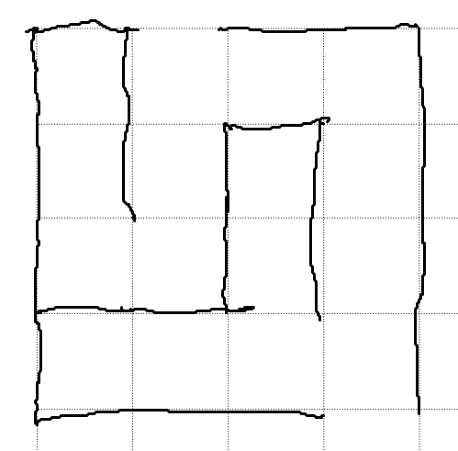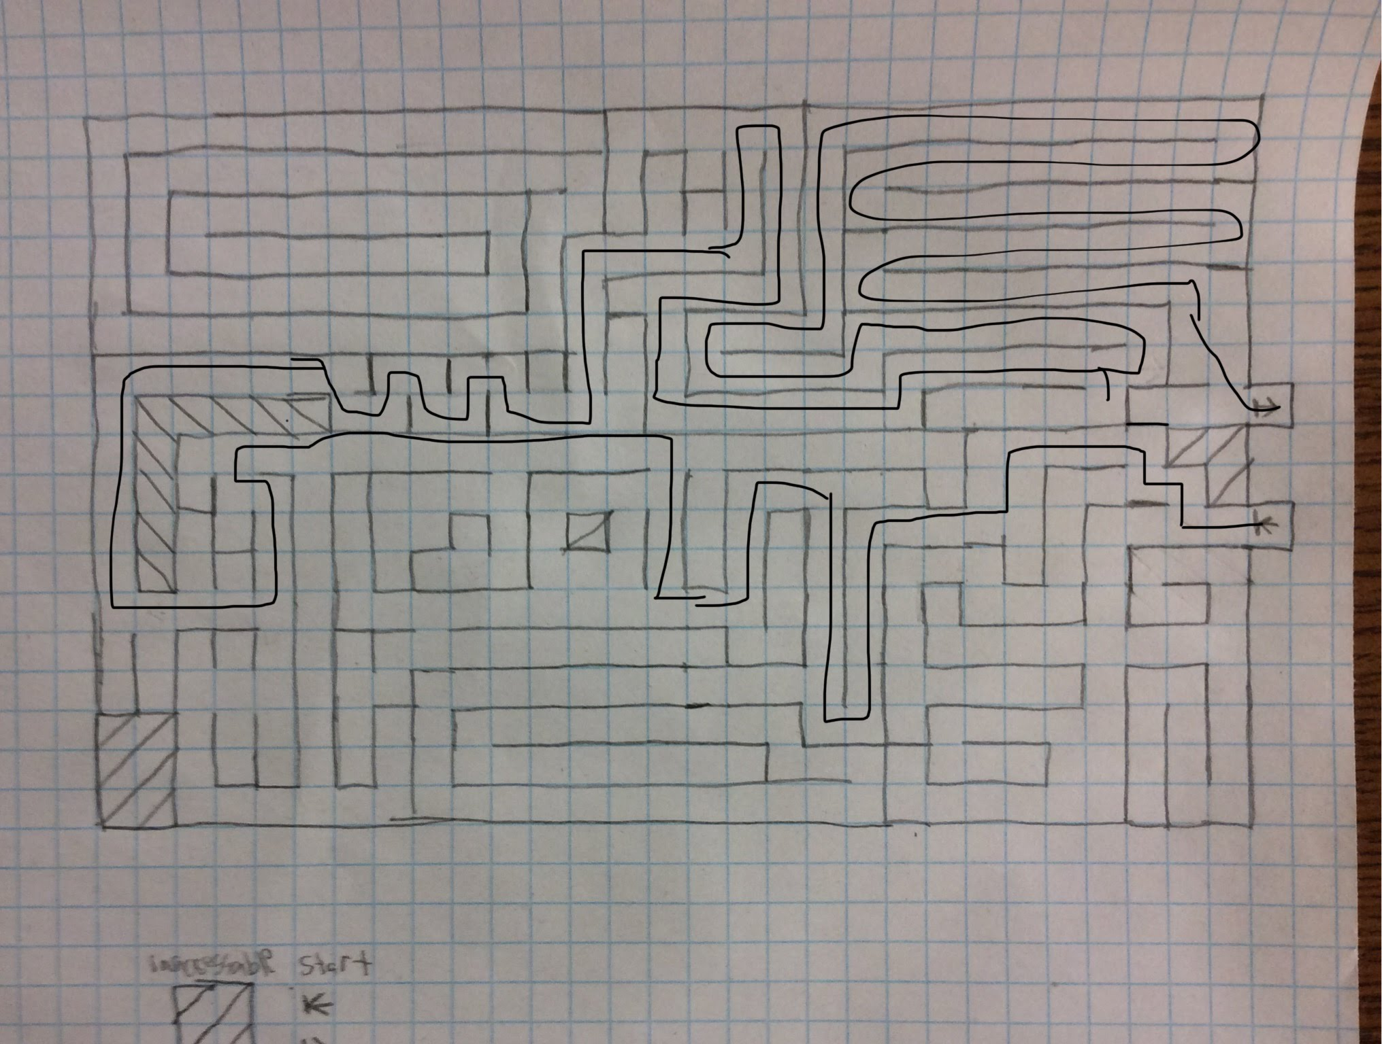



Issues

* Getting keyboard movement to work was a bit of a struggle due to some weird formatting in the turtle module
* Making the program to draw the maze was a hassle, I’ll get it to display an image of the maze next time

Research

* Turtles Documentation: <https://docs.python.org/3.0/library/turtle.html>
* How to make .py to .exe
  + <https://stackoverflow.com/questions/41570359/how-can-i-convert-a-py-to-exe-for-python>
  + [https://stackoverflow.com/questions/41204057/pygame-not-loading-png-after-making-exe-with-pyinstaller/41215253#41215253](https://stackoverflow.com/questions/41204057/pygame-not-loading-png-after-making-exe-with-pyinstaller/41215253" \l "41215253)
* .png to .ico converter: [http://convertico.com](http://convertico.com/)
* End popup image:
  + How to make it: <https://pythonprogramming.net/tkinter-popup-message-window/>
  + Centering: <https://stackoverflow.com/questions/14910858/how-to-specify-where-a-tkinter-window-opens/14912644>
* Keyboard help:
  + Example I used to get help: <https://www.youtube.com/watch?v=iv1VcEyLI54>
  + My question on SO: [https://stackoverflow.com/questions/48777798/key-event-seems-stuck-using-turtle-onkeyfunction-key/48778739#48778739](https://stackoverflow.com/questions/48777798/key-event-seems-stuck-using-turtle-onkeyfunction-key/48778739" \l "48778739)

Other

None