Green Therapy:
How Nature Affects Mood and Stress Levels
Justin Mabry
Indiana University

Author Note
Justin Mabry, Department of Arts and Sciences, Indiana University
Any concerns to this article should be addressed to Justin Mabry, Department of Arts and Sciences, Indiana University.
Contact: jlmabry@iu.edu

Abstract
This study investigates the effects of outdoor activities on stress levels. Participants’ stress levels were measured before and after engaging in outdoor activities. Statistical analyses, including ANOVA and the Sign Test, were conducted to evaluate changes. The ANOVA results revealed that anxiety significantly influenced stress levels, while the Sign Test showed a trend toward reduced stress after outdoor activities, with a p-value of 0.0625. Although this trend was not statistically significant at the 0.05 level, it suggests that outdoor activities may contribute to stress reduction. The study highlights the potential benefits of exposure to nature in lowering stress levels and underscores the need for further research with larger sample sizes to confirm these findings. These results provide a foundation for promoting outdoor activities as a means to enhance mental well-being and manage stress effectively.

Exploring the Benefits of Outdoor Activities on Stress Levels: An Empirical Study
Stress is a pervasive issue that has plagued humans for as long as there have been humans. But it seems like there has been a trend of more people being more stressed without a means to decompress. It affects an individuals’ mental and physical health. Numerous studies have indicated that exposure to natural environments, such as your backyard, can alleviate stress and enhance your overall well-being. The experiment I conducted aims to explore the impact the outdoors can have on stress levels, providing empirical evidence to support the therapeutic benefits of nature that I believe exist.
Researchers have pondered for a long time the effects that nature could have on people brain activity and stress. Research done at Harvard Medical School found similar correlations during their study as well, however the process of their study was different. They asked 36 people to spend 10 minutes or longer, three days a week for eight weeks, in an outdoor place where they could interact with nature. Similar to my experiment the settings could vary from yards to public parks, to green areas near places of work if that’s what worked best. They tested their levels of cortisol, a stress hormone, from saliva samples taken before and after nature outings. Their participants were also told not to do any exercise beforehand and to avoid unrelated stimuli like social media, phone calls, conversations, and reading (A 20-minute nature break relieves stress 2019).
Their study found that spending at least 20 to 30 minutes immersed in a nature setting was associated with the biggest drop in their cortisol levels. Time of day and specific settings didn’t really seem to affect stress levels, it was simply the fact of being out and being connected to nature. Although their study has a more concrete way of testing stress levels, we can see similar results in our own study, as well as studies conducted by other entities.
An article written by Kirsten Weir for the American Psychological Association also talks about the many benefits that being outdoors can have on your cognitive effects. Under the Cognitive benefits section of the article, she states that the biophilia hypothesis argues that since our ancestors evolved in wild settings and relied on the environment for survival, we have an innate drive to connect with nature. The stress reduction hypothesis posits that spending time in nature triggers a physiological response that lowers stress levels (Weir, Nurtured by nature).
Theres a theory called the attentional restoration theory that states present-day cityscapes suffer from too much bottom-up stimulation. People have to use their attention to overcome the effects of being constantly stimulated by their surroundings, which creates cognitive fatigue. In contrast to that theory however, one article by David G Pearson and Tony Craig for the National Library of Medicine states an effect coined by Kaplan and Kaplan. Their effect, soft fascination, refers to scene content that automatically captures attention while simultaneously eliciting feelings of pleasure (Pearson & Craig, 2014). Nature is one of those environments, everything around you seem to be fascinating for seemingly no reason, but even though your eyes and mind are being constantly attracted to different objects in your vicinity, there isn’t really any stress or cognitive fatigue taking place. The terms soft and hard fascination aren’t actual terms in cognitive literature; however, we can see similarities drawn between those and the concept of voluntary and involuntary attention (James, 1892). The process of soft fascination seems to reduce the demand on executive-based attention, thereby allowing greater restoration of depleted attentional resources in comparison to the perception of urban environments.
The one correlation between all of these studies and others that have been done, is that being out in nature almost always reduces stress levels on a participant. My goal is to find my on quantifiable way to test and measure this in order to support my own hypothesis. My findings should show also show a correlation in some way of nature effects participants levels of stress, and how they feel.
The primary objective of this experiment is to determine whether there is a significant difference in stress levels before and after a participant goes outside. By measuring their stress levels, along with other points, this study seeks to quantify the reduction in stress that can be attributed to spending time in a natural environment. I believe that my study will show a direct correlation between people who spend more time outside, and those who have less stress in their daily lives.
A sample of participants were recruited from online and from within my own friends and family to measure their stress levels using a form, that I created myself, at two different time points. The data I collected includes various emotional and psychological states, such as anxiety and calmness, in order to garner a deeper understanding of their emotional state at the various times of the experiment. I also had participants record other results as well, like how they might feel about themselves, along with external factors, to see if it was just stress that nature had power over, or if it some effect on other thought processes as well. Statistical analysis, including the Sign Test and an ANOVA, were conducted to determine the significance of any changes in stress levels.
After gathering the data, I put the results from my participants through multiple tests in order to understand whether or not there truly was a correlation. I first started off by running my data through an ANOVA (see Figure 1). The results show that there is a significant correlation between anxiety, stress, and time outside. On anxiety’s part, with a p-value of 0.0006 it was an incredibly significant finding when looking at stress, not only that, but it also showed that after being out in nature for some time, along with stress, anxiety was also reduced. That makes sense, since there is a common correlation with anxiety and stress, being the more anxious someone is, the more stress they typically are. Time on the other hand, only showed marginally significant at a p-value of 0.0990. While still significant, I think this is due to the relatively low sample-size I had in my data. With more participants, I’m sure we would see a spike in significance for time in correlation to stress.
This experiment was my first foray into Sign Tests, and while it took a second to get everything set up, it shows similar results to the output from the earlier ANOVA. While the p-value of 0.0625 is slightly above the threshold for significance, this can once again be trace back to a somewhat small sample-size. Although the p-value gave underwhelming results, the confidence interval gives us a clear outlook of the results of the sign test. With a confidence interval of [2,2], it suggests a consistent decrease in stress levels after going and spending time outside (See figure 2.)
Discussion
The primary objective of this study was to determine whether exposure to outdoor environments significantly reduce stress levels. The hypothesis was that participants would report lower stress levels after spending time outside compared to their stress levels prior to the outdoor activity. The results from both the ANOVA and the Sign Test provide insightful data on the impact of outdoor activities on stress.
The ANOVA analysis indicated that anxiety significantly influenced stress levels, which aligns with existing literature on the close relationship between the two. The Sign Test, although slightly above the conventional threshold of significance, suggests a trend towards a reduction in stress after going outdoors for a period of time. This finding is particularly noteworthy as it implies a potential benefit of outdoor activities in alleviating stress, even if it does not reach statistical significance at the 0.05 level. I believe with even a handful more participants; we would’ve reach significant significance.
The initial hypothesis state that outdoor exposure would lead to a significant decrease in stress levels. While results provide some support for this hypothesis, the evidence is not completely airtight. The trend observed in the Sign Test indicates that there might be a meaningful reduction in stress, suggesting that further research with a larger sample size could yield more definitive results.
Conclusions and Future Study
Despite the limitations, these findings highlight the potential benefits that being outside can have in reducing stress. This can have practical implications for mental health interventions, encouraging individuals to incorporate nature-based activities into their routines as a means to mange stress and improve overall well-being.
This study has several limitations. The small sample size and the presence of ties in the data may have impacted the statical power of my analyses. My future research would aim to include a larger and more diverse sample to validate my findings. In addition to that, exploring other environmental and psychological variables could provide a more comprehensive understanding of the factors that influence stress reduction.
In conclusion, this study provides preliminary evidence that spending time outside may contribute to stress reduction. While the hypothesis was partially supported, further research is necessary to confirm these findings and explore the underlying mechanisms. However, encouraging spending time outdoors remains a promising approach to enhancing mental health and well-being.

References
A 20-minute nature break relieves stress. Harvard Health. (2019, July 1). https://www.health.harvard.edu/mind-and-mood/a-20-minute-nature-break-relieves-stress
James W. (1892). Text-Book of Psychology. London: Macmillan [Google Scholar]
Pearson, D. G., & Craig, T. (2014, October 21). The great outdoors? exploring the mental health benefits of Natural Environments. Frontiers in psychology. https://pmc.ncbi.nlm.nih.gov/articles/PMC4204431/
Weir, K. (n.d.). Nurtured by nature. Monitor on Psychology. https://www.apa.org/monitor/2020/04/nurtured-nature

Tables and Figures
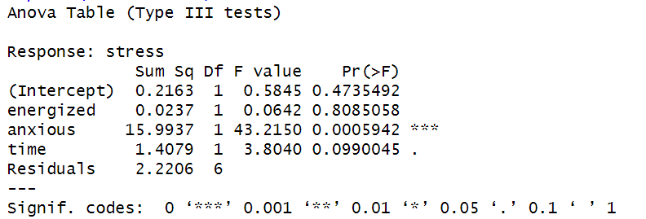
Figure 1 ANOVA Results
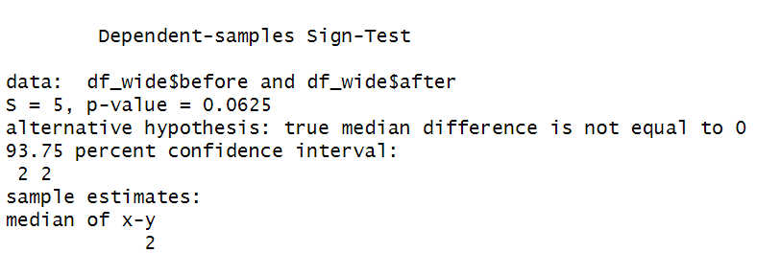
Figure 2 Sign-Test
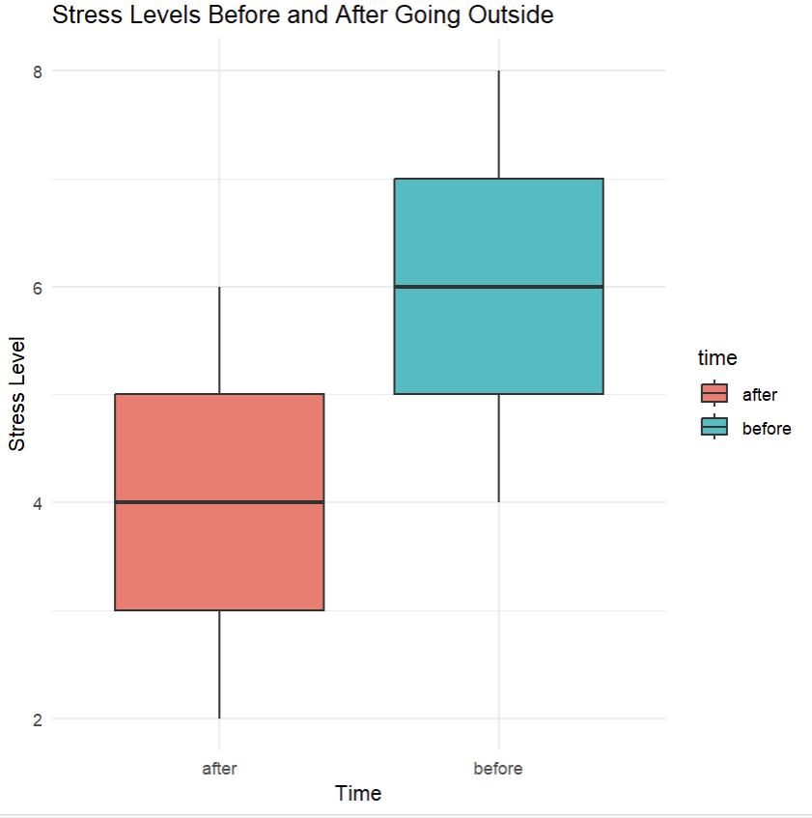
Figure 3. Box Plot for Stress and Time Outside

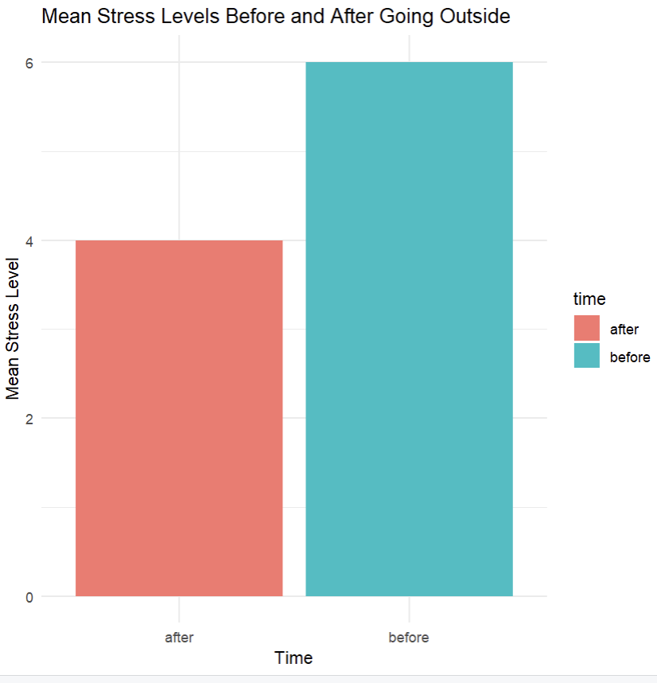
Figure 4. Bar Plot for Anova Results

