1)

|  |  |
| --- | --- |
| TCP | UDP |
| Establishes connection prior to sending message | Does not establish connection prior to sending message |
| Offers retransmissions (considered reliable) | No retransmissions (unreliable) |
| Offers flow control/congestion control | More streamlined |
| Layer based |  |

2) OSI layers:

a) Application: direct interface and access to users with the network

b) Presentation: present data in an easily understood form

c) Session: provides sync in dialogue between distinctive applications

d) Transport: guarantees end to end error-free connection between 2 different hosts. Information is received in order it’s sent.

e) Network: finds easy/shortest/most efficient path

f) Data Link: error detection

g) Physical: provides interface between devices and transmission media

3) HTTP vs HTTPS:

HTTP: Hyper Text Transfer Protocol

HTTPS: the secure version of HTTP.

Encryption: transform a message into a coded version such that even if the encrypted data falls into the wrong hands, the encoded info will remain confidential.

Allows for secure web transactions all over the internet.

4) Ports vs. Sockets

a) ports: unique numbers assigned to various units and requiring that the appropriate port number be appended to a message’s address before starting the message on its journey.

b) sockets: an abstraction for processes at the application layer of the network stack to connect with other processes on the network via the transport layer beneath.

Port number for email: 25

5) There is rarely security for public wifi networks, which makes it easier to fall victim to attacks (Malware, virus, worm, trojan, spyware, etc.). If you connect to HTTPS versus HTTP, you will have a more secure connection and uses public-key encryption.

6) IPv4 address: 192.168.1.152

7) ping: used to test the ability of the source computer to reach a specified destination computer. Used to verify if a computer can communicate. Ping command operates as a ICMP.

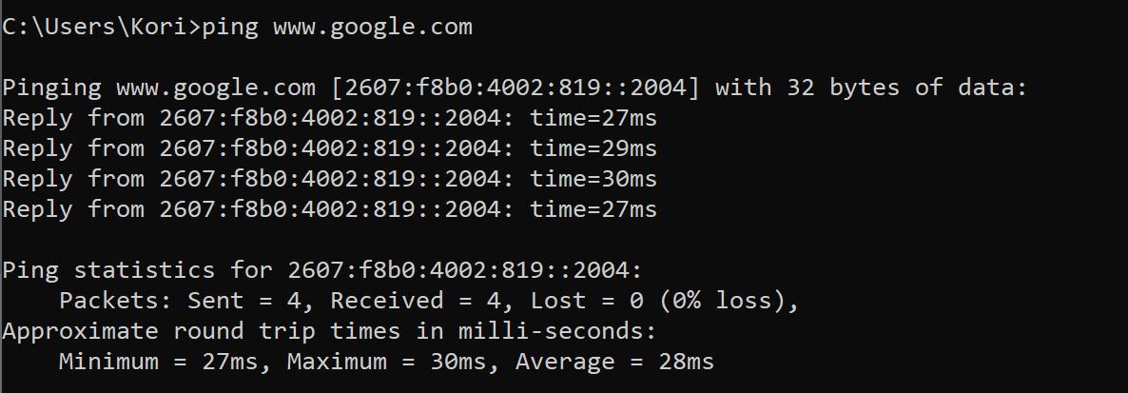

8)

a) 5GHz

b) I have a dual band router (2.4 GHz and 5GHz)

c) bandwidth = 200mbps

9)

a) status code 200 = Success

b) status code 404 = Error

c) yes

d) no

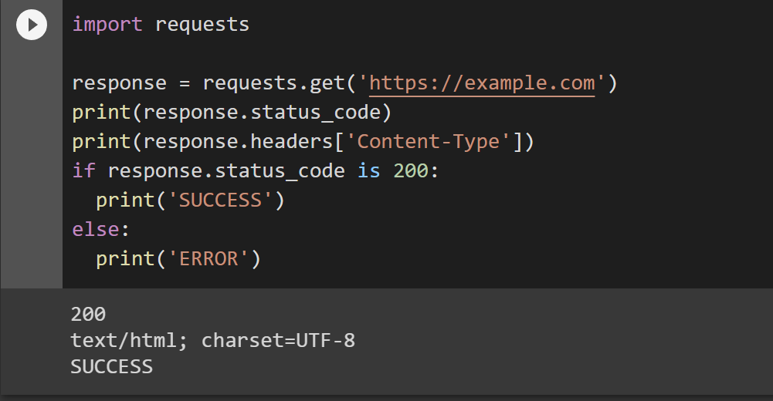

d)

