CSC 120 Lab 01

This is an introductory lab. **The purpose of this lab is to understand your background and to provide guidance on how to submit assignments using Blackboard.** Questions will require you to provide screenshots as proof of your understanding. Make sure you attempt everything as there are points for attempting. Good luck!

**Motivation (**25 points)

Please provide your motivation for taking this class.

**My motivation for taking this class is to start off my career change. I currently work in public service, and want to move into programming.**

**Background** (25 points)

Please provide a short summary of your computer science background. You can answer ‘None’ if you do not have any background.

* Do you have any experience with programming? If yes, which language?
  + - **I do not have experience using any programming language.**
* Have you ever used Python? If so, in what capacity?

**I have not used Python before.**

* Do you have any experience with digital logic and binary?

**I started taking Google IT Certification, but realized 2 lessons in that I wasn’t learning anything from the class. I did learn a bit about the binary.**

* Do you have any experience with algorithm design?

**I have used Flowgorithm. I use that for my CTI 110 class.**

**Resources (**25 points)

* Do you have access to a laptop and internet?

**I have access to both a laptop and desktop. I have stable wifi, but no ethernet.**

* Are you able to find the lectures and assignments on Blackboard? Please provide a screenshot.

**See Image 1 below.**

* Do you know where to read the announcements on Blackboard? Please provide a screenshot.

**See Image 2 below**

* Do you know where to find the course syllabus? Please provide a screenshot

**See Image 3 Below**

**Google Colab (**30 points)

Please create an account and a new notebook on Google Colab and provide a url to the Notebook.

[jordan_manus.ipynb - Colaboratory (google.com)](https://colab.research.google.com/drive/1K-XwhfROSsURDFnWX3PpXCrTAI3KxQ1c)

**Instructions: Upload the file with the screenshot on Blackboard with your firstname_lastname.docx**

**Image 1:**

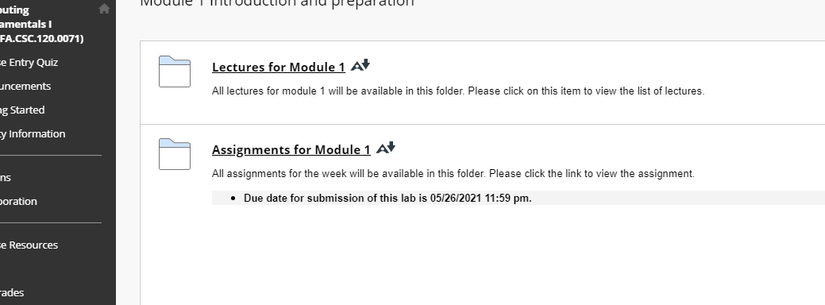

**Image 2:**

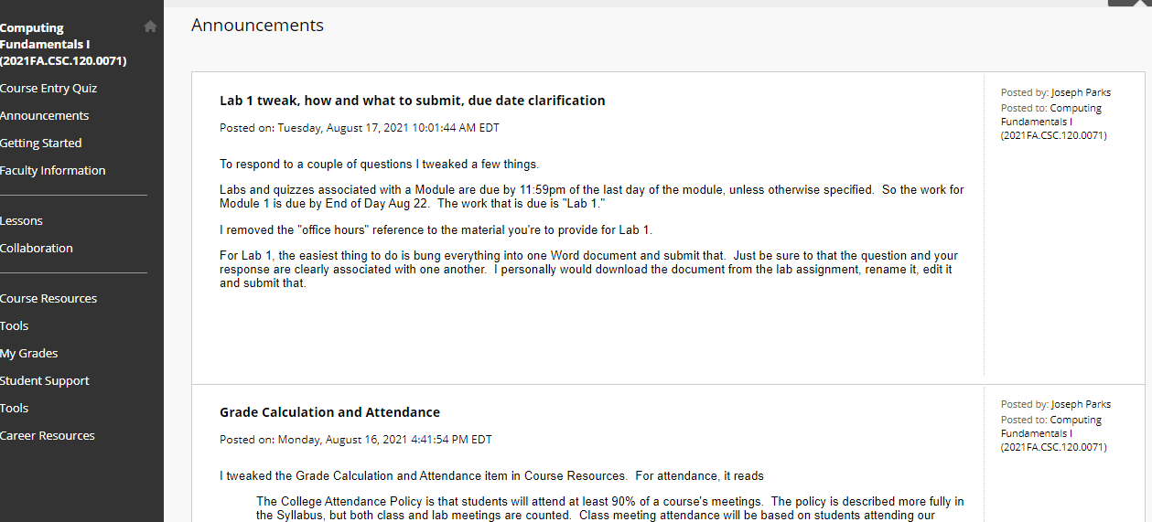

**Image 3:**

