## CSC 120 Lab 03

Use the **emulator** to find the answers to your work. The goal of this lab is to understand how to use the emulator and run instructions on it. You should be able to make sense of the values returned by the emulator.

**Emulator link below**

https://joeledstrom.github.io/brookshear-emu/#AA01

**Appendix C link below**

https://blackboard.waketech.edu/bbcswebdav/pid-18088193-dt-content-rid-148874207_1/xid-148874207_1

### (10 points) The following table shows a portion of a machine's memory containing a program written in the language described in the language description table. See the first page of this lab Answer the questions below (there are two) assuming that the machine is started with its program counter containing 00. Recall the language requires two bytes per instruction

### Address Content Interpretation

### 00 21 Execute the instruction 210B

### 01 0B

### 02 14 Execute the instruction 1404

### 03 04

### 04 C0 Execute the instruction C0000

### 05 00

### What bit pattern will be in register 4 when the machine halts?

### *B. C0*

### 

### What bit pattern will be in the program counter when the machine halts?

### *B. 06*

Take a screen shot of the CPU after the program finishes.

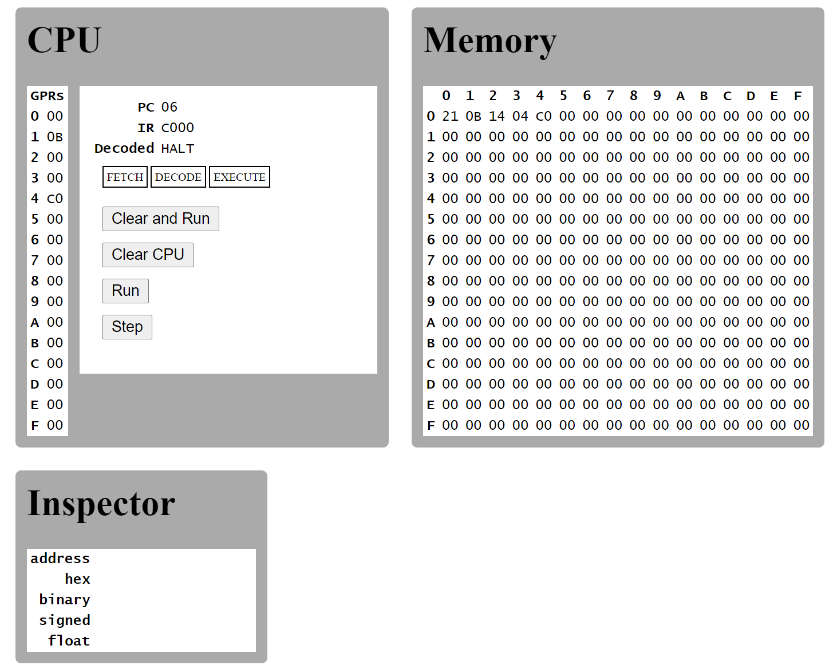

**(10 points) The following table shows a portion of the machine's memory written in the language described in the language description table. Answer the questions below assuming that the machine is started with its program counter containing 00.**

**Address Content Interpretation**

00 25 Execute instruction 2503

01 03

02 A5 Execute instruction A502

03 02

04 35 Execute instruction 3503

05 03

06 24 Execute instruction 2400

07 00

08 34 Execute instruction 3404

09 04

0A B0 Execute instruction B003

0B 03

0C C0 Execute instruction C000

0D 00

What bit pattern will be in memory location 03 when the machine halts?

***A C0***

Take a screen shot of the computer memory after the program finishes.

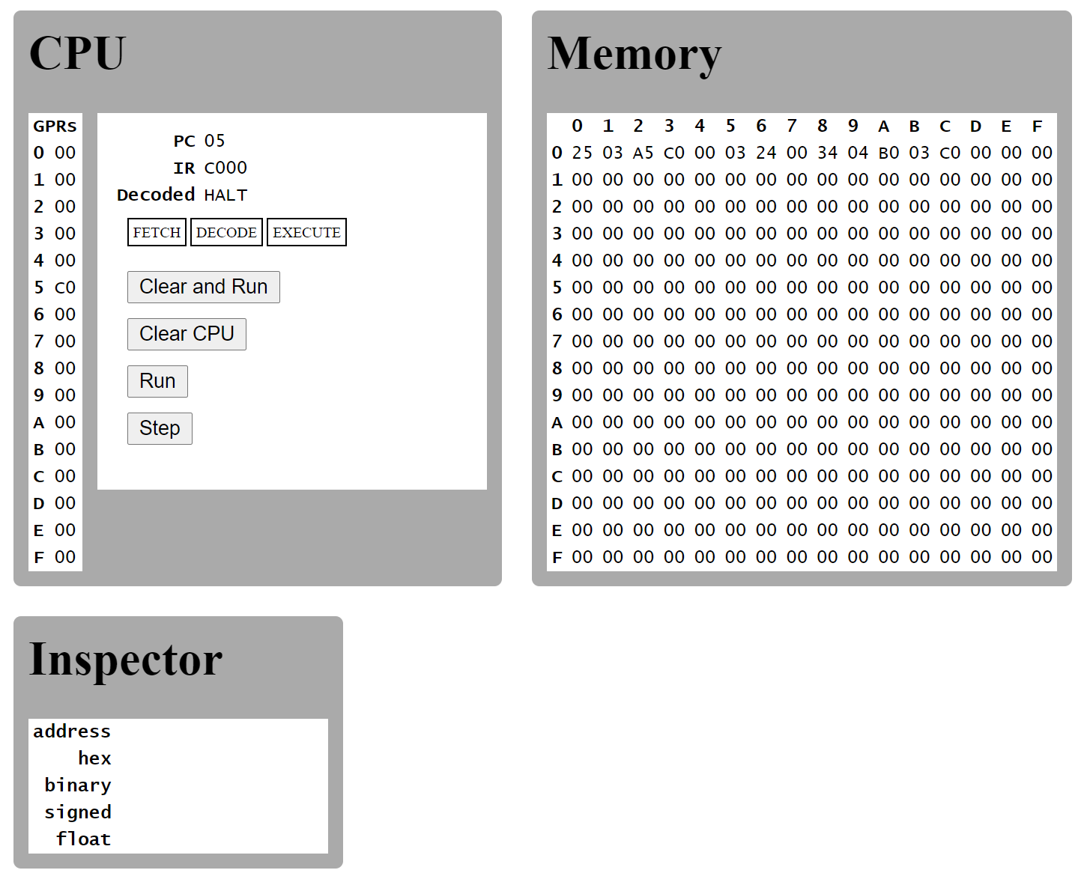

**(15 points) The following table shows a portion of a machine's memory containing a program written in the language described in the language description table (adopted from Chapter review problem #15 ) Use the emulator**

**Address Content Interpretation**

0x00 1C Execute instruction 1C03

0x01 03

0x02 2B Execute 2B03

0x03 03

0x04 5A Execute 5ABC

0x05 BC

0x06 3A Execute 3A00

0x07 00

0x08 C0 Execute C000 (Halt)

0x09 00

What bit pattern will be in register A when the machine halts?

***D. 06***

What bit pattern will be in memory address (cell) 00 when the machine halts?

***D. 06***

Take a screen shot of the computer’s CPU and memory after the program finishes.

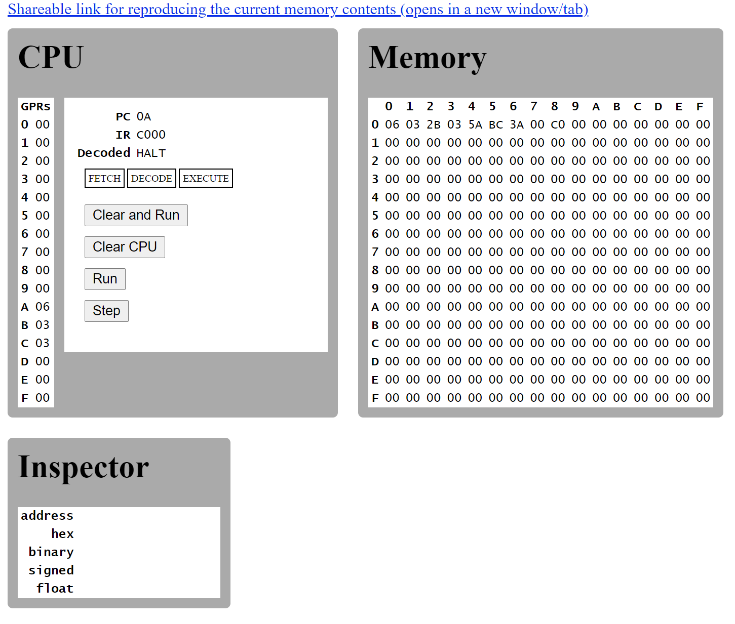

### 

### (15 points) Explain briefly the concept of opcode/operand and the types of load instructions for the Vole architecture. What is the general format of the instruction? Give examples

### An operand is a part of a computer instruction that specifies data operating/manipulated on the data itself. An op-code is the first byte of an instruction; it tells the CPU what operation needs to be performed. Load Instructions are a request to fill a general-purpose register with contents of a memory cell. Examples of an op-code are: 1, 2, 3, 4, 5, 6, 7, 8, 9,A, B, C. Examples of operands are: RXY, 0RS, RST, R0X, 000. An example of these together is: 52A4; this will add Registers A and 4 and place the sum into Register 2. 5 tells us that we need to add A and 4, and then put the results in the new Register.

### Section B Exploration Challenge (20 points)

In this module, we learned about processor architecture. In recent years, deep learning and AI advances are creating a revolution in processor design. Researchers and engineers today are having to rethink the idea of chip design. It is a very exciting time to witness this change. Therefore, your role in this assignment is to research how the field of artificial intelligence and deep learning is revolutionizing chip design. Use google as well as Google Scholar or ACM Digital Library. You can start by reading the below article which was published in Communications of the ACM

[Making Chips Smarter](https://cacm.acm.org/magazines/2017/5/216326-making-chips-smarter/fulltext)

URL: https://cacm.acm.org/magazines/2017/5/216326-making-chips-smarter/fulltext

Your answer should be 2-3 paragraphs and should try to answer the following questions.

* Summarize 3 key points from the article.
* How are chips developed for deep learning different from traditional processors?
* What are some of the emerging technologies that are being used today in chip design?
* What is Moore’s law and why is it relevant in this context?
* What are some of the challenges? (Price, power consumption, design)

Once again the aim is to promote self learning and exploration. Provide references for your sources and come up with your own answer. Do not copy.paste information directly from other articles.

**Note:** Google Scholar is a free search engine for searching research and academic articles. You should definitely try using this to understand how scientific articles are written,

### Section C Programming Challenge (30 points)

1. (15 points) Write a python program to accept a number from a user. The program should print "even number" as an output if the number is even and print "odd number" as an output if the number is odd. If the number is negative, it should print "negative number".0 is considered even.

Hint: Use the modulus operator "%". Read online on what it does and how to use it. Part of the exercise is to learn to find information online. Do not copy code directly without understanding it.

1. (15 points) Write a python program to print the first 20 even numbers.

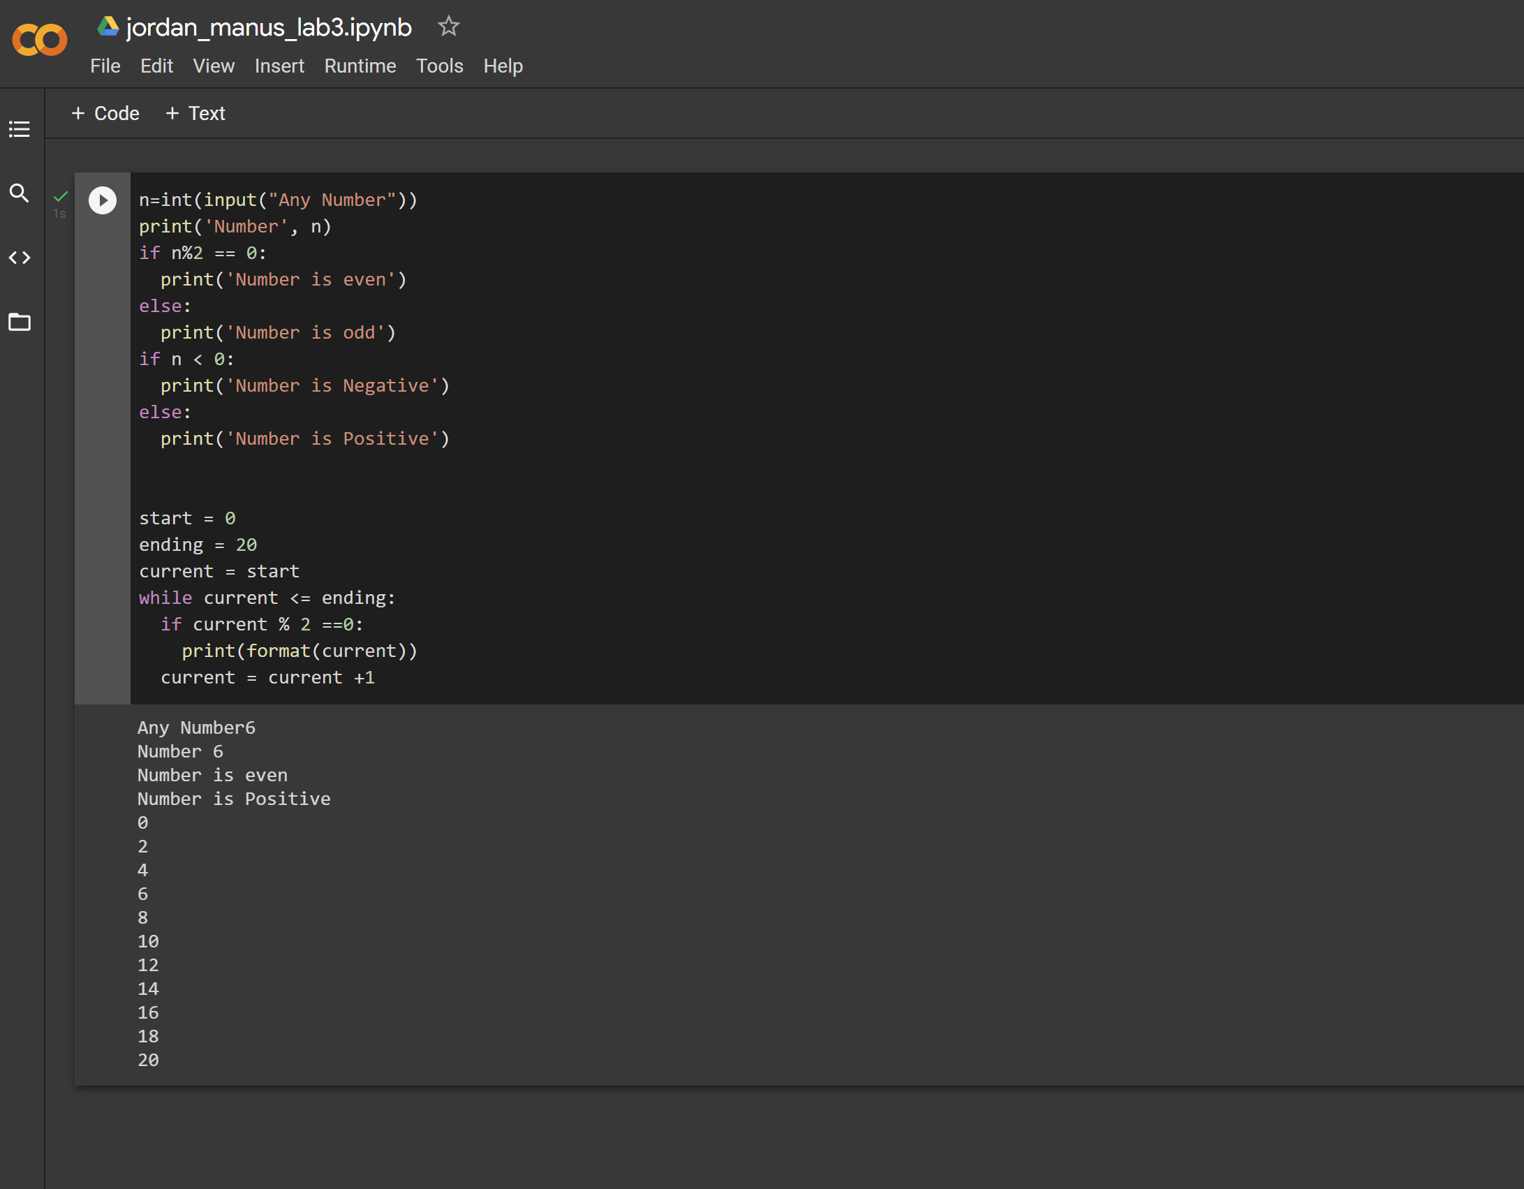

**Instructions: Upload the file with the screenshot on Blackboard with your firstname_lastname.docx**