Sol AR: Augmented Reality Window

to the Solar System

Lukas Nilsson

lukaspnilsson@gmail.com

Monmouth College

Computer Science

November 21, 2019

Table of Contents

Abstract……………………………………………………………………………………………………..4

1. Introduction.……………………………………………………………………………………………...5

1.1 Background….………………………………………………………………………………....5

1.2 History of AR…………………………………………………………………………………..5

1.2 Current state of AR…………………………………………………………………………….6

1.2.1 Technical Problems……………………………………………………………….....7

1.3 Future of AR…………………………………………………………………………………...7

1.4 Sol AR in History……………………………………………………………………………....7

2. Project Description……………………………………………………………………………………….8

2.1 Features of the app in Sol AR 2.0……………………………………………………………...8

2.1.1 Placement on a plane………………………………………………………………..8

2.1.2 Placement on an Image……………………………………………………………...8

2.1.3 3D Models…………………………………………………………………………...9

2.1.4 UI Features…………………………………………………………………………..9

2.1.5 Body Occlusion…………………………………………………………………….10

2.2 Use Cases in Sol AR 2.0……………………………………………………………………..10

2.2.1 Use case 1………………………………………………………………………….10

2.2.2 Use case 2………………………………………………………………………….10

2.3 Features of the app in Sol AR 2.1 and 2.2……………………………………………………11

2.3.1 Info Pages…………………………………………………………………………..11

2.3.2 Relative scale……………………………………………………………………....12

2.4 Use Cases in Sol AR 2.1 - 2.2………………………………………………………………...12

2.4.1 Use case 3………………………………………………………………………….12

2.4.2 Use case 4………………………………………………………………………….12

3. Foundations……………………………………………………………………………………………..13

3.1 Development Kits…………………………………………………………………………….13

3.2 ARKit Library………………………………………………………………………………...13

3.2.1 class ARSession……………………………………………………………………13

3.2.2 class ARConfiguration……………………………………………………………..14

3.2.3 class ARAnchor……………………………………………………………………14

3.3 Unity………………………………………………………………………………………….14

3.3.1 ARKit 3 support on Unity…………………………………………………………14

3.3.2 Shaders……………………………………………………………………………..15

3.3.3 3D modeling……………………………………………………………………….15

3.4 XCode………………………………………………………………………………………...15

3.4.1 UI…………………………………………………………………………………..16

3.4.2 Permissions………………………………………………………………………...16

3.4.3 App Store…………………………………………………………………………..16

4. Implementation Plan and Timeline……………………………………………………………………..16

4.1 Implementation plan………………………………………………………………………….16

4.2 Timeline………….…………………………………………………………………………...17

4.2.1 Stretch Goal schedule….…………………………………………………………………...19

5. Conclusion….…………………………………………………………………………………………..20

6. Bibliography….………………………………………………………………………………………...21

Abstract

Sol AR aims to be a source of inspiration for imagination and education through practical use of the app, creating an interesting experience for users to enjoy. For the users who will download the app out of curiosity, Sol AR hopes to satisfy this curiosity by creating an augmented reality (AR) experience that gives a small peek into a future where the features of Sol AR can be implemented in various ways, working their way into our everyday reality. The window to the solar system is just one implementation of an infinite amount of uses for an app with these features and hopefully those that are intrigued by the infinity of space will too be intrigued by the infinite potential of AR.

Sol AR will bring a window through which you can view the whole solar system right onto the users desk. It will expand the functional space of the users room by creating virtual realities inside of the physical environment around them. These functionalities are not yet perfected but the ability to begin these early transformations of our realities are available and Sol AR hopes to be an early contributor to the technology that will inevitably change our world.

1. Introduction

1.1 Background

The goal of this app is to explore some of the current capabilities of AR by developing a fun and interesting app that is focused on exploring our cosmic backyard. At one level the goal for Sol AR is for it to be educational for users to investigate our solar system but at another level its goal is to demonstrate the growing power of AR technology and even further to inspire the users to imagine the future capabilities of AR. Much of the interest that lead to the development of this project comes from this inspiration of the future capabilities of AR and the reason the solar system was the theme of the app comes from a similar inspiration of the solar system and beyond that has energized humanity to reach for the stars.

1.2 History of AR

The theory of augmented reality has been around for far longer than any implementation with the term ‘Augmented reality’ not being introduced until 1990. One of the first ideas of AR we have record of was in 1901 when an AR-like concept of augmented reality glasses found its way into L Frank Baum's short novel, *The Master Key*. Released one year after Baum published *The Wonderful Wizard of Oz, The Master Key* follows a young boy, Rob Joslyn, who enjoys experimenting with electrical devices and through his tinkering, summons the Demon of Electricity. The Demon gives Rob nine gifts, one of which is a pair of glasses. These glasses have the ability to read a person's electrical aura to tell something about their character. Whether they are good, evil, wise or kind for example. While mystical, electronic glasses providing us with information through the lenses begins to look familiar in today's age. This is the first time that an AR-like technology is mentioned in the history of literature (“The History of AR and VR,” 2018).

Virtual reality (VR) development is strongly linked with AR for obvious reasons and has historically advanced earlier than AR. Early on VR pushed ahead of AR development with limited successful implementations of a flight simulator in 1929 and a simple stereoscopic viewer in 1939. By 1960 Morton Heilig had developed two VR-like machines with the Sensorama and the Telesphere Mask, the latter of which “provided the user with a stereoscopic 3D picture and stereo sound” [1].

Throughout the 20th Century AR and VR developed with various forms taking place. “In 1968, Ivan Sutherland created a head mounted three dimensional display which was a form of an AR headset which he named the Sword of Damocles. It was a very early form of AR and is some ways more VR than AR but this is one of the first attempt at mixed reality glasses[2]. Videoplace was later developed by Myron Kruger in 1974 which allowed users to virtually communicate with each other using their projections of their bodys to interact with other people's projections as well as completely virtual objects [3]. By 1990 the term “augmented reality” had been introduced by Tom Caudell and mixed reality promised to find its way into the workplace and niche parts of society [1].

Over the next decade AR and VR grew with their influence becoming prominent in western culture, most being reached through the entertainment mediums of film and gaming. Influential examples throughout the 90s include SEGA and Nintendo’s VR headsets, 2D barcodes, AR overlays on NFL games, and one, if not the most influential films regarding virtual reality, the Matrix. Mixed Reality (MR) began to reach further and further facilitating different applications. Up until the recent success of AR and VR, most of the uses where in specific use cases such as the military using Battlefield Augmented Reality Systems [1]. The first commercial release of AR glasses went to Google Glass which was a huge step and a massive feat in AR engineering but limited functionality and big expectations resulted in poor reviews and was not successful in capturing the public's imagination.

While VR was having lots of attention with it being a very promising gaming market, AR was getting less and less attention relative to it. Both markets where growing in investments and market potential but there had yet to have been a breakthrough in the AR market that the world enjoyed. That is until the internet breaking phenomenon that is Pokemon Go was released onto the app store in 2016.

1.2 Current State of AR

Today, Pokemon Go remains one of the most played games on the app store as well as the second release by its creators, Harry Potter: wizards unite. To facilitate this growing industry, both Google and Apple have release AR Core and ARKit respectively to provide software to developers for AR development with other companies following suit increasing the accessibility and compatibility of AR with their products such as Unity and vuforia. AR development and investment continues to grow and the technology continues to advance on all fronts. Hardware for phones such as processors and cameras are being added that is purpose built to handle the AR processes increasing the performance of AR software. The software is constantly being improved and upgraded as ARCore, ARKit and Vuforia lead the market with continuous updates on their development kits.

Developments in AR glasses is also doing well with some industrial uses already beginning to implement them showing signs of efficiency improvements in the workplace. Upskill released an experiment in which an AR headset helped improve warehouse management with “an immediate 46% improvement” [4]. There are a large number of AR headsets that are being released onto the market, but the industry leader appears to be Microsoft with the Hololens 2 being the most powerful headset for developers. None of the releases are convenient and unobtrusive for the user so no headset has reached the mass public just yet.

1.2.1 Technical problems

One of the main technical problems that are still to be solved is increased accuracy and consistency of the software. While there has been huge strides in the last few years, there is still a long way to go in terms of creating a consistent AR experience using our smartphones and even more so in the glasses. The cameras still find it hard to handle low light, featureless environments and also struggle to deal with faster movements of the phone which can cause the camera to blur and inputs to be misinterpreted. The computing that AR requires is very intensive and so even still larger renderings and more complex scenes need more powerful processors to provide believable experience. These technical problems are just a few of the multitude of issues that arise in AR but as technology progresses the issues will be ironed out and result in a more and more polished experience.

1.3 Future of AR

Because of the increased efficiency that come as a result of implementing AR in the workplace, AR is rapidly growing and has no signs of slowing down. “Nowadays, augmented reality is applicable in almost all architecture industries”[5]. It has applications is teaching, training, VR, and many, many more. The immediate future promises to be one where AR becomes more and more part of everyday life, increasing productivity with every application it touches. The far future holds incredible potential with these technologies with a future where it redefines everyday reality seeming more likely than not.

1.4 Sol AR’s place.

With the multitude of AR apps hitting the market as a result of increased accessibility to AR development, Sol AR’s place is with these apps alongside these apps developed to test the current abilities and work to provide the best experience currently possible.

Because of the current limitations with the technology in terms of creating a believable object in the world and all the issues that come with it Sol AR will use ARKit to provide the best experience but alongside the other apps on the App Store release with a build that is concurrent with the abilities of the hardware and ARKit. Sol AR will find itself on the App Store amongst other solar systems AR apps that provide similar experiences of placing models of the solar system into the world. What makes Sol AR different to these is the window that sets the view position inside the plane or image recognised. This idea looks to inspire further ideas of how we can manipulate the world around us with this technology. Future technology that relates to this has been seen in science fiction consistently. The bedrooms in the hunger games of which the windows show vast forests while actually being flat panes. The therapy rooms in the film sunshine which provide an almost AR experience where they are surrounded by vast expanse of their choosing. While only a simple implements of the concept, it is hoped that this idea can connect the current abilities of AR to these not so science fiction ideas of the future.

2. Project Description

Sol AR will be an app supported on IOS devices and will run on IOS 13 and above on both the Iphone and iPad.

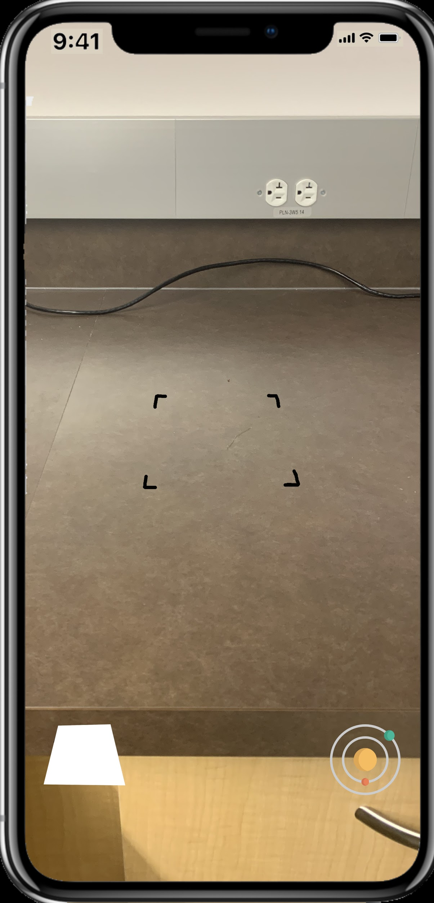

2.1 Features of the app in Sol AR 2.0

2.1.1 Placement on a plane

Sol AR will have the ability to place the scene onto a plane. The feature will allow the user to use their phone camera to find and detect a plane and then place the model on to the detected plane. This feature is the more convenient of the placement options as no outside object or image is required, only a flat horizontal plane (which are almost everywhere) is required for it to run smoothly.

2.1.2 Placement on an Image

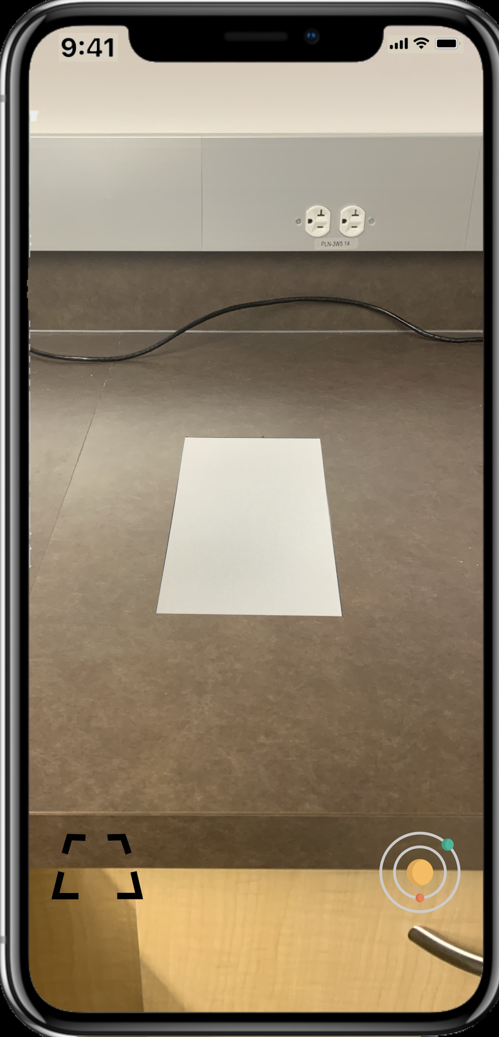

Sol AR will have both plane detection and image detection. This means that the user will be able to select between placing the portal on a recognised plane with a tap of the screen, or they can select to place the portal when it recognises and image in the target image set. Sol ARs image set will only include an white image the same dimensions as a piece of A4 paper. This will mean that instead of the user needing to print out or display a specified image from the app, they can find a sheet of A4 paper which is easily accessible to most people and removes the extra effort required to print out an image. By having both options of plane and image recognition it allows the best of both worlds to the user. The ease of use of the plane detection as you don’t need anything other than a surface to place it. It also provides the stability of image recognition as it is more stable than the plane detection as the anchor is connected to the image, not a computed plane that is being constantly updated.

2.1.3 3D Models

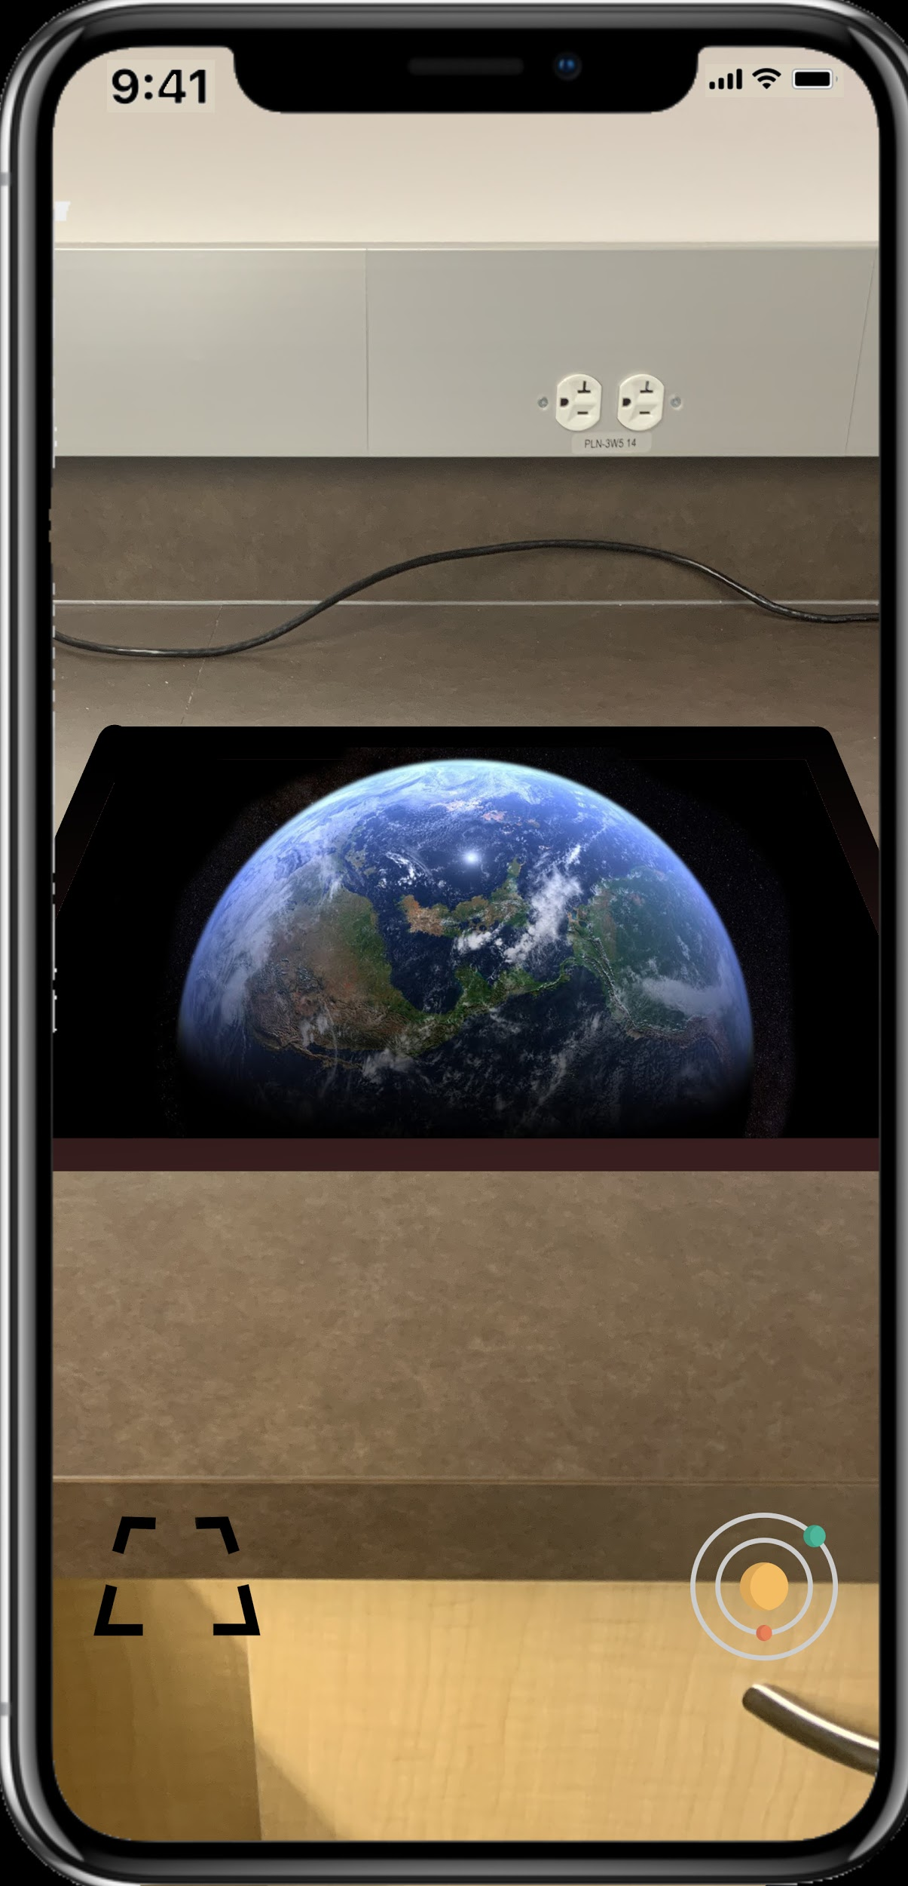

When the selection has been made of plane or image placement has been made, a window will appear with a 3D model of the solar system inside. This is the main ability of Sol AR. The ability to view a 3D model of the solar system inside a window on a plane or A4 piece of paper. The view of the solar system will be restricted as it is positioned inside the Window and you will need to move the camera around the window in order to see all the planets. This will appear as though the solar system is inside of your desk, table or floor.

The Solar system is not the only model that will be included in Sol AR as you will have the ability to switch models between the solar system and all of the planets including their respective moons and rings as well as the sun.

2.1.4 UI Features

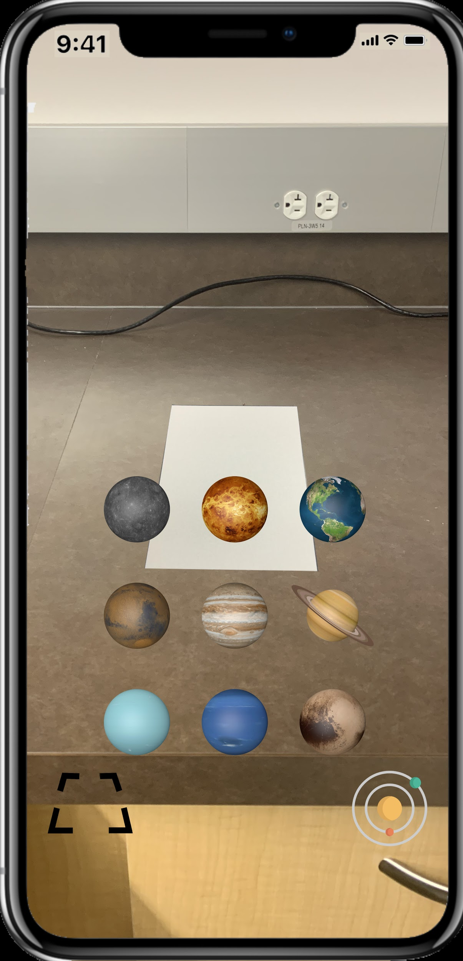

UI will be minimal with it providing the framework to navigate between the planetary models, the sun and the solar system as well as switching between plane detection and image detection states.

Switching between models UI will appear as a button of the solar system in the bottom right and when pressed nine models will appear in three rows of three in order from closest to the sun to furthest. When one of the other planets is selected it will change the model in the portal to be the model of the planet or sun selected. To select the solar system the use just has to double tap the solar system button in the bottom right.

Switching between plane detection and image detection states will occur just by pressing the button in the bottom right. When the plane detection state is live the button icon will show a piece of A4 paper to represent the switch to the image detection state. When the image detection state is live the button icon will show a plane detection identifier to represent the switch to the plane detection state.

2.1.5 Body Occlusion

Body Occlusion is a feature which will allow the app to recognise body parts so should an arm appear in between the camera and the window, the app will recognise this and allow the camera to pick up the hand as if it is moving in front of the portal staying consistent with reality. Otherwise the portal will still be shown over the hand and it would break the experience as it would not be consistent with what we expect to occur.

2.2 Use Cases in Sol AR 2.0

2.2.1 Use case 1

A person has downloaded Sol AR off of the app store on his Iphone X hoping to look at a model of the solar system. They open up the app for the first time and are prompted with a quick loading screen at which they will be requested to allow access to the camera. They allow permission to use the camera and it opens the rear camera display with the plane detection identifier visible as well as the selection to image recognition available in the bottom left and the selection for individual planetary models in the bottom right. When the screen is touched it will place a window facing down into the plane it was placed at the position where the plane detection had been selected. The placement was not as accurate as this person would have liked so they move closer to the table and tap again, removing the old portal and adding a new one in a better position. Now that the portal is positioned in the world where this person wants it, they begin to look at it through their Iphone. Within this portal will be a birds eye view of the solar system with earth north pole pointing out of the portal. The solar system will have all of the planets as well as the sun visible. The planets will have slightly different sizes but none of them are accurate or relative as well as their orbits around the sun. The position of the plane on which the planets and sun will be positioned will be only slightly under the ‘pane’ of the window and will be contrasted by a backdrop of stars serving as a skybox within the window. They can then move around the window and get different perspectives, moving closer to certain planets while the window stays in the same place grounded to physical reality.

2.2.2 Use case 2

A person wants to use the app again as they had already downloaded and viewed the solar system but wants to look at some of the planets individually and use image detection instead of plane detection. They open up the app and after the short loading screen it opens up displaying the rear camera. It has defaulted to plane detection so the person then taps the image detection icon in the bottom left. The plane detection identifier then disappears and the icon in the bottom left turns into the plane detection icon. There will also be a message in the bottom middle to the user saying “searching for A4 paper” until it detects a piece of white A4 paper. This person grabs a piece of A4 paper from their printer and places it on their table. They then move the camera over the table and Sol AR recognises it, placing the window and solar system directly on top of the paper. The portal is not quite completely on the table so the person movers the paper further onto the table and the portal moves with it, now centered completely on the table. The person wants to view individual planets and at the moment they are viewing the whole solar system. They press the icon in the bottom right which brings up eight models of the planets and one of the sun in the middle of the screen overlaid on top of the camera display. They select Jupiter and a model of jupiter replaces the model of the solar system inside the window. This model has all of the moons of jupiter moving around it. The planet will also slowly rotate inside the window. The person then looks through all of the other models having the same experience where the planets are accompanied by their respective moons and rings orbiting around them while the planet rotates as well.

2.3 Features of the app in Sol AR 2.1 and 2.2

The initial release of Sol AR will be 2.0. 2.1, 2.2 and anything after this release is a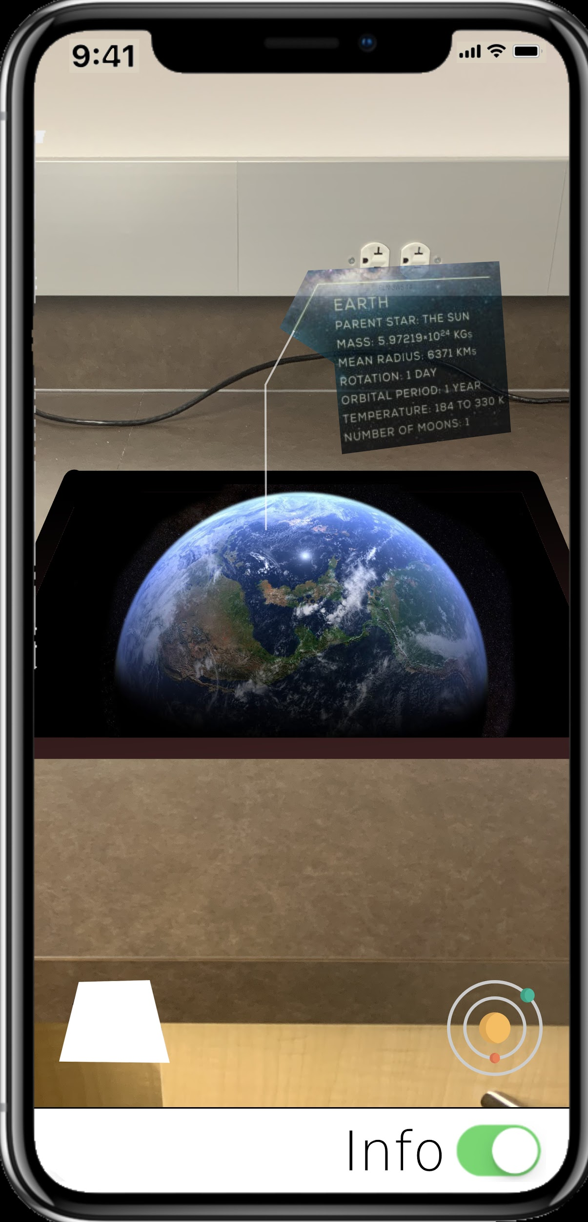 stretch goal.

2.3.1 Info pages

With the update to 2.1 the feature for the user to view info pages about the specific models will be added. These info pages will be above the window floating over the desk. They will contain information about the planet sun or solar system likely with stats and interesting facts. This setting will be togglable with a switch in the bottom right on a new UI bar that will take up part of the bottom of the screen.

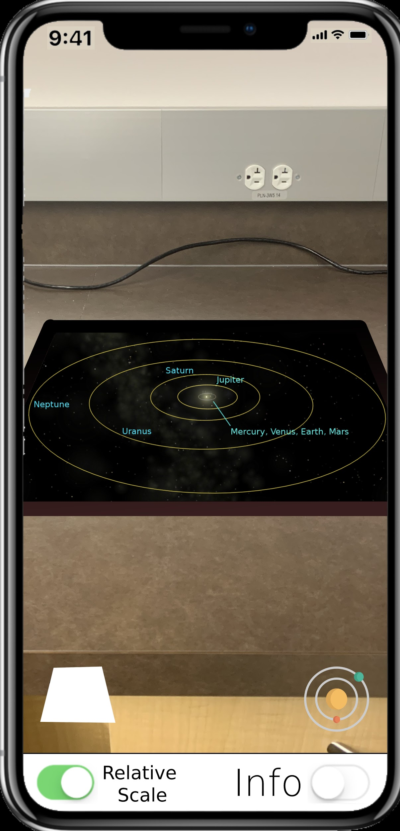

2.3.2 Relative scale

With the update to 2.2 the ability to change to a relative scale will be added. Because the initial model will have very incorrect scales the relative scale will give a better and more realistic view of the solar system. This feature will have a similar toggle ability as the info page with the switch in the bottom right. When on the model will change to one which has a correct size relative to the other objects in the scene.

2.4 Use Cases in Sol AR 2.1 - 2.2

2.4.1 Use case 3

A person has already downloaded the app but would like to learn some things about the planets and the solar system which comes with the 2.1 update. They update their app to version 2.1 and open up Sol AR. they get the same loading screen and then are faced with the rear camera display with a new UI bar that takes up space at the bottom. On the right of the bar is a switch labeled info which is defaulted to off. The person touches the switch and it turns info to its on state. The person then looks at a desk and taps, placing the window onto the plane. It now has a slightly transparent information page above the window anchored in the real world containing information about the solar system as that is what is currently displayed. The info page has information about the size, its makeup and other interesting facts. The person then changes to the model of Earth by pressing the icon in the bottom right above the info switch and touching the Earth that appears on the screen. It then changes to Earth and has and info tab about it positioned above the window. They then turn the info switch off and the info page disappears.

2.4.2 Use case 4

A person has used the app before but wonders what the actual spacing of the planets are. The person has updated Sol AR to 2.2 and opens up the app. It goes through the normal loading screen and then opens up displaying the rear camera with the same UI bar at the bottom from 2.1. This bar now contains two switches with the 2.2 update, the new one being labeled “Relative Scale.” The person then touches this switch and the model switches to a relative scale model with indicators identifying the positions of the planets.

3. Foundations

In the last decade AR technology has had a great amount of investment put into it as the industry continues to grow. With the growing capabilities of the hardware smartphone companies have looked to build development kits that open up the accessibility of AR development to a much wider audience. Technical difficulties without these development kits would prove to be insurmountable barriers for a large number of developers and so these prove to be the foundation on which majority of AR apps are developed.

3.1 Development Kits

Developments kits provide access to features that the companies have developed which give the tools to build AR apps. There are three main software development kit’s (SDK) that provide libraries for AR development. These are:

* ARCore - Google’s Augmented Reality development kit which provides the tools for android app development.

* ARKit - Apple’s Augmented Reality development kit which provides the tools for AR app development for IOS devices.
* Vuforia - An independent company who’s proprietary software allows for the most accessible AR development kit allowing AR development across both Android and IOS devices.

ARKit was the chosen SDK to be used in this project as publishing with vuforia has a large cost associated with it and ARCore requires an android device which was not immediately accessible.

3.2 ARKit Library

3.2.1 class ARSession

“An ARSession object coordinates the major processes that ARKit performs on your behalf to create an augmented reality experience”[6]. This provides a vital framework for the developer, configuring and analysing much of the background data. Processes that the class ARSession() provide include reading data from the device's motion sensing hardware, controlling the built in camera on the device, performing image analysis on captured camera images. The session then provides a framework in which all of these processes are synthesised and “establishes a correspondence between the real-world space the device inhabits and a virtual space where you model AR content” [6].

3.2.2 class ARConfiguration

ARConfiguration allows you to configure your ARSession with different options that allow you to manipulate your program in multiple ways. These configurations allow more specific abilities such as the image tracking configuration which allows a specific utility with image tracking where the developer can edit which images are to be tracked and the configuration largely takes care of the rest. ARConfiguration allows other important classes such as AROrientationTrackingConfiguration(), ARPositionalTrackingConfiguration(), and ARWorldTrackingConfiguration() which are all important is tracking the camera's position in the world [7]. Without these it would be much harder to access these kinds of data as well as using the data as it would be in a less useful form. One of the sub-features that has been released with the latest build is personSegmentation() [7]. This class allows the difficult job of person recognition to be simplified for the user and allows Sol AR to include person occlusion which will be an important feature in grounding the portal to physical reality.

3.2.3 class ARAnchor

ARAnchors provide the ability to create “a position and orientation of something of interest in the physical environment” [8]. Anchors are important for anchoring the virtual environment to a set position in the physical world. This functionality is vital to Sol AR as the window needs an anchor to be grounded in physical reality.

3.3 Unity

Unity is a graphical editor supported on Windows, Mac and Linux. It has a vast range of tools that allow 3D and 2D modeling and many layers of tools that allow the modification of these assets allowing developers to build complex graphical scenes. Unity is one of the largest game development programs because of its range of tools and this will allow Sol AR’s graphical renderings to be constructed through it.

3.3.1 ARKit 3 support on Unity

Unity also works closely with ARKit developers to ensure that the ARKit SDK is compatible and has been updated to support ARKit’s latest release ARKit 3. The main feature that comes with ARKit 3 is the person occlusion which is required to match the feature goals of Sol AR. Unity also supports the previous iterations of ARKit, 1 and 2 which provide the essential AR development libraries as well as ensuring compatibility with Xcode and IOS devices [9].

3.3.2 Shaders

Shaders are small scripts that contain the mathematical calculations and algorithms for calculating the colour of each pixel rendered, based on the lighting input and the Material configuration. Shaders are not AR technologies but are part of unites modeling technologies. Shaders are the base on which materials are made but because they are scripts, it allows developers to create certain properties which are not available to materials. Once the shader has the properties that the developer wants, they can create a material out of the shader and the material will adopt the shaders properties. The materials can then be applied to an object and it will adopt the properties of the material and thus the shader. Shaders are important for Sol AR as this is how the model of the window through which you will see the solar system will have the properties of a window. Through creating shader scripts for the materials of both the planets and the window, it allows for relationships to occur between them. Very simply,

if (viewed through window shader){

Solar system and skybox is visible

}else{

show background

}

This is a simplified version of the logic that allows the planets and solar system models to appear only when looking through the model of the window giving the desired effect.

3.3.3 3D modeling

Unity’s 3D modeling tools allow for all of creation as well as animation tools that Sol AR needs. The animation of the orbits is also supported in unity and so Unity provides the tools to have the complete solar system orbiting the sun with the planets too rotating as they do so. This can then be exported to Xcode where further AR features can be added.

3.4 Xcode

Xcode is apple’s development software which provides the tools for all apple devices. Xcode runs on the swift programming language which is specific to apple products.

3.4.1 UI

Xcode has UI tools which will provide the framework for creating ui functions and displays. This will be used to create the planet selection window which will appear when the icon is pressed. It will be used to create the plane detection window and to switch between the icons depending on which mode is selected. The UI of the plane detection will not be though Xcode as this is a part of the ARKit library.

3.4.2 Permissions

Xcode also handles the permissions needed for the app which in this case is the access to the camera. Unity, ARKit and Xcode automatically handle the hand offs of the camera and the other sensors of the phone.

3.4.3 App Store

To publish Sol AR it first has to go through apples review process before the app can be published. Because the goal of this app is to have it published in the app store apples guidelines and restrictions need to be followed in the process. Because ARKit is designed by apple it makes it much easier to follow the process and the SDK is accepted by apple as they own it. The other concern before publishing is that there is already similar apps on the app store. With the wave of AR app development there are numerous AR solar system apps that have been released and apple requires that there be significant difference in the app and that it is not a copycat [10]. This should not be a problem as while they all appear to have the same design, Sol AR is original in its design through having a window to view the models.

4. Implementation Plan and Timeline

4.1 Implementation plan

Every two weeks a new version of Sol AR will be scheduled with new features described for that version. Each version is aiming to be relatively bug free and polished before the next version begins development. By 3/20 Sol AR is scheduled to release and every update after this is a stretch goal. The schedule is bound to change and so the scheduled dates are subject to change however the order to the version and features accompanying them are less likely to change.

4.2 Timeline

Schedule date: 1/24

* Sol_AR.1.0
  + Basic solar system placement using plane detection

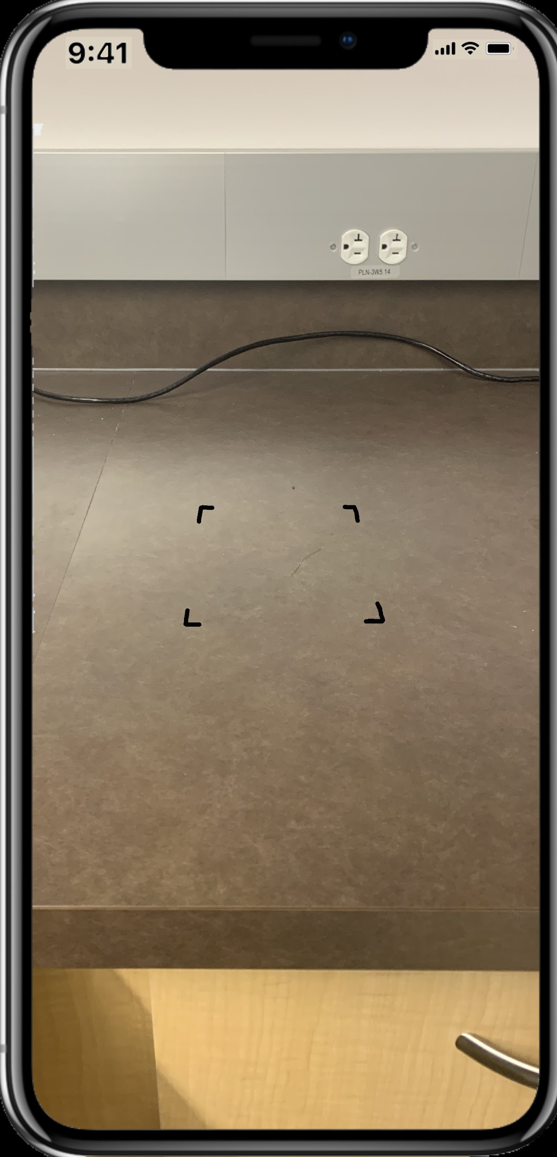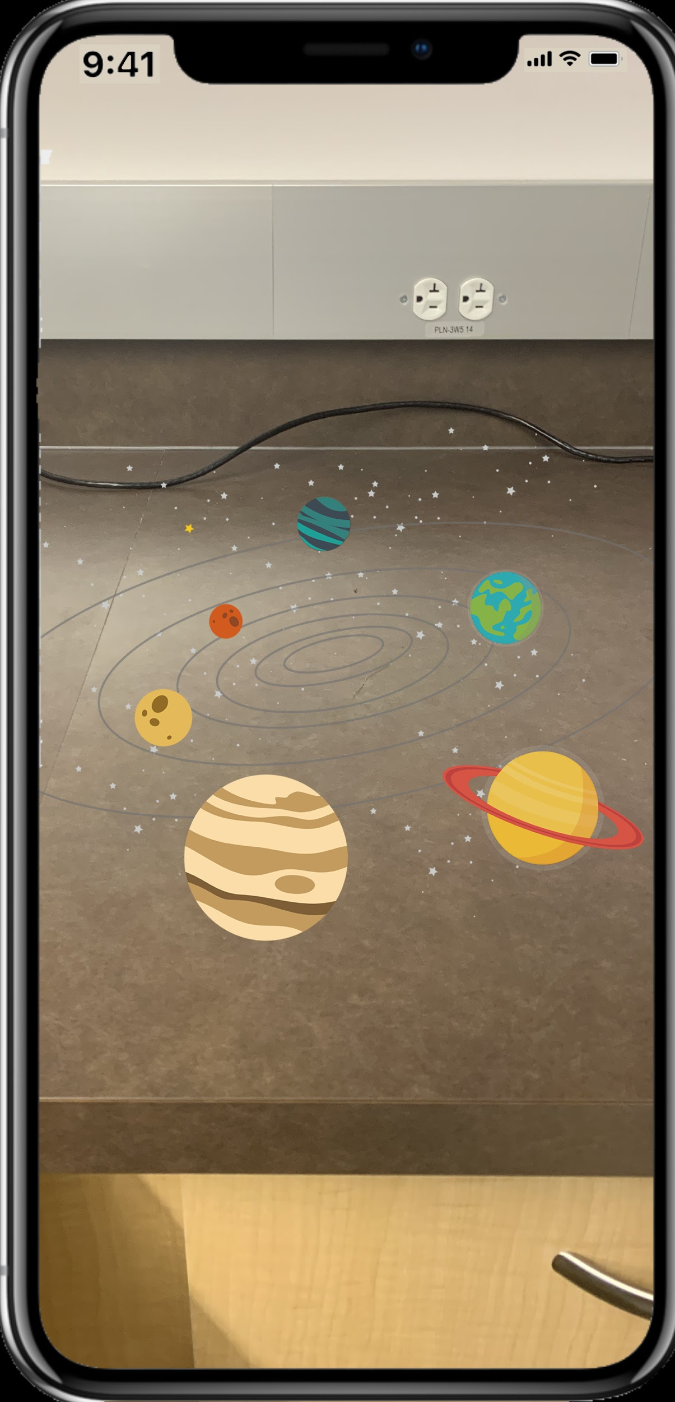

Schedule date: 2/7

* Sol_AR.1.1
  + Solar system model added into window

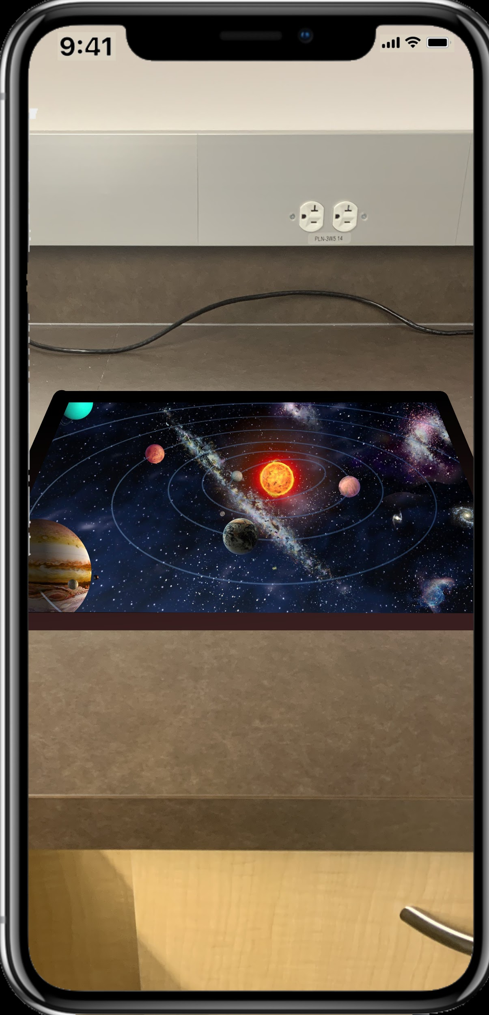

Schedule date: 2/21

* Sol_AR.1.2
  + Movement added

Schedule date: 3/6

* Sol_AR.1.3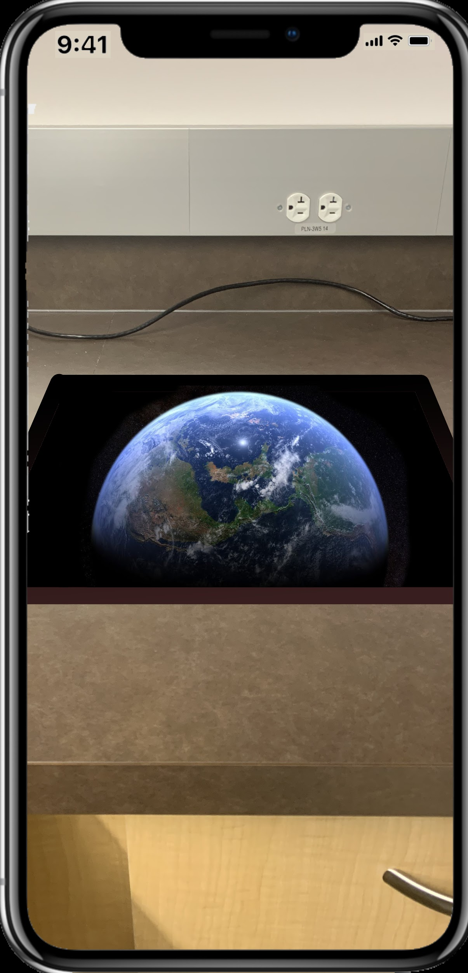
  + Multiple models added



Schedule date: 3/20

* Sol_AR.2.0
  + Image detection added
  + UI added
  + Release Sol AR - 2.0



4.2.1 Stretch Goal schedule

Schedule date: 4/3

* Poster draft due
* Sol_AR.2.1
  + Info pages added
  + Release Sol AR - 2.1



Scheduled date: 4/17

* Poster & bibliography due
* Sol_AR.2.2
  + To scale model added with UI
  + Release Sol AR - 2.2



Scheduled date: 5/7

* Sol_AR.3.0
  + Bug fix and polish
  + Release Sol AR - 3.0

5. Conclusion

With a growing AR market full of new and interesting apps, Sol AR aims to join this market and provide a fun and interesting experience which shows off some of the forefront of current AR technology. In doing this Sol AR hopes to create an experience which inspires those curious about AR to look at the possibilities of this technology and see how it can shape our lives in the future.

Sol AR is an App for IOS devices that aims to bring a 3D model of the solar system into the physical world by making use of space that is already occupied by physical objects such as a desk. This feature has already been implemented in different ways and Sol AR will build on ideas that is prominent in sci-fi to bring them into reality and expand our physical world beyond their physical limits using AR technology

6. Bibliography

References

[1] The History of AR and VR: a Timeline of Notable Milestones. (2018, October 8). Retrieved

November 14, 2019, from hqsoftwarelab.com/about-us/blog/augmented-and-virtual-

reality/the-history-of-ar-and-vr-a-timeline-of-notable-milestones.

[2] Sutherland, Ivan E. “A Head-Mounted Three Dimensional Display.” Proceedings of the December

9-11, 1968, Fall Joint Computer Conference, Part I on - AFIPS 68 (Fall, Part I), 1968,

doi:10.1145/1476589.1476686.

[3] “Videoplace 1975.” *Myron Krueger*, https://aboutmyronkrueger.weebly.com/videoplace.html.

[4] “Upskill & GE Healthcare: Pick & Pack Productivity Study Using Skylight.” *YouTube*,

[5] Ratnottar, Sanjay. “Augmented Reality (AR) Trends: The Past, Present & Future Predictions

For 2019.” *Towards Data Science*, Medium, 15 Feb. 2019,

https://towardsdatascience.com/augmented-reality-ar-trends-the-past-present-future

-predictions-for-2019-8e1148345304.

[6] “ARSession.” *ARSession - ARKit | Apple Developer Documentation*, Apple,

https://developer.apple.com/documentation/arkit/arsession.

[7] “ARConfiguration.” *ARConfiguration - ARKit | Apple Developer Documentation*, Apple,

https://developer.apple.com/documentation/arkit/arconfiguration.

[8] “ARAnchor.” *ARAnchor - ARKit | Apple Developer Documentation*, Apple,

https://developer.apple.com/documentation/arkit/aranchor.

[9] “AR Foundation Support for ARKit 3 – Unity Blog.” *Unity Technologies Blog*, Unity,

https://blogs.unity3d.com/2019/06/06/ar-foundation-support-for-arkit-3/.

[10] Apple Inc. “App Store Review Guidelines.” *App Store Review Guidelines - Apple*

*Developer*, Apple, https://developer.apple.com/app-store/review/guidelines/.