iOS Mobile Application

Frienzcation

Ricardo Uriostegui

Ruriostegui@monmouthcollege.edu

Monmouth College

Computer Science

Table of Contents

Abstract 3

The Problem 3

Similar work 4

PlanChat 4

TripIt 4

Introduction 4

How do I know if there is an audience? 5

The contrarian Truth 6

Is it Time? 6

Project Description 6

Design and Architecture 7

Home Tab 9

Create Event 9

Group Feature 10

Chat Feature 10

Save Feature 10

Share Feature 10

Social Tab 11

Explore Tab 11

Map 11

Potential Features I would like to add 12

Project Startup 12

Business to User platform 13

Foundations 13

Build better apps 14

Cloud Firestore 14

Cloud Functions 14

Authentication 14

Cloud Storage 15

Improve app quality 15

Crashlytics 15

Performance Monitoring 15

App Distribution 15

Implementation Plan and Timeline 15

Conclusion 16

Works Cited 17

# Abstract

I will be developing *Friendzcation,* an IOS mobile application that allows users to track, join, and share travel arrangements and itineraries. The purpose of this paper is to highlight my goals for this mobile application project. The goal is to deliver across the entire life cycle of an app from concept, design, build, deploy, test, release and support.

## The Problem

A problem that I’ve encountered numerous times, while traveling with my friends is that there wasn't a way to organize an itinerary and share it with other people going to the same event as you. Through this experience, I noticed the lack of mobile applications that allows users to share the important details and logistics of a travel event with a group. Many know that traveling takes a lot of planning. Therefore, the value that I want to provide through this app is the ability to allow someone to join an event that has already been planned by someone else (because they have conducted the research and logistics of a trip) and allow it to be public, so that others can join them in their adventure. Thus, allowing users of this app to save time and money. Users will save time by joining an event that has already been planned out. As well as, be able to save money by going halves on logistics and travel arrangements. This is done by allowing users of the app to explore events on the ‘Social’ tab of the app.

The purpose of the social feature is to find travel-minded travelers seeking to find someone willing to go to the same event as them, while saving time and money. In an article written by Google titled, “*How Micro-Moments Are Reshaping the Travel Customer Journey*” the article broke down the four main micro steps that today’s travelers go through when searching for their next journey. Specifically, those four micro steps are: “I-Want-to-get-away moments (Dreaming Moments), Time-to-make-a-plan moments (Planning Moments), Let’s-book-it moments (Booking Moments), Can’t-wait-to-explore moments (Experiencing Moments). My ideal vision for the app itself is to tap into all four of these moments a traveler experiences. I plan to develop an app in particular because most of travel searches come from mobile devices. Interesting enough, “As of the first quarter of 2016, “40% of U.S. travel site visits come from mobile” [1]. In the same article by Google, “Travelers increasingly turn to mobile in shorter spurts to make informed decisions faster than ever before.” Through *Friendzcation,* I plan to make travel arrangements more organized, and make travel more affordable all by providing a platform that lets you join events that have already been planned.

## Similar work

### PlanChat

### 

This app started off as a messaging app for planning travel events. This app also allowed users of the app to: track flight and hotel process to find the perfect deal, have a poll feature so that the users in the group can vote on travel arrangements, and allow users to split expenses with everyone in the group. This app isn’t on the App store anymore, so it wasn't downloadable.

### TripIt

Tripit has become a popular travel app that helps you organize and share your next trip’s itinerary easily. This is done by sending your confirmation emails to their forwarded system that aligns an itinerary for you on the app. Tripit allows their users to share their itineraries with friends and family. They also allow you to follow your itinerary across multiple devices or platforms. Tripit is a similar concept that I would like to follow, especially how they are able to share their itinerary.

Many of the applications that is similar to what I want to build does not have the feature or the differentiation concept that I want to implement. The differentiation concept that I want to implement is the ability to join public events. Following the ‘Sharing economy’ concept of Uber and Airbnb, but with vacation events. Throughout this proposal, I will be using event/vacation/trip interchangeably.

# Introduction

I came across this idea when I went to Colorado for spring break. I noticed that there wasn't an app out there that allowed users to create a custom itinerary, so that you can then share it with your group of friends whom you are traveling with. The idea of *Friendzcation* allows you to conveniently see all the important information of a trip. Overall, the purpose of the app is to solve: all the important information that has been lost because of the clutter in conventional group messaging platforms, the repetitive process of sending important information to individuals in your group such as- addresses, links or other important information. By using *Friendzcation,* you’ll be able to conveniently see all the vital information for a trip.

Throughout another travel experience, I noticed that the expense of a trip can be minimized by traveling and splitting the cost with friends. Friends can be people you may or may not already know. Through *Friendzcation,* traveling doesn't only have to be a shared experience with friends who already know each other, it can be an experience for travelers who do not know each other yet. For example, in my recent trip to Colombia I stayed at a beautiful Airbnb in Medellin. The rental was way out of my budget, but with a group of travelers, the price was reduced. For example, I went with 6 other guys that I did not know at the time. I was able to meet them because of the organizer of the trip gave individuals an opportunity to join to make the trip more affordable. My goal with this app is to allow users to join other travelers so they can experience a trip that could not possibly be affordable, but when you get together with a group expenses become more affordable. My Colombia trip was an amazing experience; It allowed me to explore a beautiful country. With *Friendzcation,* I want users to experience the same trip with a group of friends through this app.

To explain the usage of the app I will give an example of how users can use this platform. Let’s say: Two people are both flying in from Australia to Chicago for the Lollapalooza concert. Both users do not know each other prior to finding each other through this app, but because of *Friendzcation* they can now go together and perhaps go halves on lodging and other expenses. Both benefiting from:

+Meeting new people

+Save money by going halves on logistics

+Reducing the amount of time searching for lodging and other important information

## How do I know if there is an audience?

As I was thinking about this app idea, I asked myself, “If people will use this?” I know that personally it is a good idea (although some bias in there). I asked my close friends about the idea. I know that the market is always looking for travel deals and plan a lot of time and resources to get away. Especially this particular generation that loves to get away and have that “Vacation itch”, but money and friends are the problem. My primary target market is the generation Z, “The tween and teenage cohort following the Millennials is sometimes called Generation Z. This group accounts for 25.9 percent of the U.S. population and contributes $44 billion to the U.S. economy. Born after 1995, Gen Zers are diverse, risk averse, and incredibly tech savvy. Never having known a world without the Internet, they expect everything to be instantaneous” [2].

I am confident that there are users out there who are willing to contribute to the ‘Sharing economy’ of creating events and having them to be public, for others to join. Throughout doing research I’ve seen countless tweets by people who are dealing with this problem. Particularly finding that someone who has the willingness to travel.

“I just want a nice group of friends to travel and prosper with!”

“I need friends that want to travel & experience”

“I need a friend or 2 that wants to travel”

“I wish I had a group of friends that would travel the world with me.. but I don't even have friends”

“I want some best friends that wanna travel with me and go to cool places and festivals and concerts and just experience as much life as possible”

These types of tweets come from individuals who are under 30. All of these tweets describe the I-want-to-get-away moments, where people are at the early stages of thinking about their next trip. They're exploring destination options and dreaming about what their next getaway could look like. The problem throughout my research is that people have the “vacation itch”, but do not have the friends that want to travel with them. By creating a platform like *Friendzcation* after someone has chosen a travel destination, the dreaming starts to become reality when you tap onto the ‘Social’ tab of the app.

## The contrarian Truth

The contrarian truth is how people will react in the future, in ways either they are unwilling to admit right now or just unaware of. For example: Steve Jobs believed that people will go from keyboards on your cellular devices to touch screen, Airbnb the first company to allow home owners share their living spaces to temporary travelers, Uber/Lyft the car sharing companies that connect people who want to go places with people willing to drive them there.

Peter Thiel talks about finding secrets in his book *Zero to One.* He talks about finding solutions to problems like the companies above did. Peter says, “We already had state-licensed taxicabs and private limousines; only by believing in and looking for secrets could you see beyond the convention to an opportunity hidden in plain sight” [3].

We already have services that help you find the best deals on travel amenities like flights and lodging. The value that I would like to offer through this app is the ability to save time by tapping on the social icon of the app, so you find like-minded travelers going to the same event as you. With the goal of saving time, money and the ability of meeting new people.

## Is it Time?

Contrarians truths are expressed when the time has come. In my own experience by living through this type of hassle and the demand for people looking for others who have the willingness to travel. Either through meeting new people through the ‘Social’ tab or by better organizing an itinerary. This app will allow just that. For example, in a research done by Google, “78% of leisure travelers haven’t decided what airline they will travel with” and “82% of leisure travelers haven’t chosen the accommodation provider they will book with”, and “60% of searches for destination information come from mobile devices.” Those 3 percentages itself scream opportunities and secrets that Peter Thiel talks about in his book *Zero to One.* My goal with this app is to bet on a platform that has not been explored. Peter Thiel says, “When you bet your business on a contrarian truth, you will dramatically increase your odds in avoiding competition.”

# Project Description

Throughout this project my goal is to deliver across the entire app life cycle from concept, design, build, deploy, test, release and support. The project and the idea itself is something that I am very passionate about. I think a lot about the product that I want to provide for people by building an application like this. The following represents how I vision the app to flow like and focusing on the User Interface (UI) and the User Experience (UX). Throughout the process, I plan to follow Apple’s guidelines on the app’s UI and UX so that I build a platform that is functional for both users and for scalability.

## Design and Architecture

When you first launch the app, you will be displayed an introduction of the app. The purpose of this is to introduce you to the app and what you can do using *Friendzcation* (Figure 1-2).

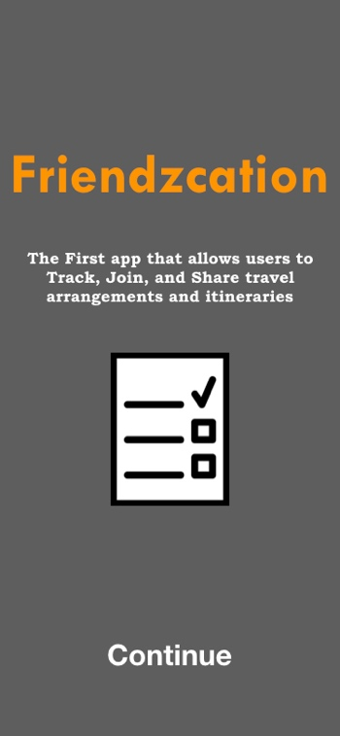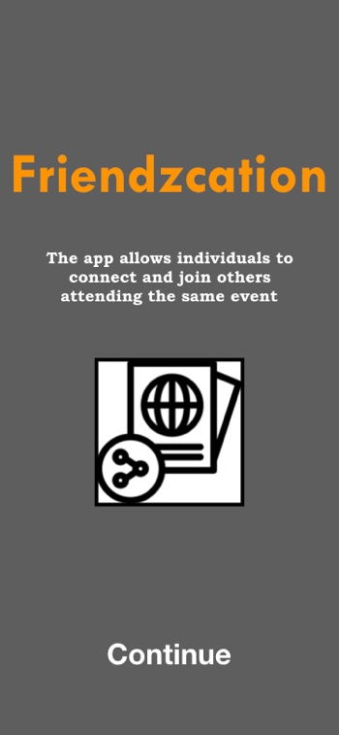

Figure 1

Figure 2

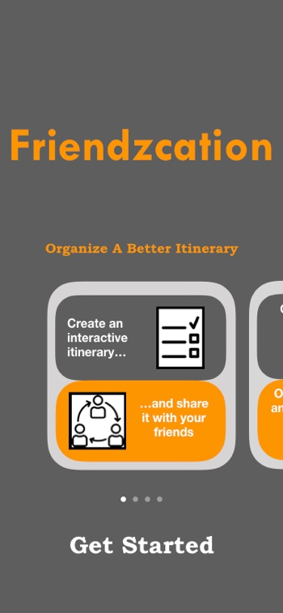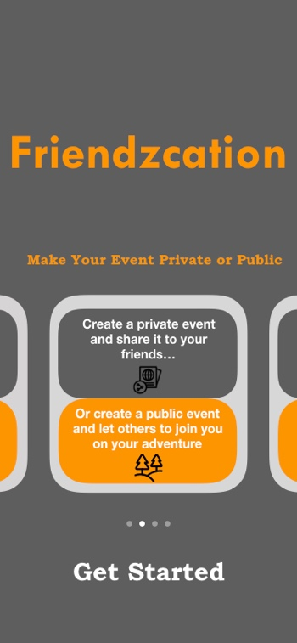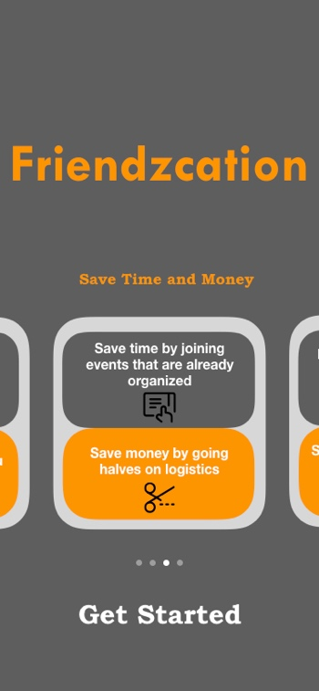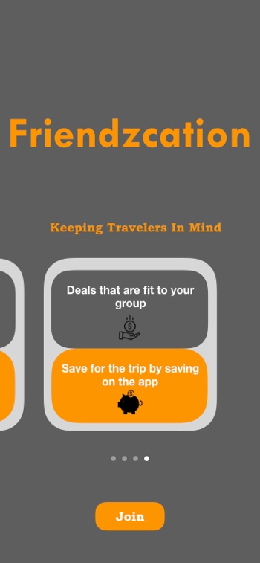

Figure 3

The following screens (Figure 3) are meant to inform the users of the capabilities users will be able to do within the app.

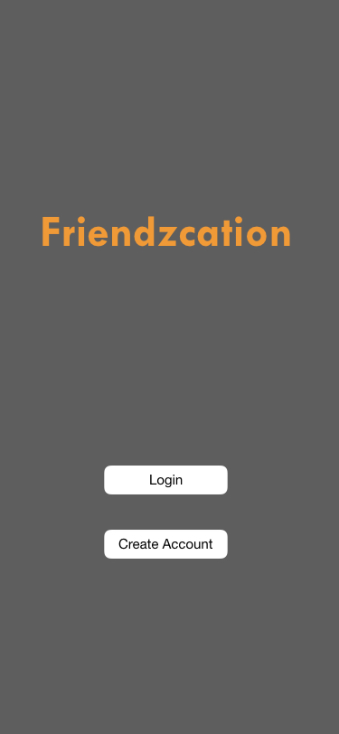

Figure 4

Once the introduction of the app is over users will be prompted two buttons. Login or Create an Account (Figure 4).

If the user clicks on the Login button the user will be prompted to enter:

* Email
* Password

If the user clicks on the Create Account user will be prompted to enter:

* Name
* Email
* Password
* Phone Number

# Home Tab

Once the user Logs in or creates an account the first page they will land on is the Home tab. In this tab you can Create an Event or navigate to other tabs that are shown at the bottom of Figure 5.

## Create Event

The Users will be able to Create/Set an event by clicking on the ‘+’ symbol on the orange container of the Home tab (Figure 5). Once the user clicks on the ‘+’ symbol the following screen will appear (Figure 6). The user will then be able to set:

* Event Name
* Date
* Location
* Itinerary
* Set events to be Public or Private
  + If Public: Events will be displayed for other users on the platform to see and join. Public events will appear on the ‘Social’ tab.
  + If Private: Events will be displayed only to those who have the specific link.
  + Admin of the event is the only ones who is able to accept or decline users from joining the event.

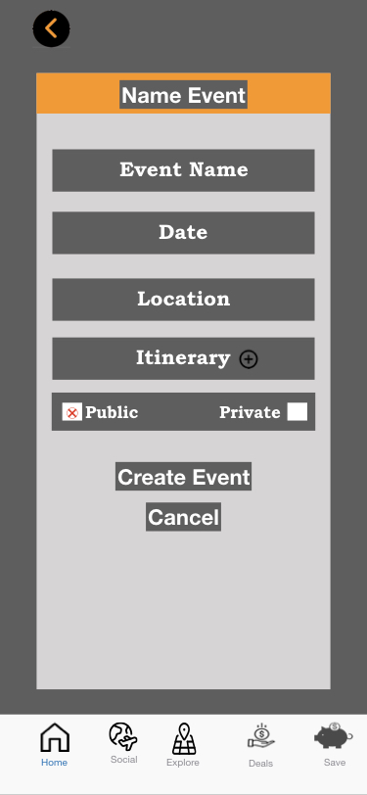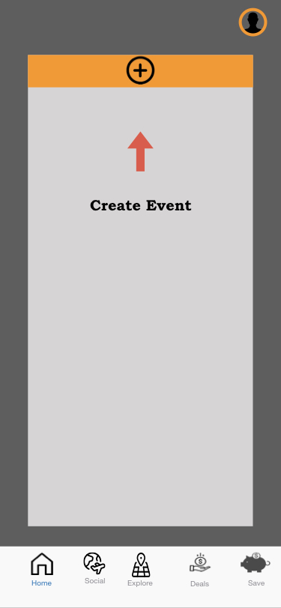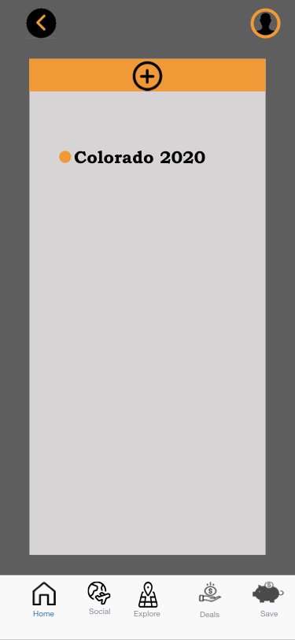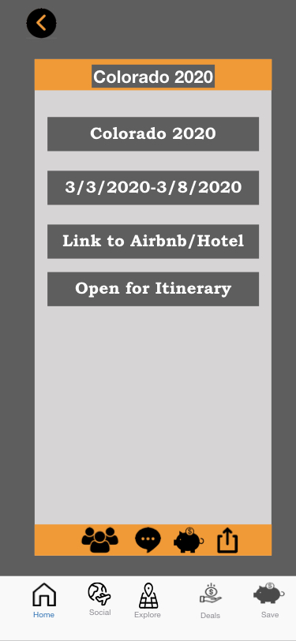

Figure 5

Figure 6

Figure 7

Figure 8

Once the user creates the event and clicks on the Create Event button then the user will now have the event saved and will now appear in the Home tab (Figure 7). When the user clicks on the event the user will now be able to see the additional features that pertains to each event. The icons highlighted by a red rectangle box (Figure 8) are the features that I will now be expanding on.

## Group Feature

The purpose of the ‘Group’ feature is to allow users to see who else is going to the event.

* Names of users who are going

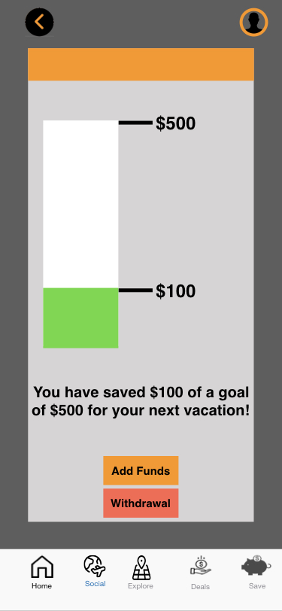

Figure 9

* + Click on their profile
    - Reviews
    - Travel history
    - Interests

## Chat Feature

The purpose of the ‘Chat’ feature is to allow the users of the event to communicate within the app, so that everybody who is going to the same event can send links, attachments, share locations, plans and discuss expenses.

## A screenshot of a cell phone Description automatically generatedSave Feature

The purpose of the ‘Save’ feature is to incentivize users to save for the event. You will be able to track savings for the event (Figure 9). Once the event is near you will be able to withdrawal the money back into your account.

## Share Feature

The purpose of the ‘Share’ feature serves to allow users of the event to share the event with others join them on their adventure. Allowing users to create an event and let others know about their event is a vital feature that is necessary for the platform that I want to provide. This feature will allow users to join the event and be prompted to download the app, “A product is viral if its core functionality encourages users to invite their friends to become users too” [3].

# Social Tab

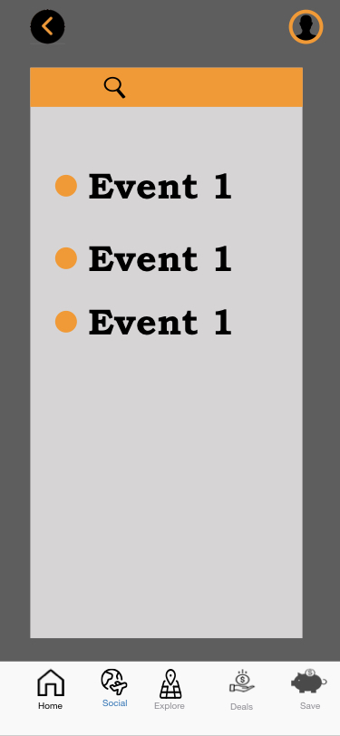

Figure 10

The purpose of the Social tab is meant for users to join events that are public and are going on globally. Users will be able to search for a destination and see the results that come from it (Figure 10). They say you can find 80% of the problems by looking at 20% of them. I would like to say that I saw a demand and a need for a platform for something like this. The reason why I want to build on a Social tab is because I want the users to contribute to the sharing economy.

It is known that, “Seventy-two percent of travelers with smartphones agree that when researching on their smartphones, they look for the most relevant information regardless of the travel company providing the information.” It is important to note that “Over 40% of travelers say they bounce back and forth between dreaming about and planning their next trip—zooming in on the details for one destination and then zooming out to reconsider all the options again” [1]. Through the Social tab users will see events going on and be able join those events.

# Explore Tab

The purpose of the Explore tab is to expand on user’s idea of “I-Want-to-get-away moments, the dreaming moments. On this tab you’ll be able to get an idea of what events are going on globally. This tab is meant for users to explore what’s going on around the world.

### Map

In this tab, I'd like to implement a map feature that allows users to better visualize what’s going on around the world. Within this feature users will be able to use the map to explore travel locations. This feature will serve as a “Be there strategy”, that Google talks about. Since “People often search for inspiration for vacation destinations based on geography or on a type of trip someone has in mind [1]. Similarly, to Instagram’s old picture map feature, that created a geographical map that displayed where you took or posted the picture (Figure 11). I’d like to have a similar feature that allows users to explore future events that are public. Going back to the user profile mentioned above. I’d like to use this same feature to allow other user accounts to see where you’ve visited. The purpose of this is to allow other users to feel confident about joining events, knowing that you can check where people have visited before allows users to have a prestige effect of it and or allow other users visiting your account to have a better piece of mind of who they’ll be traveling with.

Figure 11

## Potential Features I would like to add

* Deals tab
  + Being able to partner up with other business to allow users of the app to take advantage of travel deals.
* Save Tab
  + Saving feature – Collects x amount of money from your account so that you save for the trip.
  + Debit card fund that allows members to use with the knowledge that everything is split evenly.

## Project Startup

During the process of this project, I would like to build a valuable company that nobody is building. The niche part of the app that I am building is the social aspect by allowing users to contribute to the sharing economy like Uber/Lyft and Airbnb. I plan to follow similar business models like these companies. Companies like that all have the sharing factor in the concept of their respected apps.

## Business to User platform

By building *Friendzcation,* the appwill be serving as the middleman by connecting users who want to travel to. *Friendzcation* will contain the users (data) that can be used by businesses to accommodate users for:

* Tailored deals that are custom to your group (Airbnb, Food, Packaged deals, etc…)
* Ability to save money if you share with friends (Links)
* Ability to stay for a discount if you stay with X (Chain businesses) using Friendzcation

Hotel chains don't fill their rooms?

*Friendzcation* will find users to fill those rooms in.

Flight airlines don't fill their empty seats?

*Friendzcation* will find users to fill those seats in.

*Friendzcation* will be able to connect users to fulfill the four micro moments mentioned above that traveler’s experience.

* Dreaming Moments
* Planning Moments
* Booking Moments
* Experiencing Moments

# Foundations

Doing a project like this consist of a database. A database is an organized collection of data, stored and accessed electronically. Since I will be having user accounts, in which the users will be allowed to create content that information needs to be

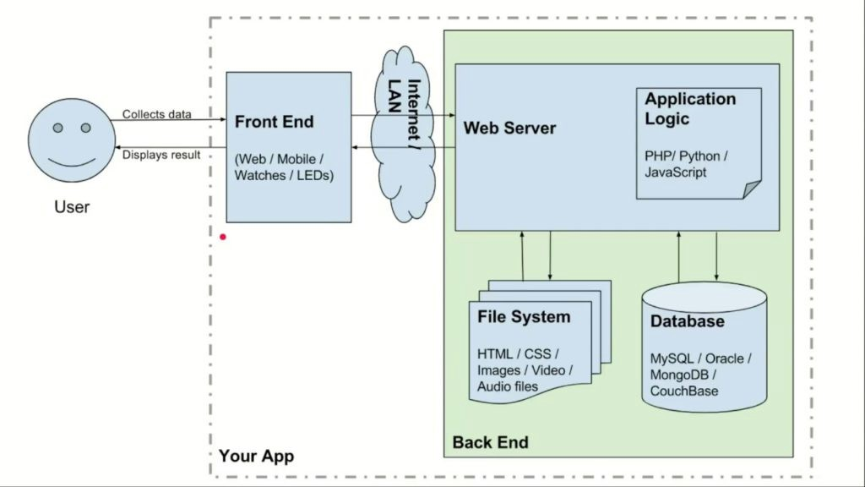

Figure 9

backed up somewhere. Since it is not possible to have all the data or information on the user’s device,

because iOS apps can’t connect to the database automatically you need to setup a webserver that allows the app to communicate to the database.

To describe figure 9 on this page, A user creates some Input/Action that is sent over the internet. Once the Input/Action is done the web server handles the service so that it requests what it needs from the database so that they are both communicating. Client-side talks to server for: files, information, and authentication. Once the web server gets what it requested from the database then it is returned back to the user.

As I was doing some research, I was looking for services that allowed me to focus on my app itself and not necessarily have to re-invent the wheel while working with the database for an app. I came across Firebase. Firebase is a backend as a service, it contains real time data that stores the data for your app as Json data. JavaScript Object Notation (Json) is an open-standard file format that uses human-readable text to transmit data objects consisting of attribute–value pairs and array data types. It is a very common data format, with a diverse range of applications. I will be using most of Firebase services to handle the life cycle of my app. I will not expand on the services Firebase offers for mobile developers. Firebase allows mobile developers to: Build better apps, improve app quality, and Grow your business.

# Build better apps

## Cloud Firestore

Firebase allows app developers to store and sync data across users and devices at a global scale using a cloud-hosted database. This allows app developers to store, sync and query data. This will allow users to synchronize data between devices [6]. This is an important library that I will need to implement because users will be creating and changing events throughout the app.

## Cloud Functions

Firebase allows app developers to scale their own servers at their own pace. This type of scaling can happen based off of users creating events that will appear on the ‘Social’ tab of the app or by having a large user base. Changes that occur during the app allows users and app developers to see the data in real time [7]. An example of how I will use this service is users creating new accounts. Firebase allows protection so that nobody tempers with the client side, so that users are sure their events are secure.

## Authentication

Firebase allows app developers to build their own interface, with the confidence of a strong authentication services Firebase provides to handle user’s data [8]. Firebase Auth offers multiple methods to authenticate users’ email, passwords and events. These are important libraries I will need so that user’s data stays protected when creating an app like this.

## Cloud Storage

Firebase allows app developers to use Firebase’s SDKs for cloud storage and Google security to allow users to upload and create user-generated content like events and images that I plan to build on the app. This type of storage is necessary so that when users are requesting data, a cloud storage like this can be used to fulfill those user demands.

# Improve app quality

## Crashlytics

Firebase allows app developers to reduce the amount of time spent on troubleshooting by collectively managing a list of issues and provide feedback to tackle the errors using this service [9]. This type of library helps developers curate crash reports so that mobile developers can continue building the app.

## Performance Monitoring

Firebase allows app developers to efficiently diagnose app performance issues that occur in users’ devices. This service allows app developers to gain better insight of an app’s performance [10]. This will be an important tool I will be using when I get to launch the product.

## App Distribution

Firebase allows app developers distribute a pre-release version of my app to trusted testers so that they can provide valuable feedback before releasing a new version of the app [11].

Tools like Firebase allows developers like me to focus on building the app by using frameworks and software developing kits (SDKs), that allow users to better integrate an app and allow you to save time by using libraries like the ones built by Firebase. Firebase was able to solve problems for developers like:

* The backend side of an application
* Server side architecture that interacts with the database
* Authentication that lets you protection user accounts and data

# Implementation Plan and Timeline

Throughout my senior capstone, my goal is to deliver across the entire app life cycle of creating an app. This consists of: Concept, Design, Build, Deploy, Test, Release and Support.

**Checkpoint 1:** My plan for checkpoint 1 Is to establish and finalize the concept of the whole app. In this checkpoint I want to gather and understand what each feature should be and how I vision it to function. At this step I also want to be done with the full implementation of creating user login/create account and finalizing their action buttons with the UI/UX. At this point I also want to focus on any troubleshooting I will encounter through this checkpoint.

**Checkpoint 2:** My plan for checkpoint 2 is to have a vision of what I want the UI/UX to be. I want to focus on the design and how I want the components to function. This will consist of working with my current knowledge at this point to get a working UI tied to the code that I will be working with along this process. This part consists of keeping up with Apple’s standards for swift and following along with their documentation to follow guidelines when creating an app. At this point I plan to start implementing the app using Apple’s Xcode software. At this point I also want to focus on any troubleshooting I will encounter through this checkpoint.

**Checkpoint 3:** My plan for checkpoint 3 is to build and align the components that I will be implementing on the app. The goal for this checkpoint is to align the components to the UI/UX so that the code is paired with actions that make an app flow. For example, when the user clicks the ‘Sign Up’ button the user will be prompted another screen to fill out some fields like name, email, and password. These actions are what users will click that prompts them a new screen. I would also like to implement the ‘Share’ feature that allows other users to join the platform and look at the itinerary. My goal for this step is to make sure all buttons are matched with their actions and their respected screens. At this point I also want to focus on any troubleshooting I will encounter through this checkpoint.

**Checkpoint 4-5:** My plan for checkpoint 4-5 is to deploy and test the app. This will consist of finalizing the UI/UX and learning about Apple’s publishing requirements. At this point I will be content of having an app that lets you conveniently create events and share these events to your friends, so that they can join the app and see the organized itineraries. If at this point I complete this before, I would like to implement other features that I have planned for my app. At this point I want to focus on any troubleshooting I will encounter through this checkpoint. I will also be working on the poster at this checkpoint.

**Checkpoint 6:** My plan for checkpoint 6 is to give myself some time to work on any additional work that has to be done. This can be working on previous work that pushed me back on my timeline, or work on additional features that allow me to work on.

# Conclusion

With the wide usage of smartphones, it only makes sense that users want to get the information they want faster than ever. On Google, mobile queries just within the travel category have increased more than 50%. This data reveals that year over year, people are increasingly using their phones to plan travel, but when they do it's happening in smaller moments across more sessions on their phones [4]. *Friendzcation* will provide its users with relevant information that a user needs in the moment. *Friendzcation* will connect them to the inspiration they're looking for and offer the quick logistics and information they want. “A trip was the largest discretionary purchase last year according to nearly 60% of leisure travelers” [1]. I plan to make those four travel decisions process clearer and more concise with the implementation of *Friendzcation.* I plan to build this application using Apple’s Xcode software environment and building it on Google’s Firebase service.

# Works Cited

[1] “How Micro-Moments Are Reshaping the Travel Customer Journey.” *Google*, Google, [www.thinkwithgoogle.com/marketing-resources/micro-moments/micro-moments-travel-customer-journey/](http://www.thinkwithgoogle.com/marketing-resources/micro-moments/micro-moments-travel-customer-journey/).

[2] “Mktg11.” *Mktg11*, by Charles W. Lamb et al., Cengage Learning, 2018, p. 139.

[3] Thiel, Peter, and Blake Masters. *Zero to One: Notes on Startups, or How to Build the Future*. Crown Business, 2014.

[4] Gevelber, Lisa, and Oliver Heckmann. “Travel Trends: 4 Mobile Moments Changing the Consumer Journey.” *Google*, Google, Nov. 2015, www.thinkwithgoogle.com/consumer-insights/travel-trends-4-mobile-moments-changing-consumer-journey/.

[5] “Firebase Products  |  Firebase.” *Google*, Google, firebase.google.com/products#develop-products.

[6] “Firebase Products |  Firebase.” *Google*, Google, firebase.google.com/docs/firestore

[7] “Firebase Products |  Firebase.” *Google*, Google, firebase.google.com/docs/functions

[8] “Firebase Products |  Firebase.” *Google*, Google, firebase.google.com/docs/auth

[9] “Firebase Products |  Firebase.” *Google*, Google, firebase.google.com/docs/crashlytics

[10] “Firebase Products |  Firebase.” *Google*, Google, firebase.google.com/docs/perf-mon

[11] “Firebase Products |  Firebase.” *Google*, Google, firebase.google.com/docs/app-distribution

[12] Apple Inc. Swift, 2019, https://docs.swift.org/swift-book/LanguageGuide/TheBasics.html