# Test 1 – Load Member Data

# 

# Test 2 – Save Member Data

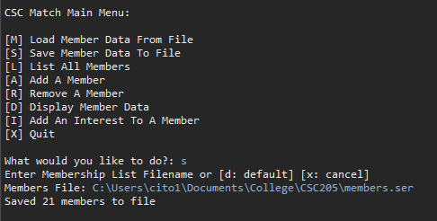

# Test 3 – List All Members

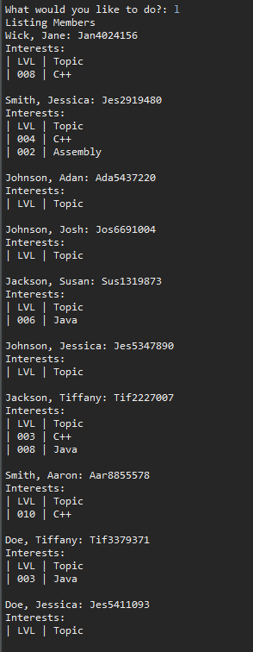

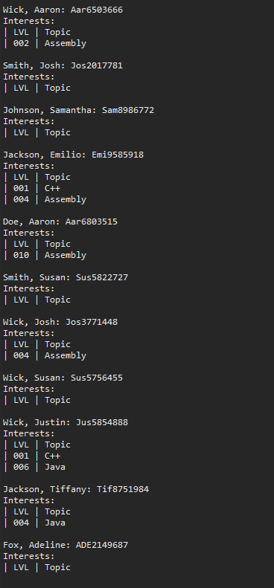

# Test 4 – Add Member

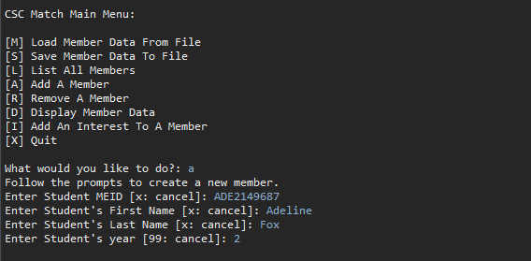

# Test 8 – User Exits Program

# Negative Test 1 – Invalid User Input

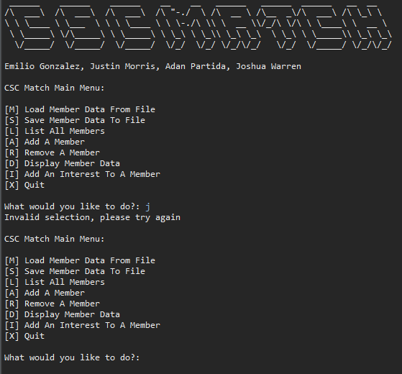

# Negative Test 2 – Invalid File Name

