NEO-M8U

What is Dead Reckoning?

Dead Reckoning is the process of determining current position by combining previously determined positional data with speed and heading. This process can also be applied to determine *future* positions as well! The NEO-M8U uses what is called **Untethered** Dead Reckoning (UDR) which calculates speed and heading (amongst many other points of data) through the use of an internal **inertial measurement unit** (IMU). The addition of an IMU allows the M8U to produce more accurate readings in between GNSS data refreshes!

|  |  |
| --- | --- |
| [Illustration of Using an IMU with GNSS Data](https://cdn.sparkfun.com/assets/learn_tutorials/1/1/6/6/Dead_Reckoning_GPS_Sensor-Based.jpg) | [Illustration of Using only GNSS Data Only](https://cdn.sparkfun.com/assets/learn_tutorials/1/1/6/6/GNSS_Only_Poor_Signal.jpg) |
| *Illustration of Using an IMU with GNSS Data* | *Illustration of Using only GNSS Data Only* |

*Illustration of Refresh Rate to Accurately Determine Position. Image Courtesy of*[*u-blox from the UDR Whitepaper*](https://cdn.sparkfun.com/assets/learn_tutorials/1/1/6/6/UDR_whitepaper__UBX-16000376__0.pdf)*.*

In addition, the module can also give accurate and useful GNSS data in areas where satellite connections are difficult to maintain: areas like the dense urban environments of major cities, long tunnels, parking garages, any large UFO's that may descend from the sky, etc.

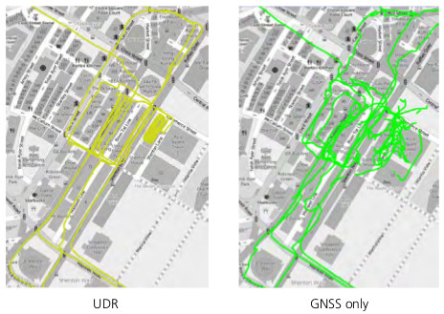

*Untethered Dead Reckoning vs GNSS Only Comparison in an Urban Canyon. Image Courtesy of*[*u-blox from the UDR Whitepaper*](https://cdn.sparkfun.com/assets/learn_tutorials/1/1/6/6/UDR_whitepaper__UBX-16000376__0.pdf)*.*

Hardware Overview

Power

Power for this board is **3.3V** and we have provided multiple power options. This first and most obvious is the **USB-C connector**. Secondly, are the **Qwiic Connectors** on the top and bottom of the board. Thirdly, there is a **5V pin** on the PTH header along the side of the board that is regulated down to **3.3V**. Make sure that power your provide to this pin does *not* exceed 6 volts. Finally, just below the 5V pin is a **3.3V** pin that should only be provided a clean 3.3V power signal.

Battery

The small metal disk in the upper left corner is a small lithium battery. This battery does not provide power to the IC like the 3.3V system does, but to relevant systems *inside* the IC that allow for a quick reconnection to satellites. The time to first fix will about **~26 seconds**, but after it has a lock, that battery will allow for about a **1.5 second** time to first fix. This is known as a **hot start** and lasts for four hours after the board is powered down. The battery provides over a years worth of power to the backup system and charges slowly when the board is powered. To charge it to full, leave your module plugged in for 48 hours.

LEDs

There's is a red power LED just to the left of the bottom Qwiic connector and near the board's edge to indicate that the board is powered. There is another LED just above the power LED labeled PPS that is connected to the *Pulse Per Second* line. When connected to a satellite, this line generates a pulse that is synchronized with a GPS or UTC time grid. By default, you'll see one pulse a second.

Jumpers

There are four jumpers on the underside of the product, each labeled with its function. At the upper right of the picture is a three way jumper labeled I²C that connects two pull-up resistors to the I2C data lines. If you have many devices on your I2C data lines, then you may consider cutting the two small traces connecting the center pad to the left and right pads. On the left side of the board is a jumper labeled PWR. If you cut this trace it will disconnect the **Power** LED. Just below is the PPS jumper that when cut disconnects the **PPS** LED. Finally, there's a jumper labeled SPI which enables the SPI data bus thus disabling the UART functions on those lines. For more information, check out our [tutorial on working with jumper pads and PCB traces](https://learn.sparkfun.com/tutorials/how-to-work-with-jumper-pads-and-pcb-traces).

U.FL Connector

The SparkFun GPS NEO-M8U has a u.FL connector in which you can connect a patch antenna.

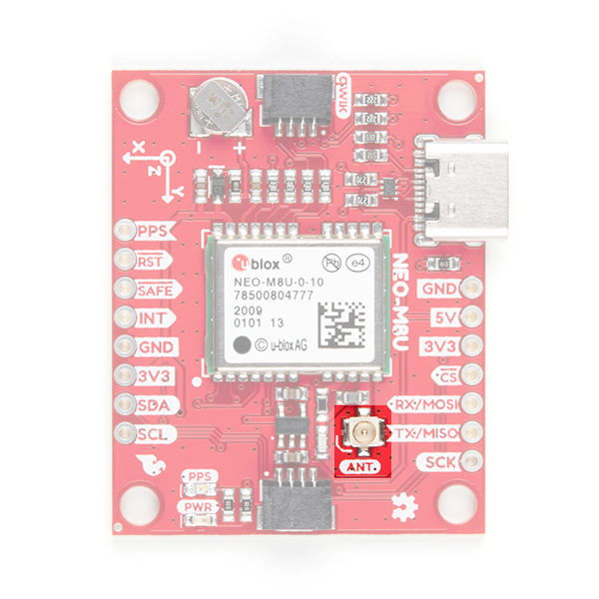

Qwiic and I2C

There are two pins labeled SDA and SCL which indicates the I2C data lines. Similarly, you can use either of the Qwiic connectors to provide power and utilize I2C. The [Qwiic ecosystem](https://www.sparkfun.com/qwiic) is made for fast prototyping by removing the need for soldering. All you need to do is plug a Qwiic cable into the Qwiic connector and voila!

The only I2C address for this and all u-Blox GPS products is **0x42**, though each can have their address changed through software.

SPI

There are four pins on the right most header that are labeled with their corresponding SPI functionality. As mentioned in the jumpers section, you'll need to close the SPI jumper on the underside to enable SPI.

UART

There are two pins on the right most header labeled for their UART functionality.

Broken Out Pins

There are four other pins broken out: Pulse per second (PPS), Reset (RST), Safeboot (SAFE), and finally the interrupt pin (INT). The first pin PPS, outputs pulse trains synchronized with the GPS or UTC time grid. The signal defaults to once per second but is configurable over a wide range. Read the **u-blox Receiver Protocol Specification** in the [Resources and Going Further](https://learn.sparkfun.com/tutorials/sparkfun-gps-dead-reckoning-neo-m8u-hookup-guide#resources-and-going-further) tab for more information. The reset pin resets the chip. The next pin, SAFE is used to start up the IC in safe boot mode, this could be useful if you somehow manage to corrupt the module's Flash memory. The final pin INT can be used to wake the chip from power save mode.

[3D IMU Orientation and Reference](https://learn.sparkfun.com/tutorials/sparkfun-gps-dead-reckoning-neo-m8u-hookup-guide/all" \l "axis)

For easy reference, we've documented the IMU's vectors with 3D Cartesian coordinate axes on the top and bottom side of the board. Make sure to orient and mount the board correctly so that the NEO-M8U can accurately calculate navigation information. This is explained in detail in the [Dead Reckoning Overview](https://learn.sparkfun.com/tutorials/sparkfun-gps-dead-reckoning-neo-m8u-hookup-guide#dead-reckoning-overview). Remember, it's all relative.

GPS Capabilities

The SparkFun NEO-M8U is able to connect to up to three different GNSS constellations at a time. Below are the listed capabilities of the GPS unit taken from the datasheet when connecting to different GNSS constellations.

|  |  |  |  |  |  |  |
| --- | --- | --- | --- | --- | --- | --- |
| **Constellations** |  | **GPS+GLO** | **GPSL** | **GLO** | **BDS** | **GAL** |
| **Horizontal Position Accuracy** | Autonomus | 2.5m | 2.5m | 4.0m | 3.0m | To Be Confirmed |
| with SBAS | 1.5m | 1.5m |  |  |  |
| **Max Navigation Update Rate** | PVT | 25Hz | 25Hz | 25Hz | 25Hz | 25Hz |
| **Time-To-First-Fix** | Cold Start | 24s | 25s | 26s | 28s | 29s |
|  | Hot Start | 2s | 2s | 2s | 2s | 2s |
| **Sensitivity** | Tracking and Navigation | -160dBm | -160dBm | -160dBm | -160dBm | -154dBm |
|  | Reacquisition | -160dBm | -159dBm | -156dBm | -155dBm | -152dBm |
|  | Cold Start | -148dBm | -147dBm | -145dBm | -143dBm | -133dBm |
|  | Hot Start | -157dBm | -156dBm | -155dBm | -155dBm | -151dBm |
| **Velocity Accuracy** |  | 0.05m/s | 0.05m/s | 0.05m/s | 0.05m/s | 0.05m/s |
| **Heading Accuracy** |  | 1deg | 1deg | 1deg | 1deg | 1deg |

Dead Reckoning Overview

As mentioned in the "[What is Dead Reckoning?](https://learn.sparkfun.com/tutorials/sparkfun-gps-dead-reckoning-neo-m8u-hookup-guide#what-is-dead-reckoning)" section, the u-blox M8U module has an internal inertial measurement unit or **IMU** for short. The IMU calculates position based on the last GNSS refresh and its own movement data points. To use the SparkFun GPS Dead Reckoning Board, there are a few guidelines to orienting and mounting the module to a vehicle outlined in the u-blox [ReceiverDescrProtSpec Datasheet](https://cdn.sparkfun.com/assets/learn_tutorials/1/1/6/6/u-blox8-M8_ReceiverDescrProtSpec__UBX-13003221__Public.pdf).

Orientation for the SparkFun Dead Reckoning

The SparkFun Dead Reckoning adheres to two particular frames of reference: one frame of reference for the car and the second a geodetic frame of reference anchoring it to the globe. The latter, known as the **local level frame** uses the following as its' axes:

* **X-axis** points to the **North**
* **Y-axis** points to the **East**
* **Z-axis** uses the right hand system by pointing **down**.

This frame will be referred to by its acronym **NED** (North-East-Down) in the image below.

The second frame of references is the **Body-Frame** reference and uses the following as *its'* axes.

* **X-axis** points to the **front** of the vehicle
* **Y-axis** points to the **right** of the vehicle
* **Z-axis** uses the right hand system by pointing **down**.

Vehicle Attitude

The transformation of the vehicle within these two frames are given as **heading**, **pitch**, and **roll**. In the datasheet these three angles are called the **vehicle's attitude**. Below is an image that illustrates how all of these elements fit together.

[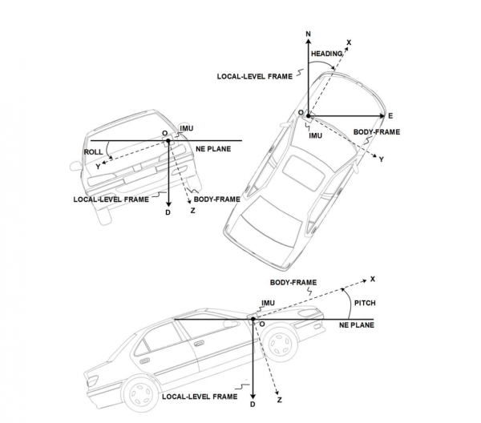](https://cdn.sparkfun.com/assets/learn_tutorials/1/1/6/6/IMU_Reference.png)

A slightly more detailed description of these frames can be found on page 106 of the [u-blox Receiver Description Datasheet.](https://cdn.sparkfun.com/assets/learn_tutorials/1/1/6/6/u-blox8-M8_ReceiverDescrProtSpec__UBX-13003221__Public.pdf)

Mounting the SparkFun Dead Reckoning NEO-M8U

**Note:** The axis for the board's installation frame is different from the local-level and body-frame. The local-level North-East-Down frame and the body-frame are transformations.

You can reference the IMU axes directly on the SparkFun Dead Reckoning NEO-M8U [silk in the corner closest to the battery](https://learn.sparkfun.com/tutorials/sparkfun-gps-dead-reckoning-neo-m8u-hookup-guide#axis).

The only guideline here is that the SparkFun Dead Reckoning is stable within 2 degrees, and of course that the X-axis points towards the front of the car as mentioned above.

In the image above the SparkFun Dead reckoning is seen in the front, driver's side of the car and it may be tempting to think that this is also a necessary requirement. However, it can be mounted anywhere within the vehicle (or RC-car, or boat). Keep in mind that the **pitch** and **roll** is relative to the SparkFun Dead Reckoning's position.

Calibration

After you've mounted the SparkFun Dead Reckoning M8U, there is still a calibration phase to complete that must satisfy the following movements:

* First, the car needs to be stopped with the engine turned on.
* Secondly, the car must do left and right hand turns.
* Lastly, the car must reach a speed over **30 km/h**.

In SparkFun's u-blox Arduino library, SparkFun has included an [Example](https://learn.sparkfun.com/tutorials/sparkfun-gps-dead-reckoning-neo-m8u-hookup-guide#example-1---calibrate-sensor) (shown below), that prints out the module's calibration status.

Example 1 - Calibrate Sensor

**Heads up!** Make sure stay focused when driving and obey all traffic laws when driving. Ensure that you are not distracted while operating a vehicle and are aware of your surroundings. For each example, make sure to plan your route accordingly to achieve the maneuvers. If you need, grab a friend and adult as you ride in the passenger seat. After you attempt these movements, park your car in a safe location and turn your engine off before checking the status or monitoring the readings!

**Note:** Dead reckoning calibration is intended for automobiles and is not supported for other modes of transportation such as walking, bicycling, or e-bicycling. The dead reckoning has been factory calibrated but the extra calibration steps shown below, are intended for automobiles only.  
  
Once calibrated, the NEO-M8U's readings will not be accurate if it is mounted on a different vehicle. You will need to re-calibrate the NEO-M8U should you decide to use the GPS module on a different vehicle.

Now that the SparkFun Dead Reckoning is mounted and oriented correctly with regards to the vehicle, it's time to calibrate the sensor. To do this, a few movements with the vehicle must be done all while maintaining good GNSS reception.

* First, the car needs to be stopped with the engine turned on.
* Secondly, the car must do left and right hand turns.
* Lastly, the car must reach a speed over **30 km/h**.

For the first example (located in **File Examples > SparkFun u-blox GNSS Arduino Library** > **Dead Reckoning** > **Example1_calibrateSensor**), the **calibration** status will be printed to the Arduino's serial monitor to indicate when calibration is ongoing and when it has completed.

In the first code block, there's a call to myGNSS.setI2COUtput(COM_TYPE_UBX) towards the bottom which turns off NMEA noise.

void **setup**() {

Serial.begin(115200);

**while** (**!**Serial); //Wait for user to open terminal

Serial.println("SparkFun Ublox Example");

Wire.begin();

**if** (myGNSS.begin() **==** false) //Connect to the Ublox module using Wire port

{

Serial.println(F("Ublox GPS not detected at default I2C address. Please check wiring. Freezing."));

**while** (1);

}

myGNSS.setI2COutput(COM_TYPE_UBX); //Set the I2C port to output UBX only (turn off NMEA noise)

}

The second code block below is where the heart of the sketch lives. The code pings the module to get its "ESF Info" (External Sensor Fusion Info), to see what Fusion Mode has been achieved. A *zero* indicates calibration while a *one* indicates **calibrated**.

void **loop**() {

**if** (myGNSS.getEsfInfo()){

Serial.**print**("Fusion Mode: ");

Serial.println(myGNSS.imuMeas.fusionMode);

**if** (myGNSS.imuMeas.fusionMode **==** 1)

Serial.println("Sensor is calibrated!");

}

delay(250);

}

If you have not already, select your Board (in this case the **Arduino Uno**), and associated COM port. Upload the code to the board and and set the serial monitor to **115200 baud.** Perform those fancy maneuvers (while obeying the traffic laws) before parking your car in a safe location. Then turn your engine off before checking the status! You should see a message indicating that the NEO-M8U is calibrated. If you do not, try driving around with the board once again!

Example 2 - IMU Data

After you have your sensor calibrated ([see example 1](https://learn.sparkfun.com/tutorials/sparkfun-gps-dead-reckoning-neo-m8u-hookup-guide#example-1---calibrate-sensor)), you can now poll the internal IMU to see what data is being fed to the GNSS calculations. Open the second example (located in **File Examples > SparkFun u-blox GNSS Arduino Library** > **Dead Reckoning** > **Example2_getIMUData**) to follow along! First, the sketch checks to see that the board is calibrated before it attempts to read IMU data.

{

Serial.begin(115200);

**while** (**!**Serial); //Wait for user to open terminal

Serial.println("SparkFun Ublox Example");

Wire.begin();

**if** (myGNSS.begin() **==** false) //Connect to the Ublox module using Wire port

{

Serial.println(F("Ublox GPS not detected at default I2C address. Please check wiring. Freezing."));

**while** (1);

}

myGNSS.setI2COutput(COM_TYPE_UBX); //Set the I2C port to output UBX only (turn off NMEA noise)

**if** (myGNSS.getEsfInfo()){

Serial.**print**("Fusion Mode: ");

Serial.println(myGNSS.imuMeas.fusionMode);

**if** (myGNSS.imuMeas.fusionMode **==** 1){

Serial.println("Fusion Mode is Initialized!");

}

**else** {

Serial.println("Fusion Mode is either disabled or not initialized - Freezing!");

Serial.println("Please see Example 1 description at top for more information.");

}

}

}

Next, the sketch grabs that IMU data which is stored in a **struct** called imuMeas.

void **loop**() {

**if** (myGNSS.getEsfIns()) {

Serial.**print**("X: ");

Serial.println(myGNSS.imuMeas.xAngRate);

Serial.**print**("Y: ");

Serial.println(myGNSS.imuMeas.yAngRate);

Serial.**print**("Z: ");

Serial.println(myGNSS.imuMeas.zAngRate);

Serial.**print**("X Acceleration: ");

Serial.println(myGNSS.imuMeas.xAccel);

Serial.**print**("Y Acceleration: ");

Serial.println(myGNSS.imuMeas.yAccel);

Serial.**print**("Z Acceleration: ");

Serial.println(myGNSS.imuMeas.zAccel);

// These values also have "validity checks" that can be provided by the

// ublox library, add "Vald" to values: e.g. xAngRateVald or xAccelVald.

}

delay(250);

}

If you have not already, select your Board (in this case the **Arduino Uno**), and associated COM port. Upload the code to the board and set the serial monitor to **115200 baud**. This may be a good time to bring a friend along to drive if you decide to actively monitor the output. Otherwise, check out the data after taking the board for a stroll. Try driving around as the board senses the car's movement. Then park in a safe location with the engine turned off before inspecting the data.

Example 4 - Vehicle Dynamics

What happened to Example 3? It's been skipped over because its used primarily as a diagnostic sketch. What sensors are currently being used, are they functioning correctly, are the measurements being listed as bad or non-existent? Example 3 helps diagnose these various issues. Lets move ahead to the fourth example in the library (located in **File Examples > SparkFun u-blox GNSS Arduino Library** > **Dead Reckoning** > **Example4_vehicleDynamics**)

The **vehicle attitude** is a termed coined by u-blox that encompasses three measurements: **vehicle pitch**, **vehicle roll**, and **vehicle heading**. Much like the other example sketches, this one checks to make sure that the SparkFun Dead Reckoning NEO-M8U has been calibrated before pulling data.

**if** (myGNSS.getEsfInfo()){

Serial.**print**("Fusion Mode: ");

Serial.println(myGNSS.imuMeas.fusionMode);

**if** (myGNSS.imuMeas.fusionMode **==** 1){

Serial.println("Fusion Mode is Initialized!");

}

**else** {

Serial.println("Fusion Mode is either disabled or not initialized - Freezing!");

Serial.println("Please see Example 1 description at top for more information.");

}

}

}

If the SparkFun Dead Reckoning NEO-M8U has indeed been calibrated, then it gets the relevant information by calling myGNSS.getVehAtt(). As in Example 2, the data is stored within a *struct* called **vehAtt**.

Void **loop**(){

myGNSS.getVehAtt(); // Give the sensor you want to check on.

Serial.**print**("Roll: ");

Serial.println(myGNSS.vehAtt.roll);

Serial.**print**("Pitch: ");

Serial.println(myGNSS.vehAtt.pitch);

Serial.**print**("Heading: ");

Serial.println(myGNSS.vehAtt.heading);

Serial.**print**("Roll Accuracy: ");

Serial.println(myGNSS.vehAtt.accRoll);

Serial.**print**("Pitch Accuracy: ");

Serial.println(myGNSS.vehAtt.accPitch);

Serial.**print**("Heading Accuracy: ");

Serial.println(myGNSS.vehAtt.accHeading);

delay(250);

}

If you have not already, select your Board (in this case the **Arduino Uno**), and associated COM port. Upload the code to the board and set the serial monitor to **115200 baud**. This may be a good time to bring a friend along to drive if you decide to actively monitor the output. Otherwise, check out the data after taking the board for a stroll. Try driving around as the board senses the car's movement. Then park in a safe location with the engine turned off before inspecting the data.

* **SparkFun u-Blox NEO-M8U with Chip Antenna**
  + [Schematic (PDF)](https://cdn.sparkfun.com/assets/3/0/c/5/4/SparkFun_NEO-M8U_Schematic.pdf)
  + [Eagle Files (ZIP)](https://cdn.sparkfun.com/assets/4/a/8/5/c/SparkFun_NEO-M8U.zip)
  + [Board Dimensions (PNG)](https://cdn.sparkfun.com/assets/0/4/c/6/9/SparkFun_NEO-M8U_Untethered_Dead_Reckoning_GPS_Board_Dimensions.png)
* [**u-blox NEO-M8U Module Documentation and Resources**](https://www.u-blox.com/en/product/neo-m8u-module)
  + [NEO-M8U Datasheet (PDF)](https://cdn.sparkfun.com/assets/6/d/7/c/6/NEO-M8U_DataSheet__UBX-15015679_.pdf)
  + [Protocol Summary (PDF)](https://cdn.sparkfun.com/assets/9/a/d/7/f/NEO-M8U_ProductSummary__UBX-15013483_.pdf)
  + [Integration Manual (PDF)](https://cdn.sparkfun.com/assets/7/0/f/5/d/NEO-M8U_HardwareIntegrationManual__UBX-15016700_.pdf)
  + [u-blox Protocol Specification (PDF)](https://cdn.sparkfun.com/assets/c/f/d/8/a/u-blox8-M8_ReceiverDescrProtSpec__UBX-13003221__Public.pdf)
  + [UDR Whitepaper (PDF)](https://cdn.sparkfun.com/assets/learn_tutorials/1/1/6/6/UDR_whitepaper__UBX-16000376__0.pdf)
  + [u-center Software](https://www.u-blox.com/en/product/u-center)
* **GitHub**
  + [SparkFun u-blox Arduino Library](https://github.com/sparkfun/SparkFun_u-blox_GNSS_Arduino_Library)
  + [Product Repo](https://github.com/sparkfun/SparkFun_u-blox_NEO-M8U)
  + [SFE Product Showcase](https://www.youtube.com/watch?v=4Q9fT6ePqBo)