|  |  |  |  |
| --- | --- | --- | --- |
| **Plane** | **Wing Area** | **Max loaded mass** | **Thrust** |
| B-737Max | 127 m2 | 80,000 kg | 2 x 119kN |
| B-787 | 377 m2 | 227,000 kg | 2x280kN |

1mph = .45 m/s, 1 knot (kt) = 1.15 mph. 1 Pa = 1 nt/m2. 737 takeoff: 150 knots.

*Lift coefficient, CL*: CL=L/[1/2ρV2S]. Drag coefficient, CD: CD=D/[1/2ρV2S]. Note that the *angle of attack,*α, is defined as the *angle between the wing or airfoil chord and the freestream velocity vector*, not between the velocity and the horizontal.

*Ideal or Perfect Gas Equation of State*: P=ρRT. *Bernoulli’s Equation*: P + ½*ρ*V2 = P0.

Bernoulli’s equation is only guaranteed to hold true along a streamline or path in a flow.

Deflecting a split flap with a length of 20% of the airfoil chord to an angle of 60 degrees increases the maximum lift coefficient 1.6 to 2.

-2.0 < CL < +2.0 for a normal wing or airfoil with no flaps

-3.0 < CL < +3.0 for a wing or airfoil with flaps

0.005 < CD < 0.025 for a wing or airfoil (more for a whole airplane)

-0.1 < CM < 0.0 for a wing or airfoil when measured at c/4

Let’s look at the use of Bernoulli’s equation for the case shown below of a wing moving through the air at 100 meters/sec. at an altitude of 1km.

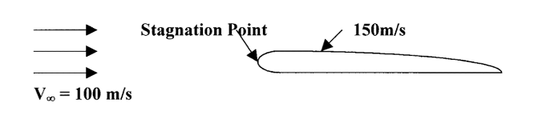

We want to find the pressure at the leading edge of the wing where the flow comes to rest (the ***stagnation point***) and at a point over the wing where the speed has is 150 m/s.

First, note that the case of the wing moving through the air has been portrayed as one of a stationary wing with the air moving past it at the desired speed. This is standard and it can be shown that the answers one finds using this method are the correct ones.

At the stagnation point: Pstagnation = P0 = 95430 Pa

Now let’s review the steps in working any problem with Bernoulli’s equation. *First,* we must sketch the flow and write down everything we know at various points in that flow. *Second*, we must write Bernoulli’s equation at every point in the flow where we either know information or want to know something. *Third,* we must carefully assess which pressure, if any, can be obtained from the standard atmosphere table. *Fourth*we must look at all these points in the flow and see which point gives us enough information to solve for the total pressure (P0). *Finally,*we use this value of P0 in Bernoulli’s equation at other points in the flow to find the other missing terms

As air moves over a wing it accelerates to speeds higher than the “free stream” speed. In other words, *at a speed somewhat less than the speed of sound, the speed on top of the wing may have reached speeds greater than the speed of sound*. This does not cause any problem. *It is slowing the flow down again that is problematic*. Supersonic flow does not like to slow down and often when it does, it does it quite suddenly, through a ***“shock wave”.***  A shock wave is a sudden deceleration of a flow from supersonic to subsonic speed with an accompanying increase in pressure (remember Bernoulli’s equation). This sudden pressure change can easily cause the flow over the wing to break away or ***separate***, resulting in a large wake behind the wing and an accompanying high drag.

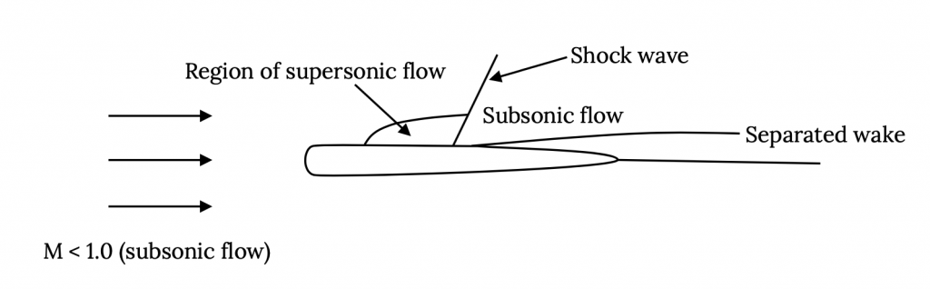

At some high but subsonic speed supersonic flow over the wing has developed to the extent that a shock forms, and drag increases due to a separated wake and losses across the shock. The point where this begins to occur is called the ***critical Mach number, Mcrit.***Mcrit will be different for each airfoil and wing shape.

Once the plane is supersonic, there are actually two shocks on the wing, one at the leading edge where the flow decelerates suddenly from supersonic freestream speed to subsonic as it reaches the stagnation point, and one at the rear where the supersonic flow over the wing decelerates again. As a result, the “sonic boom” one hears from an airplane at supersonic speeds is really two successive booms instead of a single bang.

Reynolds Number may be seen in different texts abbreviated in different ways [Re, Rn, R, Rex, etc.] depending on the convention in the field of use and on its application. Here we will use **Re**.

ρRe=[ρVI]/μ

Reynolds number is really a ratio of the inertial forces and viscous forces in a fluid and is, in a very real way, a measure of the ability of a flow to follow a surface without separating. The Reynolds number is also an indicator of the behavior of a flow in a thin region next to a body in a flow where viscous forces are dominant, determining whether that flow is well behaved (*laminar*) or randomly messy (*turbulent*). This thin region is called the *boundary layer*. In general, a *laminar boundary layer*, which occurs at *lower Reynolds Numbers*, results in *low friction drag* (skin friction) but isn’t very good at resisting separation and may promote a *large “wake” drag*. A *turbulent boundary layer*, which occurs at *higher Reynolds Numbers*, has *higher friction drag* but resists flow separation better leading to *lower “wake” drag*.

We also need to define the way we relate the orientation of the wing to the flow; i,e., the wing or airfoil *angle of attack****,***α.

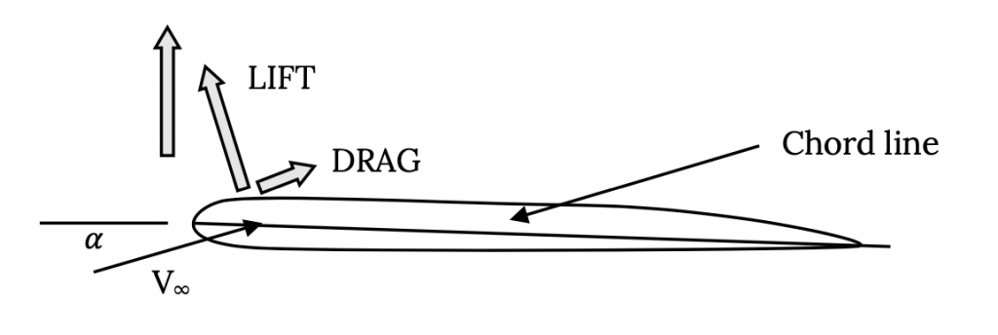

W=L=CLmax(1/2)ρVstall2S

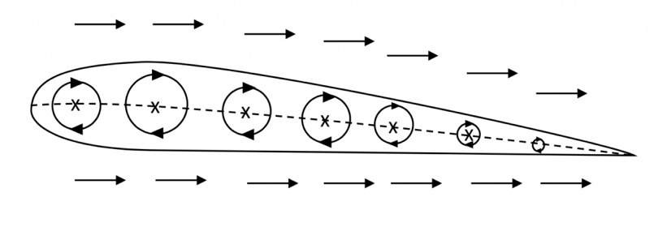

These “circular” flows are known as ***vortices*** (a single circular flow is a *vortex*) and they are the mathematical equivalent of a little tornado. It turns out that vortices are very important flows in aerodynamics and they occur physically in many places. Of course, there are no vortices in the middle of a wing. Here, we are just using a real physical flow, a vortex, to create a mathematical model that gives us the result that we know actually exists.

Friction: concrete 0.03.

The approach‑to‑landing descent will probably be made using full flaps, at least in its final “glide” (this will be true for almost any aircraft). This will lower the stall speed and allow approach and touchdown at a lower flight speed. It will also steepen the approach glide and, on the ground, add to the drag to help slow the aircraft.

As soon as the pilot feels that the aircraft is under full control after touchdown, he or she may raise the flaps. While this reduces the drag and contributes to a longer ground roll, it also reduces the lift, increasing ground friction forces and allowing better directional control of the aircraft in a crosswind.