F-SAR ICESAR 2019 SAR images at L, C, X-band

For each band, they are splittet into 10 segments (10, 10R, 11, … 14, 14R). They are delivered as stacks of 15 layers:

Layer 1: Phase HH-VV in deg

Layer 2: Correlation HH-VV

Layer 3: sigma VV in dB

Layer 4: sigma VV linear

Layer 5: gamma VV in dB

Layer 6: gamma VV linear

Layer 7: sigma HV in dB

Layer 8: sigma HV linear

Layer 9: gamma HV in dB

Layer 10: gamma HV linear

Layer 11: sigma HH in dB

Layer 12: sigma HH linear

Layer 13: local incidence angle

Layer 14: gamma HH in dB

Layer 15: gamma HH linear

The ending of these files is either missing or it is .dat.

For use in ENVI there is also a .hdr file and a .enp file (the letter for building a pyramid, not necessarily needed)

All images are geocoded. The images of the different frequencies match one another.

Example:

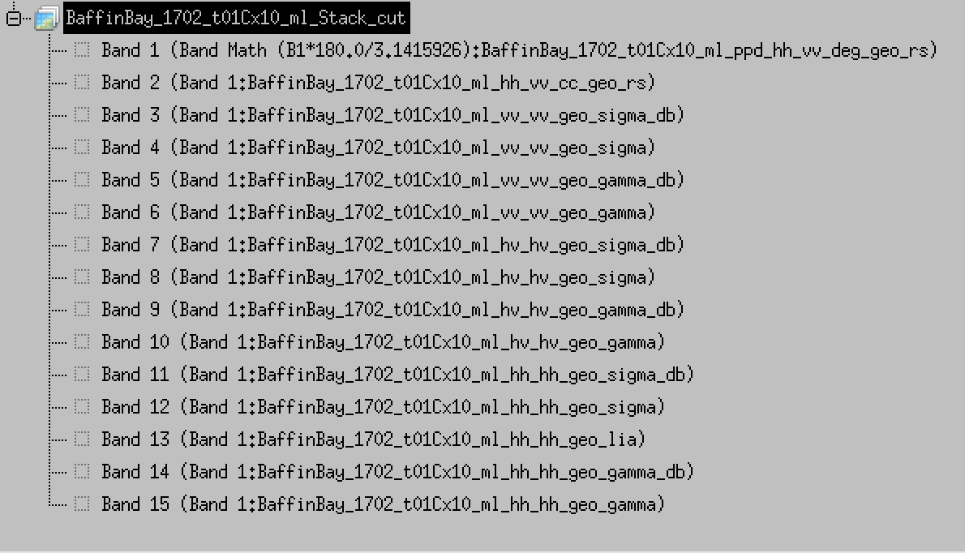

From .hdr file:

ENVI

samples = 3340

lines = 1080

bands = 15

data type = 4

(A 32-bit, single-precision, floating-point number in the range of ±1038, with approximately six or seven significant digits.)

interleave = bsq

(Band Sequential: BSQ format is the simplest format, where each line of the data is followed immediately by the next line in the same spectral band)

file type = ENVI Standard

header offset = 0

byte order = 0

map info = {UTM, 1.000, 1.000, 528600.000, 7025001.000, 3.000000e+00, 3.000000e+00, 20, North, WGS-84, units=Meters}

coordinate system string = {PROJCS["UTM_Zone_20N",GEOGCS["GCS_WGS_1984",DATUM["D_WGS_1984",SPHEROID["WGS_1984",6378137.0,298.257223563]],PRIMEM["Greenwich",0.0],UNIT["Degree",0.0174532925199433]],PROJECTION["Transverse_Mercator"],PARAMETER["False_Easting",500000.0],PARAMETER["False_Northing",0.0],PARAMETER["Central_Meridian",-63.0],PARAMETER["Scale_Factor",0.9996],PARAMETER["Latitude_Of_Origin",0.0],UNIT["Meter",1.0]]}

x start = 444. (attention: x- and y_start are related to the original files which were larger)

y start = 348

band names = {

Band 1 (Band Math (B1*180.0/3.1415926):BaffinBay_1702_t01Cx10_ml_ppd_hh_vv_deg_geo_rs),

Band 2 (Band 1:BaffinBay_1702_t01Cx10_ml_hh_vv_cc_geo_rs),

Band 3 (Band 1:BaffinBay_1702_t01Cx10_ml_vv_vv_geo_sigma_db),

Band 4 (Band 1:BaffinBay_1702_t01Cx10_ml_vv_vv_geo_sigma),

Band 5 (Band 1:BaffinBay_1702_t01Cx10_ml_vv_vv_geo_gamma_db),

Band 6 (Band 1:BaffinBay_1702_t01Cx10_ml_vv_vv_geo_gamma),

Band 7 (Band 1:BaffinBay_1702_t01Cx10_ml_hv_hv_geo_sigma_db),

Band 8 (Band 1:BaffinBay_1702_t01Cx10_ml_hv_hv_geo_sigma),

Band 9 (Band 1:BaffinBay_1702_t01Cx10_ml_hv_hv_geo_gamma_db),

Band 10 (Band 1:BaffinBay_1702_t01Cx10_ml_hv_hv_geo_gamma),

Band 11 (Band 1:BaffinBay_1702_t01Cx10_ml_hh_hh_geo_sigma_db),

Band 12 (Band 1:BaffinBay_1702_t01Cx10_ml_hh_hh_geo_sigma),

Band 13 (Band 1:BaffinBay_1702_t01Cx10_ml_hh_hh_geo_lia),

Band 14 (Band 1:BaffinBay_1702_t01Cx10_ml_hh_hh_geo_gamma_db),

Band 15 (Band 1:BaffinBay_1702_t01Cx10_ml_hh_hh_geo_gamma)}