# Database Textual Description: Rio Olympic Tickets

The Rio Olympic Games Organising Committee (herein ROCO) want to be able to track tickets to the 2016 Summer Olympic Games (herein the Games). Accordingly ROCO have commissioned Newton’s Nerds to design a database management system for them. Managing tickets to the Games is a considerable challenge because of the large number of tickets involved. It has been estimated that a total of 7.5 million tickets will be needed to cover all of the seats for the events throughout the Games.[1] Some sample tickets are shown in figure 1.

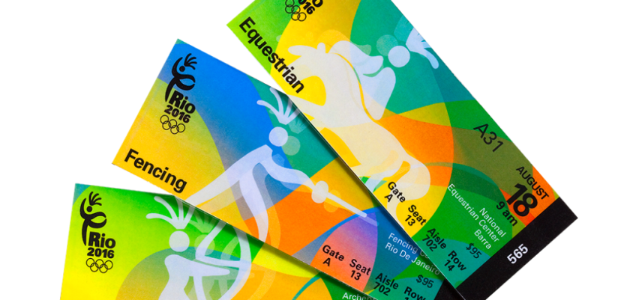

Figure 1 – Tickets to Rio 2016[2]

### Tickets

A **ticket** contains a large amount of information including: a barcode (used to uniquely identify each ticket), event details, venue name and seat details. All tickets costs are in USD and will be less than USD $200.

|  |  |  |  |  |
| --- | --- | --- | --- | --- |
| **Ticket** | | | | |
| Barcode | event_name | venue_name | seat_code | round_no |

### Events

An **event** can have number of properties including: sport (e.g. running), an event name (e.g. 400m sprint), round (e.g. 3rd round of 400m Sprint Event), participating_countries, venue name, and date and time.

|  |  |  |  |  |
| --- | --- | --- | --- | --- |
| **Event** | | | | |
| Sport | event name | round_no | participating_countries | date and time |

### Seats

Depending on the venue, a **seat** can have a number properties including: the gate that the participant must enter from, the aisle code, the seat code, and the seat class (e.g. Class A, Class B or VIP). Seat code is number less than 999999. The seat code uniquely identifies a seat for a given event where the first three digits represent the seat’s row and the last three for the position in the row.

|  |  |  |  |  |  |
| --- | --- | --- | --- | --- | --- |
| **Seat** | | | | | |
| gate | aisle | venue_name | seat_code | event | seat_class |

### Ticket Status

Throughout the life of a ticket, the **status** of a ticket will be managed by the ROCO ticketing team. Having a ticket status allows ushers to track if a ticket is valid. Tickets can have one, and only one, status at any time. At the time a ticket is ordered the status becomes “ordered”. After ordering a ticket is printed and mailed to a spectator. Upon mailing a ticket’s status is set to “active”. Upon use at a venue at the time of the event a ticket becomes “used”. If a ticket is declared lost not less than one week prior to an event being held a fee, a spectator can request, for an extra fee, that the ticket be reissued. If a ticket is reissued then the original ticket’s status is set to “lost” and a new ticket is issued with the status of “ordered”.

|  |  |
| --- | --- |
| **Ticket Status** | |
| Ticket Barcode | Status |

### Spectators

To minimise scalpers, ROCO’s security team has asked for tickets to be linked back to **spectators**. The following information is kept about spectators: name, address, ISO-2 code for country of origin, state, identifying document type (e.g. passport, driver’s license, social security card etc. and document unique identifier e.g. passport number, license number, social security number etc.). The ISO-2 country code standard holds that each country must be represented by a unique two letter long code (for example AU for Australia)[3].

|  |  |  |  |  |  |
| --- | --- | --- | --- | --- | --- |
| **Spectator** | | | | | |
| Name | address | iso-2 code for country of origin | o_state | identifying document type | document unique identifiers |

Despite the name, document unique identifiers do not uniquely identify the individual as more than one class of document is permitted. For example two people may have the same driver’s license number but it was issued from a different state or country. The purpose of the unique identifier is to make ticket scalping more difficult by providing a cross check with names not to uniquely identify the individual.

### Participating_countries

The ISO-2 country code assigned to each country and each participating country must be represented by a unique two letter long code (for example AU for Australia)[4]. Each ISO-2 code must be unique.

|  |  |
| --- | --- |
| **Participating_countries** | |
| iso | country_name |

### Transactions

The transaction number is generated by separate (external software). The database just receives the number and stores it. Here the transaction is defined as a weak entity, its key can only be generated if a spectator entry exists to be assigned with the transaction number.

|  |  |  |  |  |
| --- | --- | --- | --- | --- |
| **Transactions** | | | | |
| transaction_number | iso-2 code for country of  origin | state | identifying document  type | document  unique identifiers |

1. <http://rio2016olympicswiki.com/wp-content/uploads/2015/03/Rio-2016-Tickets.jpg>
2. <http://www.ritz-g5.com/rio-2016-sells-240000-tickets-in-eight-hours/>
3. <http://www.nationsonline.org/oneworld/country_code_list.htm>
4. <http://www.nationsonline.org/oneworld/country_code_list.htm>