Software Manual for PM-04n

Author: | Ing. Jan Lochman
Email: | jan.lochman@icloud.com
Telephone: | +420 604 658 921
Company: | VEZAS s.r.o.
Written:

Contents

Chapter

Introduction
This text describes the software for PM-04n measuring instrument. Software is designed for controlling two PM-04n’s simultaneously. Technically, in software, there are two almost independent windows for each PM-04n instrument. These windows share some configuration parameters and database, which stores the saved measurements, but the measuring procedures are completely separate.
In the first Chapter, the hardware will be presented. This includes the requirements on the computer running the program and basic description of two regulators which are inside the PM-04n instrument, together with description of their communication with PC.
The program is described in the second Chapter. Here, some remarks on installation are presented. There are some built-in constants, which user is not allowed to change - these constants will be presented in this Chapter as well. The biggest part of this Chapter is a description of graphical blocks of the program, so called GUI (graphical user interface).
In the last Chapter, the instructions for measuring and calibration procedures are presented. These should provide an user everything, what he needs, to operate this software.
Chapter 1

Hardware

1.1 Computer
Program is compiled as a 32-bit Windows application. It was successfully tested on both 32 and 64-bit versions of Windows XP, Windows 7 and Windows 8.1. It is not possible to run this program on different OS, such as Linux or OSX, without a proper Windows emulator.
PC requirements depend on the version of Windows, you are running on PC, where you want this program to be installed. Generally, 2 GHz CPU, 2 GB RAM, 1 GB Hard Drive free space, 256 MB Graphics Memory and Ethernet Connection should be enough for fluent run of the program, delivering enough disc space for storing thousands of measurements.

1.2 Regulators
PM-04n instrument contains two regulators, through which the program reads the instrument status and controls the measurement. Their description follows in this Section.

1.2.1 Eurotherm e3508
The first of these regulators, which can be seen on the front panel of the PM-04n instrument, is Eurotherm e3508 (Figure 1.1). The purpose of this regulator, is to control the furnace temperature, including the turning on/off the cooling ventilator and safety insurance to ensure the temperature in the furnace does not exceed the maximum allowed value.

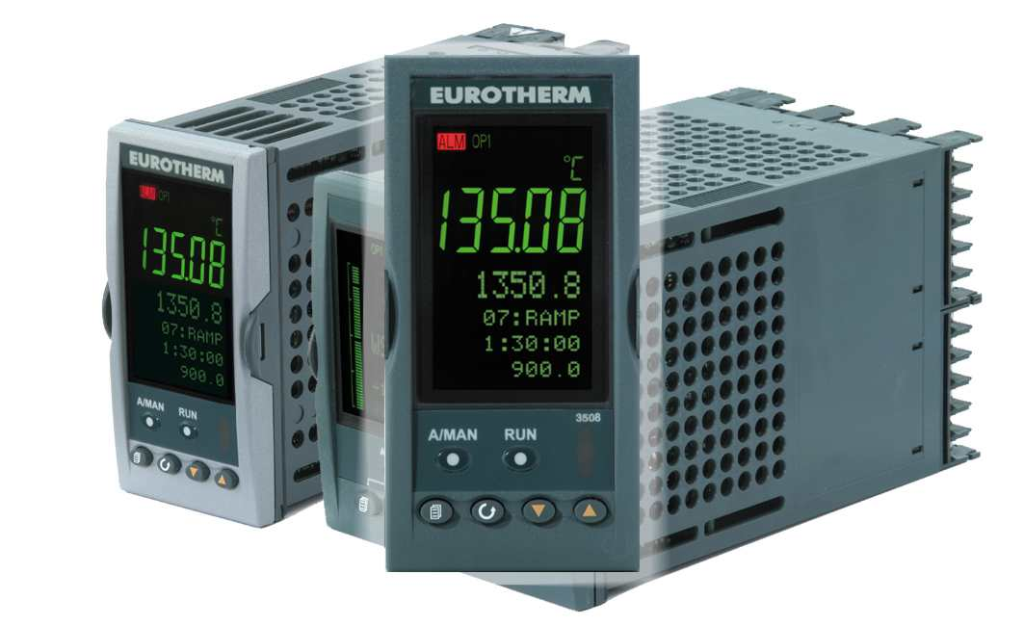
Figure 1.1: Eurotherm e3508 front view
Rare view of this regulator is shown in Figure 1.2. Table 1.1 shows the electrical connections, which are in PM-04n instrument in usage, together with their purpose. Safety relay turns the heating off, when the temperature in furnace exceeds . The meaning of the remaining connections should be apparent.
Eurotherm has its own program, independent on the PC. This program controls, e.g., the turning ventilator on/off, turning the safety relay on/off or PID regulation of furnace heating which ensures, the desired temperature is reached effectively.

Connection | Usage
1A:1B | Furnace
2A:2B | Ventilator
V+:V- | Thermocouple
AB:AC | Safety relay
HA..HF | Ethernet

Table 1.1: Eurotherm electrical connection.

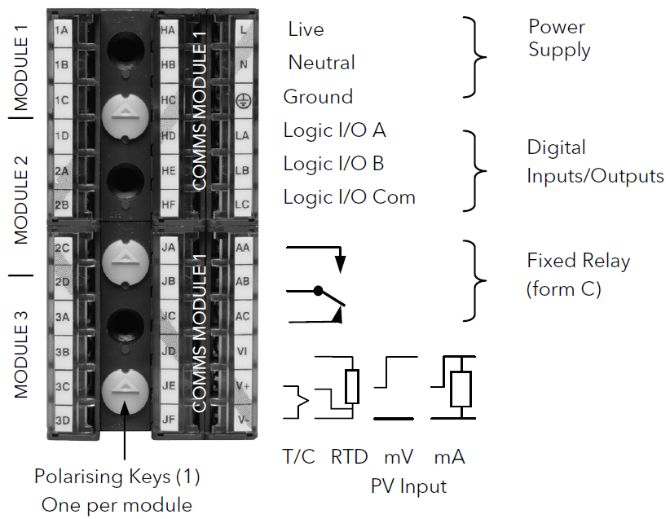
Figure 1.2: Eurotherm e3508 rare view
Program reads/writes from/to e3508 the values on addresses shown in Table 1.2. Here, ramp units are chosen to be and ramp speed defines a speed, by which the temperature in furnace should be increased until the desired temperature is reached.

Address | Meaning
2 | Reading thermocouple temperature
3 | Writing desired temperature
36 | Writing ramp speed
532 | Writing ramp units

Table 1.2: Eurotherm addresses used in the program.
More information about this regulator can be found on the official pages of Eurotherm Company http://www.eurotherm.com. On these pages, the basic software package, caled iTools, for Eurotherm devices can be downloaded.

1.2.2 LabJack T7
The second regulator, which can be found in PM-04n instrument, is LabJack T7 (Figure 1.3). This regulator is hidden inside the PM-04n instrument and its purpose is to control the measuring head. This includes the reading the position of the head, controlling its movement up/down and the most importantly, LabJack controls the rotational motor and measures the disc rotational speed.

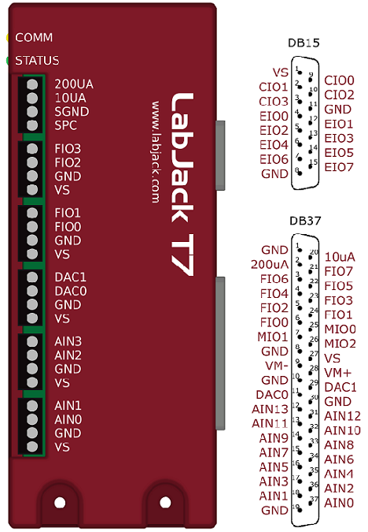
Figure 1.3: LabJack T7
Connections, which are used, together with their usage description, are shown in Table 1.3. Rotational speed of the head is controlled by the voltage of the DC motor.

Connection | Usage
DAC0 | Writing DC motor voltage
CIO2 | Reading and Reseting counter
EIO0 | Reading, if the head is down
EIO1 | Writing to head goes down
EIO2 | Reading, if the head is up
EIO3 | Writing to head goes down
EIO5 | Writing to turn the rotation on/off

Table 1.3: Labjack Connections and addresses used in the program.
More information about this regulator can be found on the official pages of LabJack Company http://labjack.com. On these pages, the software package can be downloaded under the LabJack T7 bookmark. To connect to LabJack T7, the Kipling program serves.

1.3 Communication
Communication is done using TCP/IP protocol. Each device, namely PC, Eurotherm and LabJack, must have defined its own unique IP address and all devices have to be in local area network. Program is designed to be able to control two PM-04n instruments simultaneously, so be sure, each device has its own unique IP address.
IP address of Eurotherm, can be found/changed using the official software of Eurotherm Company, which was mentioned at the end of the Section 1.2.1. LabJack IP address can be found/changed with the official software of the LabJack Company - Section 1.2.2. Predefined addresses are shown in Table 1.4 - please, change them with caution.

Instrument | Device | IP
 | PC | 192.168.1.2
2*PM-04n 1 | Eurotherm | 192.168.1.233
 | LabJack | 192.168.1.208
2*PM-04n 2 | Eurotherm | 192.168.1.234
 | LabJack | 192.168.1.209

Table 1.4: IP addresses.
Chapter 2

Program

2.1 Installation
There is no installation package for PM-04n controlling software. There are only a few files, which have to be copied into selected directory on hard drive (I recommend using C:/Program Files/Plastometer/*). Please, make sure, that users have read/write/modify privileges in that directory to avoid the data loss.

2.1.1 File System
Files needed by program are shown in Figure 2.1.

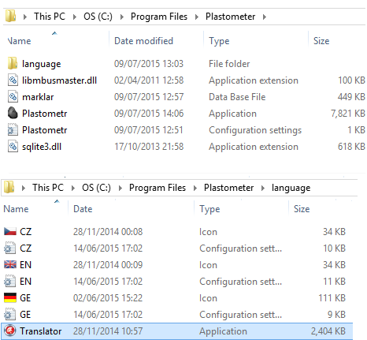
Figure 2.1: File System
• libmbusmaster.dll, sqlite3.dll
These are the external libraries which program needs to read/save data and to communicate with Eurotherm regulator.
• marklar.db
Stores all measurements. To create back-up of measured data, please, store this file.
• Plastometr.exe
Executable file by which the program is started.
• Plastometr.ini
Configuration file, which stores the configuration.
• langauge/CZ.ini, EN.ini, GE.ini
Different language versions of program are loaded from these files.
• language/Translator.exe
Little application for simple translation between different language versions.

2.2 Built-in Constants, Definitions
Although there are some values, user can change in GUI of the program, there are also some fixed, unchangeable, built-it constants, which are hidden from user.
• MIN_TEMP_MOVE = 240 C
When the measurement is running, then the movement of head is blocked by the program, if the temperature is below this value. Reason: Stannum in furnace could have not be melted and the user could damage the instrument.
• MAX_TEMP = 600 C
When the measurement is running and the temperature ramp is on, this is the temperature, at which the measurement will be stopped by the program. Reason: Eurotherm regulator has built-in safety relay, which turns the heating off at MAX_TEMP.
• QUIT_TEMP = 20 C
When the program is quit and regulators are still connected, this temperature is written on regulators. Reason: Instruments may be still on. This should ensure, the instrument will cool down.
• TOLER_TEMP = 5 C
If the program has to check, if the desired temperature has been reached, then this is the allowed tolerance, i.e., if the temperature is in interval , then is assumed to be reached.
• RAMP_TEMP = 3 C/min
The rate the furnace is increasing its temperature with time during a measurement.
• STAB_TIME = 600 s
During measurement, when the retort goes down to the furnace, this is the dead time, during which the temperature in furnace has time to stabilize. If it stabilizes, then measurement goes on, if not, the measurement stops.
• TOLER_TEST = 50
When the sample is prepared, the user has chance to perform a test on sample, i.e. try to shortly attach voltage three times greater than the voltage attached during the measurement. If there is fewer than 50 pulses counted during the test, the test is marked as OK.
Each partial measurement has as a result 5 constants
• T1
Temperature, at which the first pulse was measured.
• T2
Temperature, at which the maximum value of pulses per minute was reached.
• T3
Temperature, at which the last pulse was measured.
• fmax
Maximum value of pulses per minute measured. This occurs at temperature T2.
• ftotal
Total value of pulses measured during measurement.

2.3 Graphical User Interface
In this Section, the basic blocks of the program GUI (graphical user interface) are described. In can be seen, that most of the following figures, contain the blue question mark in it. By clicking on this question mark, a little help is displayed inside the program, which, in the most cases, should answer an user question. For more concise information about GUI, you are welcome in this Section.

2.3.1 Top Panel
Top panel is shown in Figure 2.2. It can be seen, the Top Panel is divided into two parts. The top part serves for switching between PM-04n instruments, the bottom part offers some basic features including saving measurements/connecting to regulators/starting measurement.
Firstly, let’s look at the structure of the top part. User can switch between 3 tabs. The first two tabs are named according to the following logic
• Instrument Name
The name of the instrument the tab switches to. This can be changed in the Settings bookmark (see Section 2.3.3). In Figure 2.2, the instruments are named Left and Right.
• Measurement Number
Each measurement has its own unique number. Here is shown the number of active measurement. If the number is #-1, then the measurement is new and not saved yet. After saving, the number is automatically assigned.
• Connection Status
CONNECTED or DISCONNECTED.
• Measuring Status
MEASURING or PAUSED. In the first case, the measured temperature and dd/min are shown also.

Figure 2.2: Top Panel
The last tab contains only Instrument 1 Name | Instrument 2 Name and should be used during measurement, where I recommend the program lookup as shown in Figure 2.3.
The bottom part of the Top Panel contains some image buttons, which have some built-in hint help. These buttons are
• Create a New Measurement
A new measurement is prepared. Data are cleared, graph emptied and the Measurement Number is changed to −1. This number changes after saving the measurement.
• Save/Update Measurement
The actual measurement is either saved or updated.
• Create a Protocol and Export Data
There is a fixed path, where all the protocols and data are exported. This path is defined in configuration file Plastometr.ini under ProtocolPATH= and can be changed here. By default, this path is set to /Desktop/Protocols/. Inside this directory, program creates a new directory with the structure
MeasurementNumber_SampleName_SomeOtherNumber/
and adds two files in it. First of these is a protocol in pdf format, which is shown in Section 2.3.8 and the second is exported data in txt format, which is described in more details in Section 2.3.9.
• Create a Connection with Regulators
Connects to both regulators. There are some messages which should help detect a problem, if there is any. If the connection is not successful, try to connect again.
• Disconnect from Regulators
Connection to both regulators is closed. If program is measuring, then the measurement is stopped.
• Start Measurement
Starts the measurement and the periodic reading data from instrument. The starting temperature (see Section 2.3.6) is automatically written and Settings and aList of Measurements bookmarks are disabled. Note that buttons controlling the head movement up/down are enabled only when temperature is above a certain threshold (see Section 2.2).
• Stop Measurement
Stops the measurement and the periodic reading data from instrument. The head rotation is disabled, Settings and List of Measurements bookmarks are enabled and the buttons controlling the head movement up/down are enabled.
• Language Buttons
Switches between different language versions of the program.

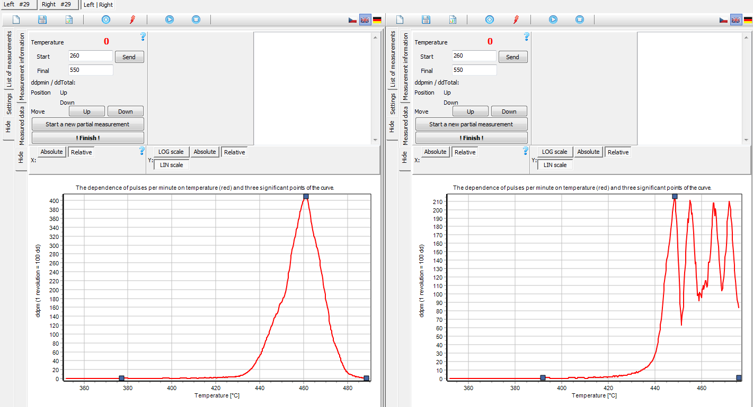
Figure 2.3: Recommended program lookup for measuring on two PM-04n’s simultaneously.

2.3.2 List of Measurements
First of the bookmarks on the left is the List of Measurements bookmark. It is shown in Figure 2.4 and its purpose is to search in the saved measurements. Measurement is loaded after mouse click on it in the table. There are two ways, how to find the desired measurement.

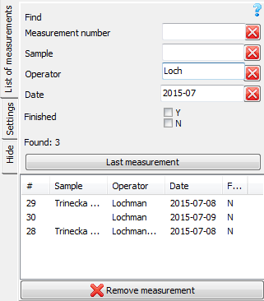
Figure 2.4: List of Measurements bookmark
1. According to the Measurement Number
In this case, you simply enter the measurement number into the Measurement Number edit. If the measurement with this number exists, it is shown in table, if not, the table is left empty.
2. According to the Remaining Parameters
There are 4 additional parameters, you can search by, namely
• Sample
• Operator
• Date (in format YYYY-MM-DD)
• Finished
In the table, the measurements fulfilling all the criteria, you enter, are displayed. In the example in Figure 2.4, the measurements performed in 2015-07 with operator starting at Loch are displayed.
Next, the number of found measurements is shown. You can go to the last measurement by pressing the Last Measurement button. It is also possible to remove selected measurement by pressing the Remove Measurement button at the bottom.

2.3.3 Settings
Next to the List of Measurements bookmark, there is the Settings bookmark. This is shown in Figure 2.5. This bookmark is divided into several blocks, each of them has its own built-in help.

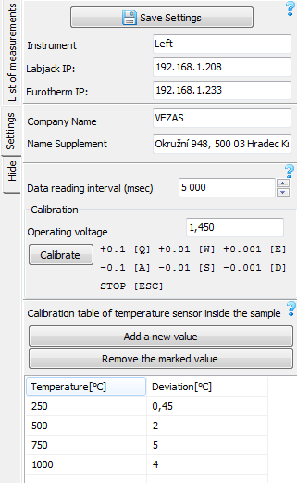
Figure 2.5: Settings bookmark
• Save Settings
This button simply saves the current settings. These include not only the values displayed in the Settings bookmark, but some values shown elsewhere in the GUI of the program. These include the Start and Finish Temperature (Figure 2.8) and the current axis settings (Figure 2.9).
• Instrument, LabJack IP, Eurotherm IP
Instrument characterizes the name of the instrument and is displayed at the top of the Top Panel (Figure 2.2). Instrument is defined by IP addresses of two regulators, which must be entered here.
• Company Name, Name Supplement
Are shown in the head of the protocol, as it is demonstrated in Figure 2.10.
• Data Reading Interval
Interval, the data are read from the regulators. The pulses per minute are displayed and calculated in this interval as well.
• Calibration
Calibration starts by the pressing the Calibrate button. After this, the voltage shown in the edit is written on the LabJack. Calibration is done using the QWEASD keys and is stopped either by pressing the Save Settings button, or by pressing the ESC key. Calibration is described in more detail in Section 3.2
• Calibration Table
Is delivered together with the temperature sensor. The row with values (500,2) means, that if regulator shows a temperature , than the real temperature is about higher. There are two buttons over the table allowing adding/removing the selected row in table.

2.3.4 Measurement Information
Measurement Information bookmark contains the basic informations about the measurement and is shown in Figure 2.6. It can be filled during the measurement. Some of these informations are used to search the measurement in the List of Measurement bookmark described in Section 2.3.2, remaining informations are used in the head of the protocol, which is shown in Figure 2.10.
• Measurement Record
Unique measurement number assigned to the measurement. This is done automatically by the program after the first measurement save and cannot be changed.
• Operator
Name of the person performing the measurement.
• Sample Name
Short name of the measured sample.
• Finished
If there is no interest in adding additional partial measurement into measurement, then Finished can be checked.
• Sample Characteristic
Additional characteristic of the measured sample.
• Note
Additional information e.g. about the non-standard measurement procedure.
It is recommended to save the measurement after editing this information.

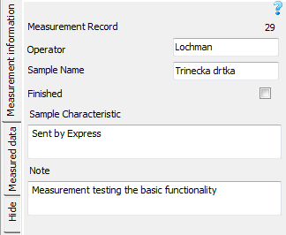
Figure 2.6: Measurement Information bookmark

2.3.5 Measured Data
Measured Data bookmark contains the data measured during the measurement and is shown in Figure 2.7. Table at the top contains the data measured during one concrete partial measurement. The partial measurement, which is displayed, is shown at the top. At the bottom, the results of partial measurements are shown and from the checked measurements, the final results are calculated. These are shown at the bottom. The meaning of the symbols used here, is defined in Section 2.2. More details to each building block follows.

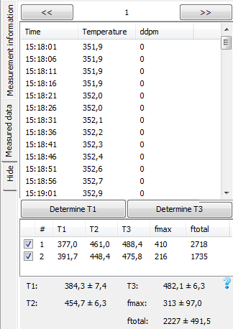
Figure 2.7: Measured Data bookmark
• Listing Between Partial Measurements
Using buttons << and >>. Between these buttons, the partial measurement number is shown together with the instrument, which this partial measurement performed.
• Table Time,Temperature,ddpm
Shows the measured data for the selected partial measurement. ddpm are the pulses per minute. 100 pulses equals one revolt.
• Determine T1, Determine T3
Although T1 and T3 are determined automatically by the program, user can change these values by moving the corresponding points on the graph. When these buttons are pressed, program determines T1 or T3 again.
• Table T1,T2,T3,fmax,ftotal
Results for partial measurements.
• Results at the Bottom
From the checked measurements, the average and variance of measurement characteristic values are calculated.
In protocol, only checked partial measurements are used. This can be seen from Figure 2.10.

2.3.6 Measurement Control Panel
This panel is the basic operational block of the program and is shown in Figure 2.8. It shows the actual values read from the instrument, allows user to write a temperature, set the measurement final temperature, manipulate with the measurement head, finish the measurement and guide the user around the measurement. The description of building blocks follows.
• Temperature
Actual temperature value from regulator. Start temperature is the temperature at which the measurements starts, Final temperature is the temperature at which the measurement will be stopped by the program automatically.
• ddpmin/ddTotal
Actual value of pulses per minute (ddpmin) and total number of pulses (ddTotal).
• Position
Shows the head position.
• Move
Controls the movement of the measuring head. If the measurement is in progress, then these buttons are disabled for temperature below a certain threshold defined in Section 2.2.
• Start a New Partial Measurement
Prepares a new partial measurement inside the opened measurement.
• Finish
Completes the measurement, i.e. forces the measuring head to move up, turns the rotation off and writes the starting temperature, so the instrument is prepared for a new measurement as soon as possible.
• Preparation of Measurement
Sample preparation. Checks three events:
1. Furnace Heated up
The furnace has to be heated up to the starting temperature. If the error is smaller than the allowed tolerance defined in Section 2.2, the OK is displayed.
2. Sample Test (ARBITRARY)
User can try to attach shortly a voltage three times greater than the voltage applied during the measurement, to test, if the sample is prepared correctly. The test starts by pressing the Test button and ends automatically. Test is assumed to be successful, if a number of pulses counted during test is smaller than built-in constant defined in Section 2.2. OK is then displayed.
3. Sample Position
When the furnace is heat up, user must put the sample inside the furnace, i.e. by pressing the Move Down button. If the position Down is read, then OK is displayed.
• Stabilization Retort Temperature
Program waits time defined in Section 2.2 to the temperature in furnace stabilizes. If it happens, the measurement continues automatically after time counter.

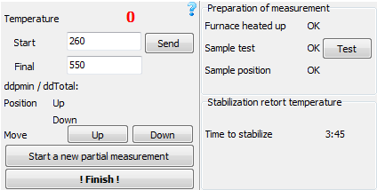
Figure 2.8: Measurement control panel

2.3.7 Graph
The purpose of this block is to graphically display a measured data of one selected partial measurement. This block is shown in Figure 2.9 and you can see, next to the red line representing the measured data, three blue points are displayed - these are the three characteristic temperature points T1, T2 and T3 defined in Section 2.2. Above the graph, there are some options to configure the graph axes.
• X Axis
You can switch between Absolute and Relative options. In Absolute case, the axis range is entered manually and graph is repainted after pressing Enter key. In Relative case, the axis range is chosen automatically to comprise all the measured data. When a protocol is created (see Section 2.3.8), then all graphs in it are set according to this settings.
• Y Axis
What holds for the X Axis is holds for Y Axis as well. There is, however, one additional option for the Y Axis: You can switch between logarithmic and linear scale.
• Graph
Red line represents the measured data and three blue-square points represent the three significant temperatures T1, T2 and T3 defined in Section 2.2. The T1 and T3 can be dragged by the mouse, but the T2 is fixed, unchangeable.

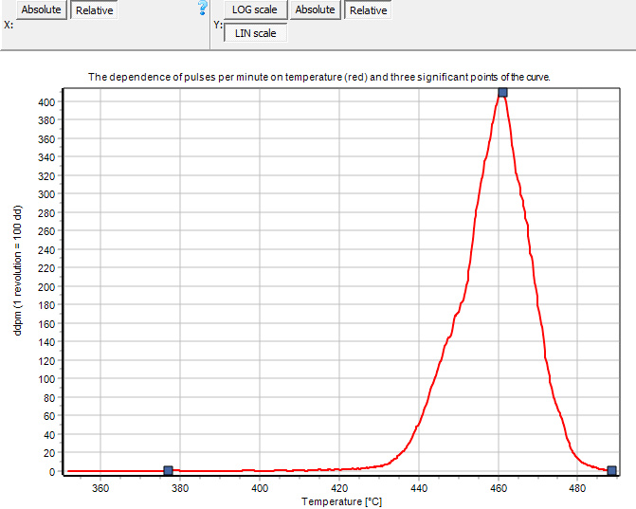
Figure 2.9: Graph

2.3.8 Protocol
When the Create a Protocol and Export Data button (see Section 2.3.1) is pressed, two files are created. First of these files is the measurement protocol in pdf format, whose structure is described in this Section, the second file is the exported data in txt format. Its structure is described in the next Section. The path, where these files are saved, is defined in Section 2.3.1.
After files are created, the protocol is opened automatically by the default program for .pdf extension (I recommend the use of Adobe Acrobat Reader, but other programs should serve as well). Using this program, you can easily print the created protocol.
The first page of the protocol has the structure shown in Figure 2.10.

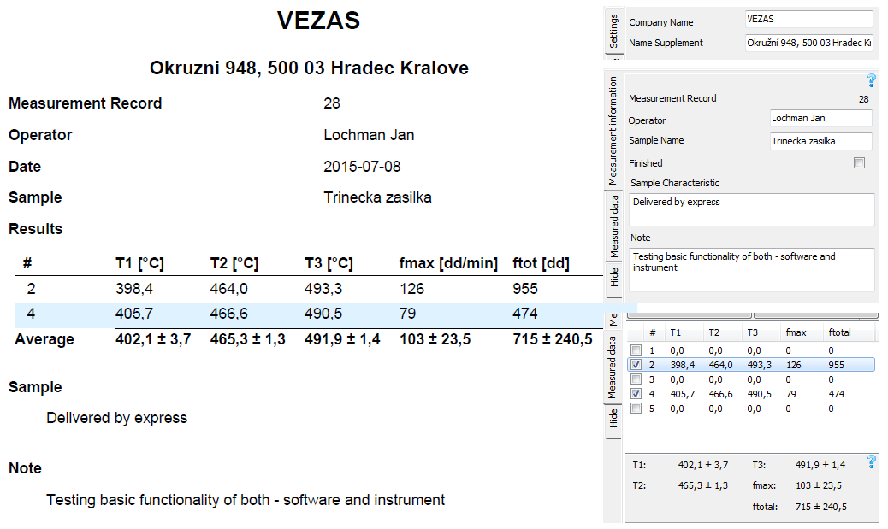
Figure 2.10: Example of the first protocol page.

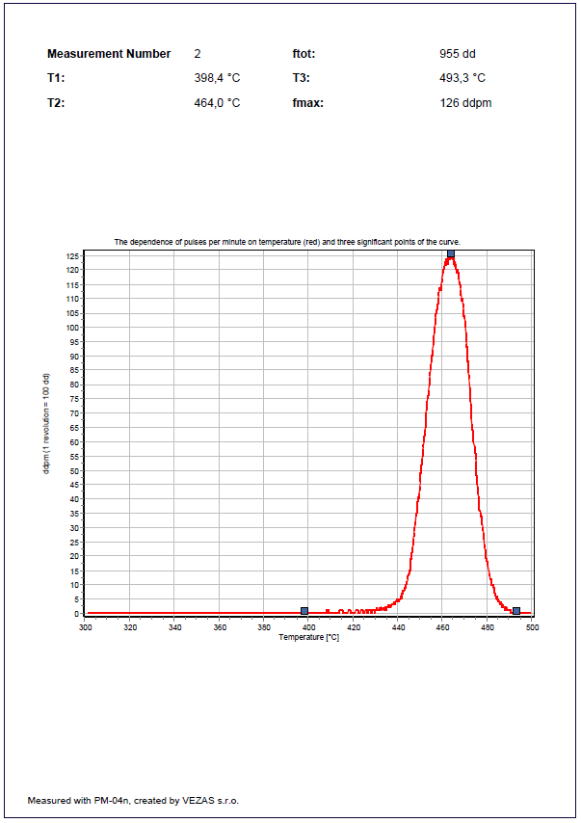
Figure 2.11: The second protocol page. The first page of this protocol is shown in Figure 2.10.2.10
• Title
Is loaded from the Settings bookmark (Section 2.3.3).
• Information above Results
Is loaded from the Measurement Information bookmark (Section 2.3.4). Only Date is not shown in this bookmark, it is loaded directly from the database.
• Results
Are loaded from the Measured Data bookmark (Section 2.3.5). You can see, that only checked partial measurements are included in the protocol and that the mean and variance is calculated from these measurements only.
• Sample, Note
Are loaded from the Measurement Information bookmark (Section 2.3.4).
The second (and any other) page of the protocol has the structure shown in Figure 2.11 and generally, it displays the results of partial measurements shown in the first protocol page.
• Header
Partial measurement number together with the results of characteristic values. These values are the values shown in one row in the table from Figure 2.10.
• Graph
Uses the axis settings defined in Section 2.3.7.

2.3.9 Data Export
Next to the protocol, the data are exported into separate file. This serves for further processing in table-oriented programs such as Microsoft Excel. The structure of data exported is shown in Figure 2.12.
By closer look at the data structure on the left, you can see, the data are semicolon separated values, which can be easily loaded as table, so you get the table structure on the right.
Each partial measurement is displayed on three columns with the structure
• Finished
In the first row, there is shown, if the measurement is checked as Finished or not. This means, also the results of the unchecked measurements are exported.
• Characteristic Values
Next 5 rows contain the measurement characteristic values defined in Section 2.2.
• Measured Data
Table containing all the data measured during the partial measurement.

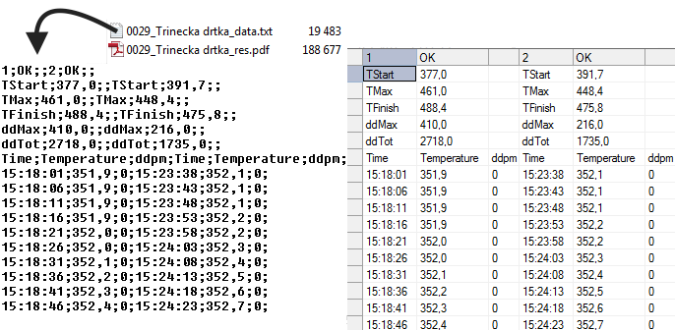
Figure 2.12: Data exported by the program.
Chapter 3

Usage
This Chapter describes the basic instructions to perform a measurement and calibration on PM-04n instrument. Some informations from the previous chapters are, for convenience, written here as well, but for more information, a references to previous Sections are provided.

3.1 Measurement

3.1.1 Select the Instrument
Firstly, it is needed to select the instrument, you are going to measure on. For this purpose, the top of the Top Panel serves. This is shown in Section 2.3.1.

3.1.2 Connect to the Regulators
Next, you must connect program to regulators. This is done using the Create a Connection with Regulators button, which is the fourth button on the Top Panel (Section 2.3.1).
If there is any problem with connection, you are welcome to try pressing the Create a Connection with Regulators button a few times (if the PM-04n instrument was turned on recently, the regulators can not be initialized yet). Program has built-in messages to help you indicate the problem. When the connection is successful, the program let you know about the success.
If you are unable connect to regulators, see Section 1.3 for more details - probably, there is a problem with the network settings and you will need an assistance from the network administrator.

3.1.3 Select the Measurement
Before the measurement starts, it is needed to choose, where the measurement will be added. Basically, there are two possibilities
1. Add a Partial Measurement to an Existing Measurement You have a sample, which was already measured and the measurement was successfully saved and you want to add to this measurement a new partial measurement.
You must load your measurement using the List of Measurements bookmark (Section 2.3.2) and press the Start a New Partial Measurement button in the Measurement Control Panel (Section 2.3.6).
2. Start a New Measurement You have a new sample, which was not measured yet. By pressing the Create a New Measurement button in the Top Panel (it is the first button, Section 2.3.1), a new measurement is prepared.
I recommend to fill Operator and Sample Name in the Measurement Information bookmark (Section 2.3.4) and save the measurement using the Save/Update Measurement button at the Top Panel (it is the second button, Section 2.3.1).
Generally, you can edit the information in Measurement Information bookmark (Section 2.3.4) anytime, even during the measurement. If you make some changes to it, do not forget to save them.

3.1.4 Start the Measurement
Now, everything is prepared to measurement could start. This is done by pressing the Start Measurement button at the Top Panel (it is the sixth button, Section 2.3.1).
By pressing this button, the Start Temperature is automatically written, but it can be changed easily using the Send button in the Measurement Control Panel (Section 2.3.6). Please, check, if the Final Temperature is set correctly as well.
[Sorry. Ignored \begin{namedtheorem} ... \end{namedtheorem}]
[Sorry. Ignored \begin{namedtheorem} ... \end{namedtheorem}]

3.1.5 Prepare Sample
In this step, no interaction between user and program is needed. After retort is prepared and placed in the measuring head, continue to next step.

3.1.6 Test Sample (Arbitrary)
The sample test is arbitrary and is performed by pressing the Test button in the Measurement Control Panel (Section 2.3.6).

3.1.7 Wait for the Furnace is Heated Up
Wait until the furnace is heated up to the desired starting temperature. This is checked automatically by the program and user can see this in the Preparation of Measurement part of the Measurement Control Panel (Section 2.3.6). If there is OK next to the Furnace heated up, you can proceed to next step.
[Sorry. Ignored \begin{namedtheorem} ... \end{namedtheorem}]

3.1.8 Move Sample into the Furnace
By pressing the Move Down button, the measuring head goes down to the furnace and measurement starts automatically. You are welcome to enter the next step.
[Sorry. Ignored \begin{namedtheorem} ... \end{namedtheorem}]

3.1.9 Make a Coffee
The measurement is now fully controlled by the program. Firstly, there is a fixed time interval, defined in Section 2.2, which program waits for temperature to stabilize after the sample entered the furnace. If the temperature stabilizes, the measurement goes on, if not, the measurement goes to the Stage 3.1.10.
After successful stabilization of temperature, program enables the temperature ramp (fixed value defined in Section 2.2) and sends the Final Temperature. Next to this, the head starts to rotate with the voltage defined in Settings bookmark (Section 2.3.3).
If the Final Temperature is reached, the measurement goes to the last stage. User can evoke this event by pressing the ! Finish ! button in the Measurement Control Panel (Section 2.3.6).
[Sorry. Ignored \begin{namedtheorem} ... \end{namedtheorem}]

3.1.10 Finish the Measurement
Finalization of the measurement. Program moves the measuring head up, disables the temperature ramp, sends the Start Temperature and disables the head rotation, so the instrument is prepared for next measurement as soon as possible. Measurement is saved automatically as well.
If you want to make a new partial measurement, proceed to Stage 3.1.5.
Otherwise, stop the measurement by pressing Stop Measurement button (the last button on the Top Panel, Section 2.3.1) and continue to Stage 3.1.3.

3.2 Calibration
To perform a calibration, go to the Settings bookmark (Section 2.3.3). Here, in part Calibration, the Operating Voltage item is located. This voltage has to be set during the process of calibration. The way, this voltage is set, is defined by the norm.
To start the calibration, press the Calibrate button (make sure, the program is connected to regulators). This causes the motor to start rotate. Now, by pressing the QWEASD keys, find the voltage which satisfies the conditions stated by the norm.
Calibration ends either by pressing ESC key (do not forget to save a new settings thereafter) or by pressing Save Settings button. Both of these actions cause the rotation to stop.

