**  **

Reference document

**Topothek @ Computer Vision (CV)**

Inventory of Topothek Data

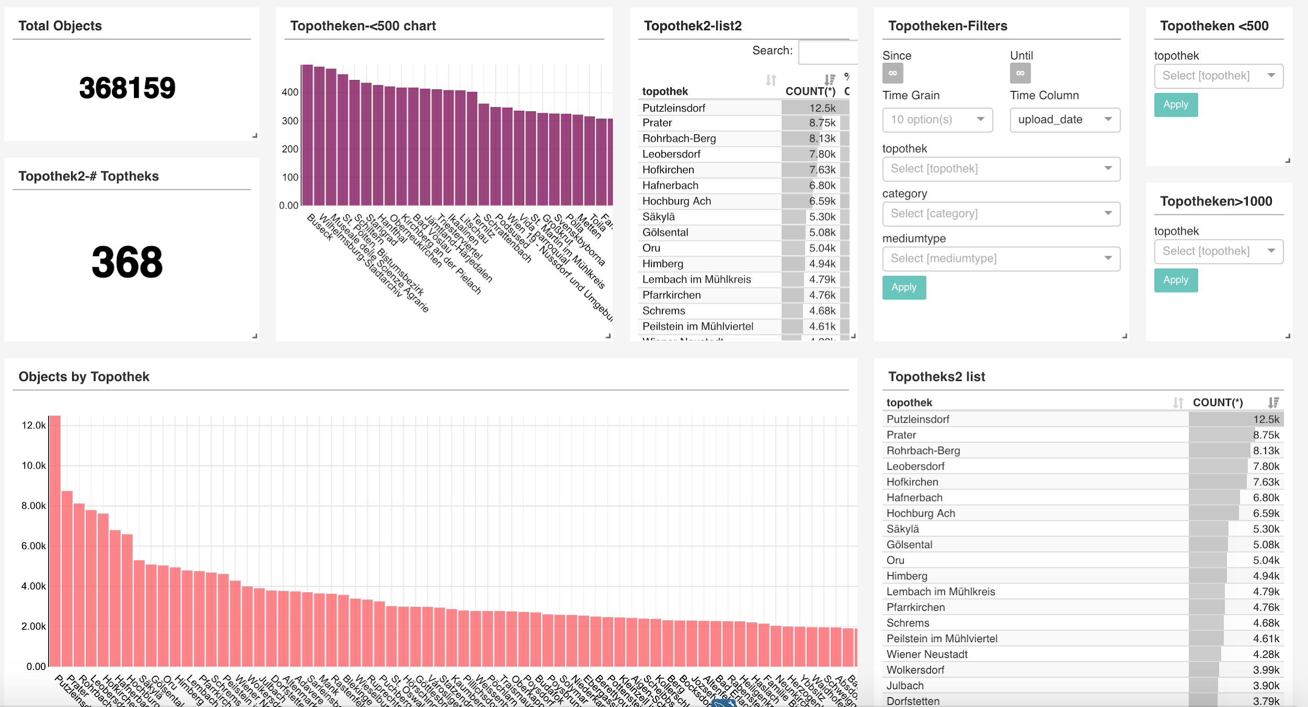

Date processed: 2018

Processed by: Jose Luis Preza Diaz

Link to results:

https://superset.acdh-dev.oeaw.ac.at/superset/dashboard/40/?preselect_filters=%7B%22299%22%3A%7B%22category%22%3A%5B%22IMAGE%22%5D%2C%22mediumtype%22%3A%5B%22PHOTOGRAPH%22%5D%2C%22__time_col%22%3A%22upload_date%22%2C%22__from%22%3A%22%22%2C%22__to%22%3A%22%22%7D%2C%22301%22%3A%7B%22topothek%22%3A%5B%22Leobendorf%22%2C%22Waxenberg%22%2C%22Vitis%22%5D%7D%2C%22302%22%3A%7B%22topothek%22%3A%5B%5D%7D%7D