 **tContextInput**

**Purpose**

This component reads context variables from various files

The configuration of the files (context properties file filter) to read can be:

|  |  |
| --- | --- |
| Configuration | What happens |
| Points to a file | Exact this file will be read |
| Points to a directory | Reads all property-files within this directory |
| Points to a file with wildcard characters | Use this as file filter |

It is possible to use variables withing the configuration.

In the advanced settings you can configure placeholders which can be used in the values read from the context properties and they will simply be replaced by string replacement with the configured replacement values.

It is also optional possible to use the replacements within the file filters.

**Talend-Integration**

This component can be found in the palette under Management

This component provides several return values.

**Parameters**

|  |  |
| --- | --- |
| **Property** | **Content** |
| Schema | The schema of the output |
| Sheet name | The schema is fixed and shows the schema of the outgoing flow named “Context Variables”. This flow contains ALL variables read from the files.   |  |  | | --- | --- | | Column | Meaning | | VAR_NAME | Name of the context var | | VAR_VALUE | String representation of the value | | CONFIGURED_IN_CURR_JOB | True if the variable is configured in the current job | | IS_PROMPT | Variable is a prompt | | SOURCE_FILE | From which file the variable was finally read | |
| Load Context Properties Files | If checked, the component reads variables from context files. All files must be formatted as properties file. <https://docs.oracle.com/cd/E23095_01/Platform.93/ATGProgGuide/html/s0204propertiesfileformat01.html>  The expected encoding is ISO-8859-1  UTF-8 characters not part of ISO-8859-1 must be encoded (see the documentation above) |
| Prevent embedded jobs from loading if already loaded | If true, this takes care the first job run containing this component and reads context file prevents all other jobs from loading also the properties files.  This is very useful to prevent redundant loading of the files and allows to test child jobs without any change to use the context load. |
| Context property file filters | The component uses these entries to find the files to read in the order of this list.  You can also specify if the file must be present or for wildcard filters there must be at least one file. |
| Apply value replacement also for | If true, the component also tries to replace the configured placeholders within the file filters. |
| Encrypt password | Talend use an internal fixed set password to encrypt the password value.  This option is in former version wrong labelled “Encrypt” instead of “Decrypt” |
| Set master password | Talend use a fix configured password. You can decide to use your own password. You need your own routine to encrypt the passwords. |
| Master password | The password which will be used for the symmetric decryption of the passwords in the context files. |
| Allow file includes | This option enables the loading of context files which path (or directory) can be taken from a context var value. The same possibilities as you can use in the file filters can be used here. If the file has none or only a relative path the path of the current context file serves as root-path. |
| Pattern to identify file include keys | Setup here the regex pattern to identify a context variable as reference to another context file. |
| Print variables | Boolean value and it true (default) the component send the variables to the outgoing flow to be printed with e tLogRow e.g. |

**Advanced settings**

|  |  |
| --- | --- |
| **Property** | **Content** |
| Replacements for value | You can use placeholders in your context values and in the list you need to configure the placeholders and the values replacing the placeholders.  You can also configure if the replacement values should be converted to upper or lower case or keep them unchanged. |

**Return values of the component:**

|  |  |
| --- | --- |
| Value | Content |
| NB_LINE | Number of lines read |
| ERROR_MESSAGE | Error message if something went wrong |

**Scenario 1: Read context variables from various files**

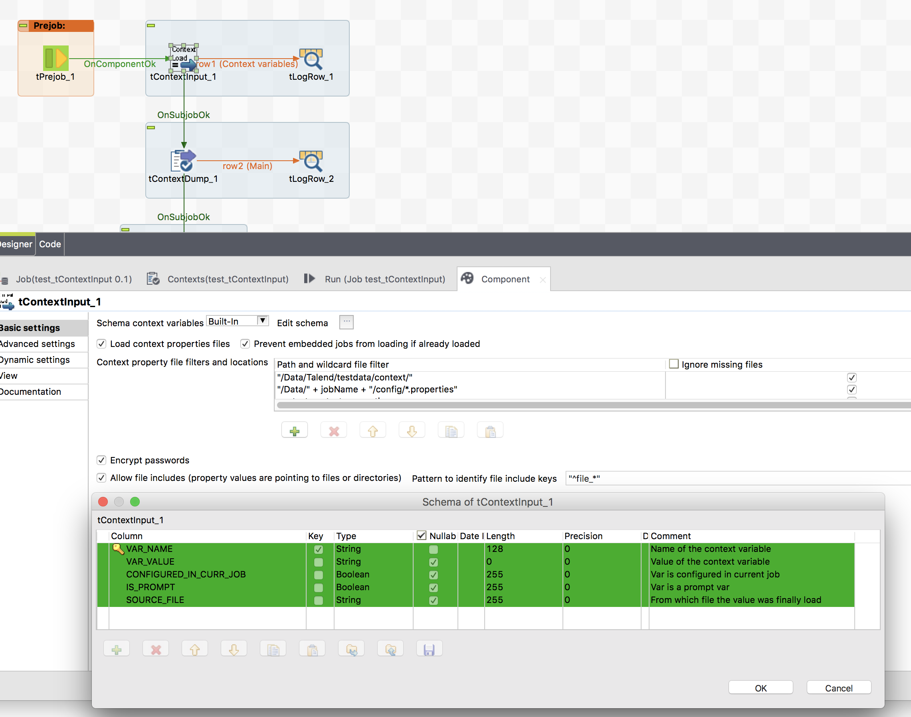

Here the output showing the component has read 3 files

