 **tDB2TemporalMergeELT**

**Purpose http://www.cimt-ag.de**

This component carries out the creation and fill procedure for Temporal Tables in the IBM DB2.

Temporal Tables are introduced with DB2 v10 and provides mechanism to keep historical data in two time possible time dimensions:

1. Business Time period is the time range within the data a valid from a business perspective. The business time period is optional.

2. System Time period is the time range, which reflects the technical creation and modification of the data. The system time period will be automatically defined by timestamps of the database management system and is mandatory.

If a table use both time periods it’s called bi-temporal table.

To get a better idea about this concept please refer to this web resource:

http://www.ibm.com/developerworks/data/library/techarticle/dm-1204db2temporaldata/

**Talend-Integration**

This component can be found in the palette under Database -> DB2 and

Business Intelligence -> DB SCD.

**Parameters**

**Connection configuration:**

|  |  |
| --- | --- |
| **Property** | **Content** |
| Property Type | Choose the database connection from the Metadata or use the build-in mode to setup individual configurations. (Only if use want to establish a dedicated connection for this component) |
| Use existing connections | True: choose an existing connection component in your job  False: configure its own connection. |
| Host | Host (IP address or hostname) of your DB2 server. ***Required*** |
| Port | Port where the instance is listening. Default is 50000. |
| Additional JDBC Parameters | Set here semicolon separated list of key=value pairs with JDBC parameters.  The default pair in this component is: retrieveMessagesFromServerOnGetMessage=true which cause in case of errors a readable error message instead of getting only the SQLCODE. |
| Database | The database you want to work with |
| Source DB Schema | The database schema containing the source table. |
| Username | User name |
| Password | Password of the user |

**Source configuration:**

|  |  |
| --- | --- |
| **Property** | **Content** |
| Source table | Name (without schema) of the source table. The name will be set automatically if you drag and drop the component from a metadata table. |
| Where condition | The condition to select the source datasets. The keyword *where* is not needed here (it will be added in the SQL code generation in case of this attribute is not empty). |
| Schema from input table | Talend Schema chooser for the input table. |
| Use self defined source key | The component can take the keys from the input schema. In case of there are no keys defined in this schema (e.g. the source table is probably a view) it is possible to define the keys which are part of the source key. It is necessary to have at least one input field declared as source key. Source key field will not update and will be used to find a single unique dataset. |
| Track updates for all columns | If this option is checked, all datasets which source key already exists in the target table causes an update and a versioning of the previous dataset (regardless if it was a real change or not). It is recommended using this option if the source provides only changed datasets (e.g. with a source selection by last modified timestamps). |
| Supplementary Source Column Config | Per source column you can specify:  *Ignore:* If true the column will be ignored. This is helpful if you prefer using a schema from the repository and it contains not needed columns.  *Track real changes for*: This cause the component to track real changes of this field. Visible only if the option “Track updates for all columns” is switched off.  *Is source key*: Check all columns, which identifies a unique source dataset. Visible only of option “Use self defined source key” is enabled. |

**Target configuration:**

|  |  |
| --- | --- |
| **Property** | **Content** |
| Target DB Schema | Database schema for the target table. |
| Target table | Name (without schema) of the target table. |
| Create table if not exists | If the table (and its historical counterpart) does not exist, it will be created. |
| Create indexes for source key,  bus-tp, sys-tp | In addition to the creation of the table, also indexes on the source keys, on the business time period columns (if needed) and on the system time period columns for the target table will be created. |
| Use a specific table space | If the target table should created within a specific table space, this table space will be created if needed in case of the table have to be created. |
| Tablespace name | Name of the table space in which the target table should be created. |
| Surrogate Key column | If set, a surrogate key will be added to the target table and configured as auto increment column with type BIGINT. |
| Use Business Timeperiod | If this option is switch on, the table and fill method a carry out a bi-temporal versioning of data. |
| Business Timeperiod is of data type Date | If switched on the business time period columns will work with days and ignores the time (set the time to 00:00:00) |
| Business Timeperiod Start Column | Name of the column holding the start date/timestamp of the business time period. Typically in data warehouse projects it is needed to follow project specific naming conventions for those kinds of fields. |
| Business Timeperiod End Column | Name of the column holding the end date/timestamp of the business time period. Typically in data warehouse projects it is needed to follow project specific naming conventions for those kinds of fields. |
| Value Start BUS time | The value (as literal or a context variable) which defines the start of the business time period (timestamp or day).  The value has to be of a data type inheriting java.util.Date. |
| Value End BUS time (insert) | The value (as literal or a context variable), which defines the end of the business, time period (timestamp or day) in case of insert a new data set.  The value has to be of a data type inheriting java.util.Date.  In case of days, this has typically 2 different values depending the situation:  The value should point to a date in the far future (like a SCD end value to specify the current valid dataset). |
| Value End BUS time (update) | The value (as literal or a context variable), which defines the end of the business, time period (timestamp or day) in case of update an existing data set.  The value has to be of a data type inheriting java.util.Date.  In case of days, this has typically 2 different values depending the situation:  The value should contains the next time slice (e.g. the next day) after the start value of the business time period. |
| System Timeperiod Start Column | Name of the column for the system time period start. |
| System Timeperiod End Column | Name of the column for the system time period end. |
| Set history table append on | With this option the history table can be set as append on. This option increases the performance in case of many updates. |
| Switch Off Versioning at the End | Especially in data ware house applications it is a common task to update foreign key fields in the target table or converting / transforming special values. To avoid creating historical datasets by this post processing it is possible to switch off the versioning feature at the end. Every new run of this component will switch on the versioning in case of it is switched off. |
| Additional Columns in Target Table | If additional columns are needed (e.g. meta data columns like job instance keys, processing information and so on) it is possible to specify them here and they values. As values can be used literals or context variables matching the data type of the added column. It is possible to enable the column for the insert or update statement. |
| Delete condition | If the source data contains info to mark the data for delete you can specify the condition here.  It will cause an additional part of the merge statement to delete if the dataset exists and the delete condition is true. |

**Return values**

|  |  |
| --- | --- |
| **Return value** | **Content** |
| ERROR_MESSAGE | Last error message |
| COUNT_MERGED | Number of datasets actually merged by the component |

**Scenario: Bi-temporal processing of the EMPLOYEE table from the DB2 examples**

The component creates its own database connection and carries out a bi-temporal versioning.

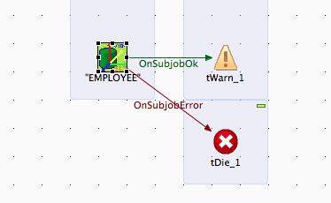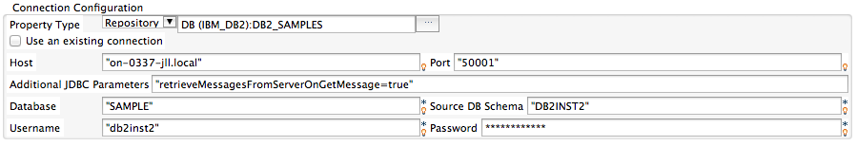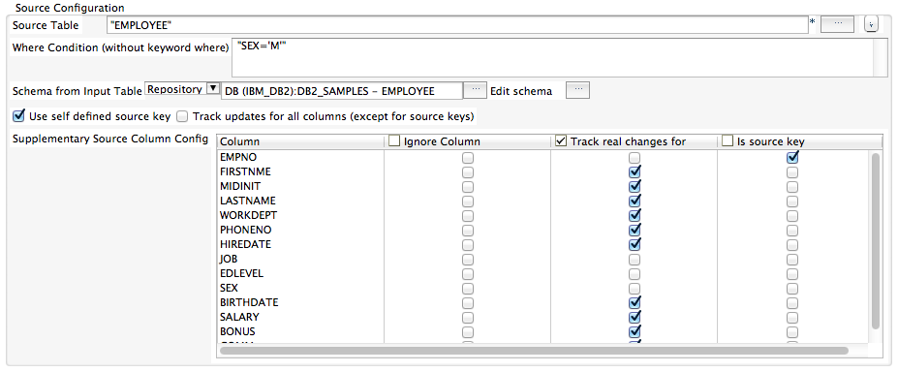

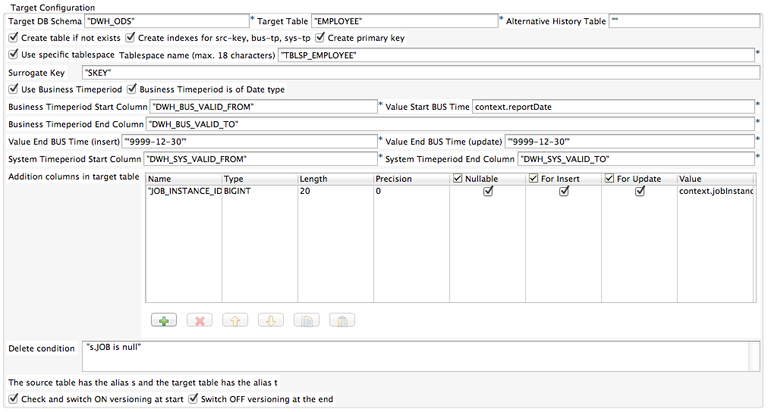

**Statements created by the component**

Create target tables and indices

-- create tablespace

**create tablespace** TBLSP_EMPLOYEE;

-- create table

**create table** DWH_ODS.EMPLOYEE (

TRANS_START **TIMESTAMP**(12),

DWH_BUS_VALID_FROM **DATE** **NOT NULL**,

DWH_BUS_VALID_TO **DATE** **NOT NULL**,

DWH_SYS_VALID_FROM **TIMESTAMP**(12) **NOT NULL**,

DWH_SYS_VALID_TO **TIMESTAMP**(12) **NOT NULL**,

SKEY **BIGINT** **NOT NULL GENERATED BY DEFAULT AS IDENTITY (START WITH 1 INCREMENT BY 1)**,

EMPNO **CHAR**(6) **NOT NULL**,

FIRSTNME **VARCHAR**(12) **NOT NULL**,

MIDINIT **CHAR**(1),

LASTNAME **VARCHAR**(15) **NOT NULL**,

WORKDEPT **CHAR**(3),

PHONENO **CHAR**(4),

HIREDATE **DATE**,

JOB **CHAR**(8),

EDLEVEL **SMALLINT** **NOT NULL**,

SEX **CHAR**(1),

BIRTHDATE **DATE**,

SALARY **DECIMAL**(9,2),

BONUS **DECIMAL**(9,2),

COMM **DECIMAL**(9,2),

JOB_INSTANCE_ID **BIGINT**

)

**in** TBLSP_EMPLOYEE;

-- setup table as temporal table

**alter table** DWH_ODS.EMPLOYEE **alter column** TRANS_START **set GENERATED ALWAYS AS TRANSACTION START ID;**

**alter table** DWH_ODS.EMPLOYEE **alter column** TRANS_START **set IMPLICITLY HIDDEN;**

**alter table** DWH_ODS.EMPLOYEE **alter column** DWH_SYS_VALID_FROM **set GENERATED ALWAYS AS ROW BEGIN;**

**alter table** DWH_ODS.EMPLOYEE **alter column** DWH_SYS_VALID_TO **set GENERATED ALWAYS AS ROW END;**

**alter table** DWH_ODS.EMPLOYEE **add PERIOD SYSTEM_TIME (**DWH_SYS_VALID_FROM,DWH_SYS_VALID_TO**);**

**alter table** DWH_ODS.EMPLOYEE **add PERIOD BUSINESS_TIME (**DWH_BUS_VALID_FROM,DWH_BUS_VALID_TO**);**

**alter table** DWH_ODS.EMPLOYEE **add constraint** EMPLOYEE_pk **primary key (**EMPNO**, BUSINESS_TIME WITHOUT OVERLAPS);**

-- create index for source key

**create index** DWH_ODS.EMPLOYEE_src_pk **on** DWH_ODS.EMPLOYEE(EMPNO);

-- create index for business time period

**create index** DWH_ODS.EMPLOYEE_bustp **on** DWH_ODS.EMPLOYEE(DWH_BUS_VALID_FROM,DWH_BUS_VALID_TO);

-- create index for system time period

**create index** DWH_ODS.EMPLOYEE_systp **on** DWH_ODS.EMPLOYEE(DWH_SYS_VALID_FROM,DWH_SYS_VALID_TO);

-- create history table

**create table** DWH_ODS.EMPLOYEE_HIST **like** DWH_ODS.EMPLOYEE **in** TBLSP_EMPLOYEE;

**alter table** DWH_ODS.EMPLOYEE_HIST **append on**;

-- switch on versioning

**alter table** DWH_ODS.EMPLOYEE **add versioning use history table** DWH_ODS.EMPLOYEE_HIST;

Statement to switch on the versioning if it was switch off

-- switch on versioning

**ALTER TABLE** DWH_ODS.EMPLOYEE **ADD VERSIONING USE HISTORY TABLE** DWH_ODS.EMPLOYEE_HIST

After the completing the processing (after the merge statement) and if the option to switch off the versioning at the end is on:

-- switch off versioning

**ALTER TABLE** DWH_ODS.EMPLOYEE **DROP VERSIONING**

Merge statement

-- merge

**merge into** DWH_ODS.EMPLOYEE t

**using** (

**select** * **from** DB2INST2.EMPLOYEE **where** SEX='M'

) s

**on** (t.EMPNO = s.EMPNO **and**

t.DWH_BUS_VALID_TO > **?**/*#1 business_time_start */

)

**when not matched and not** (s.JOB **is null**) **then**

**insert** (

DWH_BUS_VALID_FROM,

DWH_BUS_VALID_TO,

EMPNO,

FIRSTNME,

MIDINIT,

LASTNAME,

WORKDEPT,

PHONENO,

HIREDATE,

JOB,

EDLEVEL,

SEX,

BIRTHDATE,

SALARY,

BONUS,

COMM,

JOB_INSTANCE_ID)

**values** (

**?**/*#2 business_time_start */,

'9999-12-30',

s.EMPNO,

s.FIRSTNME,

s.MIDINIT,

s.LASTNAME,

s.WORKDEPT,

s.PHONENO,

s.HIREDATE,

s.JOB,

s.EDLEVEL,

s.SEX,

s.BIRTHDATE,

s.SALARY,

s.BONUS,

s.COMM,

**?**/*#3 JOB_INSTANCE_ID*/)

**when matched and** (

(t.FIRSTNME <> s.FIRSTNME)

or (t.MIDINIT <> s.MIDINIT)

or (t.LASTNAME <> s.LASTNAME)

or (t.WORKDEPT <> s.WORKDEPT)

or (t.PHONENO <> s.PHONENO)

or (t.HIREDATE <> s.HIREDATE)

or (t.BIRTHDATE <> s.BIRTHDATE)

or (t.SALARY <> s.SALARY)

or (t.BONUS <> s.BONUS)

or (t.COMM <> s.COMM)

) **and not** (s.JOB **is null**) **then**

**update for portion of business_time**

**from** **?**/*#4 business_time_start */

**to** '9999-12-30'

**set** t.FIRSTNME = s.FIRSTNME,

t.MIDINIT = s.MIDINIT,

t.LASTNAME = s.LASTNAME,

t.WORKDEPT = s.WORKDEPT,

t.PHONENO = s.PHONENO,

t.HIREDATE = s.HIREDATE,

t.JOB = s.JOB,

t.EDLEVEL = s.EDLEVEL,

t.SEX = s.SEX,

t.BIRTHDATE = s.BIRTHDATE,

t.SALARY = s.SALARY,

t.BONUS = s.BONUS,

t.COMM = s.COMM,

t.JOB_INSTANCE_ID = **?**/*#5 JOB_INSTANCE_ID*/

**when matched and** (s.JOB **is null**) **then**

**delete for portion of business_time**

**from** **?**/*#6 business_time_start */

**to** '9999-12-30'