 tMysqlTableTransfer

Purpose
This component copies a defined set of rows from one table into another table. It generates an internal field mapping, by matching equal names in both tables.
By using two asynchronous threads, the component gains more performance, than the normal single threaded version, generated by a normal input->map->output compontents. It’s main working scenario is copying data from one database to another.
This components transfers only values from columns which are exists in source table/query and target table. None existing columns in source and target will be ignored.

Properties

Component family |  | Database/Mysql Java only
Function |  | tMysqlTableTransfer: Transfer data from a query into a table rapidly
Purpose |  | tMysqlTableTransfer reads and writes data simultaneously and use automatically generated schemas and statements. It can in this version only insert data.
Basis settings | Use existing connections | If checked you can choose for source and target existing connections
 | Source Connection  Target Connection | source connection and target connection
 | Source Host | Host of Mysql database
 | Source Port | Port at which the Database is listining (Standard 3306)
 | Source Database | Source database
 | Source User | Username to connect to source database
 | Source Password | Password for user to connect to source database
 | Use self defined query | default=false: a source table name will be required
 | Source table | visible if Use self defined query is not set.  Name (without schema) of the table as source.  The source table must have columns with fits to the column name+types of the target table. All fields of target table which does not find a matching field in source table will set to null.
 | Source where clause | visible if Use self defined query is not set.  Define the where condition to gather selected data.
 | Source Query | visible if Use self defined query is set.  Define the query to gather the source data. The query must return columns with fits to the column name+types of the target table. All fields of target table which does not find a matching field in source query will set to null.
 | Target Host | Host of Mysql database
 | Target Port | Port at which the Database is listining (usually 3306)
 | Target Database | Mysql database
 | Target User | Username to login into target database
 | Target Password | Password to login into the target database
 | Target Table | Name of the target table without schema.
 | Truncate Target Table | Option to truncate the target table before import starts.
 | Disable keys while importing | Option to disable indexes (only not unique indexes) to improve the performance. At the end, indexes will be enabled and that task can consume notable time.
 | Log interval | Seconds between log output (which reflects read and write counter and the average transfer rate (rows/s)
 | Die on error | default=true: Let the component stop working if errors occurs.
Advanced Settings | Source fetch size | default=10000. The amount of rows which will be loaded at once from the source database.
 | Target batch size | default=10000. The amount of rows which will be processed at once in the target database.
 | Source Properties | Additional properties for the connection to source database. (key=value pairs separated with semicolon)
 | Target Properties | Additional properties for the connection to the target database. (key=value pairs separated with semicolon)
 | Synchron Transfer | Option to disable asynchronous transfer. This should be used only in seldom circumstances if performance will decrease with asynchronous transfer.
 | Log out source query | default=true: writes the source query (regardless of self defined or internal generated) at log output.
 | Log out target insert statement | default=false: writes the target insert prepared statement (before executing transfer).
 | Single Instance | If true only a single instance of this component works within the sub job. Otherwise for every iteration a new instance will be created (not simultaneously!)

Scenario 1: Transfer a couple of tables

Filling a database test system using an amount of data from the productive system.
First we store a list of all tables which we want to transfer in an configuration table.
We iterate over these table names by reading the configuration table and start a transfer for each target.

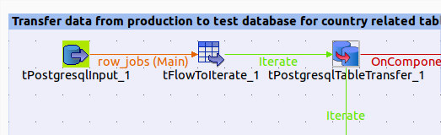

The properties for tMysqlTableTransfer component:

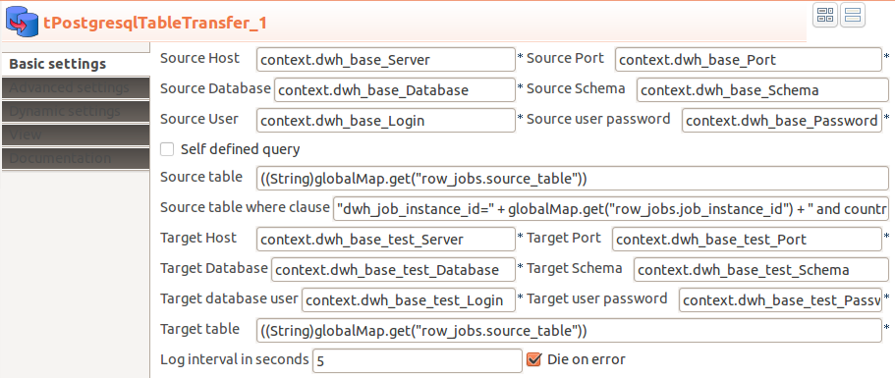

You can use context variables to set the properties.
This example shows of the component creates it own database connections.

Scenario 2: Transfer a couple of tables with using of existing connections

Here an example of using existing connections (using the derived component for PostgreSQL):

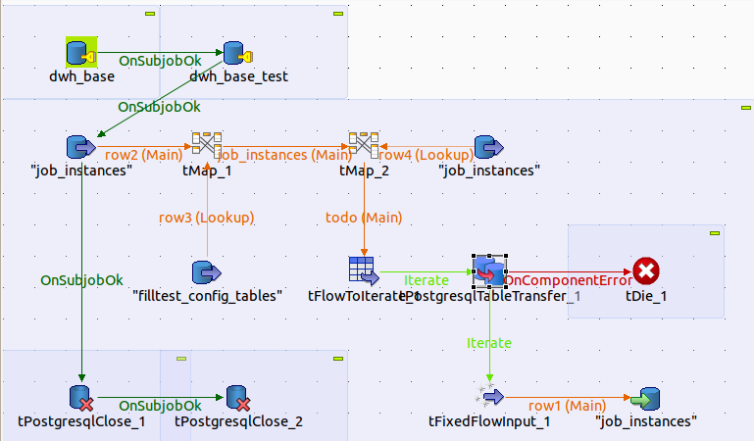

Appropriated properties for tMysqlTableTransfer:
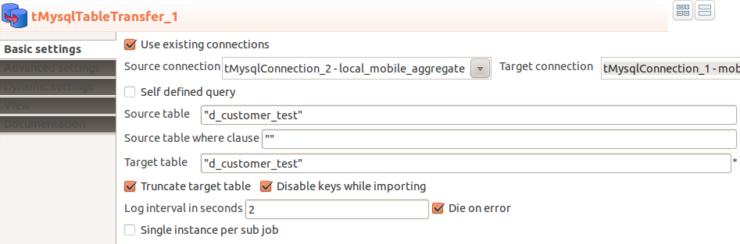

Single Instance property helps to save resources. An instance of tPostgresTableTransfer will be cached in the globalMap.

Scenario 3: Transfer a couple of tables in parallel running sub processes
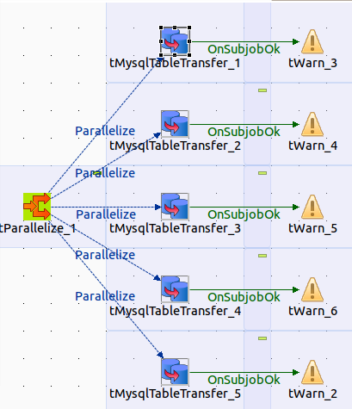
Transfers can run parallel. After creating tMysqlTableTransfer_1 you can populate the others as copy and change the table names.

Here the appropriated settings
