 **tPostgresqlTableTransfer**

**Purpose**

This component inserts records from one table into another table. It generates an internal field mapping, by matching equal column names in both tables.

If there are columns which should not be transferred (e.g. because they are auto increment columns), you can exclude them from the transfer with the Exclude fields section.

If the target table expects more columns filled with fixed values, you can add them in the Fixed Column Value section.

By using two asynchronous threads, the component gains more performance because the component can read and write at the same time.

It’s main working scenario is copying data from one database to another or create backup files.

**Talend-Integration**

This component can be found in the palette under Database -> PostgreSQL

**Basic Settings**

|  |  |
| --- | --- |
| **Property** | **Content** |
| Use data source | Check this if the component should use a connection from a database connection pool.  Otherwise the component expects external connection components. |
| Source data source alias | Set here the name of the database pool for the source connection. |
| Target data source alias | Set here the name of the database pool for the target connection. |
| Source Connection | The connection used to read the data. This is not necessarily a MySQL connection. The component can also use connections from other databases. If there are some mismatches between the data types, you can adjust the type mapping in the advanced settings in the Custom Type Mapping. |
| Target Connection | This must be a tPostgresqlConnection. This connection is only used if the option " Only backup in file, no inserts into table" is not set. |
| Self-defined query | Check this if the source data should be read from a query. Otherwise the component takes the data from the given source table |
| Source Table | Source table, if not a self-defined query is used. |
| Source table where clause | The where condition. A missing where keyword will be added automatically. |
| Truncate Table | Check this if the component have to truncate the table before import new data. |
| Enable exclude source columns | This enables the table of the columns to exclude |
| Source columns to exclude | Add here the names of the columns which have to be excluded. The generated query will not contain these columns. This works only if the query is generated from the component itself, if you provide your own query, this list will not be applied. |
| Enable columns with fixed values | This enables the table of fixed column values |
| Columns with fixed values | If the target table expect some columns with fixed valued, setup them here.  The value expression is a java expression like context variables or literals. |
| Log Interval | Because of there is no flow visible in the job, the component sends a log message about the progress. Setup here how often this happened. This interval is also the interval in which the component detects the end of the processing or errors. |
| Die On Error | If there is something wrong while reading or writing data, the component will throw an error to the job. |
| Backup Data in File | If true, the component writes the source data also in a CSV-file.  See the format information below. |
| Only backup in file, no inserts into table | If true, the component only writes the backup data and performes no inserts (and also no truncates etc.) |
| Backup file or directory | If it is a directory, the component use the target table name as file name +".csv" and if the entry points to a file, it takes exactly this to write into. |
| Export boolean as number | If true boolean values will exported in the file as 0 or 1 instead of false or true. |

**Format information about the backup file:**

* The charset is UTF-8
* The line delimiter is in UNIX format
* Fields are separated by semicolon
* All values are quoted with double quote
* Line breaks in a field content will survive
* Already existing double quotes will be escaped with a backslash
* Already existing backslashes will also be escaped
* Null values are written as \N
* Boolean values are written per default als 0 or 1 (can be changed)
* Date, datetime or timestamp values are written in the format yyyy-MM-dd HH:mm:ss

This is a very common file format to transfer data. These kind of files can be directly used with the PostgreSQL bulk import.

**Advanced Settings**

|  |  |
| --- | --- |
| **Property** | **Content** |
| Source select fetch size | The number records the component let the driver read at once. This can increase the performance. |
| Insert batch size | The component uses the batch mode and this is the number of records kept in memory until send to the database as batch request. |
| Logout query | If set, the component prints the select query to standard out. |
| Logout insert statement | If set, the component prints the insert statement to standard out. It is a prepared statement printed once. |
| Enable Log4J | Enables the internally used Log4J framework |
| Debug | In case of problems the component prints a lot of useful debugging information |
| Custom Type Mapping | Here you can setup in which way specific database types are mapped to the internal java types. All types not mentioned here will be read as Object and transferred to the target database as Object. |
| Reuse data model information for further runs | This option keeps the already collected information about schemas, tables and columns within the memory for further usage. This can shorten the necessary initialisation phase. |
| Alternative key to keep the data model in memory | The data model information will be hold by a key in the memory. By using the same key for different components you can share the same data model for different components.  Normally it is supposed to keep this attribute empty. In this case the data model will be reused only for the same component. |

**Return values**

|  |  |
| --- | --- |
| **Return value** | **Content** |
| ERROR_MESSAGE | Last error message |
| NB_LINE | Number rows read |
| NB_INSERTS | Number rows inserted into the target table |
| SOURCE_QUERY | Query used to select the source records |
| SOURCE_TABLE | Source table (not in case of using self-defined query) |
| TARGET_TABLE | Target table (not in case of using only backup mode) |
| BACKUP_FILE | The current written backup file with the full path. |

**Scenario 1: Copy tables from the actual database into a mirror database**

This job reads all table names from the DWH database and compares it with the table names from the mirror database and starts the transfer only for the tables existing in both databases. The example is actually from the component tMysqlTableTransfer but it works exactly in the same way.

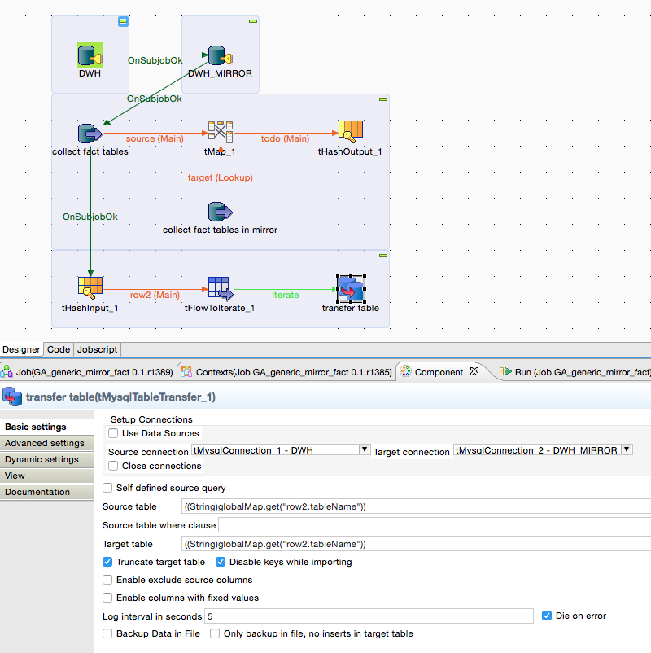

The table name is the same for source and target. The component takes both connections build at the start of the job and should therefore not close them because the component runs within an iteration.

**Scenario 2: Backup all tables**

In this scenario all tables will be simply dumped as CSV files but the job has to avoid dumping a table twice.

This is the steering job:

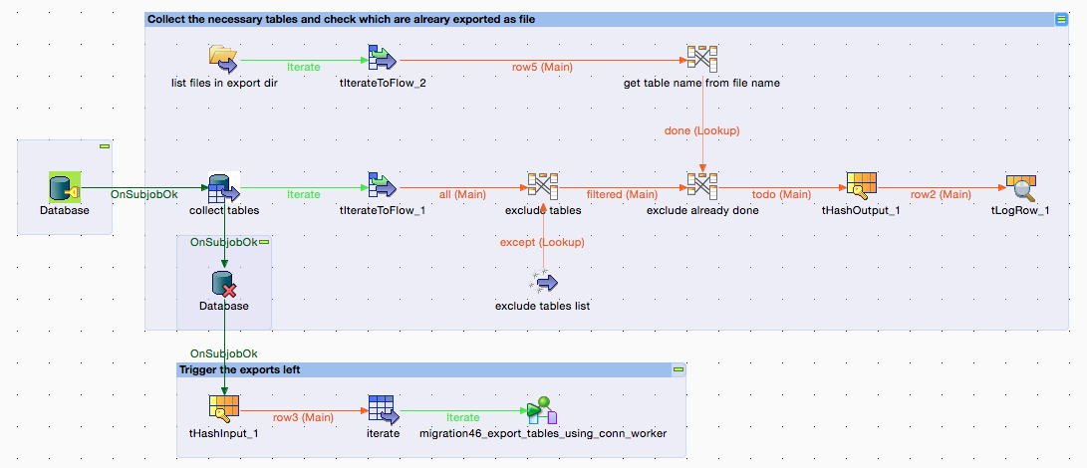

... and this is the simple worker job triggered here (the example shows the component tMysqlTableTransfer but it works in exactly the same way):

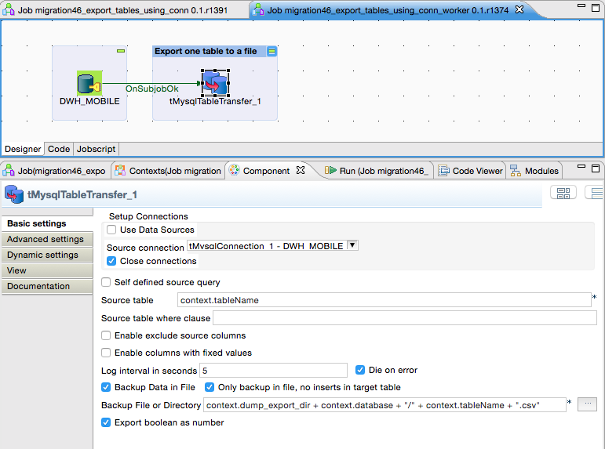

Because of the option "Only backup in file, no inserts in target table" we only need one connection and all settings for the target table are hidden.