 **Talend User Component tPostgresqlConnectionPool**

**Purpose**

This description applies also to the other derivates of this component:

tOracleConnectionPool

tDB2ConnectionPool

tMysqlConnectionPool

This component provides a data source to normal jobs as well as to services made in DI technology.

The idea is to have a connection pool wth following advantages:

1. The pool can be used in normal DI jobs, especcially in use cases where worker job needs a database connection and these jobs are called very frequently
2. The pool can be configured with normal context variables and therefore can be configured with the same configuration file as the DI batch jobs.

**Talend-Integration**

You find these components in the palette under Databases/PostgreSQL

**Basic settings**

|  |  |
| --- | --- |
| **Property** | **Content** |
| Operational Mode | **Create Connection Pool**: Creates a connection pool for the PostgreSQL database  If a pool already exists with this name,  **Close Connection Pool**: Closes the pool.  *Next next modes are independent from the kind of the database.*  **Provide pooled DataSource in child job**: This causes every database component which is configured to use the data source gets its own connection.  Otherwise ALL components work with the SAME connection.  **Workaround let connection work with datasource:** Let the connection get its own connection from the data source. It is a workaround for the bug TDI-36765.  The function is inactive in the case the mentioned bug will be solved in any way.  (see example at the end of this documentation) |
| Host | Database host |
| Port | Database port |
| Database | Database instance |
| Schema | Database schema |
| User | Database user |
| Password | Database user password |
| DataSource alias | The alias of the connection pool (JNDI name) |
| Auto Commit | Set the new connctions auto commit |

**Advanced settings**

|  |  |
| --- | --- |
| **Property** | **Content** |
| Addional JDBC Parameters | Set here the addional JDBC properties. The parameters are key=value pairs separated by a semikolon or & |
| Test on borrow | If true all connction requested by the job will be checked before delivered |
| Test while idle | These settings are for background check for idle connections |
| Validation SQL | Set here a cheap SQL to check the connection. Avoid time consuming SQL here! |
| Time between checks | The time between 2 checks automatically performed in ms |
| Max idle time | The maximum milliseconds a connection can be idle before it will be removed from the pool |
| Number checked connection | The number of the connections checked whithin a background check cycle |
| Initial Size | The initial number of connections made at the start of the pool |
| Maximum Pool Size | The maximum number of connecxtion within the pool. If this size is reached all next attempts to get a connection will wait for the next free connection |
| Max. time to wait for a connection | The max. time a request hase to wait until releasing the thread. The return connection is null – this will in most cases cause an exception. Leaf is blank to avoid the timeout. In this case the job will wait here until a connection becomes free. |
| Intial SQL | For some reason it is necessary to run special SQL code just at the time when the connction is newly created. |
| Debug | Cause debug output |

**Return values**

|  |  |
| --- | --- |
| **Return value** | **Content** |
| ERROR_MESSAGE | Last error message. |
| DATABASE | The name of the connected database |

**Scenario 1: Using the pool in a batch DI job**

Think about a data-integration job which calls very rapidly a job using database connections.

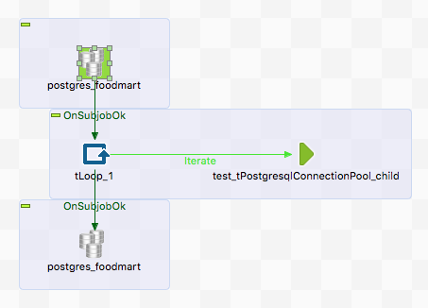

The loop simulates the call trigger for the embedded job.

In the embedded job this pool can be used as usual. If you want to have a standard conform behavior of the DataSource (unfortunately Talend in release up to 6.1.1 provides) you can improve the embedded job by adding the component here again with the mode: “Provide pooled DataSource to child job”. Starting with Talend version 6.4.1 this workaround is not necessary anymore.

It is recommended to add the pool in the embedded job in the same way as you do in the main job. The advantage is you can test the embedded job for itself. Do not worry about you create unwantet additional pool instances, the component prevents creating a pool more than once in the whole job structure.

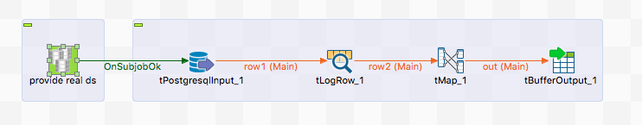

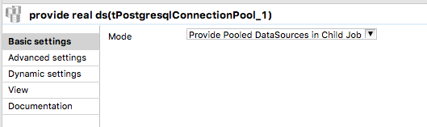

This way all database components using the DataSource settings gets their own connection – exactly what the standard recommends. If you need exactly one connection, leaf out this component or if you wish to steer it use reight at the start of the job a tPostgresqlConnection and configure here the DataSource. In all other database components choose the using of a separate connection -> your tPostgresqlConnection. Do not forget to close this connction again (it means in this case to put the connction back into the pool.

**Scenario 2: Using the pool in a service job**

This established the pool at the start of the service. The advantage is, you can use the normal context variables to control the pool and use e.g. the implicit context load. The disadvantage of a pool dedicated to one service is the pooled connections are dedicated to this service. Because of the idle eviction this does not lead to a unwanted high number of connections.

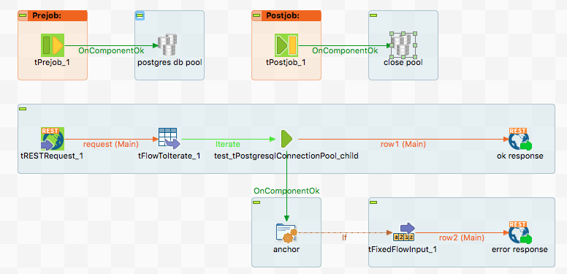

If the service will shut down the pool will be closed this way.

Here the settings:

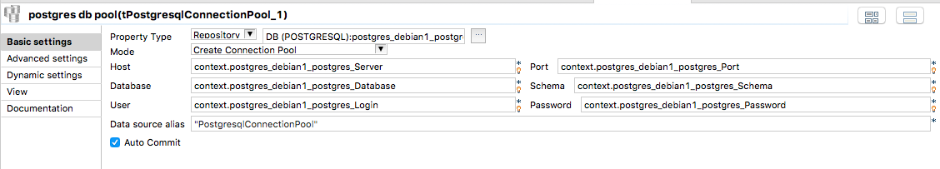

The child job is the same as in Scenario 1.

**Scenario 3: Workaround for the bug TDI-36765**

The mentioned bug describes the problem a connection fetched via the DataSorce settings will be handled as singleton connection. The actual connection component does not establish the connection and all components referencing to the same data source indeed get the exaclty same connection. This leads to a number of problems, especcially in case this job works within a service.

A solution is on the way but in Talend ESB 6.1.1 und 6.2.1 this bug will still exist.

It exists a workaround and with the help of this component you can enforce this workaround in your job.

You need this component twice:

Right at the start of the you need this component with the mode: **Provide pooled connections to this child job**

And right after every connection component like tOracleConnection or tPostgresqlConnection you have to set this component with the mode: **Workaround let connection work with datasource**.

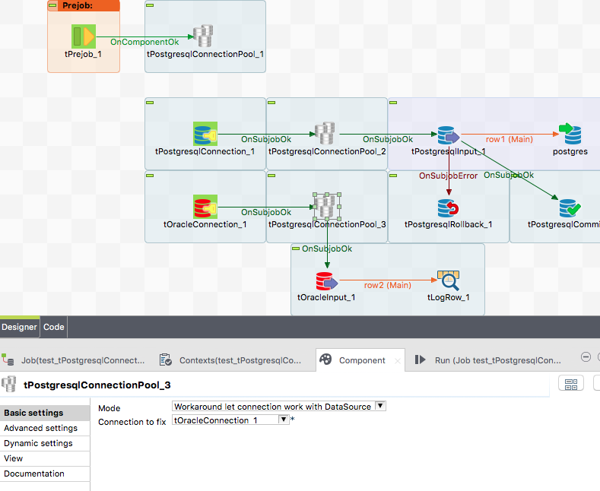

The tPostgresqlConnectionPool_1 component in this job replaces the singleton connection provier with a provider allowing to have multiple connection from the same data source.

The tPostgresqlConnectionPool_2 component fixes the behaviour of tPostgresqlConnection_1 and allows to use this component to have its own connection.

The tPostgresqlConnectionPool_2 component fixes the behaviour of tOracleConnection and allows here this component to have its own connection.

In the mode: **Workaround let connection work with datasource** and **Provide pooled connections to this child job** the connection pool components work completely database type indifferent.

The workaround code is designed to not disturbing in case of the bug TDI-36765 will be solved, so do not worry about any Talend updates.