tConnectionPool – Documentation

* Component allows you to create a connection pool inside a Talend DI Job
* Available databases:
  + MySQL
  + Oracle
* Two operation modes:
  + Create Connection Pool
  + Close Connection Pool
* Uses the “specify a data source alias” feature in other database components
* Can also be used over different jobs, if they are combined via tRunJob

Basic Settings

|  |  |
| --- | --- |
| **Item** | **Description** |
| Database Version | MySQL  Oracle   * Supported Version: 11-6,11,10 * Connection Types: SID, ServiceName |
| Host | “127.0.0.1” |
| Port | “3306” |
| Database | “myDatabase” |
| User | “databaseUser” |
| Password | “password” |
| Alias | Enter a job wide unique name. You have to use this alias in every other database component  e.g. “MyConnectionPool” |

Advanced Settings

* Please note: All time declaration for
  + MySQL in milliseconds
  + Oracle in seconds

|  |  |
| --- | --- |
| **Item** | **Description** |
| Additional JDBC Parameter | Specify additional properties  property_1=value1;property_2=value_2; … |
| Test On Borrow | If checked, every connection is validated before it is used |
| Time Between Checks | Idled connections are checked during a validate run. Here you set the time between that runs. |
| Max Idle Time | Maximum time an connection can stay in idle mode, before it is removed from the pool. |
| Number Checked Connections | Only available for MySQL. Defines the number of connections that are checked during a validation run. |
| Set Initial Size | Initial amount of available connections. |
| Set Max Connection Size | Maximum amount of connections that are available within the pool. |
| Set Max Time To Wait For Connection | Maximum time a connection request can wait if all connections are in use. |
| Set Initial SQL | Only available for MySQL. Sets the list of SQL statements to be executed when a physical connection is first created. Separated via semicolon |

Usage

Jobimplementation:

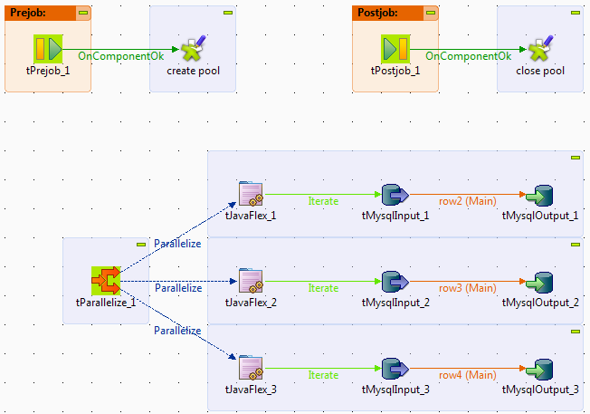

Create Connection Pool:

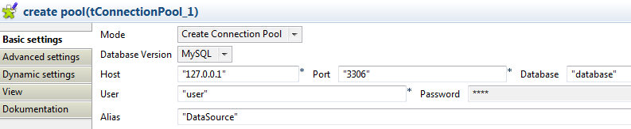

Usage in other database components:

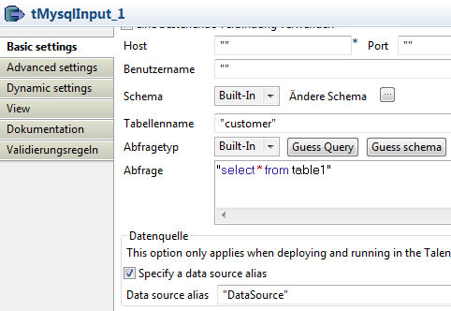

Close Connection Pool:

