 **tFileExcelSheetInput**

**Purpose**

This component reads Excel sheets.

This component needs the components tFileExcelWorkbookOpen (open a file or creates a workbook)

Advantages of this component:

* The columns to read can be set also with gaps
* The column position can automatically configured by a header line and additional by the use of regularly expressions
* Can read reliable all possible data types and tries also to convert it into the schema target column type
* Can read comments
* Can fill the output stream for empty cells with the last not empty value
* Can ignore cell read errors e.g. in case of a type conversion is impossible
* Uses always the latest Apache POI API

**Talend-Integration**

This component can be found in the palette under File/Spreadsheet

This component provides several return values.

**Parameters for tFileExcelSheetInput**

|  |  |
| --- | --- |
| **Property** | **Content** |
| Workbook | Choose the tFileExcelWorkbookOpen component holding the Apache POI Excel workbook |
| Schema | The schema of the output |
| Sheet name | The name or the index of the sheet. Please take care of a valid sheet name or simply type the index of the sheet your want to write.  If the sheet does not exist, it will be created automatically.  You can take the sheet name from the return value of the tFileExcelSheetList. |
| Row start index | The component starts reading data with this row (1-based) |
| Stop at empty row | If no values from the row was received (only all configured columns) the component stops reading. |
| Skip empty rows | If the all needed values are empty, the row will be skipped. |
| Column start | Is visible only if no individual column configuration takes place  The first column A in an excel sheet can be referenced with "A" or 0. |
| Use individual column configuration | If chosen it shows the configuration of columns and its position can be configured individual |
| User header to configure position of columns | If true the column position will be configured according to its position in the header line. The name will be found not case sensitive. |
| Header line | In the column configuration it is possible to configure the column position by the header line. Here set the index of the header line (1-based) |
| Column configuration | You can specify the columns in the Column Configuration in the column Sheet Column Name. Here you can use the Excel letter reference (“A” for the first column) or an index (0 for the first column). It is possible to have gaps between the different columns (unlike the build-in Talend components).  **Column**: Name of the schema column  **Sheet Column Name**: Column position as letter (starts with “A” or 0)  **Name in Header:** if position should be found in header, set here the name in the header (also with the use of regex)  **Read cell comment:** If checked the comment will taken as value  **Use last value for empty:** If checked an empty cell will be filled with the last known value  **Ignore Errors:** If something goes wrong this option avoids aborts |

**Advanced setting parameters for tFileExcelSheetInput**

|  |  |
| --- | --- |
| **Property** | **Content** |
| Language / Country for number format | Number formats are different for different languages/countries. In case of the number is stored in a text typed cell and the schema expects a number this local will be used to find the correct format pattern for the text-to-number conversion. |
| Return Hyperlink URL | The normal value for a cell is always the visible cell value. If the cell has an underlying hyperlink, this option must be switched on to get the hyperlink instead of the value. |
| Concatenate Label | URL | The label of the hyperlink is the visible cell value and if both (label and hyperlink) are needed the component read both values and concatenates them with a pipe symbol. |
| Trim columns | If checked all textual content will be trimmed (leading and trailing spaces, tabulators or line breaks will be removed) |
| Use cached value if formula evaluation fails | It could happen especially if a formula references to external files, the formula fails. Excel usually keeps the value of the last evaluation and this value will be delivered. |

**Return values of the component:**

|  |  |
| --- | --- |
| Value | Content |
| NB_LINE | Number of lines read |
| ERROR_MESSAGE | Error message if something went wrong |
| LAST_ROW_INDEX | Index of the last read row in this sheet. |
| MAX_ROW_INDEX | The maximum row index available in the sheet (not necessarily read) |
| CURRENT_ROW_INDEX | The current absolute excel row index (available within the flow) |

**Scenario 1: Read from cells referenced by the Excel column names**

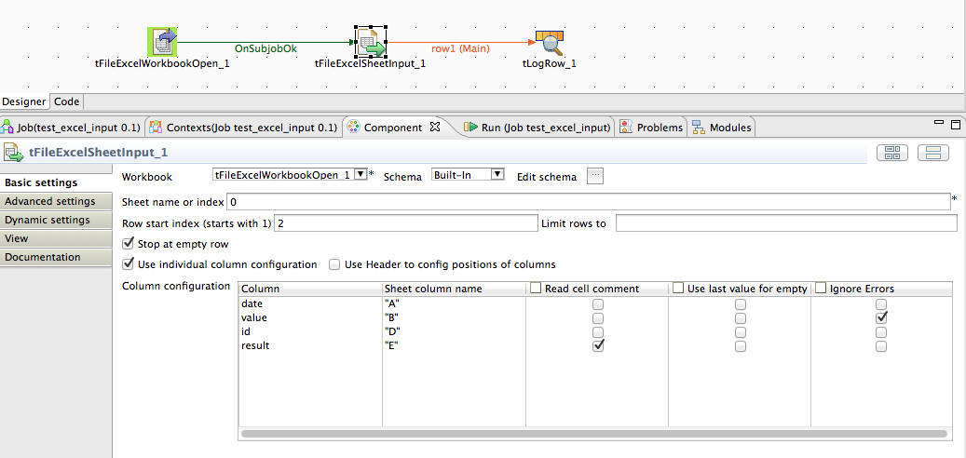

The cell can be addressed with the well-known Excel column name (staring with “A”) or the cell index (starting with 0).

**Scenario 2: Read from cells referenced by the header line**

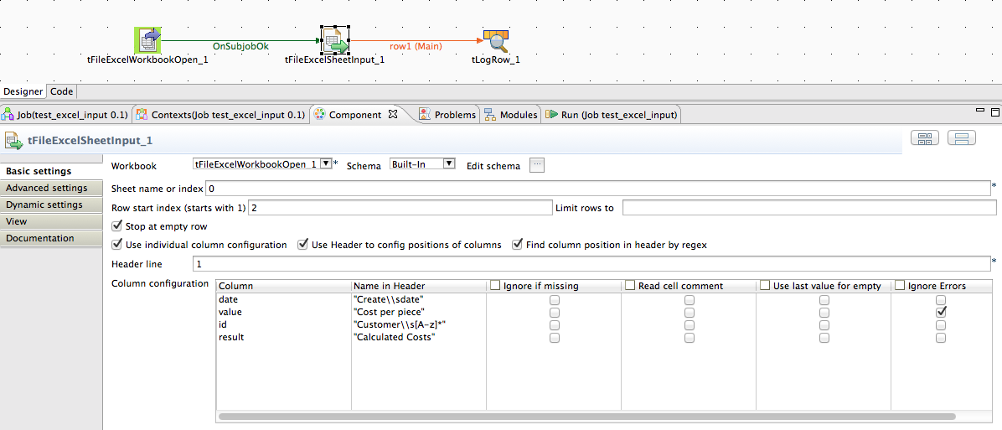

In this scenario the column the header line will configure positions. The component tries to find the column by its name (case insensitive) or by regularly expressions (also case insensitive).

**Scenario 3: Read hyperlinks from a cell**

The file to read looks like this:

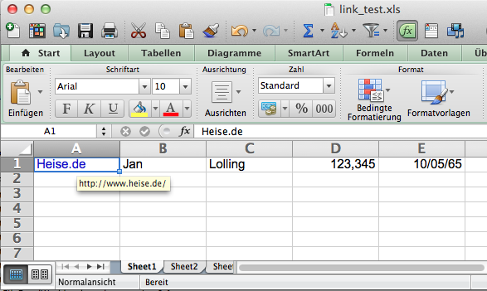

Here a simple job reading the hyperlink and separate label and URL with a regex expression.

In the component tFileExcelSheetInput activate in the advanced settings the options “Return Hyperlink URL” and “Concatenate Label | URL” (if you only need the URL, disable the last option and leaf out the regex component).

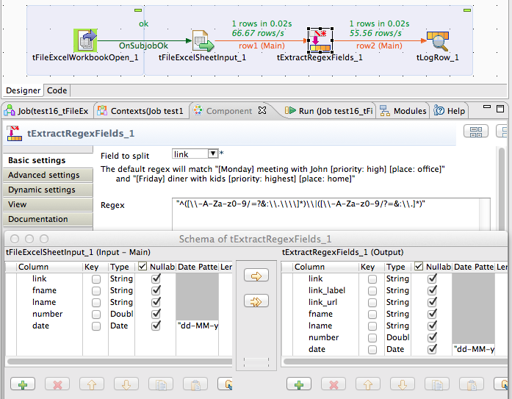

The tExtractRegexFields expects after the parsed field (link) additional fields as much as you want to extract content by regex groups. It is highly recommended to check the regex expression with external tools and take care you get only one regex sequence with (in this case) to groups. Please keep in mind every regex sequence causes an output record (e.g. an additional output record).

The regex expression here is: "^([\\-A-Za-z0-9/=?&:\\.\\\\]*)\\|([\\-A-Za-z0-9/?=&:\\.]*)"

The output of the job:

.-----------------------------+----------+--------------------+-----+-------+-------+----------.

| tLogRow_1 |

|=----------------------------+----------+--------------------+-----+-------+-------+---------=|

|link |link_label|link_url |fname|lname |number |date |

|=----------------------------+----------+--------------------+-----+-------+-------+---------=|

|Heise.de|http://www.heise.de/|Heise.de |http://www.heise.de/|Jan |Lolling|123.345|10-05-1965|

'-----------------------------+----------+--------------------+-----+-------+-------+----------'