 **Talend Component tGoogleAnalyticsUnsampledReports**

**Purpose and procedure**

This component manages Google Analytics un-sampled reports.

Un-sampled reports are only available to premium analytics accounts.

There are limitations for the usage of un-sampled reports. Per account you can start 100 reports per day.

Un-sampled reports are reports, which avoids sampling regardless the size of the undelaying raw data.

These reports will be processed asynchronously.

Steps to run un-sampled reports:

1. Start the report
2. Wait for the status COMPLETED
3. Download the report result as CSV file from the Google Drive
4. Parse the result file

A service account can also have its own drive. Unfortunately there is no option to take a look into this drive for a service account from the Drive web interface. This component supports step 1, 2 and 4.

For step 3: (download the file) use the user component tGoogleDrive.

It is supposed to proceed this way consisting of these 3 tasks:

* Starting all necessary un-sampled reports.
* Read the metadata of all reports related to the current view (profile) and check their status frequently. To support a reliable proceeding it is strongly recommended to persist the report metadata into a database table. The component provides an input flow and schema, which can be used for this table.
* Download and parse (and store the data) all result files for the completed reports

All tasks should be done in separate jobs. Please be aware it could take minimum about 10 minutes for the Google servers to finish one report. A typical duration time is about one hour.

The component uses the Core Reporting API 3.0 and the Authentication API OAuth 2.0 final.

To provide the ability to run in multiple iterations the component has special capabilities to avoid multiple logins through iterations. Usually automated processes should not use personal accounts. This requirement is addressed by using a service account, which are the only preferred way to login into Google Analytics for automated processes.

Please in case of problems check the checklist at the end of this document.

This component can be set to different modes to support the different steps. A change of the mode reconfigures the component in its properties and flows.

**Talend-Integration**

This component can be found in the palette under Business->Google

This component provides an input flow and several return values (depending on the operational mode).

Because of the very different functionality of this component in the different modes all modes are described with all aspects in separate chapters.

**Parameters and Usage**

There are 3 different functionalities, which have to choose with the operational mode switch.

|  |  |
| --- | --- |
| **Property** | **Content** |
| Operational Mode | Switches between the different modes the component provides.  **Start un-sampled report (START)**: Start an un-sampled report. Means the report will be sent to Google and is awaiting it processing.  **List un-sampled reports (LIST)**: In this mode the component reads the meta information of all reports related to a given view. If the status is COMPLETED the result file can be downloaded.  **Parse report result file (PARSE)**: In this mode the component reads the downloaded result file of one report and extracts the key figures. |

**Parameters for the operational modes: START and LIST to establish the connection**

Only in these both modes a connection to the Google servers and therefore authentication is needed.

It is supposed to use a service account because this is the preferred authentication mode for background processes.

For test proposes (especially if you want to see the result files in your personal Google account) it could be helpful to use the Application Client-ID authorization.

|  |  |  |
| --- | --- | --- |
| **Property** | **Content** | **Data types** |
| Application Name | Not necessary, but recommended by Google.  Simple provide the name of your application gathering data. ***Required*** | String |
| Authentication Method | Choose the method to authenticate:  Service Account or Client-ID for native applications | String |

Properties to use the Service Account

|  |  |  |
| --- | --- | --- |
| **Property** | **Content** | **Data types** |
| Service Account Email | The email address of the service account. Google creates this address within the process of creating a service account. Only for service accounts! ***Required*** | String |
| Key File (p12) | The Service Account Login works with private key file for authentication. In the process of creating a service account you download this file. Only for service accounts ***Required*** | String |

Properties to use the an Client-ID for native application

|  |  |  |
| --- | --- | --- |
| **Property** | **Content** | **Data types** |
| User Account Email | Email of the user account or the Client-ID | String |
| Client secret file (json) | This json file downloaded for the Client-ID | String |

The usage of the Client-ID for native applications expects on the first run an user interaction with the Google web page and after finishing the form to approve the access right you need to close the browser to let the component continue, otherwise the authentication process will not complete.

**Operational Mode: START**

In this mode the component initiate an un-sampled report. Every new such requests is a new report regardless if the parameters are the same as the last one. Be aware of the quotas limiting the number of reports per day and web property. Currently the limit is 1000 reports per day and web property.

To start a report your need pretty much the same information as for the normal Reporting API but additional the account-id and web-property-id are needed.

**Parameters to set the report context**

|  |  |  |
| --- | --- | --- |
| **Property** | **Content** | **Data types** |
| Account-Id | Account-Id | Long, String |
| Web-property-Id | Web-Property-Id | String |
| View-Id (Profile-Id) | View-Id (formally known as profile-Id) | Long, String |

**Properties to define the report**

|  |  |  |
| --- | --- | --- |
| **Property** | **Content** | **Data types** |
| Report title | A report must have a title. This title will be also the name of the result file in the Google Drive.  It is supposed to give every report its own title. It is a good practice to add the report date to the title.  Unlike in the web interface every request is a new report and existing reports cannot be reused via the API. | String |
| Start Date | All queries need always a time range (only date, not time). ***Required!*** | Date, String (yyyy-MM-dd) |
| End Date | Time range end. If you want gather data for one date, use start date as end date. ***Required!*** | Date, String (yyyy-MM-dd) |
| Dimensions | Dimensions are like group clauses. These dimensions will group the metric values.  See advise for notations below. Separate multiple dimensions with a comma. | String |
| Metrics | Things you want to measure. Separate multiple metrics with a comma.  See advise for notations below. ***Required!*** | String |
| Filters | Contains all used filters as concatenated string.  See advise for notation below. | String |
| Segment | Segments are stored filters within Google Analytics, which applies to sessions.  If a service account is used it is necessary to declare dynamic segments here because normal segments are always bound to a personal account. | String |

**Advice for filter and segment notation**

For dimensions, metrics, filters and sorts you have to use the notation from the Google Core API:

<https://developers.google.com/analytics/devguides/reporting/core/dimsmets>

Filters can be concatenated with an OR or AND operator.

Separate filter expressions with a comma means OR

Separate filter expressions with a semicolon means AND

Comparison operators in filters and segment:

|  |  |
| --- | --- |
| **Operator** | **Meaning** |
| “==” | Exact match to include |
| “!=” | Exact match to exclude |
| “=~” | Regex match to include (only for strings) |
| “!~” | Regex match to exclude (only for strings) |
| “>=” | Greater or equals than (only for numbers) |
| “=@” | Contains string |
| “!@” | Does not contains string |
| “>” | Greater than (only for numbers) |
| “<=” | Lower or equals than (only for numbers) |
| “<” | Lower than (only for numbers) |

If you use a service account it is not possible to use predefined segments made by a user because they are always limited to the user context. At the moment the preferred way is using dynamic segments, which are made in exactly the same way as the normal segments but only for the current report and not as predefined and named segment.

In this mode the component provides and output flow with the very first meta-data of the transmitted report (as one record)

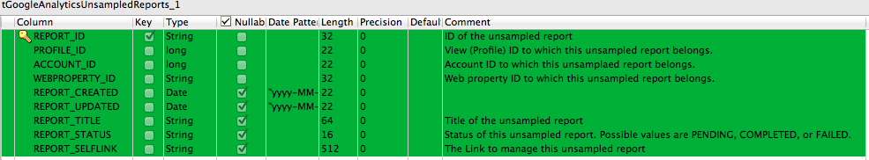

**Return values**

|  |  |
| --- | --- |
| **Return value** | **Content** |
| ERROR_MESSAGE | Last error message |
| CURRENT_REPORT_ID | The ID of the current sent report as response of the successful request. |

**Scenario to start the report**

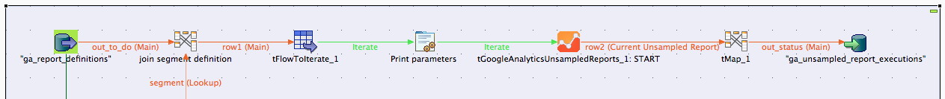

In this scenario the necessary information about the report are stored in a database table.

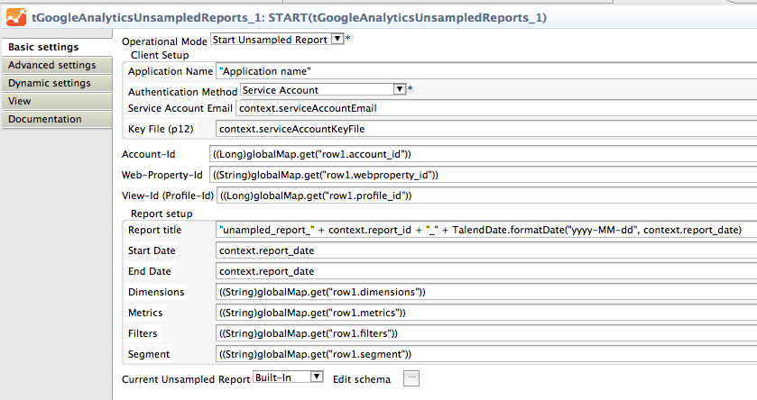

Here the configuration of the component in this scenario. The output flow returns the first created metadata of the started report. The start and end date can also provided as real Date typed objects.

**Operational Mode: LIST**

The component connects to the Google servers and reads the metadata for the un-sampled reports for the given context.

**Parameters to set the context to list the reports for**

|  |  |  |
| --- | --- | --- |
| **Property** | **Content** | **Data-types** |
| Account-Id | Account-Id. | String, Long |
| Web-Property-Id | Web-Property-Id is the ID of the web site. | String |
| View-Id (Profile-Id) | ID of the View (formally known as profile) | String, Long |

Here a typical job gathering the report metadata for a context.

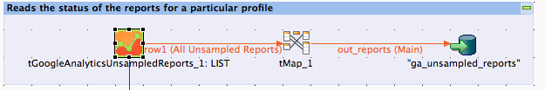

To recognize the different modes of the component in a job it is a good practice to set as View for the component this term: __UNIQUE_NAME__: __MODE__

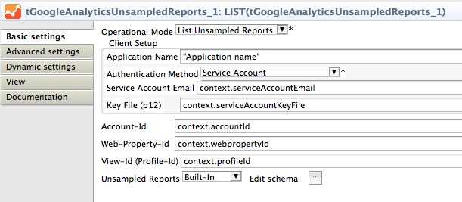

The component provides an output flow with this schema:

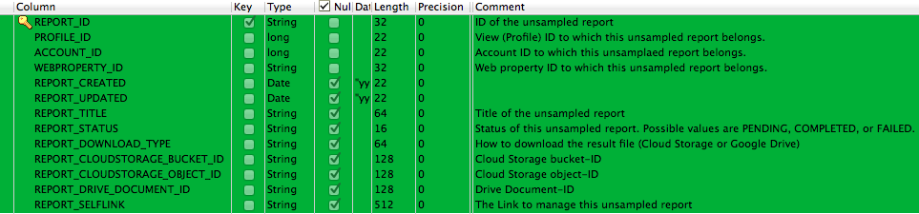

**Return values**

|  |  |
| --- | --- |
| **Return value** | **Content** |
| ERROR_MESSAGE | Last error message |
| NB_LINE_UNSAMPLED_REPORTS | Number un-sampled reports for the given view (profile) |

**Operational Mode: PARSE**

In this mode the component does not connect to the Google servers, instead it reads a downloaded result file and parse it. This file is actually a csv file but has an unstable number of header lines and the field order is sometimes disturbed if a segment was used in the report. This makes it hard to use here the normal file input components Talend provides.

The header carries information about the profile, metrics, dimensions, filters and the segment. The component takes care about these specific issues and provides the same output features as the component tGoogleAnalyticsInput to make it easy to reuse the same methods to store the values.

**Properties**

|  |  |  |
| --- | --- | --- |
| **Property** | **Content** | **Data types** |
| Report Result File | Set here the file name of the result file, which is already downloaded (e.g. with the help of the tGoogleDrive component). ***Required!*** | String |
| Normalized Output Flows | Choose if you want to use a plain schema (you have to know at design time what columns your file will provide). | Boolean |
| Use Header info for Dimensions and Metrics | If you set this option, the component ignores the dimension and metrics settings below and takes this information from the header of the result file. | Boolean |
| Dimensions | If not taken from the file header. The information is necessary to build the normalized schema. Example: “ga:date,ga:source,ga:keyword” | String |
| Metrics | If not taken from the file header. The information is necessary to build the normalized schema. Example: “ga:visits,ga:newVisits” | String |

**Using flat (plain) output**

In the schema you need an amount of columns equals to the sum of the number of dimensions and metrics.

Columns in the schema must start at first with dimensions (if provided) and ends with metrics.

Schema column types must match to the data types of the dimensions and metrics. The schema column names can differ from the names of dimensions and metrics. Only the order and there types are important.

Metric columns should be of the type double. Google always provides a value and send never null or something different than a number.

In Talend schema columns must follow the Java naming rules therefore avoid writing ga:xxx instead use the name without the ga: namespace prefix.

Important: For date dimensions (e.g. ga:date) you must specify the date pattern as “yyyyMMdd” if you want it as Date typed value.

**Using normalized output**

If a normalized output is used the component reads internal the plain records and folds them into the normalized outputs. The problem with

**Return values**

|  |  |
| --- | --- |
| **Return value** | **Content** |
| ERROR_MESSAGE | Last error message |
| NB_LINE | Number plain records (only set if normalization is not used) |
| NB_LINE_METRIC_VALUES | Number of normalized metric records. |
| NB_LINE_DIMEMSION_VALUES | Number of normalized dimension records |
| REPORT_PROFILE_ID | View used to build the report |
| REPORT_METRICS | Metrics of the report |
| REPORT_DIMENSIONS | Dimensions of the report |
| REPORT_FILTERS | Filters used for the report |
| REPORT_SEGMENT | Segment used for the report |
| REPORT_START_DATE | Start date for the report |
| REPORT_END_DATE | End date for the report |

The REPORT_xxx values will be filled just before delivering the first output, though it can be used to enhance the output flows.

**Explanation for the normalized output**

The normalized output as made for scenarios in which the job will be configured with metrics and dimensions at runtime. In this use case it is not possible to declare the appropriated schema for the flat output.

The normalization creates 2 read only output schemas:

Dimensions

|  |  |  |
| --- | --- | --- |
| **Column** | **Type** | **Meaning** |
| ROW_NUM | int | The row number from the original flat result row. It identifies the records, which belongs to together. |
| DIMENSION_NAME | String | Name of the dimension |
| DIMENSION_VALUE | String | Value of the dimension |

Metrics

|  |  |  |
| --- | --- | --- |
| **Column** | **Type** | **Meaning** |
| ROW_NUM | int | The row number from the original flat result row. It identifies the records, which belongs together. |
| METRIC_NAME | String | Name of the metric |
| METRIC_VALUE | Double | Value of the metric |

**Comparison of a plain output to a normalized output**

Given the dimensions was set to: "ga:date,ga:source,ga:keyword" and the metrics was set to: "ga:visitors,ga:newVisits"

The information about dimension and metrics can read retrieved from the input file if the option

Here some example outputs:

The plain output … and the corresponding normalized output

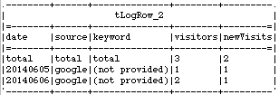 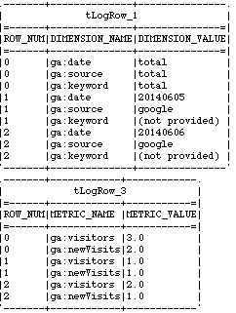

Next a real live scenario for using the normalized output in conjunction with the usage of the meta-data (gathered with the component tGoogleAnalyticsManagement):

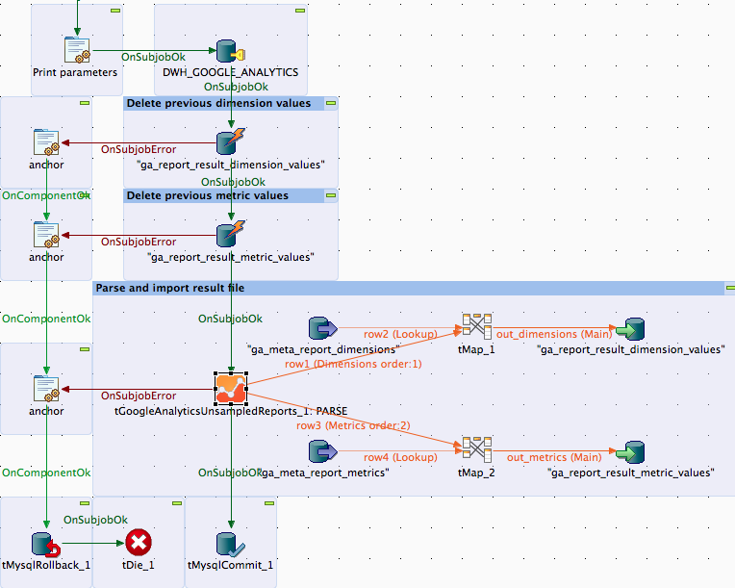

Here the configuration of the component for parsing a result file

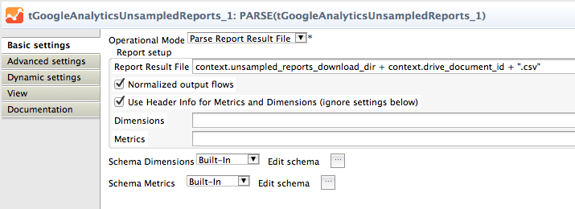

The file name in this scenario will be always assembled with the download folder and the drive document id, which we got from the report metadata (attribute REPORT_DRIVE_DOCUMENT_ID)

This job is designed to gather the data for one day and one report (a combination of a view, dimensions, metrics and filters very much like a custom report in the Google Analytics dashboard).

This job gets the view-ID, dimensions, metrics and filters as context variables and will be called, as much there are queries and dates to process.

The tMaps exchanges the dimension names and metric names with their numeric ids and adds a report-ID and the current date into the output flow for the database.

To get this job restart-able everything is done within a transaction and the previous data for the report and date will be deleted at first.

By the way, take note about the way to handle errors here, this is very easy and avoid implementing the error handling multiple times. The anchors are tJava components without any code.

It is supposed to use gather the Analytics metadata to be sure you have access to all necessary data and to be able to build a star schema for the dimensions and metrics. Take a look at the component tGoogleAnalyticsManagement.

**Configuration checklist**:

1. Is the email of the service account added to all relevant views (profiles)?
2. Is the system time of the host running the job synchronized with a NTP server?
3. Is the Google Analytics API enabled in the Google API Console?
4. Is the used account a premium account?

**Tip**:

Check your report at first in the Google Analytics API Explorer to get an idea if the data works for you.

**Advanced Option Parameters**

|  |  |
| --- | --- |
| **Property** | **Content** |
| Timeout in s | How long should the component wait for getting the first result and fetching all result with one internal iteration |
| Static Time Offset (to past) | Within the process of login, the component requests an access token and use the local time stamp (because these tokens will expire after a couple of seconds)  Google rejects all requests to access tokens when the request is in the future compared to the timestamp in Google servers. If you experience such kind of problems, this options let the requests appear to be more in the past (5-10s was recognized as good time shift) |
| Fetch Size | This is the amount of data the component fetches at once. The value is used to set the max_rows attribute. max_rows means not the absolute amount of data! The component manages setting the start index to get all data. To achieve this, the component iterates as long as the last result set are completely fetched. |
| Local Number Format | You can get numbers in various formats. Here you can define the locale in which format double or float values are should textual format by the API. |
| Reuse Client for Iterations | If you use this component in iterations it is strongly recommended to set this option. It saves time to authenticate unnecessary often and avoids problems because of max amount of connects per time range. |
| Distinct Name Extension | The client will be kept with an automatically created name:  Talend-Name-Component name + job name. In case this is not distinct enough, you can specify an additional extension to the name. |