

Talend User Component tJasperServerFileList

Purpose http://www.cimt-ag.de

The JasperServer is great tool to manage reports. In some cases companies want using JasperServer as the one portal for information.
This component addresses the scenario in which companies want to use JasperServer as the single point of trues. All results of all reports have to have to be available in this server.
To avoid have a huge amount of not needed files in your JasperServer (e.g. out dated but not obsolete files) you can archive them in a cheaper network file storage instead of keeping them in the performance critical database of the JasperServer.
This component lists all content resources (also in sub directories). Usually this component works in conjuction with the tJasperServerFileGet component.

Talend-Integration

This component can be found in the palette under Business Intelligence->Jasper
This component accepts input iterations provides output flows and iteration and several return values.

Parameters

Parameters to connect to JasperServer (setup client)

Property | Content
Repository Service URL | URL to the repository web service of JasperServer. Required!  For the Open Source version it is usually:  http://server.comany.com:8080/jasperserver/services/repository  The professional version typically use a slitly different URL:  http://server.company.com:8080/jasperserver-pro/services/repository
User | User of the account within the JasperServer. Required!
Password | Users password. Required!

Parameters to setup list files

Property | Content
Folder | URI of the folder which content resources should be listed. Required!
Include Sub Folders | If checked the content resources of the sub folders are included in the result list.
Filter | Well known file filter expressions (using * and ?) to filter the content resources to add them in the result list.

Return values

Return value | Content
ERROR_MESSAGE | Last error message
FOLDER_URI | URI of the folder which content should be listed
FILE_URI | URI of the current file
FILE_DOWNLOAD_LINK | Link in the JasperServer to download the current file for users of the Jasper Web frontends.
RESOURCE_ID | Resource-ID (typically th name) of the current file
RELATIVE_FILE_URI | Like file URI, but relative to the FOLDER_URI.  This relative URI reflects the original folder stucture of the files in JasperServer (e.g. to restore this sturcture in the file system) in the result list.
FILE_RESOURCE_LABEL | If users rename the file in JasperServer they actually only can change the label.
NB_FILE | Current number of delivered files

Szenario 1

Files in the JasperServer need to be downloaded automatically (e.g. to archive them and and lighten the database). In conjunction with the tJasperServerFileGet component this goal can be achieved.

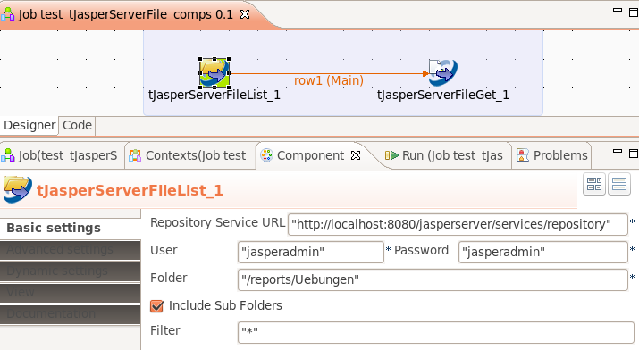
This component provides output iteration as well as output flow. Actually there is no difference between a iteration and a flow from the point of view of the source component. Using a flow has the great advantage for performance because the initialization of the component receiving the flow will be done once before the flow starts. Unlike if an iteration is used. Using an iteration has the disadvantage, that in every iteration the component will be newly initialized – this can have a huge negative impact to the performance!

