

Talend User Component tJasperServerFileCopy

Purpose http://www.cimt-ag.de

The JasperServer is great tool to manage reports. In some cases companies want using JasperServer as the one portal for information.
This component addresses the scenario in which companies want to use JasperServer as the single point of trues. All reports have to store there results in this server.
To avoid have a huge amount of not needed files in your JasperServer (e.g. out dated but not obsolete files) you can archive them in a cheaper network file system instead of keep them in the performance critical database of the JasperServer.
This component copy content resources. Usually this component works in conjuction with the tJasperServerFileList component.

Talend-Integration

This component can be found in the palette under Business Intelligence->Jasper
This component accepts input iterations or flows and several return values.

Parameters

Parameters to connect to JasperServer (setup client)

Property | Content
Repository Service URL | URL to the repository web service of JasperServer. Required!  For the Open Source version it is usually:  http://server.comany.com:8080/jasperserver/services/repository  The professional version typically use a slightly different URL:  http://server.company.com:8080/jasperserver-pro/services/repository
User | User of the account within the JasperServer. Required!
Password | Users password. Required!

Parameters to setup copy/move file

Property | Content
File URI | URI of the file to downloadto the file system. Required!
Target Folder URI | URI of the target folder in JasperServer Required!
Create Folder | Ensures the target folder exists
Delete Source | If successfully copied, the file will be deleted from the source folder
Overwrite | If the target resource already exists it will be deleted before

Return values

Return value | Content
ERROR_MESSAGE | Last error message
TARGET_URI | URI of the copy or move target (file)
FILE_NAME | Name of the copied file
FILE_DOWNLOAD_LINK | Link in the JasperServer to download the current file for users of the Jasper Web frontends.
FOLDER_CREATED | True if the traget folder was created by this process.

Szenario 1

Files in the JasperServer need to be downloaded automatically (e.g. to archive them and and lighten the database). In conjunction with the tJasperServerFileList component this goal can be achieved.

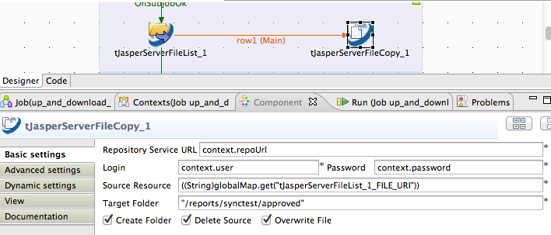
This component provides input iteration as well as an input flow. Actually there is no difference between a iteration and a flow from the point of view of the source component. Using a flow has the great advantage for performance because the initialization of the component receiving the flow will be done once before the flow starts. Unlike if an iteration is used.
Using an iteration has the disadvantage, that in every iteration the component will be newly initialized – this can have a huge negative impact to the performance!

