

Talend User Component tJasperServerFileGet

Purpose http://www.cimt-ag.de

The JasperServer is great tool to manage reports. In some cases companies want using JasperServer as the one portal for information.
This component addresses the scenario in which companies want to use JasperServer as the single point of trues. All reports have to store there results in this server.
To avoid have a huge amount of not needed files in your JasperServer (e.g. out dated but not obsolete files) you can archive them in a cheaper network file system instead of keep them in the performance critical database of the JasperServer.
This component downloads content resources. Usually this component works in conjuction with the tJasperServerFileList component.

Talend-Integration

This component can be found in the palette under Business Intelligence->Jasper
This component accepts input iterations or flows and several return values.

Parameters

Parameters to connect to JasperServer (setup client)

Property | Content
Repository Service URL | URL to the repository web service of JasperServer. Required!  For the Open Source version it is usually:  http://server.comany.com:8080/jasperserver/services/repository  The professional version typically use a slightly different URL:  http://server.company.com:8080/jasperserver-pro/services/repository
User | User of the account within the JasperServer. Required!
Password | Users password. Required!

Parameters to setup download a file

Property | Content
File URI | URI of the file to downloadto the file system. Required!
Destination Directory | Directory of the local file system, where the component starts filing the content resources. Required!
Rename | If checked, the downloaded file can get a different name as in JasperServer.
Destination File Name | If Rename is checked, this name will be used instead of resource-Id as file name. This name can also contains a relatice path. This path will be append to the Destination Directory.
Replace existing file | If file already exists in file system it will be overwritten, otherweise if not ckecked, the component failes with an appropriated error message.
Create the directory if it does not exists | Ensures the target directory (the actual directory also if Destination File Name appends sub dirs to the Destination Directory) exists.
Remove Source File | If successfully downloaded, the file can be deleted from the JasperServer

Return values

Return value | Content
ERROR_MESSAGE | Last error message
FILE_PATH | Full path to the downloaded file
FILE_NAME | Name of the downloaded file
FILE_DOWNLOAD_LINK | Link in the JasperServer to download the current file for users of the Jasper Web frontends.
RESOURCE_ID | Resource-ID (typically th name) of the current file
RELATIVE_FILE_URI | Like file URI, but relative to the FOLDER_URI.  This relative URI helps to keep the original folder stucture of the files in JasperServer (e.g. to restore this sturcture in the file system).
FILE_RESOURCE_LABEL | If users rename the file in JasperServer they actually only change the label.

Szenario 1

Files in the JasperServer need to be downloaded automatically (e.g. to archive them and and lighten the database). In conjunction with the tJasperServerFileList component this goal can be achieved.

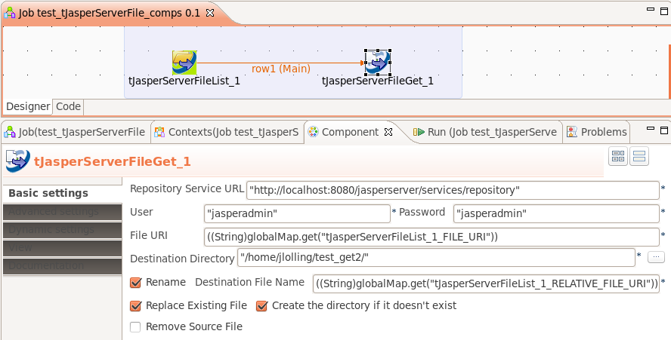
This component provides input iteration as well as an input flow. Actually there is no difference between a iteration and a flow from the point of view of the source component. Using a flow has the great advantage for performance because the initialization of the component receiving the flow will be done once before the flow starts. Unlike if an iteration is used.
Using an iteration has the disadvantage, that in every iteration the component will be newly initialized – this can have a huge negative impact to the performance!

