

Talend User Component tJasperServerFilePut

Purpose http://www.cimt-ag.de

The JasperServer is great tool to manage reports. In some cases companies want using JasperServer as the one portal for information.
This component addresses the scenario in which companies want to use JasperServer as the single point of trues. All reports have to store there results in this server.
Sometimes it is more likely to create very complex or large data files with a Talend job.
Often this leads to different places where users find information: reports in JasperServer and a lot of files in different shares.
This component helps to fill your JasperServer with files (as content resources) from the file system and ensure in this way the role of the JasperServer as source of complete informations.

Talend-Integration

This component can be found in the palette under Business Intelligence->Jasper
This component accepts input iterations and several return values.

Parameters

Parameters to connect to JasperServer (setup client)

Property | Content
Repository Service URL | URL to the repository web service of JasperServer. Required!  For the Open Source version it is usually:  http://server.comany.com:8080/jasperserver/services/repository  The professional version typically use a slightly different URL:  http://server.company.com:8080/jasperserver-pro/services/repository
User | User of the account within the JasperServer. Required!
Password | Users password. Required!

Parameters to setup file to upload

Property | Content
File | The full path to the file to upload. This file gets as resource-ID the file name.  Required!
Destination Folder | URI of the target folder in JasperServer. Please keep in mind URIs in JasperServer never ends with a slash (unlike folder pathes in filesystem).  Required!
Create Folder | If the folder does not exists in JasperServer, it will be created automatically. This new folder inherates the rights of its parent folder.
Overwrite File | If a resource with the same resource ID already exists in the same folder, it will be overwritten.
Description | Here can be set a description to this new content resource.

Return values

Return value | Content
ERROR_MESSAGE | Last error message
FILE_URI | URI for the uploaded file in JasperServer
FILE_DOWNLOAD_LINK | Link in the JasperServer to download the file for users of the Jasper Web frontends.
FOLDER_CREATED | True if the target folder was newly created. This can be used e.g. to notify administration for correcting folder permissions.
FILE_PATH | Full path from the uploaded file
FILE_LENGTH | Length of the uploaded file
FILE_NAME | Name of the uploaded file

Szenario 1

Files are created from Talend are stored in the file system and have to uploaded to the JasperServer. For every upload an notification email have to be send with a access link to the JasperServer.

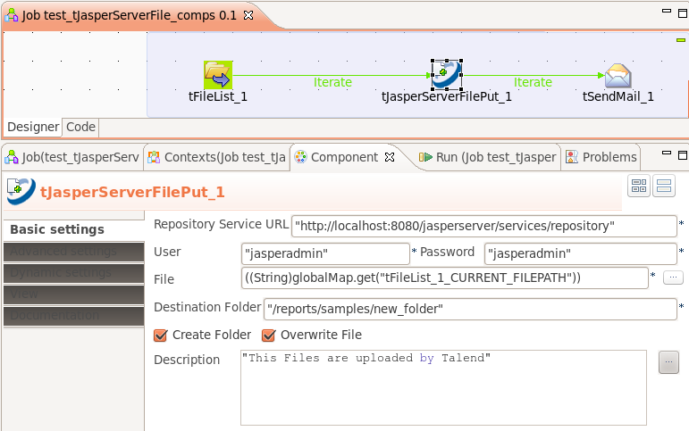
To provide the download link in the email message write tJasperServerFilePut and choose with CTRL+Space the value FILE_DOWNLOAD_LINK.

