 **Talend Component tMustacheOutput**

**Purpose and procedure**

This component renders incoming data with Mustache-templates.

The Mustache is a very simple templating engine which does not proviedes any logic but is therefore very easy to use and maintain. Here is the specification of the template language: <https://mustache.github.io/mustache.5.html>

A very good explanation can be found here: <https://www.bersling.com/2017/09/22/the-ultimate-mustache-tutorial/>

This component works in 2 modes:

1. Render all incoming rows as one document at the end of the flow
2. Render every incoming row immediately as document and put this to an output column.

**Talend-Integration**

This component can be found in the palette under Processing->Fields

This component provides an input flow and several return values (depending on the operational mode).

**Parameters and Usage**

|  |  |  |
| --- | --- | --- |
| **Property** | **Content** | **Data types** |
| Schema | Setup here your incoming and outgoing schema.  Outgoing is optional and only essential if you want to render incoming rows immediately (row by row).  ***Required*** |  |
| Mustache Template | Setup here the template. You can write here the template in the same way as you do in any database component for the SQL query. You need at minimum a quote at the beginning and at the end of the template.  It is also possible to use a context variable or a globalMap-variable.  ***Required*** | String |
| Fail if template has fields not exists in te schema | This option let the component check if the template expects fields which do not exists in the schema. This way you can prevent using the wrong template for the job. |  |
| Choose mode for rendering | Mode switch (see list above) |  |
| Name of the root list | This attribute is relevant for the mode 1.  When you render multiple rows into one document you need a list element and here you can name it to use this name in your template.  ***Required*** | String |
| Name of the output column for the document created for every row | This attribute is relevant for the mode 2.  When you render row by row the output document will be assigned to an output column. Choose here the column from the out going schema.  ***Required*** |  |
| Locale for numbers | Setup here the locale used to define the number grouping and decimal delimiter character.  ***Required*** | String |

**Return values of the component:**

|  |  |
| --- | --- |
| Value | Content |
| NB_LINE | Number of lines read |
| ERROR_MESSAGE | Error message if something went wrong |
| OUTPUT_DOCUMENT | Rendered document as String |

**Use-Cases:**

**Render all rows in one document**

This example job generates simple data and all rows will be rendered into one result. To do so you need the iteration to let the template engine iterate through the fetched records. Because the iteration needs a name, that why you have to configure it in the component.

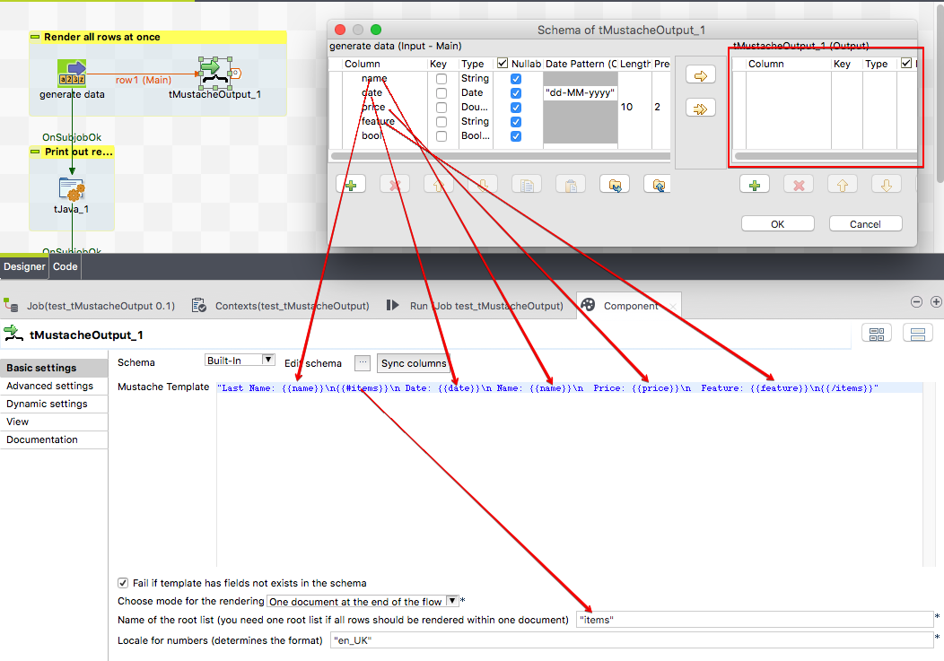

The names in the template must match to names of the schema, otherwise if the schema does not contains all fields mentioned in the template the component will raise an error. The schema can of course have more columns than expected from the template.

Here how the example data are generated:

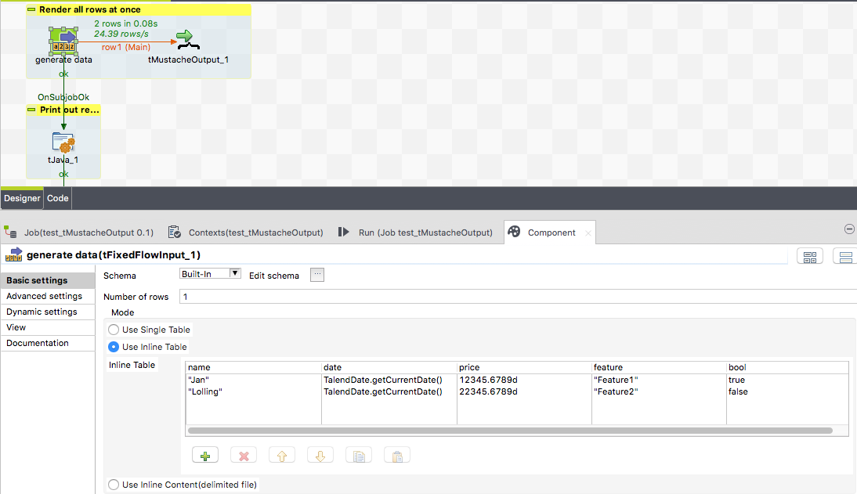

Here the part of rendering the output to the console:

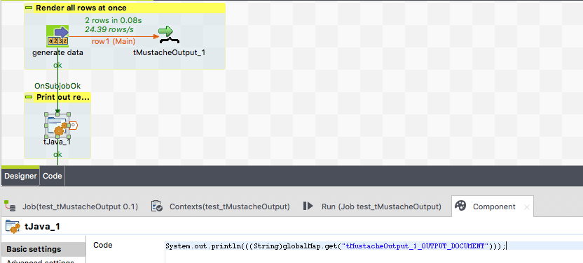

And here how the output looks like:

Last Name: Lolling

Date: 24-05-2019

Name: Jan

Price: 12345.68

Feature: Feature1

Date: 24-05-2019

Name: Lolling

Price: 22345.68

Feature: Feature2

If a field appears outside the iteration, the last value will be used.

**Rendering every incoming row**

If you want to render incoming rows ro by row you have to choose mode 2.

Here the part of the job generating the example data:

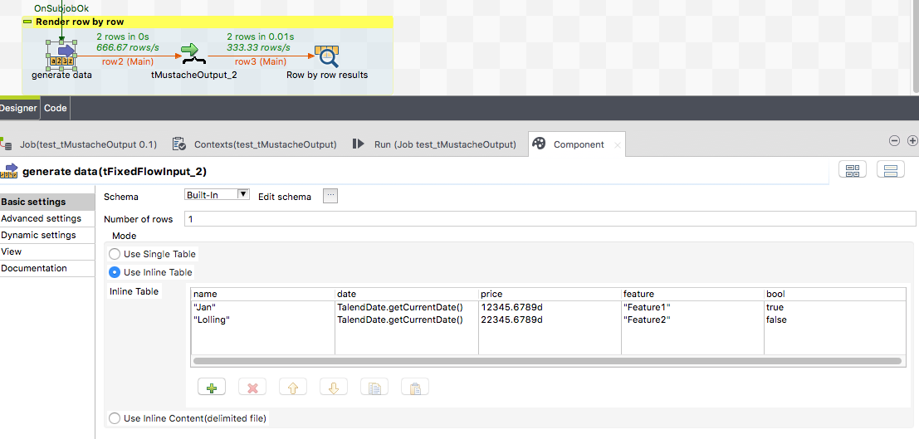

Here the part of the job rendering the documents (row by row -> mode 2)

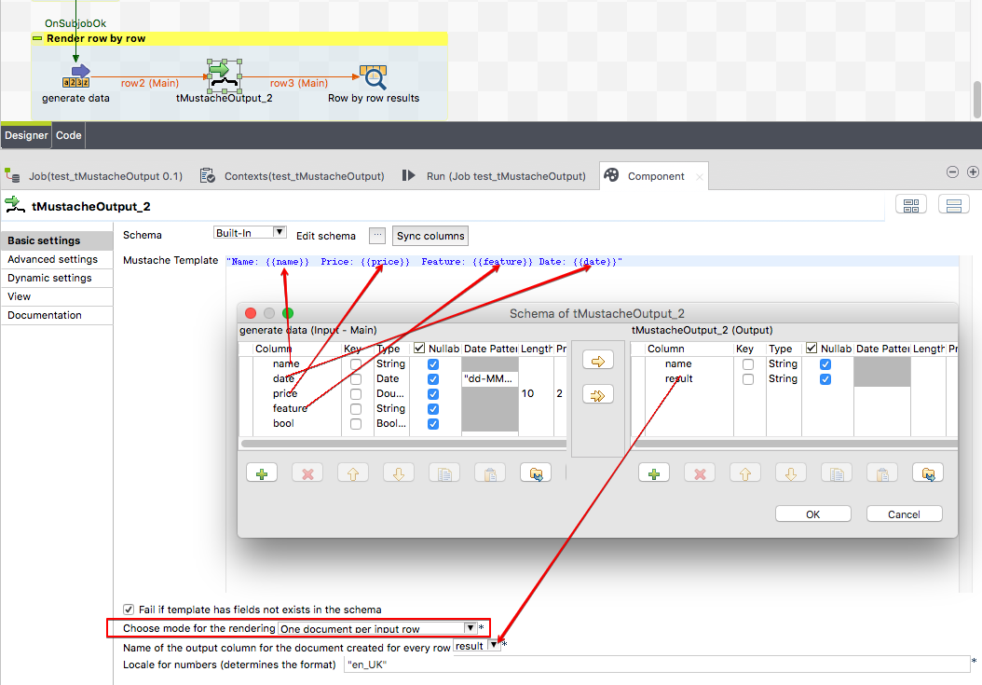

And this is how the output looks like:

.-------+------------------------------------------------------------------.

| Row by row results |

|=------+-----------------------------------------------------------------=|

|name |result |

|=------+-----------------------------------------------------------------=|

|Jan |Name: Jan Price: 12345.68 Feature: Feature1 Date: 24-05-2019 |

|Lolling|Name: Lolling Price: 22345.68 Feature: Feature2 Date: 24-05-2019|

'-------+------------------------------------------------------------------'