
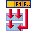
Talend User Component tNormalizeSchema

Purpose http://www.cimt-ag.de

This component normalize a wide schema into a smaller one. It has the same result like the build in tSplitRow component but provides these advantages:
* the field mapping is much easier and simple be done with a few settings
* byte code foot print is lower (helps to avoid violating the 64k method byte size in Java)
* the memory foot print is lower because the component does not keep the occurrence of fields in memory.

Talend-Integration

This component can be found in the palette under Processing->Fields
This component provides an output flow and several return values.

Parameters

Property | Content
Schema | At first the input schema, but need configuration.
First Column to Normalize | The first (or the only) column which occurce more than one (and therefore should to be normalize).
Number of fields to normalize | In case there are more then one column to normalize (they have to follow after the first column) please specify here the number of columns.
Occurrence of field group | Specify how often the field or the group of fields occurse.
Write repetition into a output column | The number of occurrence can be saved into a output column.
Column for repetition index | Specify here the column (must be an Integer type) for the repetition index.

Return values

Return value | Content
ERROR_MESSAGE | Last error message
NB_LINE_IN | Number of input lines
NB_LINE_OUT | Number of output lines

Szenario

Normalize the given schema, read from a text file.

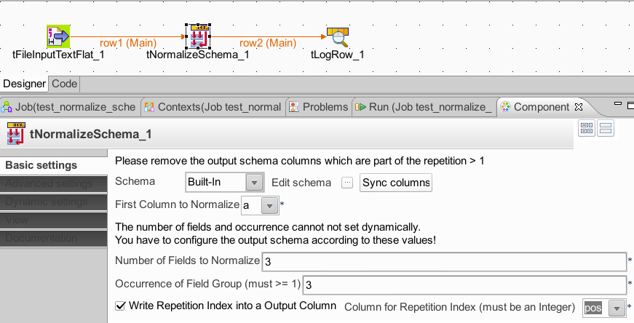
Here the schema:

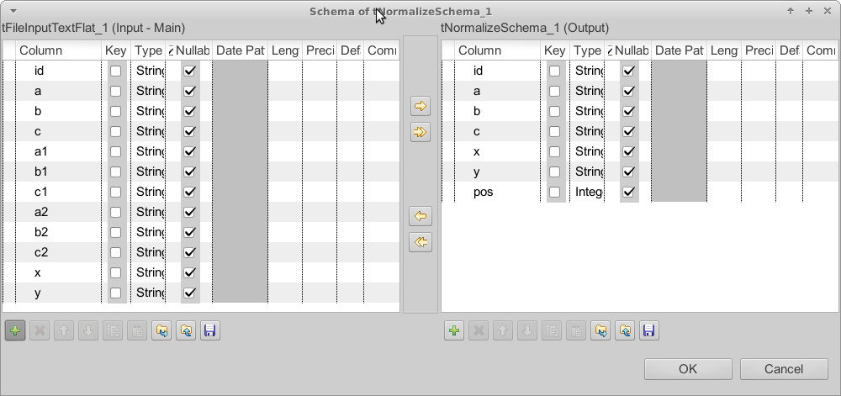
Remove all columns which are used in the normalization.
It works with any kind of data types. This picture shows a very basic usage with only Strings used. But there is no limitation in data types.

Here the result of a demo job:

Demo data input:
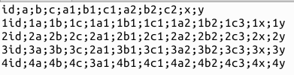

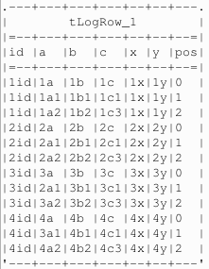
Demo data output:

