 **Talend User Components tOracleMergeELT**

# Purpose

This component provides the Oracle SQL merge command as Talend component.

The main difference to the build-in component from Talend is the developer does not need a schema to work with the component. The component fetches the table and query metadata from the database and configure the merge command based on the columns of the target table as well as the on clause (configures the key condition).

The Oracle merge command is describes here: [https://docs.oracle.com/cd/B28359_01/server.111/b28286/statements_9016.htm#SQLRF01606](https://docs.oracle.com/cd/B28359_01/server.111/b28286/statements_9016.htm" \l "SQLRF01606)

# Talend-Integration

You find this component in the studio palette under: Databases/Oracle

## Basic settings

|  |  |
| --- | --- |
| **Property** | **Content** |
| Connection | Choose the Oracle connection component (which must be added before this component).  The component expects a separate connection. |
| Source Select | Add here the source select. You can et it as String just like in a normal tOracleInput component or use a context variable or a globalMap variable.  Please take care the source select must contains the columns of the target table (case insensitive) except the target columns which must be excluded or are fixed value columns.  It is not necessary to declare the columns explicitely, a select * works fine as long as the result will return the necessary columns. |
| Target Table | The target table. The schema of this table is defined in the target connection component. |
| Allow Insert | Activates the on not matched part of the merge statement. Means based on the primary key of the target table all new records will be added |
| Allow Update | Activates the on matched part of the merge statement. Means based on the primary key of the target table the already existing recordss will be updated. |
| Enable where clause for update | You can define an additional condition which existing records should be updated. |
| Update where condition | This is the condition selection the existing records for update. The where keyword will bew added automatically. The source fields must be referenced via the alias s |
| Allow update only for a fixed set of columns | You can restrict the update to these columns. It does not matter if the column does not exist in the source or target, if the columns exist, only these columns will be updated. |
| Allow Delete | Activates the delete part of the merge statement (sub part of the update part). |
| Delete where condition | It is mandary for the syntax of the merge statement the optional delete part must have a where condition. If you do not want such set simply 1=1 |
| Allow Exclude columns | Enables the feature of excluding columns from transfer |
| Source columns to exclude | This list of columns will be excluded from the transfer. It does not matter if the column does not exist in the source or target. If such column appears it will be ignored. |
| Allow fixed values | Enables the feature of adding fixed values to columns which exists in the target table but most likely not in the source. |
| Columns with fixed values | This list of columns will be added to the insert or update part of the merge statement. Per column you can define a value which will be used. |
| Do Commit | If the transfer finish successfully the component can perform a commit on the traget connection. |

On word to the column related settings. Yes, the component does have a schema and read the columns from the database metadata. In a lot of use cases it is often the case you have various tables which have columns in common – mostly technical columns. Therefor the component ignores these columns if they do not exist in the target table.

## Advanced settings

|  |  |
| --- | --- |
| **Property** | **Content** |
| Keyword to enclose with " | In this list you can configure identifier which are actually keywords and must be enclosed within " to prevent SQL syntax errors. The component knows a lot of typical keywords and add automatically the " around them but if some missing, add them here. |

## Return values

|  |  |
| --- | --- |
| **Return value** | **Content** |
| ERROR_MESSAGE | If the parsing will fail, the error message goes here. |
| NB_LINE | The number of inserted, updated or deleted records. |
| QUERY | The complete merge statement executed on the target connection. |

# Example Use Cases

## Insert only new records

This use case is designed to only integrate new records in a target table. Already existing records must remain unchanged.

The query and the target table are read from a configuration file. All tables have a set of technical columns in common.

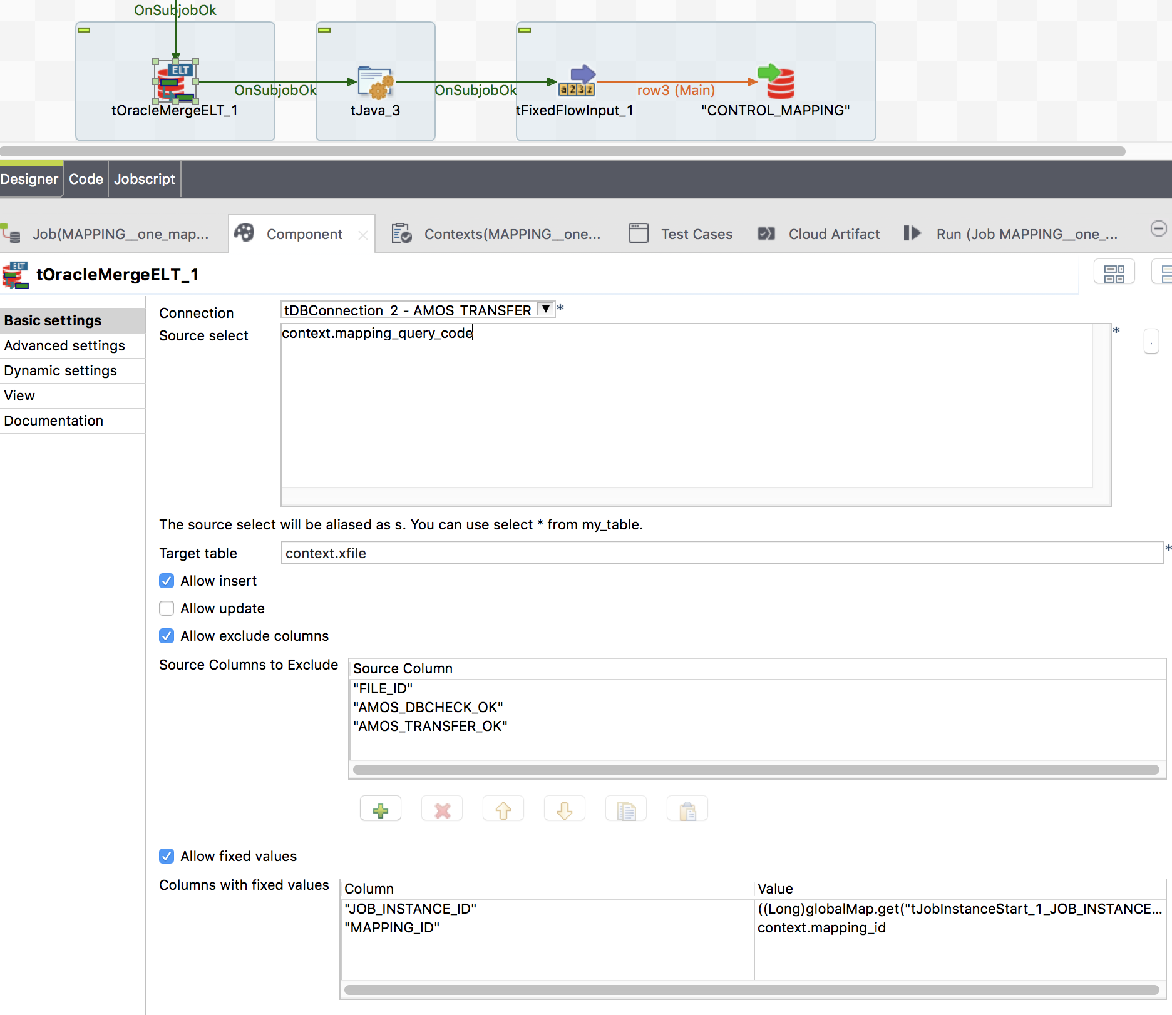

## Table which records will be inserted, updated and deleted

This use case is not real and use a simple query as source.

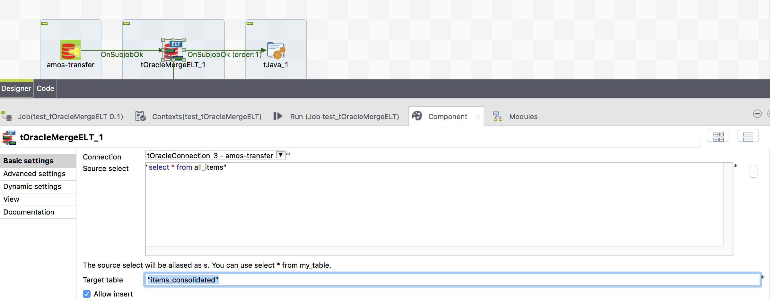

The update section wants only update records from valid source records.

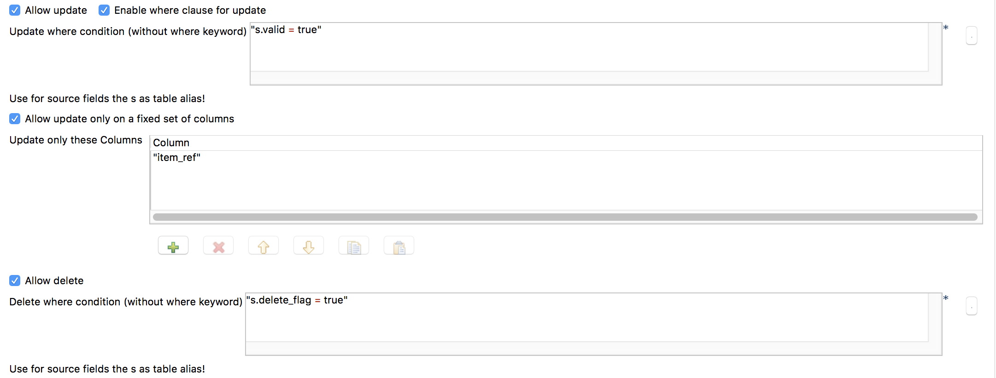

If some source records marked as delete, these records need to be deleted in the target.

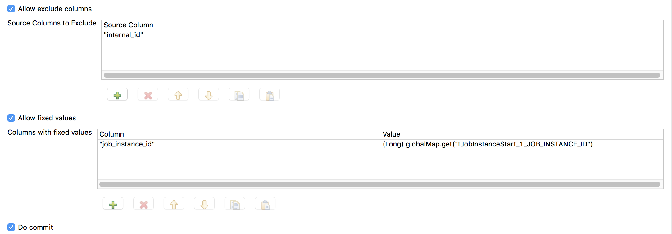

Here some examples of columns to exclude and to add as fixed value columns.