 **tYoutubeAnalyticsInput**

# Purpose

This component runs queries on YouTube Analytics.

The most recent API causes a bit cumbersome handling for the authorization because YouTube does not allow the usage of service accounts. Therefore it is only possible to authorize with personal credentials and not with a technical account (like service accounts) and it is unfortunately necessary to run the job first time in the studio because the fist authorization requires a interaction with the browser.

# Talend-Integration

This component can be found in the palette under Business/Google

This component provides return values.

# Prerequisites

You need following information:

1. The email address of the channel owner and the YouTube Channel ID
2. Your own analytics project (this is quite the same as for Google Analytics)
3. Access to the YouTube Analytics API and YouTube Data API
4. JSON formatted secret file

**1. The email address of the channel owner and the YouTube Channel ID**

Your email address used to identify your self should be well known ;-)

The channels ID can be retrieved by open the browser with this URL:

<https://www.youtube.com/account_advanced>

Here you find the YouTube Channel ID

**2. Create a project in the Google Developers Console**

You need access to the Google Developer Console:

<https://console.developers.google.com/project?authuser=0>

If you already have a project e.g. for your Google Analytics you can use the existing project.

If not please create a new project: Click on Create Project

**3. Access to the YouTube Analytics API and YouTube Data API**

Go into your project and click on APIs

All already enabled APIs are displayed at first.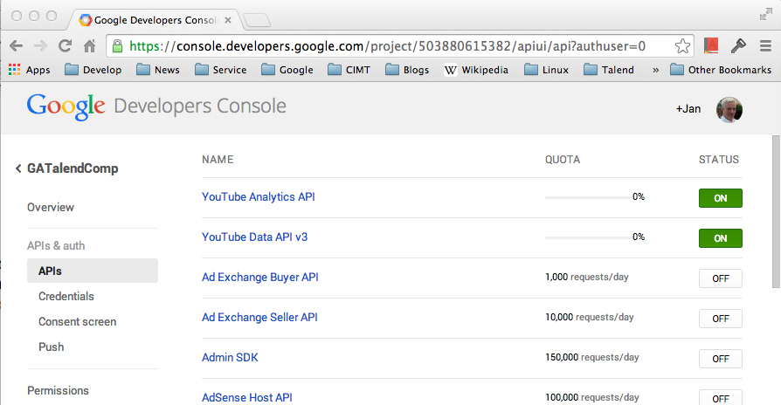

**4. JSON formatted secret file**

We need a Client ID for native application

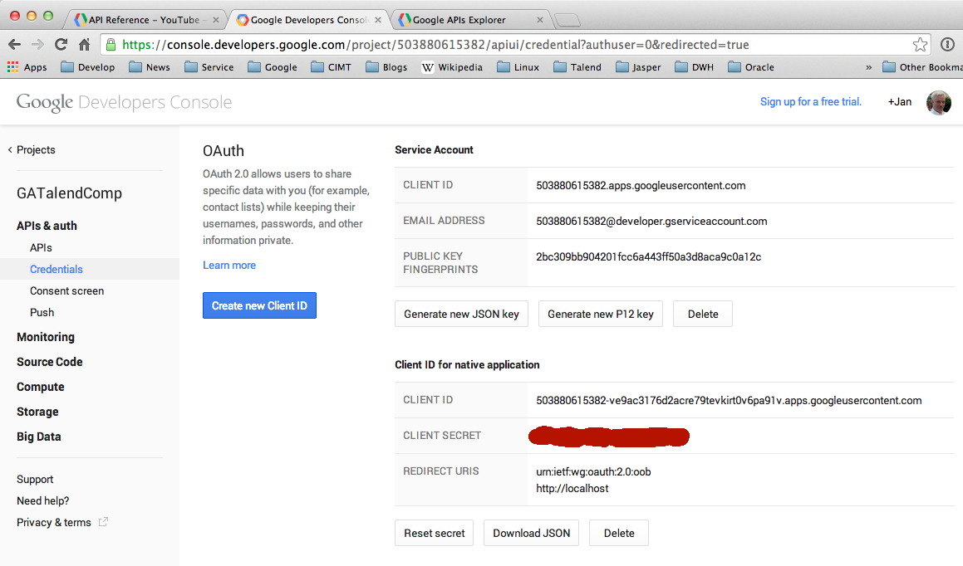

Next: download the JSON file containing the credentials and save it in a folder where your have write access and the folder it self cannot be a link (because later the API will set the permissions to this folder)

For more information about the YouTube Analytics API please visit:

<https://developers.google.com/youtube/>

You have to start a job using this credentials at first in a studio or any environment with a default browser.

Because YouTube does not allow service accounts, the application needs manually approval to get access to the analytics data. The successfully created token will be saved by the component into a sub-directory + file in the directory of the json secret file.

Here an example:

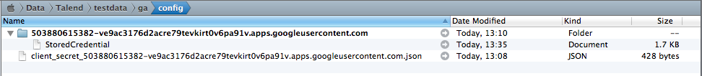

The json file was downloaded from the Google API console and the directory and file “StoredCredential” are created by the component.

It is not necessary to do this for every job you have, it is only necessary to run the approval process once and as the result you get that directory + file.

This directory will always be searched in the directory of the json secret file. You can move all at any place as long your job points to the json secret file. This is important to be able to set such jobs productive.

# Parameters

|  |  |
| --- | --- |
| **Property** | **Content** |
| Application Name | Take it from your Google Developer Console (it is the project name) |
| Client secret file | Choose the file which you have downloaded from your Client ID as JSON file |
| Account Email | The email address of the channel owner |
| Channel-ID | The ID of the channel taken from the advanced settings in YouTube |
| Start Date | Start date as String with the pattern yyyy-MM-dd |
| End Date | End date as Strung with the pattern yyyy-MM-dd |
| Dimensions | The dimensions you want to have or leaf the attribute blank. Dimensions are optional. If you do not set dimensions you will get one dataset.  Dimensions will be separated with a comma. |
| Metrics | The metrics are mandatory. You need at least one metric. Metrics will be separated with a comma. |
| Filters | The Filters are optional. |
| Sorts | The sorts are optional. Sorts will be separated with a comma. A minus in front of a sort (dimension or metric) will sort the result in descending order. |

**Return values of the component:**

|  |  |
| --- | --- |
| Value | Content |
| NB_LINE | Number of lines read |
| ERROR_MESSAGE | Error message if something went wrong |

# Scenario: Simple print out the result

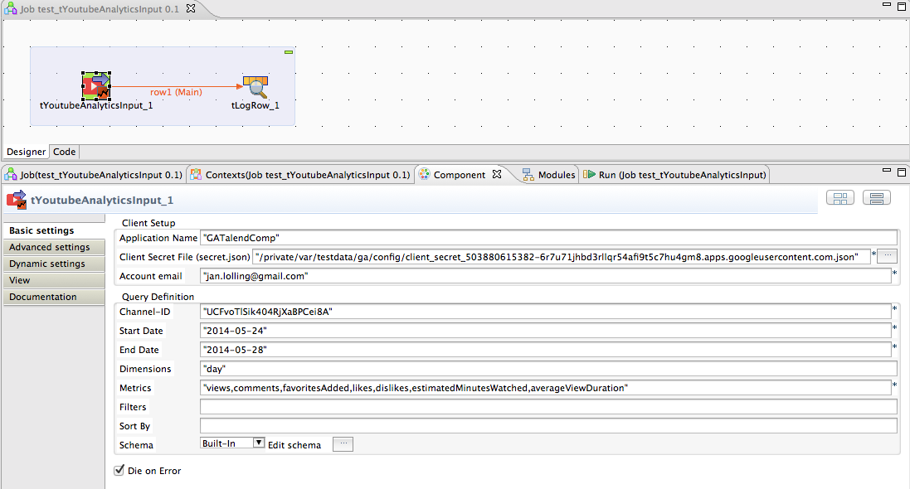

If you run the job first time you will have to allow the access of this application to your YouTube data. The job starts a browser. If you have more than one account with the same email address you have to choose the account at first.

This interaction is need only once. The component creates a credential store in the same directory as you have placed your JSON secret file. Of course you should use a database table output component instead with a tMap to add additional values (e.g. from the query parameters) to the table.

**Configure the schema:**

The necessary schema consists of:

All dimensions (if you have some)

All metrics

Or if you have declared the field: Only the fields.

Typically dimensions are of the type String and metrics are of the type Integer (but some of them are of the type Float).

If you have switched on the debug option (it is on per default) the component renders all received columns and it data types on standard out.

Here the output of this job (except the results):

Credential data store dir:/private/var/testdata/ga/config/503880615382-ve9ac3176d2acre79tevkirt0v6pa91v.apps.googleusercontent.com.json/

Result initial contains 1 rows

Result set column headers:

name: day columnType: DIMENSION dataType: STRING

name: views columnType: METRIC dataType: INTEGER

name: comments columnType: METRIC dataType: INTEGER

name: favoritesAdded columnType: METRIC dataType: INTEGER

name: likes columnType: METRIC dataType: INTEGER

name: dislikes columnType: METRIC dataType: INTEGER

name: estimatedMinutesWatched columnType: METRIC dataType: INTEGER

name: averageViewDuration columnType: METRIC dataType: INTEGER

# Typical problems:

How to find the channel-ID:

Login into YouTube and open this page: <https://www.youtube.com/account_advanced>

You get the error message: Forbidden

Take care you use the correct channel-ID and the correct email address.

You get the error message: Invalid query. Query did not conform to the expectations.

This can happen if your channel has no video at all or if you mix up dimensions and metrics what does not fit together.

Please use the Google API explorer to check your query.

<https://developers.google.com/apis-explorer/#s/youtubeAnalytics/v1/>

Also a good advice provides this guide:

<https://developers.google.com/youtube/analytics/v1/?hl=de>