React UI design and development requirement

1. Refer to the mockdata that is under \demo\static folder, use react/redux or react hook to keep defaultAccount, accounts and prefDocuments
2. UI Component (Accessibility needs to be considered)

* Header (background color: #647882)

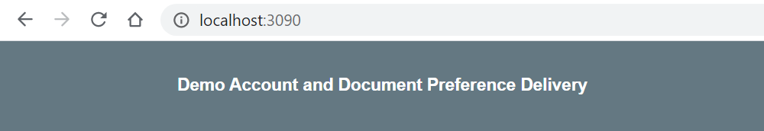

* As default account is available, initial access page will be shown as below:

default account

default account document preference delivery

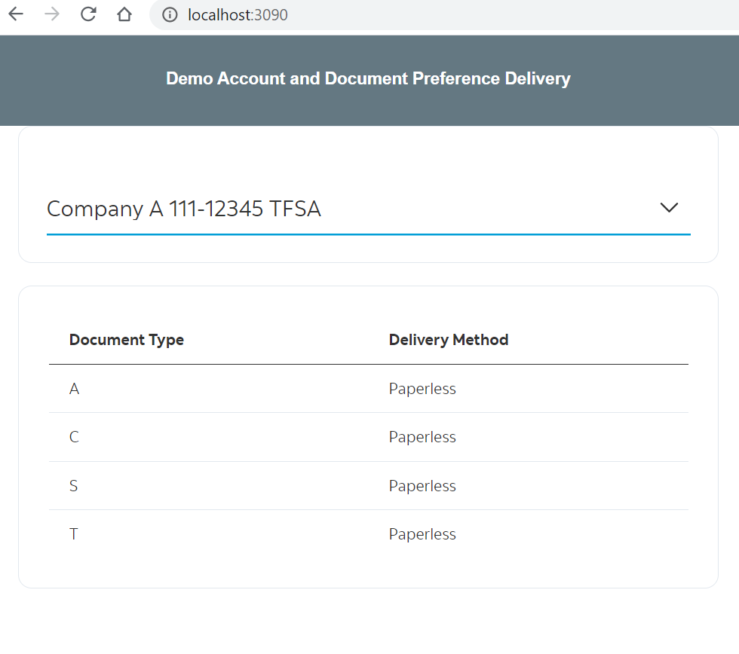

Note:

is_paper_flag: false=> Paperless

is_paper_flag: true=> Paper

* Dropdown account list from react accounts

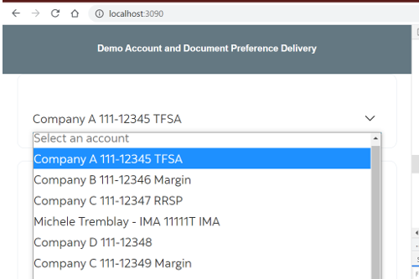

account display: description + id + typeDesc

Note: if typeDesc is not ‘IMA’, id needs to split by hyphen like this ‘xxx-xxxxx’

* If switching another account from account dropdown list, document type and delivery method will be presented accordingly.

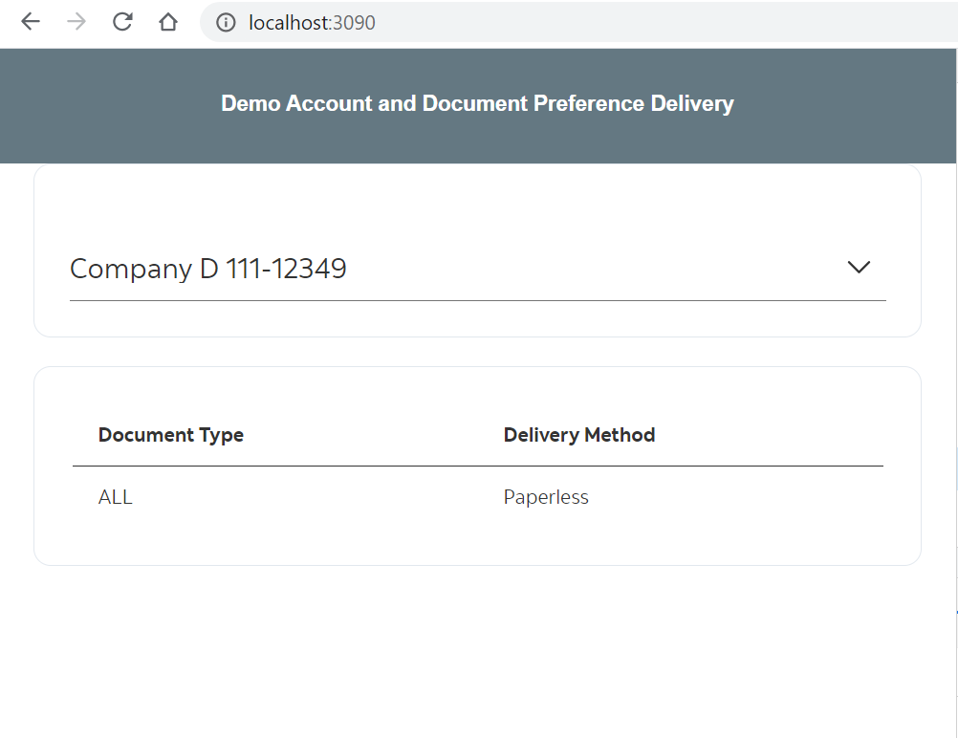

* It would be nice to consider mobile UI

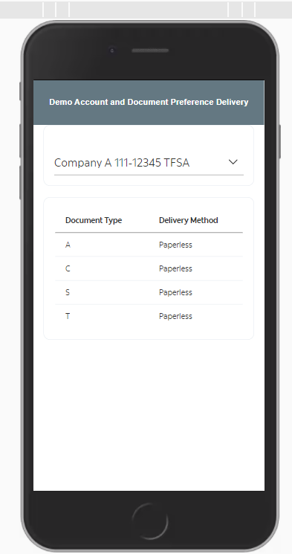

rder69TxBltONmUCJtKxXgFp1P

use sass || less || styled components for CSS

add RTL and create test files,

better to do (not required)

create redux || context API and put that value to store, pick from store

configure webpack to chunk your components34