Informe segmentación

Jordi López Sintas

23/2/2017

# Introducción

Descripción de las 6 primeras empresas y sus bases

|  |  |  |  |  |  |  |
| --- | --- | --- | --- | --- | --- | --- |
| DELSPEED | PRICELEV | PRICEFLE | MANUFIMA | SERVICE | SALESFOR | PRODUCTQ |
| 4.1 | 0.6 | 6.9 | 4.7 | 2.4 | 2.3 | 5.2 |
| 1.8 | 3.0 | 6.3 | 6.6 | 2.5 | 4.0 | 8.4 |
| 2.7 | 1.0 | 7.1 | 5.9 | 1.8 | 2.3 | 7.8 |
| 4.6 | 2.4 | 9.5 | 6.6 | 3.5 | 4.5 | 7.6 |
| 2.4 | 1.6 | 8.8 | 4.8 | 2.0 | 2.8 | 5.8 |
| 2.8 | 1.4 | 8.1 | 3.8 | 2.1 | 1.4 | 6.6 |

Descripicón de las 6 primeras empreas

|  |  |  |  |  |  |  |
| --- | --- | --- | --- | --- | --- | --- |
| TAMEMP | USAGELEV | SATISFLE | ESPCOMPR | ESTRCOMP | INDUSTRI | SITCOMP |
| Small | 32 | 4.2 | Total Value Analysis | Decentralized | Industry A Classification | New Task |
| Large | 43 | 4.3 | Specification Buying | Centralized | Other Industries | New Task |
| Large | 32 | 3.9 | Specification Buying | Centralized | Industry A Classification | New Task |
| Small | 46 | 5.8 | Total Value Analysis | Decentralized | Industry A Classification | New Task |
| Small | 32 | 4.3 | Total Value Analysis | Decentralized | Other Industries | New Task |
| Large | 39 | 4.4 | Specification Buying | Centralized | Other Industries | New Task |

# Descripción de Las bases

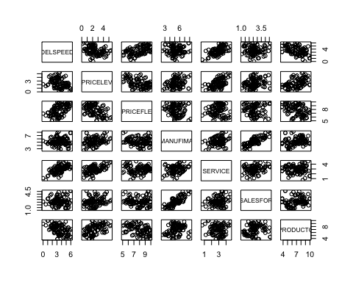

# Exploración de la heterogeneidad

## The "ward" method has been renamed to "ward.D"; note new "ward.D2"

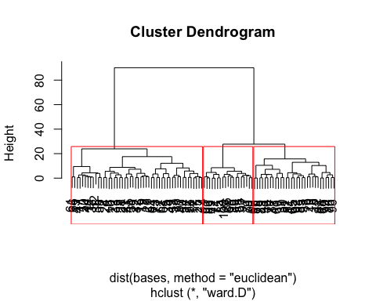

Medias de la agrupación jerárquica

|  |  |  |
| --- | --- | --- |
| 1 | 2 | 3 |
| 4.32 | 2.57 | 4.69 |
| 1.58 | 3.15 | 1.57 |
| 8.66 | 6.89 | 9.29 |
| 4.59 | 5.57 | 5.47 |
| 2.91 | 2.84 | 3.12 |
| 2.18 | 2.82 | 3.05 |
| 5.08 | 8.04 | 7.24 |

# Partición de la muestra y clasificación

## Percepciones de las empresas en los segmentos

|  |  |  |  |
| --- | --- | --- | --- |
|  | 1 | 2 | 3 |
| DELSPEED | 4.09 | 2.57 | 4.88 |
| PRICELEV | 1.62 | 3.21 | 1.51 |
| PRICEFLE | 8.63 | 6.80 | 9.37 |
| MANUFIMA | 4.42 | 5.60 | 5.81 |
| SERVICE | 2.83 | 2.87 | 3.18 |
| SALESFOR | 2.08 | 2.82 | 3.30 |
| PRODUCTQ | 5.27 | 8.13 | 7.00 |

# Descripción de las empresas que forman cada segmento

## Stratified by segmento  
## 1 2   
## n 33 48   
## TAMEMP = Small (%) 31 (93.9) 10 (20.8)   
## USAGELEV (mean (sd)) 46.33 (8.90) 42.73 (7.70)   
## SATISFLE (mean (sd)) 4.84 (0.74) 4.38 (0.76)   
## ESPCOMPR = Total Value Analysis (%) 31 (93.9) 10 (20.8)   
## ESTRCOMP = Decentralized (%) 31 (93.9) 0 ( 0.0)   
## INDUSTRI = Other Industries (%) 23 (69.7) 22 (45.8)   
## SITCOMP (%)   
## Modified Rebuy 8 (24.2) 22 (45.8)   
## New Task 8 (24.2) 24 (50.0)   
## Straight Rebuy 17 (51.5) 2 ( 4.2)   
## Stratified by segmento  
## 3 p test  
## n 19   
## TAMEMP = Small (%) 19 (100.0) <0.001   
## USAGELEV (mean (sd)) 54.21 (7.00) <0.001   
## SATISFLE (mean (sd)) 5.64 (0.57) <0.001   
## ESPCOMPR = Total Value Analysis (%) 19 (100.0) <0.001   
## ESTRCOMP = Decentralized (%) 19 (100.0) <0.001   
## INDUSTRI = Other Industries (%) 5 ( 26.3) 0.008   
## SITCOMP (%) <0.001   
## Modified Rebuy 2 ( 10.5)   
## New Task 2 ( 10.5)   
## Straight Rebuy 15 ( 78.9)

|  |  |  |  |  |  |
| --- | --- | --- | --- | --- | --- |
|  | 1 | 2 | 3 | p | test |
| n | 33 | 48 | 19 |  |  |
| TAMEMP = Small (%) | 31 (93.9) | 10 (20.8) | 19 (100.0) | <0.001 |  |
| USAGELEV (mean (sd)) | 46.33 (8.90) | 42.73 (7.70) | 54.21 (7.00) | <0.001 |  |
| SATISFLE (mean (sd)) | 4.84 (0.74) | 4.38 (0.76) | 5.64 (0.57) | <0.001 |  |
| ESPCOMPR = Total Value Analysis (%) | 31 (93.9) | 10 (20.8) | 19 (100.0) | <0.001 |  |
| ESTRCOMP = Decentralized (%) | 31 (93.9) | 0 ( 0.0) | 19 (100.0) | <0.001 |  |
| INDUSTRI = Other Industries (%) | 23 (69.7) | 22 (45.8) | 5 ( 26.3) | 0.008 |  |
| SITCOMP (%) |  |  |  | <0.001 |  |
| Modified Rebuy | 8 (24.2) | 22 (45.8) | 2 ( 10.5) |  |  |
| New Task | 8 (24.2) | 24 (50.0) | 2 ( 10.5) |  |  |
| Straight Rebuy | 17 (51.5) | 2 ( 4.2) | 15 ( 78.9) |  |  |

# Interpretación de los segmentos según percepciones y empresas

# Estrategia