PARTNERSHIP AGREEMENT ON INVESTMENT AND FINANCIAL CO-OPERATION
№: SFS-23052019
This Partnership agreement on investment and financial co-operation (hereinafter referred to as the Agreement №: SFS-23052019, volume of investments €100.000 000.00 (One hundred million Euro) are into this September 20, 2019 by and between the following parties:
(Hereinafter referred to as the Investor or Party “A”)
COMPANY NAME | STUDIO FOLLA D.O.O.
COMPANY ADDRESS
REPRESENTED BY | DR. LIVIANO FOLLA
PASSPORT NO | YA3894780
ISSUE DATE | 23-07-2013
EXPIRY DATE | 22-07-2023
PLACE OF ISSUE | ITALY
BANK NAME
BANK ADDRESS
SWIFT CODE
ACCOUNT NAME: | STUDIO FOLLA D.O.O.
ACCOUNT IBAN:
BANK OFFICER NAME
BANK OFFICER PHONE NO
BANK OFFICER EMAIL
BENEFICIARY: | STUDIO FOLLA D.O.O.

And
(Hereinafter referred to as the Partner or Party “B”)
COMPANY NAME
COMPANY ADDRESS
REPRESENTED BY
PASSPORT NO
ISSUE DATE
EXPIRY DATE
PLACE OF ISSUE
BANK NAME
BANK ADDRESS
SWIFT CODE
ACCOUNT NAME:
ACCOUNT IBAN:
BANK OFFICER NAME
BANK OFFICER PHONE NO
BANK OFFICER EMAIL
BENEFICIARY:

And according to the charter which is attached to this Agreement. (Hereinafter referred to as the Partner or Party B) on the other hand, both to get her and individually here in after referred to as the "Parties" conclude an agreement of such content, hereinafter referred to as the "Agreement":
WHEREAS:
WHEREAS the Parties hereto are desirous of entering into this Agreement for the purpose of developing own investment projects contemplated herein for the mutual benefit only and not for other purposes whatsoever.
WHEREAS both Parties hereto warrant that the currencies to be transacted, for making the investments, are all good, clean and cleared funds of non-criminal origin, without any traces of illegality or unlawfulness whatsoever.
WHEREAS each Party hereto declares that it is legally empowered, fully authorized to execute and accept this agreement, as well as agrees to be bound by its terms and conditions under the penalty and other consequences.
WHEREAS Investor through its fiduciary bank, where the final agreements will be lodged in and assigned to, confirms and warrants that it has the financial capacity of EURO - Funds and EURO - Funds to transact under this Agreement.
WHEREAS the Parties hereto with full corporate responsibility, under the penalty of perjury, declare that they will upon the execution of this Agreement complete the transaction contemplated herein, except on circumstances of force majeure and government sanctions, if such appear. The parties hereto shall not be liable for any failure to perform under the “force majeure” provisions of the ICC, Paris.
WHEREAS both Parties herein agree that each party has the fullest right to use and choose whatever company more suitable to carry out this assignment, to successfully complete the present transaction.
1. SUBJECT OF AGREEMENT.
1.1. In accordance with the provisions of this Agreement and general principles and regulations of the management of the financial resources the Investor instructs, and the “Partner” undertakes to manage investment plans accepted by parties and invested by Investor by this Agreement.
1.2. The Investor's financial resources made available to the “Partner” hereinafter referred to as the "Investments".
1.3. According to the laws of and for execution of the Law of About the regime of foreign international investing for two parties, the subject of this Agreement is a joint investment activity of the Partners, which is not connected with creation of new legal entities, on the following directions: investments in commercial sphere, social, innovative projects etc.
1.4. The High Contracting "Parties", in order to strengthen bilateral friendly international relations are intended to cooperate in the following make own projects at the expense of own funds and financial opportunities as well as attracting involving partners.
1.4.1. Promoting involvement in the real economy, and private regional priority investment projects;
1.4.2. Promoting a balanced and sustainable growing system of financial support for projects and programs in priority areas;
1.4.3. Minimizing investment and commercial risks involved in the implementation of projects.
And also can carry out reinvestment in the objects of the primary investment and other objects of investment and reinvestment.
1.5. Investor makes their material investments as reinvestment
1.6. Within, the Partner bank issues an unconditional EURO-Funds via (72) banking hours wire transfer to the bank account to be specified from the Investor, in accordance with the following schedule of investments.
2. PLANNING OF THE SWIFT MT103/202 TRANSFER.
Investor’s Currency: | (€) EURO
Total Investment Amount: | €100,000,000.00 (ONE HUNDRED MILLION EURO)
First Tranche: | €9,980,000.00 (NINE HUNDRED AND EIGHTY THOUSAND EURO)
Follow Tranches By: | AS AGREED BY THE PARTIES
Agreement №: | CONTRACT NUMBER: SFS-23052019
Transaction Code: | SFS-23052019/100
Delivery: | SWIFT MT103/202 (CASH TRANSFER)
Duration of Payment: | Payment 03 (three) banking days after delivery and booking of swift banking wire transfer in the developer’s bank account
Note: | It's understood that the amount and timing of tranches are defined in the present Agreement

3. JOINT ACTIVITIES OF THE PARTIES.
3.1. We, the undersigned Parties, hereby with full legal and corporate responsibility, under penalty of perjury, confirm that Investor is ready, willing, and able the investments, and the Partner is ready to receive the investments and to make at the mutually agreed terms and conditions hereof.
3.2. For realization of the investment programs the Parties bring the foreign investment in convertible currency during validity hereof according to the schedule fixed by the Parties, agreed currency amounts and tranches which are reflected in additional agreements hereto.
3.3. The Parties can extend kinds and spheres of investment activity and if necessary make the Additional agreements.
3.4. Addendum and changes may be brought to this Agreement by mutual agreement of the Parties, which are to be formed by separate protocols, which, after the signing of “Parties”, are considered as integral part hereof.
4. RIGHTS AND DUTIES OF THE PARTNERS.
4.1. Party-A and Party-B for the purposes of fulfillment hereof:
4.1.1. Develop investent activity for its economic and technical projects.
4.1.2. Conclude contracts, agreements, and other agreements necessary for realization of their investment programs.
4.1.3. Acquire export-import quotas and licenses for export and import of commodities and products.
4.1.4. Provide each other with all necessary legally, financial and other documents, related to the fulfillment hereof.
4.1.5. Invest money in their own projects during validity hereof according to their current legislation.
4.1.6. Carrie out economic activity to fulfill own investment programs, make debt liquidation on all kinds of expenses, payment of commodities and services, transfers facilities for payment of salaries and other types of rewards, cover all kinds of charges.
4.1.7. Attract other legal entities and individuals for the fulfillment of their investment programs under the present Agreement at their sole decision.
4.1.8. Are to provide each other with necessary assistance.
4.1.9. Are to follow and observe the terms and conditions hereof.
4.1.10. Are obligated to keep in a secret all business, technical and commercial information related to implementation hereof.
4.1.11. Can invest additional investments during the validity period of the present Agreement, and also can carry out reinvestment in primary investment projects and other investment and reinvestment objects.
4.2. The Party-A for the purposes of fulfillment hereof:
4.2.1. Develops the directions of own investment activity with its economic and technical ground.
4.2.2. Concludes contracts, agreements, and other agreements necessary for realization of its investment programs.
4.2.3. Acquires export-import quotas and licenses for export and import of commodities and products.
4.2.4. Provides Party-B with all necessary legally, financial and other documents, related to the fulfillment hereof.
4.2.5. Can invest money during validity of this Agreement according to the current legislation.
4.2.6. Carries out economic activity to fulfill own investment programs, makes debt liquidation on all kinds of expenses, payment of commodities and services, got by each of the Parties, transfers facilities for payment of salaries and other types of rewards, finance all kinds of charges.
4.2.7. Attracts other legal entities and individuals for realization of the investment programs under the present Agreement.
4.2.8. Attracts investments and financial assets, including credit and loan facilities of residents and not residents aimed on execution of investment activity.
4.3. The Party-B for the purposes of fulfillment hereof:
4.3.1. Develops the directions of own investment activity with its economic and technical ground.
4.3.2. Concludes contracts, agreements, and other agreements necessary for realization of its investment programs.
4.3.3. Acquires export-import quotas and licenses for export and import of commodities and products.
4.3.4. Provides Party-A with all necessary legally, financial and other documents, related to the fulfillment hereof.
4.3.5. Can invest money during validity of this Agreement according to the current legislation.
4.3.6. Carries out economic activity to fulfill own investment programs, makes debt liquidation on all kinds of expenses, payment of commodities and services, got by each of the Parties, transfers facilities for payment of salaries and other types of rewards, finance all kinds of charges.
4.3.7. Attracts other legal entities and individuals for realization of the investment programs under the present Agreement.
4.3.8. Attracts investments and financial assets, including credit and loan facilities of residents and not residents aimed on execution of investment activity.
5. TOTAL VOLUME OF INVESTMENTS AND ORDER OF FINANCING.
Investor’s Currency: € EURO
Total Investment Amount: € 100,000,000.00 (ONE HUNDRED MILLION EURO)
Now therefore in consideration as herein set out and in consideration of the understanding, as well as of here good valuables purposes, the adequacy and receipt of which is hereby acknowledge by Parties as follows: Party-A ready to start project financing in the volume and follows the sequence:
The Party-A provides Party-B with funding necessary for implementation development projects through their own EURO currency funds.
6. TARGETED USE OF THE FUNDS THEIR DISTRIBUTION.
6.1. Investment in the projects
6.2. Development of several companies to work with, in the field of exports and imports in Western and Eastern Europe etc. Consulting services for the support and impleentation of credit lines.
6.3. All the necessary documents on the distribution of funds, will be an integral part of this Agreement, and will be additions to the granting of this Agreement
7. TRANSACTION PROCEDURES.
7.1. Investor and Funds Manager both sign & execute the Private Investment Agreement.
7.2. This Investment Agreement, which thereby automatically becomes a full commercial recourse contract.
7.3. If necessary, the Parties will lodge copies of the Agreement with their respective banks for the compliance.
7.4. Investor will then transfer the funds Deutsche Bank System by SWIFT MT-103 & SWIFT MT-202 to the bank coordinates (Account) of the Funds Manager.
8. CONFIDENTIAL INFORMATION AND SECURITY.
8.1. In connection with present Agreement, the Parties will provide the each other with the information concerning the designated fiduciary banks originating in writing by each Party and is designated as confidential which the Parties hereby agree to treat as “confidential information”. The Parties understand and agree that any ford confidential information disclosed pursuant to this Agreement is secret, proprietary and of great value to each Party which value may be impaired if the secrecy of such information is not maintained.
8.2. The Parties further agree that they will take reasonable security measures to preserve and protect the secrecy of such confidential information and will hold such information in trust and not to disclose such information, either directly or indirectly to any person or entity during the term of this Agreement or any time following the expiration or termination hereof; provided, however, that the Parties may disclose the confidential information to an assistant, agent or employee who has agreed in writing to keep such information confidential and to whom disclosure is necessary for the providing of services under this Agreement.
8.3. Separate introductions made through different intermediary chains may result in other transactions between the Parties will not constitute a breach of confidential information, provided such new chains were not created for purposes of circumvention of the first introducing chain. Copy and paste signatures are not allowed.
8.4. Agreement which is to transfer and organize the bank shall be transmitted in the form of scanned visa authorized signature.
8.5. Unauthorized bank communication: Neither Party is allowed to contact the bank of the other Party without the written authorization for that of the Party whose bank is to be contacted. Any unauthorized contact act of either Party of this Agreement is considered as a breach of this Agreement and shall cause this Agreement immediate cancellation, and transaction becomes null and void.
9. CODES OF IDENTIFICATION.
9.1. The Parties agree that all documents related to the transactions bear the codes listed on page 01 of this Agreement and that the said codes remain unchangeable within this Agreement duration, including all rollovers, extensions and additions.
10. COMMUNICATION.
10.1. Communication with banks will be limited to those between the Investor’s bank and Partner’s bank and only by between authorized bank officers/representatives, including principals of the Investor and the Partner, in the course of completion of this transaction. No communication by any other party is permitted without prior written consent of the named account holders.
10.2. Any notice to be given hereunder from either Party to the other shall be in writing and shall be delivered by fax to the telefax number or by E-mail to E-mail address of the respective Party as provided herein. The Parties agree that acknowledged E-mail or telefax copies are treated as legally binding original documents. E-mail copies, scanned and sent on E-mail as photo, of this Agreement and exchange of correspondence duly signed and/or executed shall be deemed to be original and shall be binding and are regarded as original and good for any legal purpose.
10.3. EDT-Electronic Document Transmittal & Counterparts: This Agreement may be executed in multiple copies at different times and places, each being considered an original and binding. All facsimile /electronic transmittal/communications, including electronic signature, relating to this Agreement and which are mutually accepted by the Parties, shall be deemed legally binding and enforceable documents for the duration of the transaction. And as applicable, this Agreement shall:
  - Incorporate U.S. Public Law 106-229, "Electronic Signatures in Global and National Commerce Act" or such other applicable law conforming to the UNCITRAL Model Law on Electronic Signatures (2001);
  - Electronic Commerce Agreement (ECE/TRADE/257, Geneva, May 2000) adopted by the United Nations Centre for Trade Facilitation and Electronic Business (UN/CEFACT);
  - All electronically submitted documents shall be subject to the European Community Directive No. 95/46/EEC, as applicable.
- VALIDITY.
11.1. Once this Agreement is signed by both Parties the transaction shall begin within three (3) banking days or sooner, excluding Saturdays and Sunday and any bank holidays.
12. FULL UNDERSTANDING.
12.1. The latest edition/signature of this Agreement, executed by each party in originals, represents the full understanding between the Parties and supersedes all other undertakings, whether verbal or written. All statements and representations are made without any omission of material fact and with full corporate and legal responsibility under penalty of perjury.
12.2. The Parties hereto accept that should the present Agreement partially or in full be found invalid or unenforceable pursuant to judicial decree or by bmw virtue of any international regulations related to bank confirmation of USD/EUR validity, this Agreement shall be reconstructed upon mutual consent and agreement of both Parties to this commercial Agreement.
12.3. Until the physical exchange of original hard copies, the acknowledged fax and/or e-mail copies of this Agreement shall be deemed original.
12.4. The commission payable under this Agreement is to be distributed in accordance with the Irrevocable Fee Protection Agreement.
13. ASSIGNMENT.
13.1. Each Party to this Agreement may assign this Agreement or its total or partial performance hereof to any other company which assumes the obligations of the assigning party under the terms of the assignment. Formal notice of the assignment shall be rendered to the other party to this Agreement expressly indicating there on the assignee's full contact particulars.
14. TERM OF AGREEMENT.
14.1. This agreement is a full recourse commercial commitment enforceable under the laws of the jurisdiction of EURO, Liechtenstein, Switzerland or any other member country of the European Union as it applies. And, said law shall govern the interpretation, enforceability, performance, execution, validity and any other such matter of this Agreement, which shall remain in full force and effect until completion of the said transaction and it is legally binding upon the Parties signatories, their heirs, successors and assigns, agents, principals, attorneys and all associated partners involved in this Agreement/contract/transaction.
15. LAW AND ARBITRATION.
15.1. This Agreement is a full recourse commercial commitment enforceable under the laws of jurisdiction of the countries where this transaction is effectuated, and any dispute is to be resolved under the ICC rules for arbitration.
15.4. All disputes and disagreements, which can arise during execution of the present agreement or in connection with it, will be solved by negotiation between the Parties. In case the Parties will not come to the agreement, the disputes and disagreements are to be settled by The London Court of International Arbitration (UK) made up by one arbitrator.
15.2. The Parties hereto acknowledge and agree vital that any discrepancy and/or dispute in application of this Agreement will be solved amicably. If it is not possible, the arbitration procedure is to be followed.
15.3. This Agreement is intended to be performed in accordance with, and only to the extent permitted by all applicable laws of jurisdiction, ordinances, rules and regulations. If any provision of this Agreement be considered invalid or unenforceable, then, the reminder part of this Agreement shall not be affected (if agreeable by both Parties) and shall be enforced to the greatest extend permitted by law.
16. PENALTY CLAUSE FOR NON-PERFORMANCE.
16.1. In the event that Party «A» fail to perform in this Agreement, once it’s being signed/sealed and the term of validity thereof had expired, and excluding any banks default or delays in processing wire transfers, the Party «A» in Default indemnifies and guarantees to all present contractual parties a total penalty fee of (against an official claim and invoice) 2% (two percent) of the face value of this Agreement.
16.2. The only party allowed to make a claim under this Agreement, if any, is either Party-A or Party-B. And, any claim must be first proven by the Injured-Party and invoice settled by the Party-in-Default within 10 (ten) calendar days, or else the Injured-Party can file a legal claim against Party-in-Default in any court of jurisdiction of their choice.
FURTHER MORE WE, THE UNDERSIGNED PARTIES, HEREBY SWEAR UNDER THE INTERNATIONAL LAWS OF PERJURY AND FRAUD THAT THE INFORMATION PROVIDED BY US HEREIN IS ACCURATE AND TRUE, AND BY AFFIXING OUR SIGNATURES/INITIALS/SEALS TO THIS AGREEMENT, WE ATTEST THAT OUR RESPECTIVE BANK-OFFICERS ARE FULLY AWARE OF, HAVE APPROVED AND ARE READY PROCEED WITH THIS TRANSACTION.
For subsequent distribution companies will be coordinated by a separate annex to this Agreement which will form an integral part to it.

SIGNATURES OF THE PARTIES:

INVESTOR OR PARTY “A | PARTNER OR PARTY “B
“STUDIO FOLLA D.O.O.” | « »
PASSPORT №: YA3894780 | PASSPORT №:
DATE OF ISSUE: 23-07-2013 | DATE OF ISSUE :
DATE OF EXPITY: 22-07-2023 | PLACE OF ISSUE:
DIRECTOR: DR. LIVIANO FOLLA | REPRESENTED BY:
PLACE OF ISSUE: ITALY | PLACE OF ISSUE:
SIGNATURE & SEAL | SIGNATURE & SEAL

DATE: September 20,2019 | DATE: September 20,2019

ANNEX A: IRREVOCABLE MASTER FEE PROTECTION AGREEMENT

I, XXXXXXXXXXX acting with full responsibility, hereby irrevocably and unconditionally, without protest or notification, without prejudice, recourse, or delay guarantee to pay the fee entitled to the beneficiaries listed on this document, via Wire transfer, at the time of settlement of each tranche of the transaction. This Fee Agreement is our irrevocable pay order to the intermediaries and is and shall remain an intricate part of the Agreement between the Receiver and the Sender.

I, DR. LIVIANO FOLLA, and my legal representative, acting with full responsibility, hereby irrevocably and unconditionally, without protest or notification, without prejudice, recourse, or delay guarantee to transfer Euros to the bank account designated as mentioned in this Agreement. This transfer will be done before any orders, agreements or arrangements of Investor come into effect.

This pay order shall remain in effect until this transaction, including any renewals, extensions and additions are fully completed.

All disputes and questions whatsoever which arises between the parties to this agreement and touching on this agreement on the construction or application thereof or any account cost, liability to be made hereunder or as to any act or way relating to this agreement shall be settled by the arbitration in accordance with the arbitration laws of the ICC.

This Agreement contains the entire agreement and understanding concerning the subject matter hereof and supersedes and replaces all prior negotiations and proposed agreements, written or oral. Neither of the parties may alter, amend, nor modify this agreement, except by an instrument in writing signed by both parties. This agreement will be governed by and construed in accordance with the laws of United Kingdom. In the event that either party shall be required to bring any legal actions against the other in order to enforce any of the terms of this agreement the prevailing party shall be entitled to recover reasonably attorney fees and costs.

This Fee Agreement, if transmitted by facsimile or electronic mail shall be considered an original, legally enforceable document. Generally recognized International Standards of Non-Circumvention and Non-disclosure are applicable for a period of Five Years from the date of this document or the last date of the contract including any renewals, extensions and additions are fully completed and we agree to respect those.

We hereby declare that we are fully aware that the information received from you is in direct response to our request and is not in any way considered or intended to be a solicitation of funds of any sort, or any type of offering, and is intended for our general knowledge only. We hereby affirm, under penalty of perjury, that we have requested information from you and your organization by our choice and free will, and further that you have not solicited us in any way. Intermediaries are NOT Advisors of any kind. Parties to this agreement are independent contractors and all contemplated payments and/or disbursements hereunder are divided interests. Nothing in this agreement construes or creates a partnership or employer/employee relationship between or among the parties hereto. All taxes, federal, state or other are the independent responsibility of each of the parties hereto.

The above stated codes and any other identification codes shall remain the same and shall not be changed until this transaction including any renewals, extensions and additions are fully completed and we agree to respect those. The transaction code may be amended only by agreement between all parties hereto. This transmission via facsimile will be accepted as an original and I confirm that I have authority to execute this Pay Order.

This Agreement will come into effect only after full money transfer as of the agreement will happen, and only after the asset manager, would have already made the transfer related to the first Investment to the designated bank accounts will be transferred.

This Agreement shall be lodged in our bank and a copy will be forwarded to all beneficiaries. I agree to the above irrevocable fee protection Agreement in its entirety.

This Agreement once executed by both parties will become effective as of the date first written above. Any official notice(s) exchanged by the parties hereto, shall be sent to the first mentioned address(s) herein or as may be attached by addenda hereto a facsimile or electronically transferred copy duly signed by both parties shall be deemed original.

NOTE: BENEFICIARY/PAYMASTER CAN CHANGE ANY TIME HIS PROVIDED BANK ACCOUNT ON THIS CONTRACT BY INFORMING THE RECEIVER PRIOR TO PAYMENT.

"FUNDS ARE GOOD, CLEAN, CLEARED AND OF NON-CRIMINAL ORIGIN, ARE LIEN FREE AND UNENCUMBERED, HAS BEEN EARNED FROM SERVICES RENDERED AND FOR FREE INVESTMENT PURPOSES, ARE PAYABLE IN CASH AND IN FULL AMOUNT”
SIGNATURE PAGE FOLLOWS
DISTRIBUTION OF AMOUNTS / IRREVOCABLE PAY ORDER

SENDER’S GROUP:65% (SIXTY FIVE PERCENT) OF FACE VALUE INCLUDING ROLLS AND EXTENSION TO BE FORWARD TO:

COMPANY NAME | Monex Europe Ltd Re Bentley Legal
ADDRESS | 71-75 Shelton Street, Covent Garden, London, England, WC2H 9JQ
BANK NAME | Barclays Bank Plc
BANK ADDRESS | Level 27, 1 Churchill Place, Canary Wharf, London E14 5HP
SWIFT CODE | BARCGB22
ACCOUNT NAME: | Monex Europe Ltd Re Bentley Legal
ACCOUNT IBAN: | GB77 BARC 2077 6759 6078 22
BENEFICIARY: | CITI WORLD TRADE LTD
REQUIRED MESSAGE: | ALL TRANSFER INSTRUCTIONS SHALL STATE: “Funds are clean and clear, of non- criminal origin and are payable in cash immediately upon receipt by Beneficiary’s bank same day credit”

- RECEIVER GROUP AND CONSULTANTS: 25% (TWENTY_FIVE PERCENT) OF FACE VALUE INCLUDING ROLLS AND EXTENSION AS FOLLOWS:

RECEIVER’S BANK DETAILS TO RECEIVE 25% (TWENTY FIVE PERCENT) OF FACE VALUE INCLUDING

SENDER INTERMEDIARIES BANK DETAILS TO RECEIVE 10% (FIVE PERCENT) OF FACE VALUE OF PAYMENT OF FACE VALUE INCLUDING ROLLS AND EXTENSION TO BE FORWARD TO:

PAYMASTER : | JAMES W. DAVIS III, ATTORNEY AT LAW FOR J. DAVIS-ATTORNEY AT LAW, LLC
COMPANY NAME: | J. DAVIS-ATTORNEY AT LAW, LLC.
COMPANY ADDRESS: | 214 MAPLE ST., VILLA RICA, GA 30180
REPRESENTED BY: | J. DAVIS-ATTORNEY AT LAW
LAW LICENCE NO.: | GA 283824
PASSPORT NO: | 472726009
MOBILE NO: | +1-770-680-0418
EMAIL ADDRESS: | jay@jdavislegal.biz
BANK NAME: | WELLS FARGO
BANK ADDRESS: | 1997 MIRROR LAKE BLVD., VILLA RICA, GA 30180, 770-456-4915
BANK SWIFT CODE : | WFBIUS6S
ABA/ROUTING | 12100248
ACCOUNT NAME: | J.DAVIS-ATTORNEY AT LAW, IOLTA TRUST ACCOUNT 2
ACCOUNT NO: | 7658491001
BENEFICIARY: | AUTUMN SUNSET LLC,et al

ACCEPTED ALL ABO

INVESTOR OR PARTY “A” | PARTNER OR PARTY “B”
“STUDIO FOLLA D.O.O.” | « »
PASSPORT №: YA3894780 | PASSPORT №:
DATE OF ISSUE: 23-07-2013 | DATE OF ISSUE :
DATE OF EXPITY: 22-07-2023 | PLACE OF ISSUE:
DIRECTOR: DR. LIVIANO FOLLA | REPRESENTED BY:
PLACE OF ISSUE: ITALY | PLACE OF ISSUE:
SIGNATURE & SEAL | SIGNATURE & SEAL
DATE: September 20,2019 | DATE: September 20,2019

COPY PASSPORT INVESTOR OR PARTY “A”:

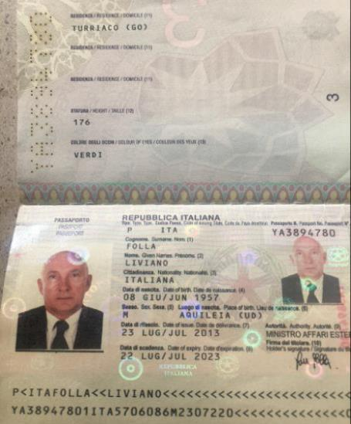

COPY CERTIFICATE OF CORPORATION INVESTOR OR PARTY A”:
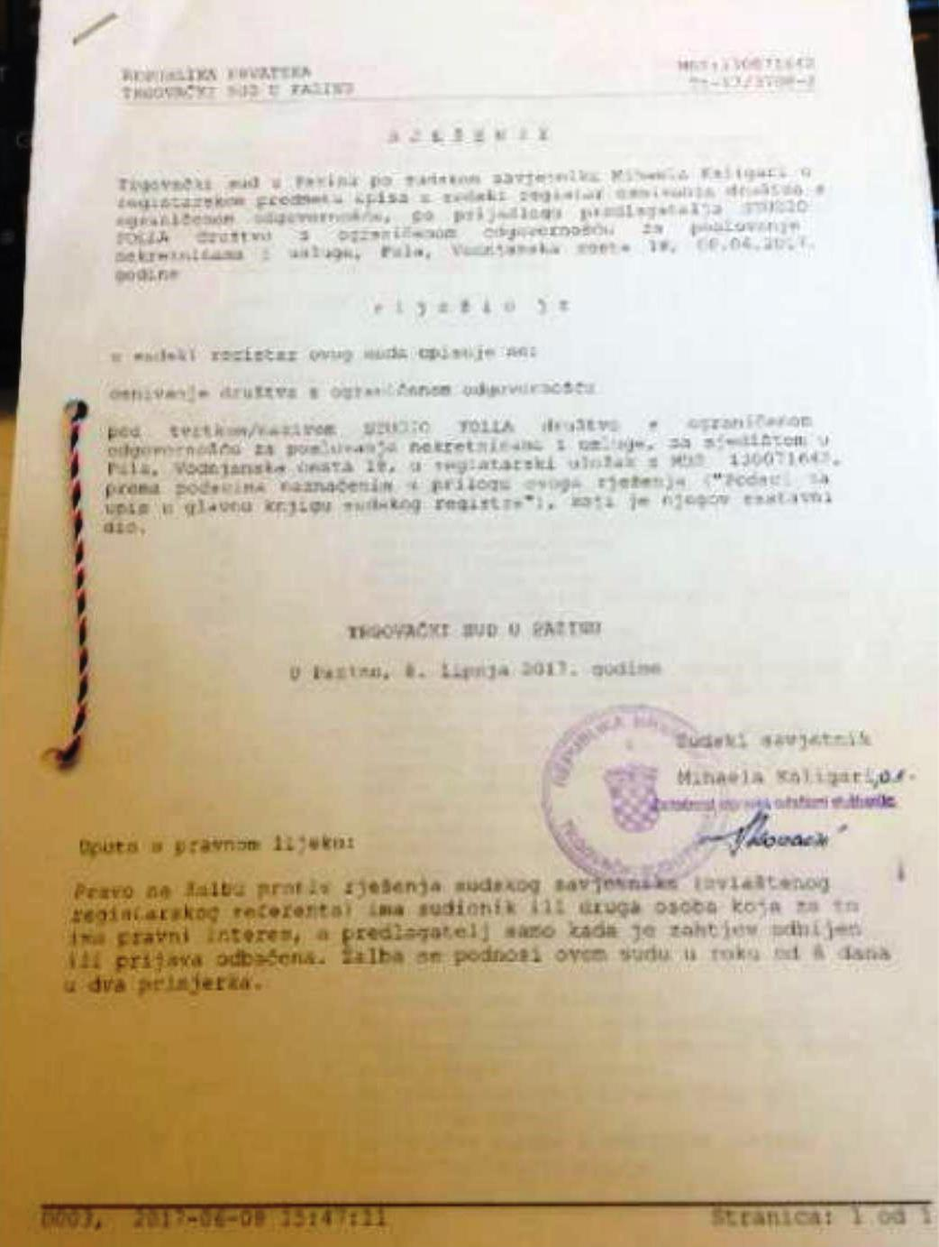

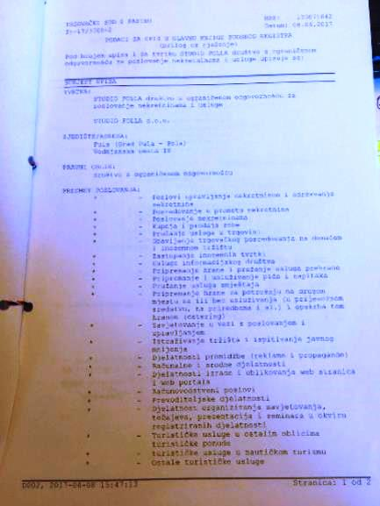

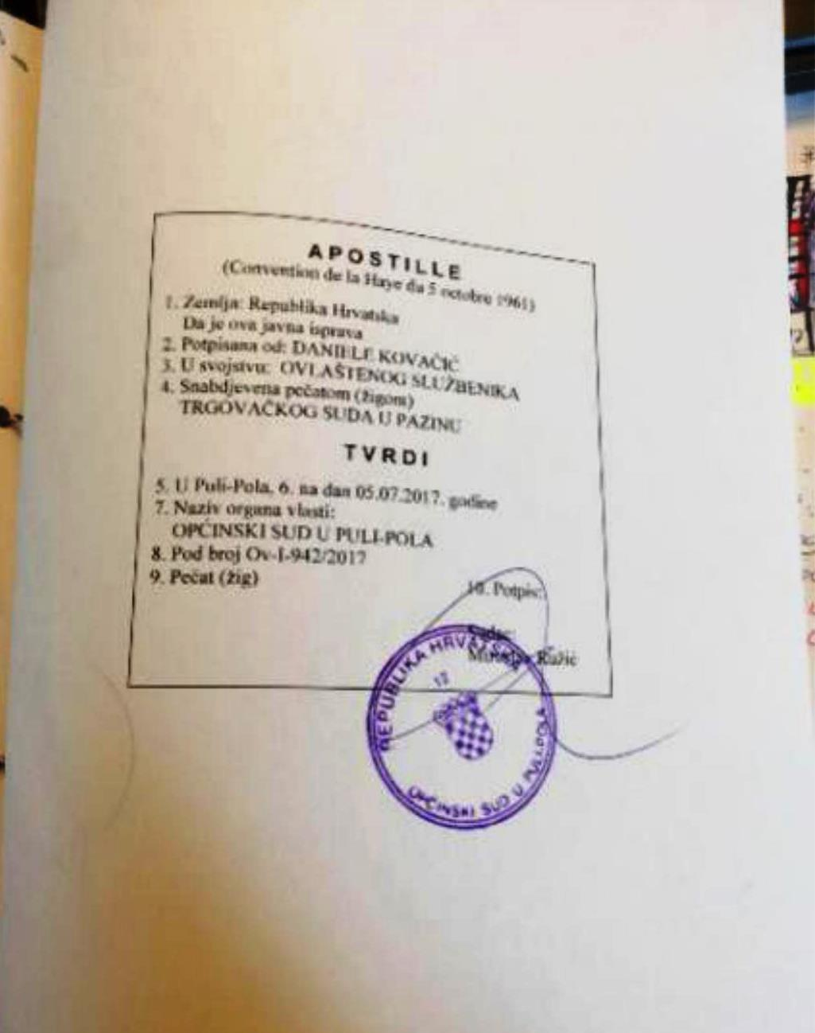

COPY PASSPORT PARTNER OR PARTY “B”:

COPY CERTIFICATE OF CORPORATION PARTNER OR PARTY “B”:

EDT (Electronic Document Transmissions)

EDT (Electronic Document Transmissions) shall be deemed and valid and any provisions of this Contract, As applicable, this agreement shall be:
1. Incorporated U.S. PublIc Law 106-229. “ElectronIc SIgnatures In Global and NatIonal CommeRCE Act” or such other applIcable Law confIrmIng to the UNCITRAL Model Law on ElectronIc SIgnatures (2001) and;
2. ELECTRONIC COMMERCE AGREEMENT (ECE/TRADE/257, Geneva, May 2000) adopted by the UnIted NatIons Centre for Trade FacIlItatIon and ElectronIc BusIness (UN/CEFACT).
3. EDT documents shall be subject to European CommunIty DIrectIve N0. 95/46/EEC as applIcabLE. EIther party may request hard copy of any document that has been previously transmitted by electronic means provided however that any such request shall in no manner delay the parties from performing their respective obligation and duties under EDT instruments.

***** THE END OF THE AGREEMENT *****

