**III. Matlab (Template for Option II: After Magali Billen)**

**This template shows you what needs to be turned in (*in Italics*) for each part of each question. Note that in some places you are asked to insert a jpeg into the document. You will also separately submit the script you write to answer questions 4-6 (see end of HW).**

1. a. (Nothing Required to be Turned In)

b. (Nothing Required to be Turned In)

c. *What did “whos” display?*

*Nothing.*

d. *What is the size of “a” and “b”?*

*a is 1x1. B is 1x7.*

e. *What are the values displayed (for d(2:5))?*

*2 4 6 8*

f. *What is the size of “C”?*

*5x2*

*In the whos listing of size, which dimension of the matrix is listed first, rows or columns?*

*Rows are first, columns second.*

*What is the size of d?*

*1x6*

*Does this mean that d is a row vector or a column vector?*

*D is a row vector. It has only one row: [blah1,blah2,…]*

*g. What is the size of f?*

*1x6*

*What is the size of g?*

*6x1*

*What is the size of x?*

*6x6*

*Did you get the dot product of d with itself?*

*No*

*What is the size of y?*

*1x1*

*Did you get the dot product of d with itself?*

yes

*What is the size of a?*

*1x6*

*What is/are the value(s) of a?*

*[1 3 5 7 9 11]*

*What is/are the value(s) of b?*

[0 4 16 36 64 100]

h. *What is the size of b?*

*1x1*

*What is/are the value(s) of b?*

*220*

i. (Nothing Required to be Turned In)

j. *What is the output of whos?*

Nothing

*Which variables are now listed by whos?*

*Everything I had before*

2. Reading in a data file.

a. (Nothing Required to be Turned In)

b. *What variable is defined?*

*Nbp0207_bath*

*What is the size of that variable?*

2632x2

c. (Nothing Required to be Turned In)

d. (Nothing Required to be Turned In)

e. *What is the size of z and d?*

Both are 2632x1

f. *What is the sign (+ or -) of these values?*

*-*

*What is the maximum depth of the seafloor in the data (in m)?*

2862 m

g. *What is the starting distance (in kilometers)?*

9.6001e+03 km

h. *What are the minimum and maximum values of seafloor topography z (in m)?*

3423 6862

i. *What are the minimum and maximum values of d (in m)?*

0 899.9280

j. (Nothing Required to be Turned In)

k. (Nothing Required to be Turned In)

3. Plotting the data.

a. (Nothing Required to be Turned In)

b. (Nothing Required to be Turned In)

c. *What color is the line?*

Blue

d. *What color is the line now?*

Red

e. (Nothing Required to be Turned In)

f. (Nothing Required to be Turned In)

g. *Write out the command you used for 3g.*

axis([400 500 3000 7000])

h. (Nothing Required to be Turned In)

i. *Insert hw1_prob3_fig.jpeg into this Word document here.*

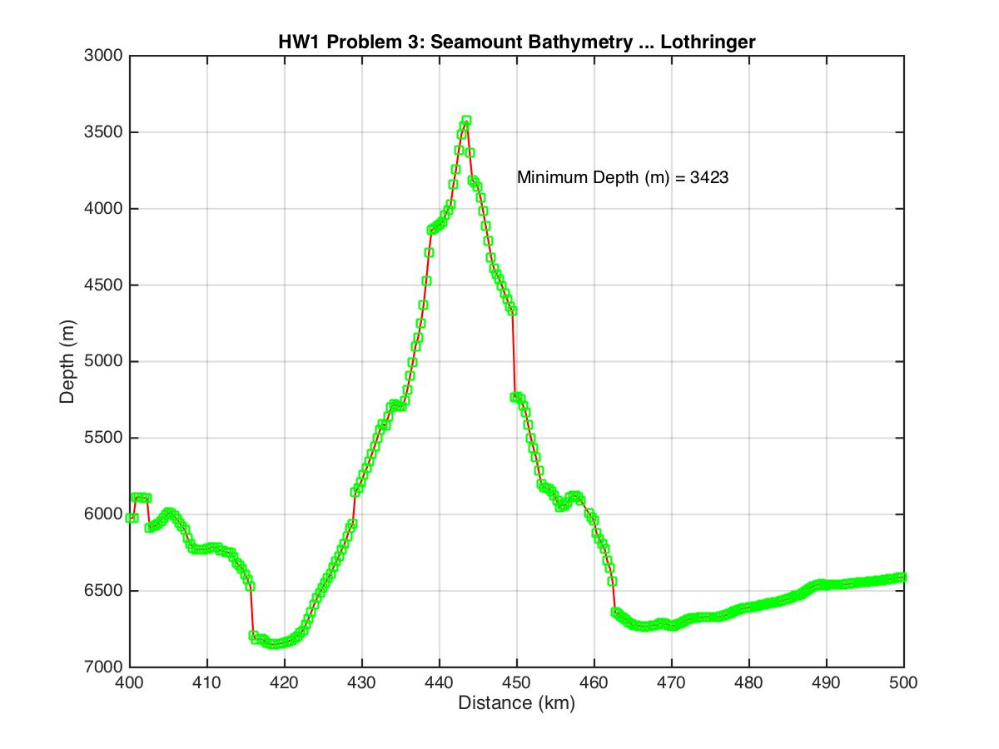

j. (Nothing Required to be Turned In)

4. Executing commands from a Matlab script.

a. (Nothing Required to be Turned In)

b. (Nothing Required to be Turned In)

c. *What is the value of mind1?*

*9.6001e+03*

*Is the file hw1_prob4.mat in your working directory?*

Yes

d. Start writing LastName_HW1.m for this problem

*Cut and paste here the output from HW1_LastName.out*

HW1:Geos 567: Lothringer

The profile runs from 0 to 900 km

*Insert hw1_prob4_fig.jpeg here.*

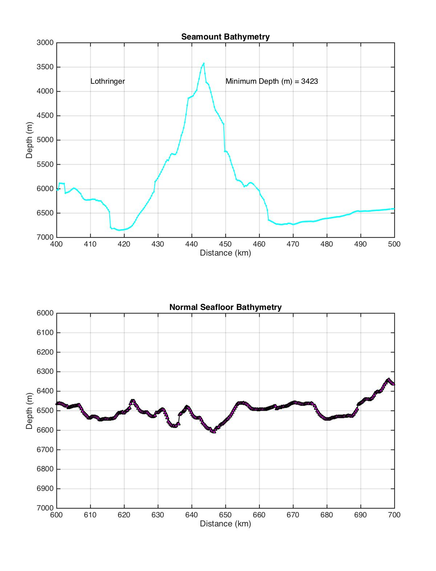

5. Using mathematical functions (sine, cosine, tangent, sqrt). Add to the script LastName_HW1.m to do the following commands:

a. (Nothing Required to be Turned In)

b. (Nothing Required to be Turned In)

c. (Nothing Required to be Turned In)

d. (Nothing Required to be Turned In)

e. (Nothing Required to be Turned In)

f. (Nothing Required to be Turned In)

g. *Insert hw1_prob5_fig.jpeg here*.

