Geos. 567 Homework #3

1. 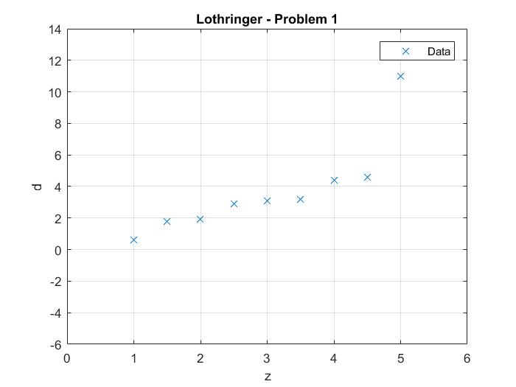
2. I find the best fit for the L1 norm to be m1 = -0.600 and m2= 1.250.

m1_best_l1 =

-0.6000

m2_best_l1 =

1.2500

3a. I find the best fit for the L2 norm to be m1 = -1.808 and m2 = 1.844.

m1_best_l2 =

-1.8080

m2_best_l2 =

1.8440

3b. 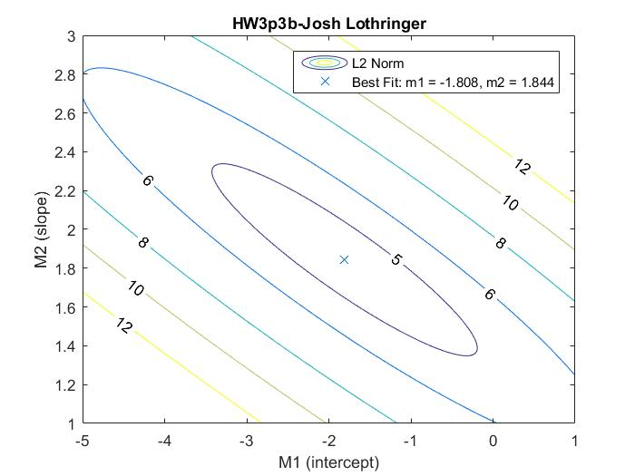

3c. The ellipsoidal nature of the contours in 3b imply that the model parameters m1 and m2 can ‘tradeoff’ error. That is to say, a decrease in m2 can be compensated with an increase in m1 to keep the error/misfit the same.

3d. mls = inv(G'*G)*G'*d'

mls =

-1.808

1.843

G =

1.0000 1.0000

1.0000 1.5000

1.0000 2.0000

1.0000 2.5000

1.0000 3.0000

1.0000 3.5000

1.0000 4.0000

1.0000 4.5000

1.0000 5.0000

The difference between the estimates of the solutions of 3a and 3d are a result of the finite nature of the parameter grid search we performed. The least squares is only limited by floating-point precision, not an arbitrary resolution. 3a, on the other hand, was limited to the resolution (m1div or m2div) of the grid in which we searched for model parameters. The true least-squares solution was never a point in this grid, so 3a never tested it as a possible model. If it had, it would have found it to be the true minimum.

4.

m1_best_l3 =

-2.640

m2_best_l3 =

2.143

5.

m1_best_linf =

-4.520

m2_best_linf =

2.594

6. 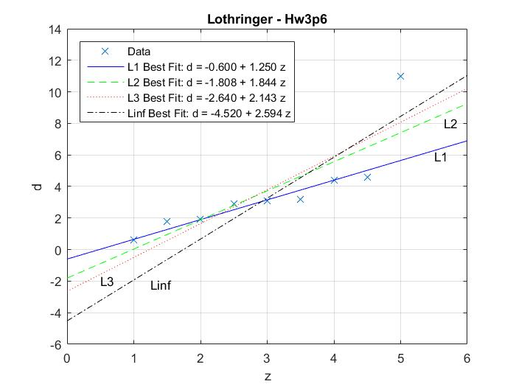

7. When it comes to outliers, the L1 norm will ignore the outlier the most. In contrast, the L-infinity norm will instead try to include the outlier in the fit, weighing it heavily compared to the other points. L2, L3,…,Ln will lie in between these extremes, ignoring or weighing the outlier. When just looking at this graph, it looks like the L1 norm does the best job because the outlier is obvious. When it is not so clear, it is less obvious. Something like the L2 or L3 norm would be good because it doesn’t completely ignore things that may (or may not) be outliers. L2, as we’ve discussed in class) is especially attractive because it leads to least-squares and is analogous to the geometric length.